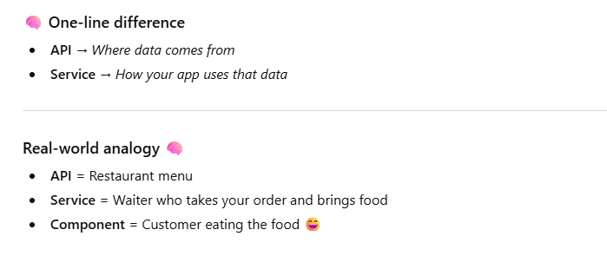
What is axiosInstance.js
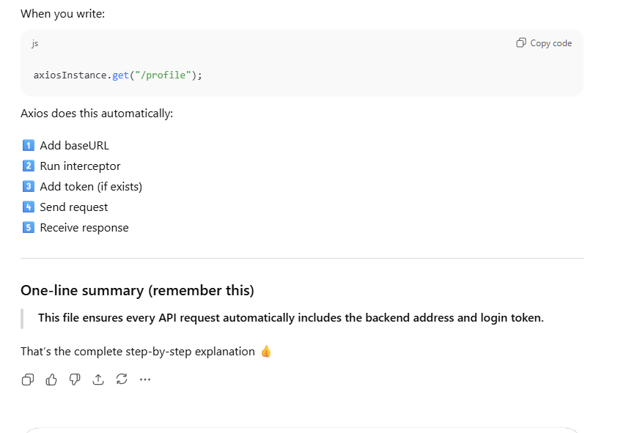

frontend\src\services\adminService.js
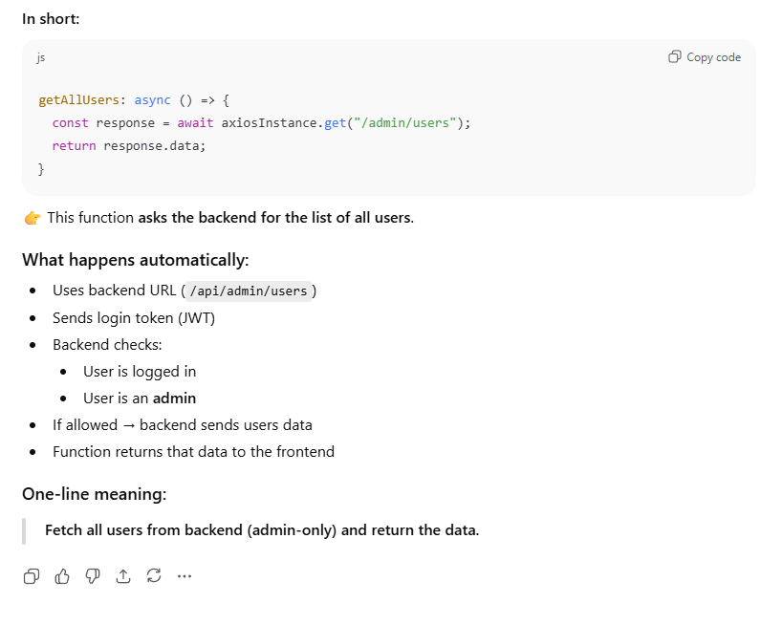
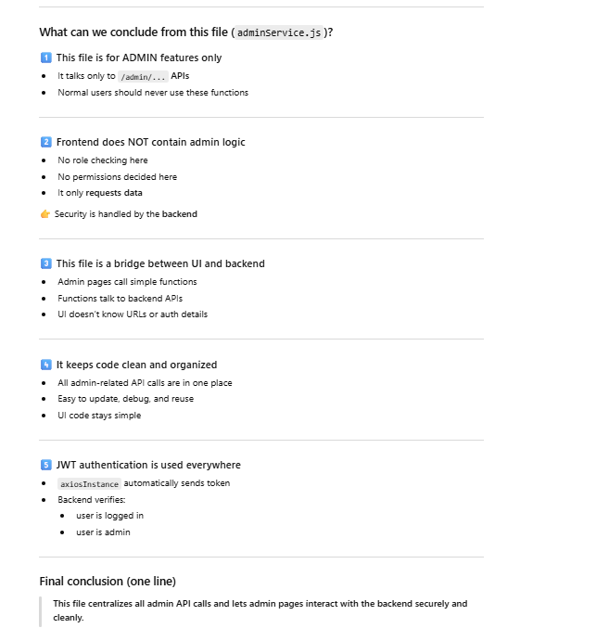
//frontend\src\services\authService.js
Same as above for authentication only -> checks JWT Token
// src/services/bookService.js
This code fetches books from the backend with pagination and optional search using query parameters.
The code
try {
const response = await axios.get(API_URL, {
params: {
page,
per_page: perPage,
search: search || undefined,
},
});

What is happening step by step
1️⃣ try { ... }
👉 “Try to run this code.
If something goes wrong (server down, internet issue), catch it later.”

2️⃣ axios.get(API_URL, {...})
👉 Sends a GET request to the backend
Example:
GET http://localhost:5000/api/books

3️⃣ params (VERY important)
params: {
page,
per_page: perPage,
search: search || undefined
}
This tells Axios to send query parameters in the URL.

What URL actually gets sent
Example call:
getBooks(2, 6, "java")
Axios sends:
http://localhost:5000/api/books?page=2&per_page=6&search=java

If search is empty
getBooks(1, 6, "")
Because of:
search: search || undefined
Axios sends:
http://localhost:5000/api/books?page=1&per_page=6
✅ search is not sent at all

Why search || undefined is used
👉 Prevents sending:
search=
which can confuse the backend.
So:
- If search exists → send it
- If empty → don’t send it
frontend\src\services\rentalService.js
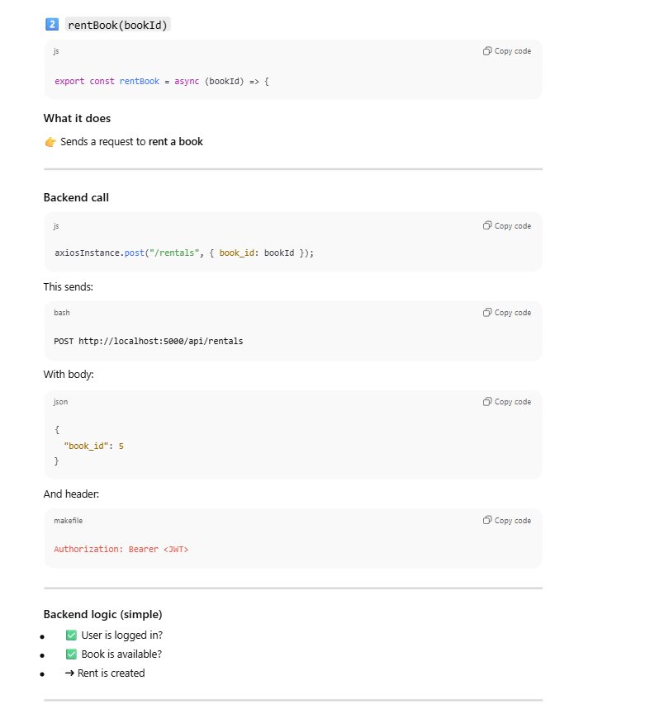

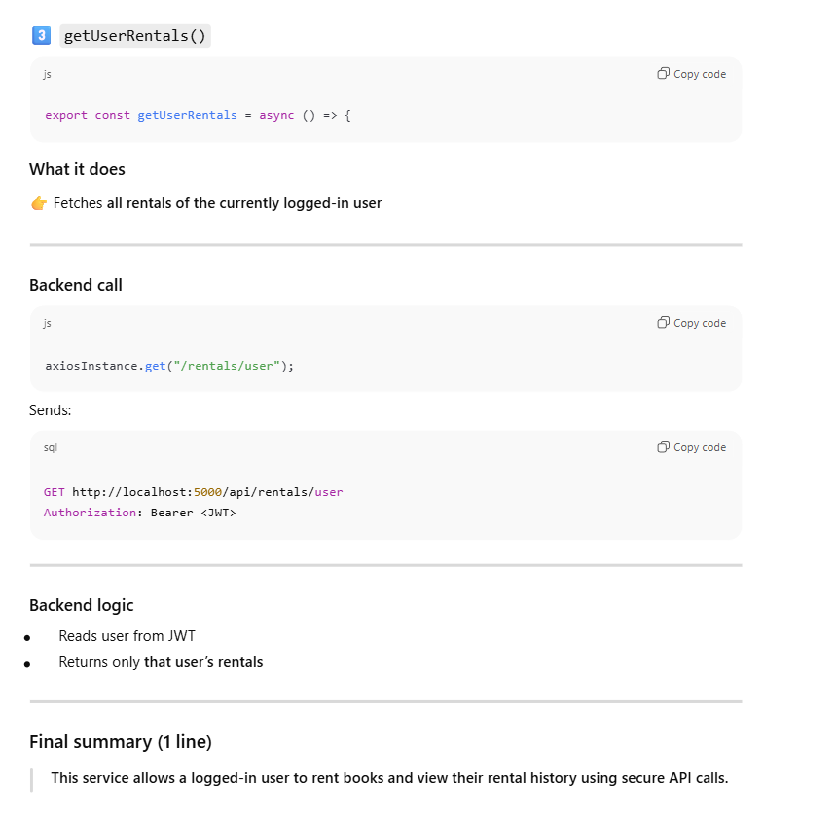
FLOW CHARTS:
frontend\src\components\books\CategoryBooks.jsx
