OLA| Dashboard

Overall

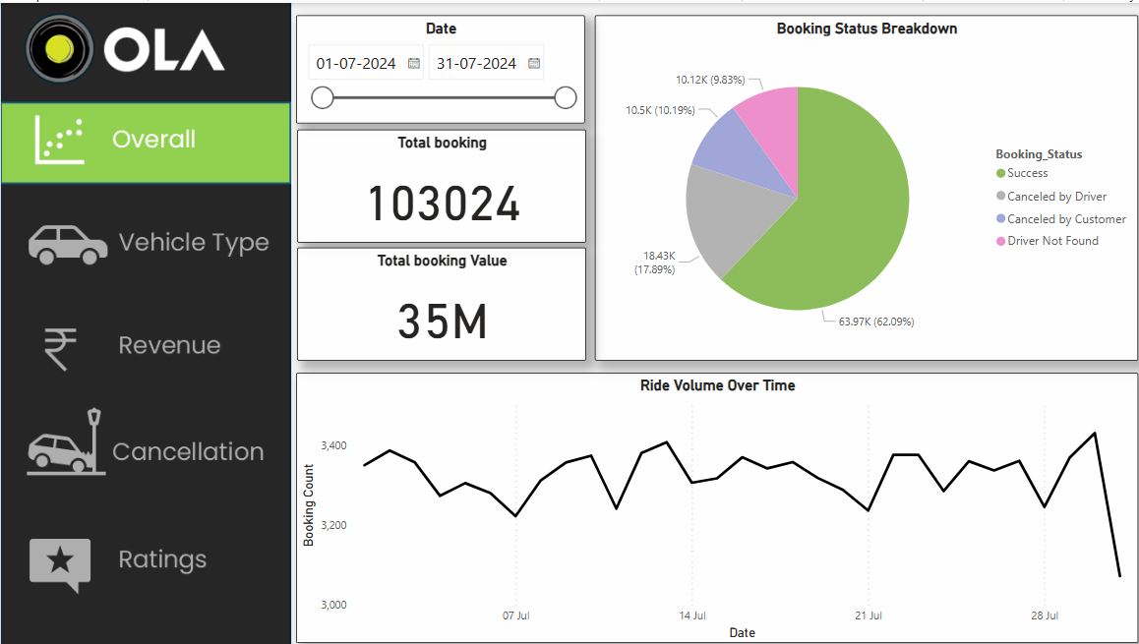

**1. Booking Overview:**

* **Total Bookings:** 103,024 rides were recorded in July 2024.
* **Total Booking Value:** 35 million (currency not specified, but likely in local currency).

**2. Booking Status Breakdown:**

* **Success Rate:** 62.09% of total bookings were successfully completed.
* **Cancellations:**
  + **Driver Cancellations:** 17.89% (18.43K) of rides were cancelled by drivers.
  + **Customer Cancellations:** 10.19% (10.5K) of rides were cancelled by customers.
  + **Driver Not Found:** 9.83% (10.12K) of rides couldn't find a driver.

**Key Takeaway:** The driver-related cancellations (either direct cancellations or unavailability) account for nearly **28%** of total bookings. Reducing these could improve the overall success rate.

**3. Ride Volume Trends:**

* The number of rides fluctuates over time, with peaks and dips visible throughout the month.
* The highest ride volumes seem to be around mid-July.
* There is a declining trend towards the end of the month.

**Key Takeaway:** Understanding the reasons behind these fluctuations (e.g., demand patterns, external events, or operational inefficiencies) could help optimize ride availability and increase revenue.

**Vehicle Type**

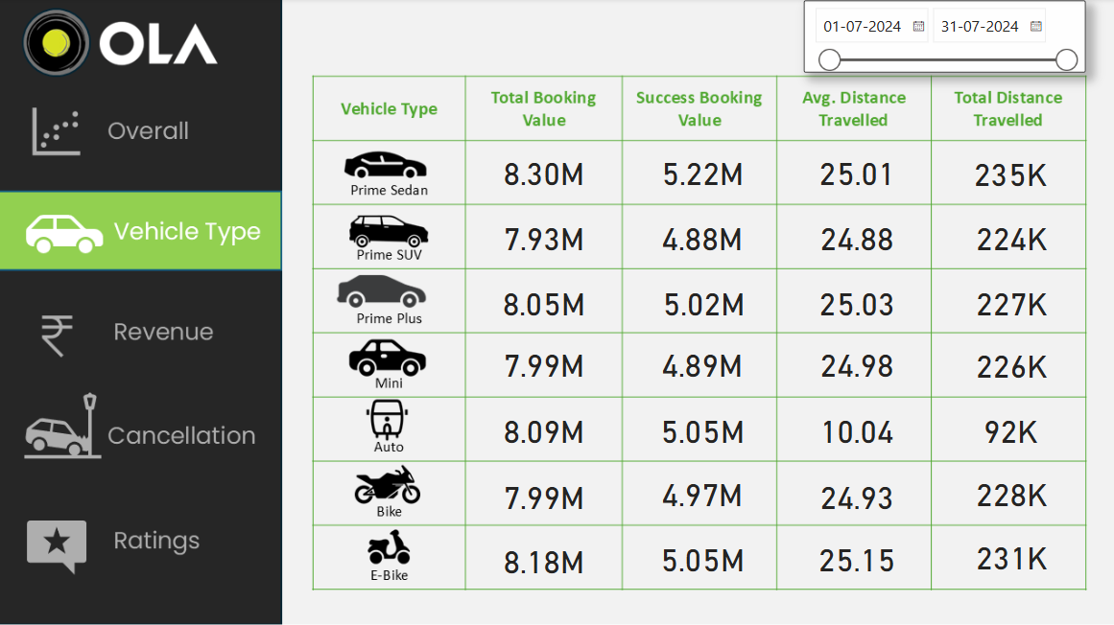

**1. Highest and Lowest Total Booking Value:**

* Highest Total Booking Value: Prime Sedan (8.30M)
* Lowest Total Booking Value: Prime SUV (7.93M)

**2. Highest and Lowest Success Booking Value:**

* Highest Success Booking Value: Prime Sedan (5.22M) and Prime Plus (5.02M)
* Lowest Success Booking Value: Prime SUV (4.88M)

**3. Distance-Based Insights:**

* Highest Average Distance per Ride: E-Bike (25.15 km)
* Lowest Average Distance per Ride: Auto (10.04 km)
* Highest Total Distance Travelled: Prime Sedan (235K km)
* Lowest Total Distance Travelled: Auto (92K km)

**Key Takeaways:**

* Sedans, SUVs, and Prime Plus have the highest revenue generation potential due to their higher booking values.
* Auto has a high booking value despite having the lowest average distance travelled, suggesting a high number of short-distance rides.
* E-Bikes and Bikes have similar total booking values to cars but cover significant distances, making them an efficient mode of transport for longer trips.
* Prime Sedan, Prime Plus, and E-Bike lead in successful booking values, indicating a high success rate in those categories.

Revenue

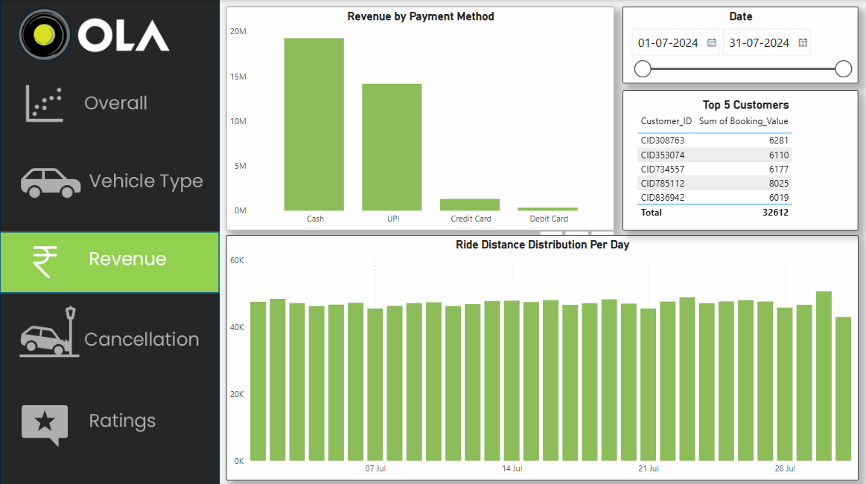

**1. Revenue by Payment Method**

* **Cash dominates transactions** with the highest revenue (19.26M).
* **UPI is the second most preferred payment method**, generating around 14.16M in revenue.
* **Credit and Debit Cards contribute minimally**, indicating that digital card payments are not widely used. (1.64M)

**Key** **Takeaway:** Encouraging more digital transactions via cards (e.g., discounts or cashback offers) could reduce cash dependency and improve payment efficiency.

**2. Top 5 Customers**

* The highest contributor, **Customer ID: CID785112**, generated **8,025** in booking value.
* The total booking value from the top 5 customers is **32,612**.
* The revenue distribution among the top customers is relatively balanced, with all contributing above 6,000.

**Key** **Takeaway:** Identifying high-value customers and offering them personalized rewards or loyalty programs could increase their engagement and spending.

**3. Ride Distance Distribution Per Day**

* Ride distances remain relatively **consistent across the month**, with daily total ride distances ranging around **45K–60K km**.
* **There are no major spikes or drops**, indicating a stable ride demand pattern.

**Key** **Takeaway:** Since the demand remains steady, optimizing vehicle allocation and pricing strategies based on peak and off-peak hours could maximize revenue.

**Cancellation**

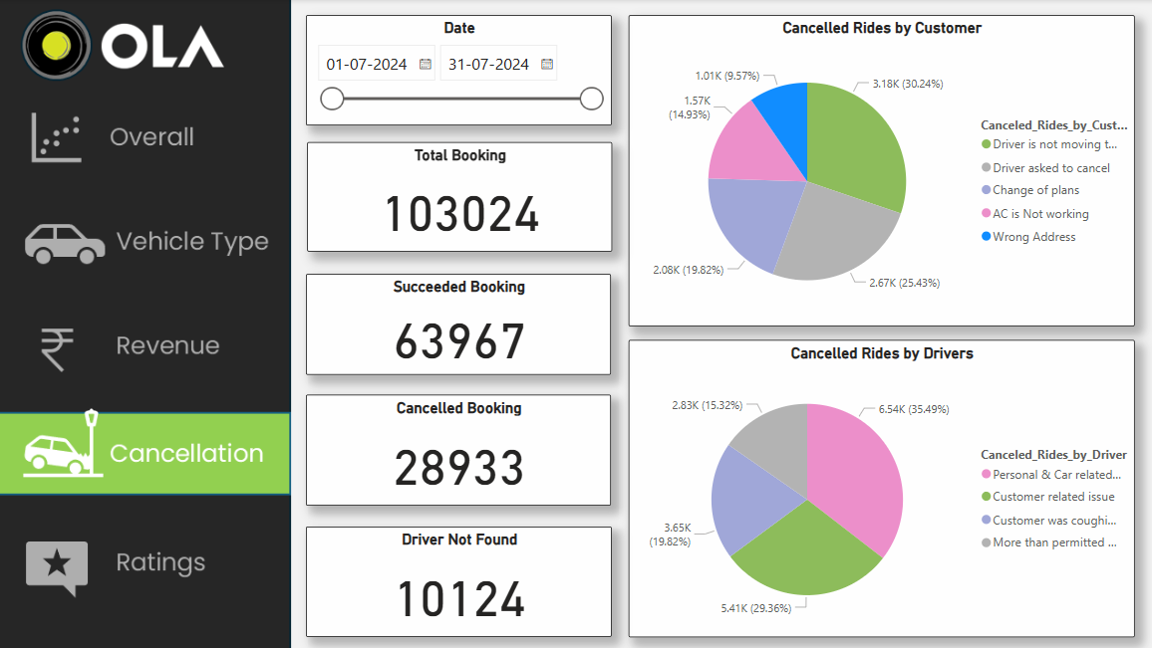

**1. Booking Performance**

Total Bookings: 103,024

Succeeded Bookings: 63,967 (62.1% success rate)

Cancelled Bookings: 28,933 (28.1% cancellation rate)

Driver Not Found Cases: 10,124

**2. Cancellation Analysis**

**By Customers**

The top reasons for cancellations include:

* Driver is not moving towards the pickup (30.24%)
* Change of plans (25.43%)
* Wrong address (19.82%)
* AC not working (14.93%)
* Driver asked to cancel (9.57%)

**By Drivers**

The top reasons for driver-initiated cancellations include:

Personal & Car-related issues (35.49%)

More than permitted wait time (29.36%)

Customer-related issues (19.82%)

Customer was coughing/sick (15.32%)

**3. Key Takeaways & Recommendations**

**High Cancellation Rate (28.1%):**

A significant number of bookings are being cancelled. Addressing the main reasons for cancellation can improve service reliability.

**Driver Not Found Cases (10,124):**

Nearly 9.8% of total bookings failed due to unavailability of drivers, highlighting a need for better driver availability and allocation.

**Customer Cancellations:**

Many cancellations occur because drivers do not move toward the pickup location or customers change plans. Incentives for drivers to stay committed to trips and clearer customer communication can help reduce this.

**Driver Cancellations:**

The highest reason for driver cancellations is personal or car-related issues, followed by long wait times.

Implementing stricter driver policies, improving car maintenance support, and optimizing wait time policies might help.

**Rating**

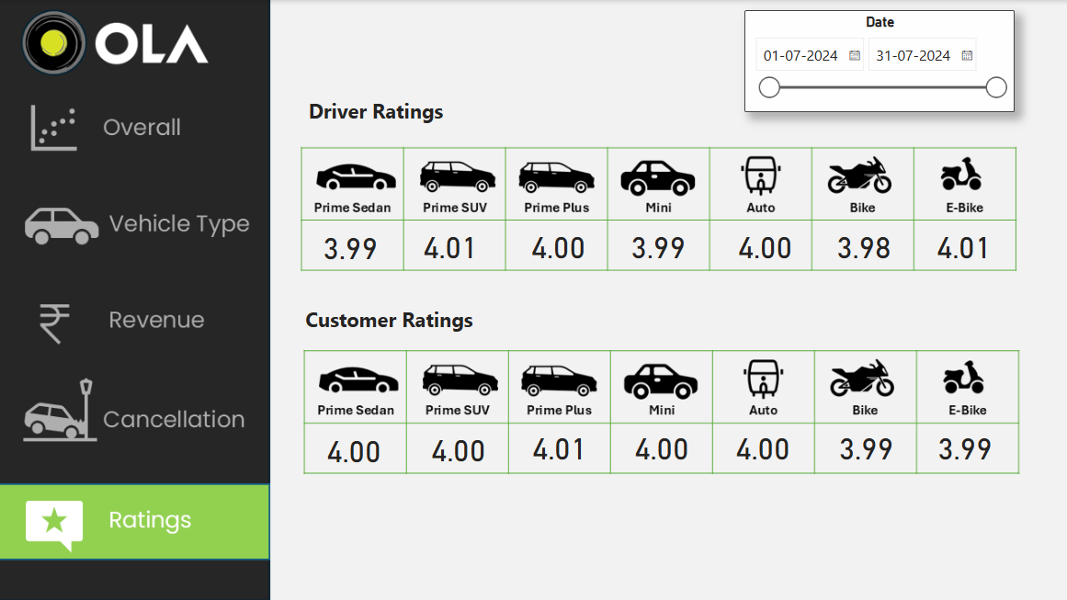

**1. Driver Ratings Analysis**

Best-Rated Vehicle Type: Prime SUV & E-Bike (4.01)

Lowest-Rated Vehicle Type: Bike (3.98)

**Overall Trend:**

All driver ratings are close to 4.00, indicating fairly consistent service quality.

Bikes & Mini cars have the lowest ratings (3.98-3.99), suggesting possible issues like safety concerns, comfort, or ride experience.

Autos and Prime Plus cars are at 4.00, showing stable performance.

**2. Customer Ratings Analysis**

Highest-Rated Vehicle Type: Prime Plus (4.01)

Lowest-Rated Vehicle Type: Bike & E-Bike (3.99)

**Overall Trend:**

Customer ratings are slightly higher and more uniform than driver ratings.

All categories except Bike & E-Bike (3.99) have an even 4.00 or more, indicating a good overall experience.

**3. Key Takeaways & Recommendations**

Customer satisfaction is slightly higher than driver satisfaction, meaning customers might have fewer complaints, but drivers could have operational challenges.

Bikes & E-Bikes have the lowest ratings from both drivers and customers. Possible reasons could be ride quality, safety concerns, or pricing mismatches. Enhancing safety measures, training, or pricing adjustments could help.

Mini cars & Prime Sedans have slightly lower driver ratings. Addressing driver concerns like waiting times, fare structures, or ride conditions might improve their ratings.

Prime SUVs & Prime Plus cars perform best across both ratings, suggesting they provide the most reliable and premium ride experience.

**END**