SprintestTM/CBF-Java User Manual



Table of Contents

1. General Information 4
1.1 Purpose of the document 4
1.2 Intended Audience 4
1.3 Points of Contact 4
2. Framework overview 4
2.1 Framework Architecture 4
2.2 Class Files 6
2.3 Flow Diagram 8
3. Framework setuP 10
3.1 System Configuration 10
3.2 Folder structure Configuration 10
3.3 Pre-requisites 11
3.4 Setup 11
4. Script Management 16
4.1 Pre Scripting Activity 16
4.2 Scripting activities 16
4.2.1 Creation of module driver file 16
4.2.2 Creation of Object Repository 17
4.2.3 Creation of reusable components in module driver file 17
4.2.4 Creation of testcase in excel file 18
4.3 Pre Execution activities 24
5. Execution and Reporting 24
5.1 How to execute 24
5.2 Execution Results 24
6. Test Management 25
6.1 Integration with test management tool <if any> 25

7. Utilities and Accelerators 25
7.1 Util 1 25
8. Standards and Guidelines 25
8.1 Framework Standards. 25
8.1.1 Standard for Class File 25
8.2 Coding Standards 25
8.2.1 Naming convention for Objects 25
8.2.2 Naming convention for Variables 25
8.2.3 Guideline for Data Table 25
8.2.4 Naming convention of Test Cases 25
8.2.5 Naming convention of Reusable components 25

General Information

Purpose of the document
The Test Automation Framework User Manual is designed with a purview of answering the most popular question – “How does this frame - work?”
The document highlights on the various automation test artifacts & the samples. The document also speaks about how to execute test cases using Quality Center and how to modify test data or the test flow, before each execution cycle.

Intended Audience
Intended audiences for this document are Test engineers, Senior Test Engineers and Automation Experts who will be using the framework for script creation.

Points of Contact
Please contact following POCs for more information and troubleshooting purpose on the framework

- Contact Name : Rashmi Nagaraj
- Contact Name : Rizvan Saiyed

Framework overview
IGATE’s Test Automation Framework (CBF) is IGATE’s Component Based Test Automation solution, aimed at optimizing test automation for business critical applications. In our assessment, effective test automation requires bringing application abstractions to test automation and further to test design itself. CBF is designed to help test analysts and engineers build and automate tests using such abstraction, thus fine-tuning the test engineering process to the application under test (AUT) and minimizing the tedium of detailing each test step in each test one by one.

Framework Architecture
In consideration to the richness and diversity of UI of the applications and nature of test cases in scope, we are using a Modular Based Hybrid Automation Framework for the Automation project.
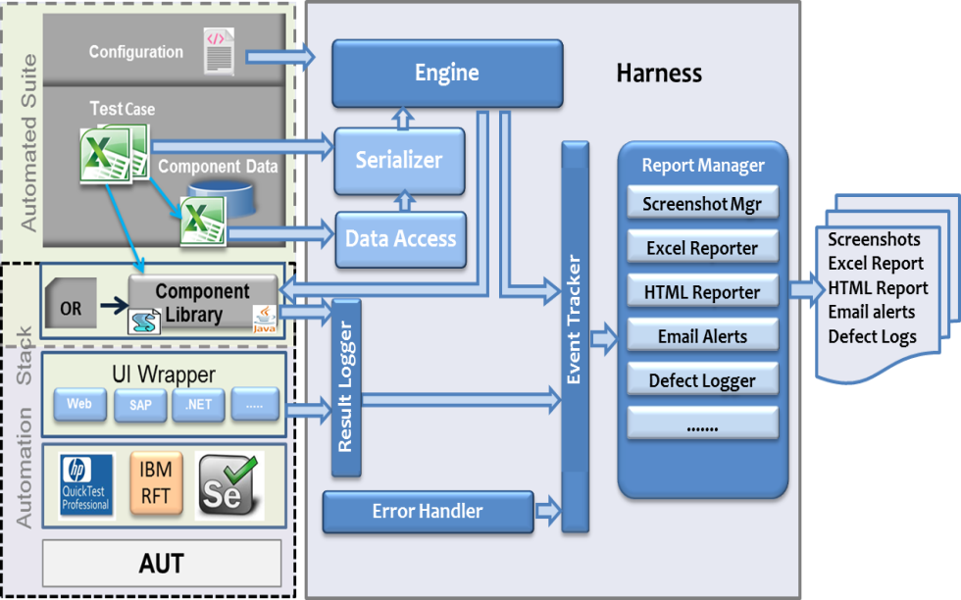
Figure: Framework Architecture

Harness: Execution gets triggered from here. Initializes the result logs, reports and initiates execution.

Engine: General purpose runner for executing component based test cases. It supports a robust event model for reporting. Also Encapsulates runtime exception handling, test failures and recovery.

Serializer: Deserializes the Auto_TC.xls file, resolves the references with the help of Data Access and creates a testcase object for execution.

Data Access: Reads data from centrally maintained data files at the module level, thus helps in resolving data refs.

Report Manager: Manages different report types on user selection like ScreenshotMgr, Excel reporter, HTML Reporter, Email Alerts etc..

Error Handler: Logs errors in a csv file, thus helps in tracking error.

Result Logger: Exposes set of methods like Passed, Failed, Error, Done etc, which will be used to log results in the component libraries on verification. The logged results are made available in the selected reports.

Component Libraries: Collection of automation driver scripts for each action. Provision to organize functions into a small number of module driver files for maintainability. Simplifies test layer to a series of calls to this layer.

TestCase: Assembly of different combinations of components.

Component Data: Data maintained for components in the module excel workbooks.

Application Under Test: Application considered for automation.

UI Wrapper: Generic methods like SetValue(), Click(), GetCtrlProperty() etc.. which will be used in scripting the components.

Class Files
Following are the classes in the framework which are implemented to a designated task.
Class Name | Description | Location
TestCase | Interface defining test case model. | CBF.engine
TestCaseRunner | Maintains the iterations of test steps and triggers the execution for each step. | CBF.engine
TestResult | Maintains a results tracker object for each test case at the test case and the test step level.  It will report the status at each level of execution in the test case. | CBF.engine
ExcelReporter | Creates a summary report in excel and logs the status of test suite and the test cases that were run in the suite. | CBF.reporting
HtmlEventReporter | Creates HTML reports. | CBF.reporting
Email Alerter | Sends mail to recipient mentioned in config file with the failure details, screenshot of application on test case failure. | CBF.reporting
ResultEventLogger | Custom report to analyse execution results based on logs generated during execution. | CBF.reporting
ManagingReporter | Manages the creation of different types of reports generated by the framework.  Reports like Summary Report, Trace Log and Error logs. | CBF.reporting
CDTAccess | Is an encapsulation for the Centralized Data Table and provides functions to access and process the data it contains. | CBF.serializer
ResourcePaths | All paths either are defined here. | CBF.harness
AppLoader | Loads all the configurations settings and bootstraps the framework. | CBF.harness
Harness | Main class for Running Engine from Harness.  Defines the runTestCase() function. | CBF.harness
TestCaseAccess | Gets the access object for the test case from Quality Center. | CBF.harness
Serializer | De - serializes the test case sheet and creates the test case object with all the parameters required for each step. | CBF.serializer
WebActions | Contains convenience function to invoke actions on web controls.  E.g. SetValue, InvokeAction, etc. | CBF.actions
DTAccess | Gets the access object for test case excel file. | CBF.serializer
SleepUtils | Utility to handle sleep with different time slabs. | CBF.utils
StringUtils | Manages to convert various data types to string | CBF.utils
Loggger | Utility for logging different types of events. | CBF.utils
FileUtils | Utility for performing various file activities.  E.g. CreateFile, CreateFolder, etc | CBF.utils
Substitutor | Evaluates the expression which provided as parameters for test step.  E.g. ${TODAY+1} gives you tomorrows date. | CBF.utils
Utils | Generic utility functions. | CBF.utils

Flow Diagram
Sequence diagrams for framework functional flow is shown in Fig 2.3(a) for Test case deserialization and Fig 2.3(b) for Test case execution and reporting.

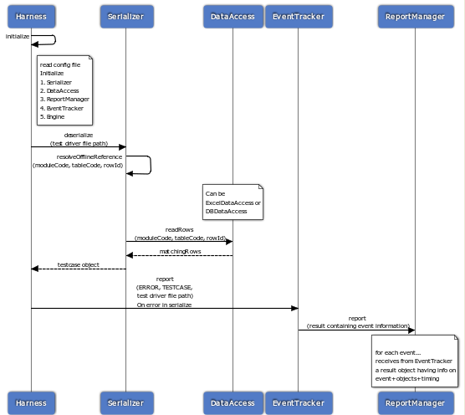

Fig 2.3(a) Test Case Deserialization

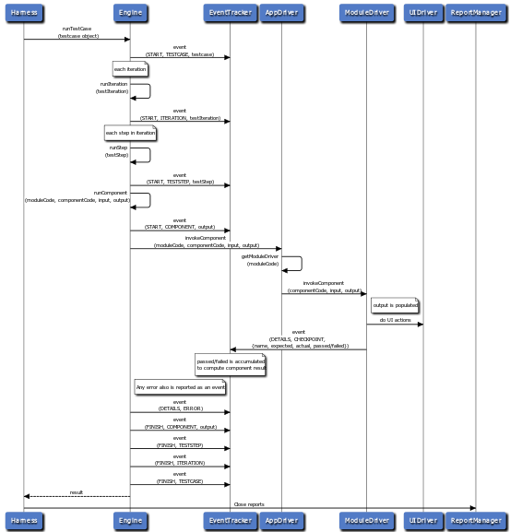

Fig 2.3(b) Test case Execution & Reporting

Framework setuP

System Configuration

- Windows xp or Windows 7 OS
- Microsoft excel
- Browser

Folder structure Configuration

Specify application wise folder under Test Automation folder. Each application wise folder has all required folders like AppDriver, OR, Data, TestCases.

Example: Application name is Application1

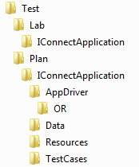

Folder | Description
App Driver | - Used to store OR.  - Config.xml is maintained which is used to configure synchronization, reporting and data file types etc.
OR | - Used to store the Object Repository map file.
Data | - Used to store the CDT and Master Data files
Test Cases | - Used to store all test cases files

Pre-requisites

- Jdk – Java Environment
- Eclipse – As a Java Editor
- Jxl jar – Java-Excel Apis
- Selenium-standalone-server.jar – Selenium-web-driver apis
- Microsoft Excel
- Firebug for identifying elements in Firefox browser.
- Extra drivers in case of chrome or safari browsers.

Setup

Steps to setup project in workspace using framework libraries

Step 1: Click on File->New->Java Project menu item

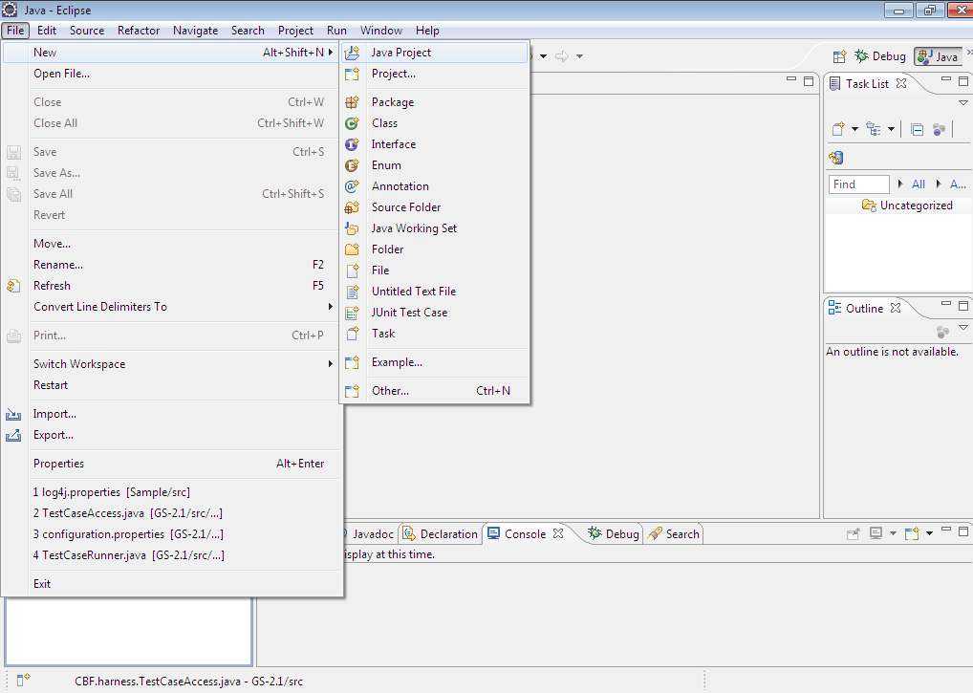

Step 2: Provide project name and select the framework source folder for import

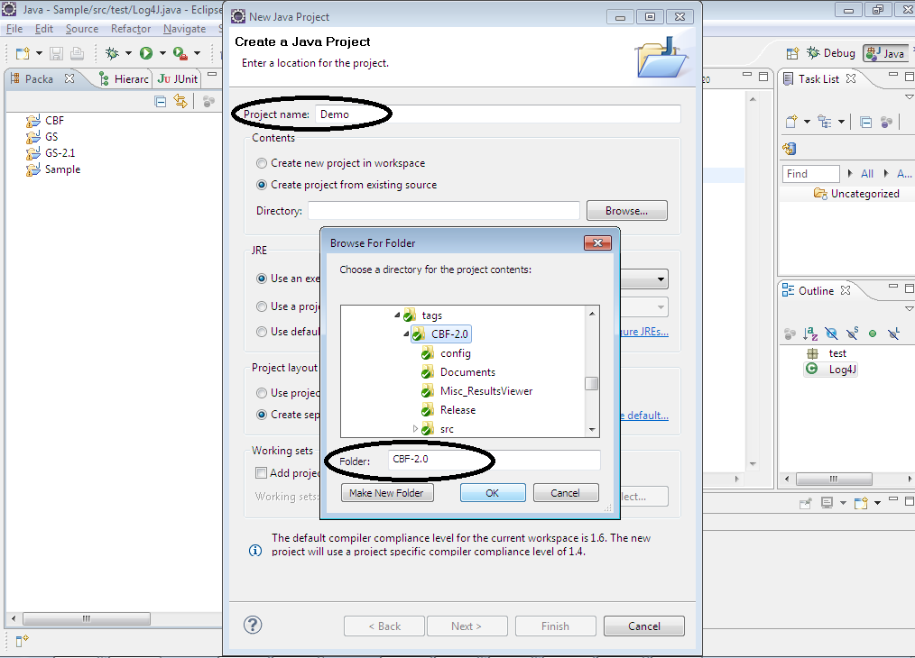

Click on OK button

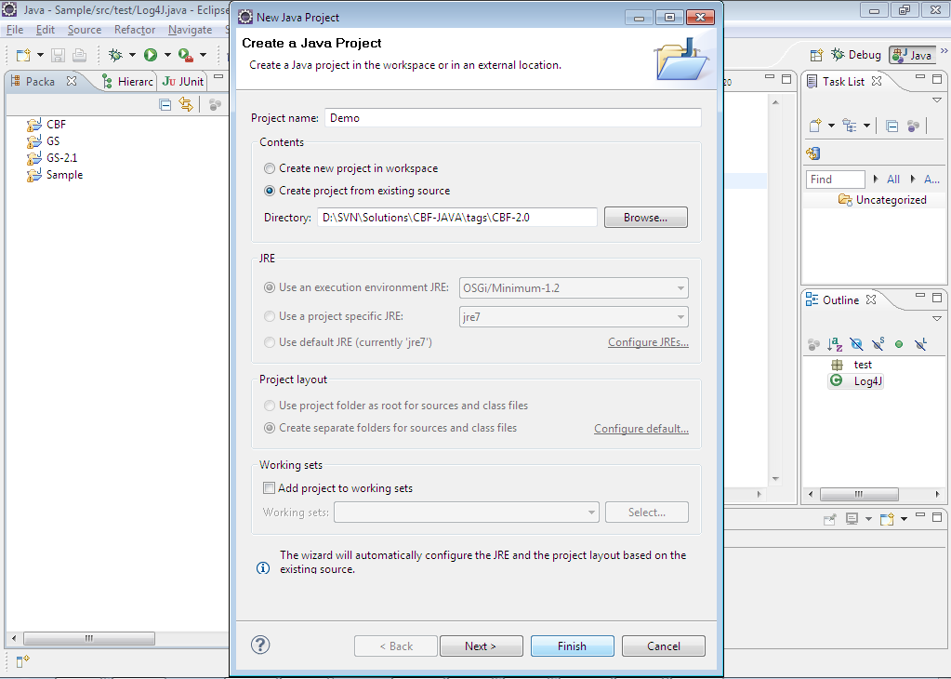

Click on Finish button, the project gets added.
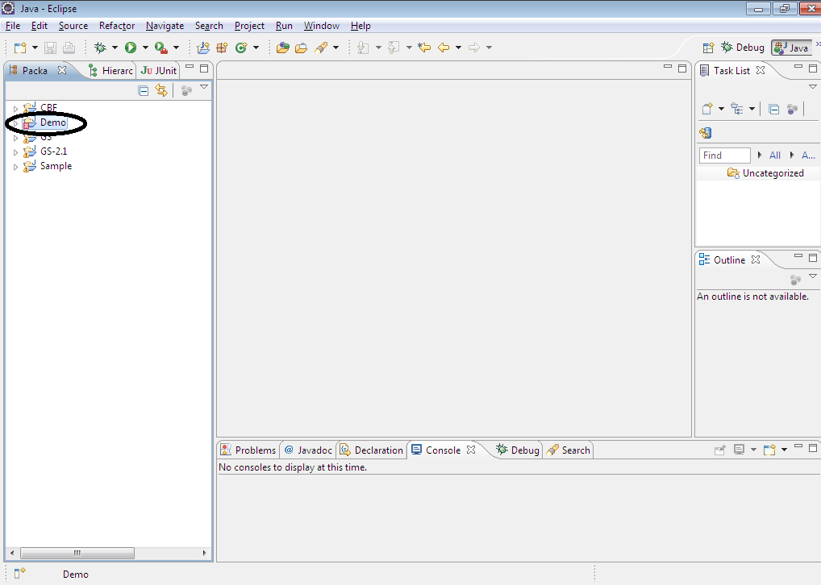

Step 3: To associate external jars, right click on the added project, go to Build Path

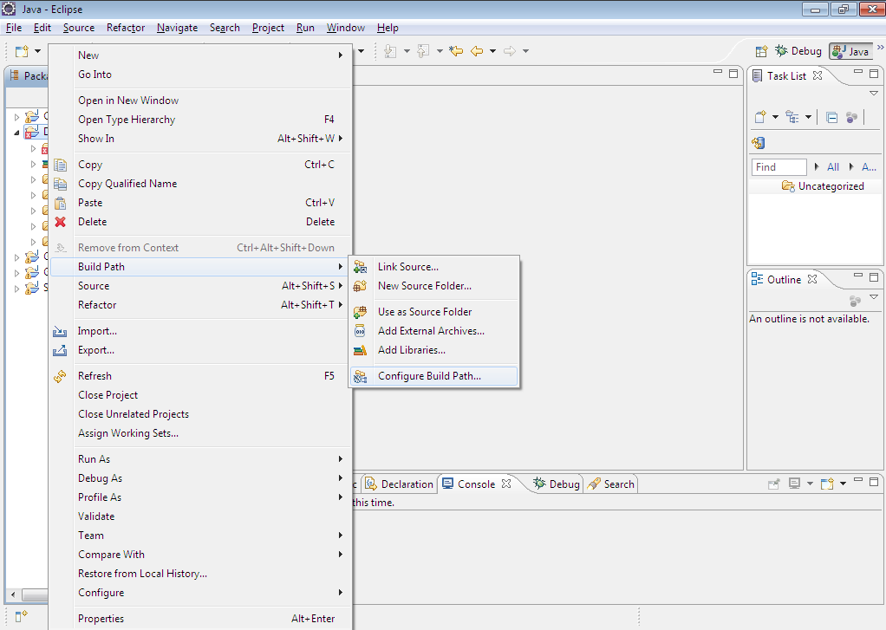

Select Configure Build Path, Java Build Path window comes up

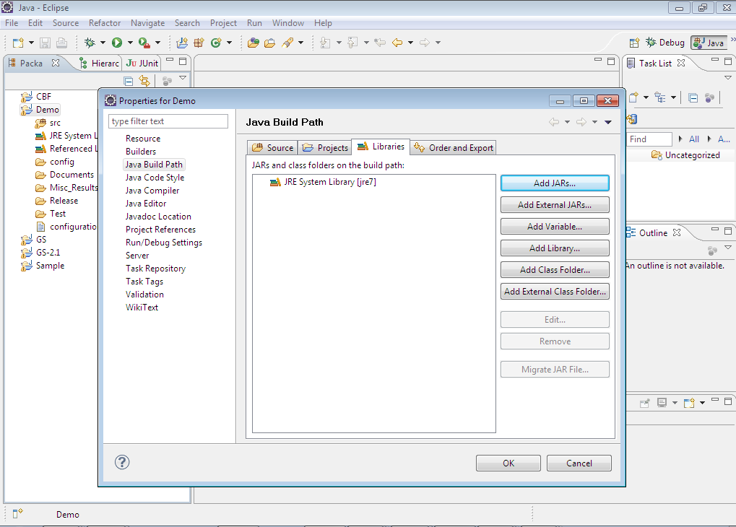

Click on Add External JARs button, locate the folder where jar files are saved, select the necessary jars for association

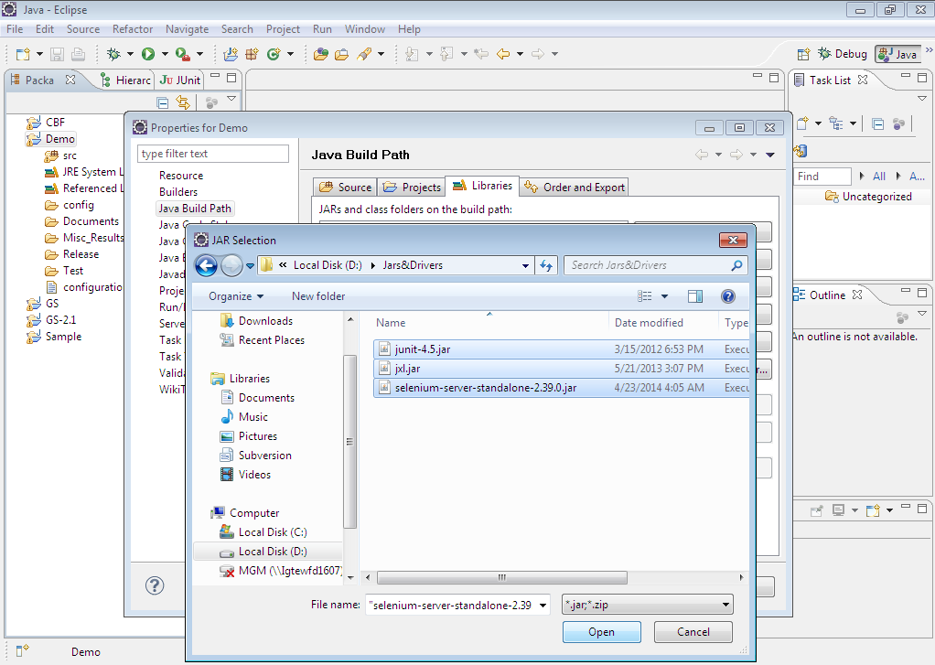

Click on Open button, so that the selected jars gets associated.

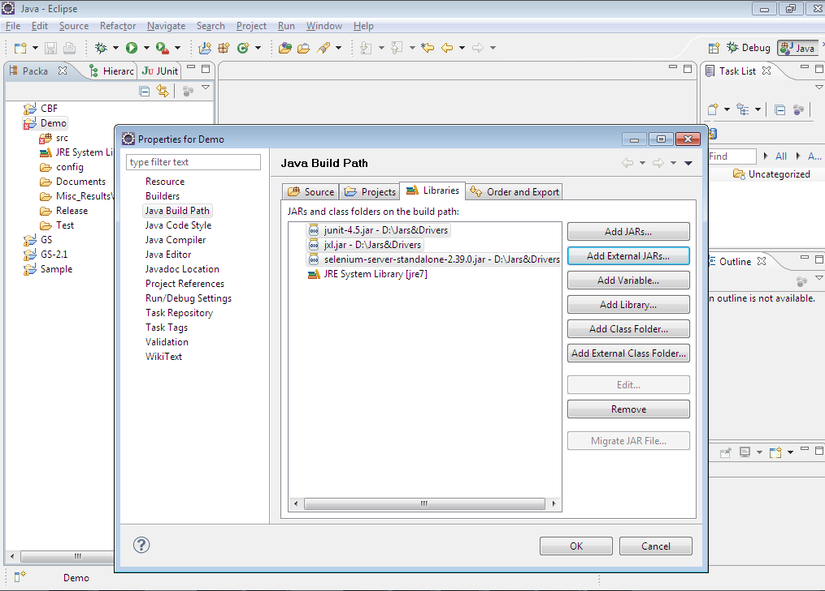

Click on OK button to close the Java Build Path window.

Script Management

This section provides details on how to create module drivers, module-wise data files and test case excel files.

Pre Scripting Activity
Understand the test cases and identify reusable components. Application functionalities are broken down to components. The granularity of the components are adjusted in such a way that tests can be built as an assembled sequence of such components.
Creation of Test inputs:
- Test case file (Excel): Create the test case file for each test case separately
- Test Data (Excel) : Gather the test data required for Test execution
- Object repository (Excel) : Store the HTML property of web-elements

Scripting activities
Scripting activities are mainly involved in creation of module driver and creation of test cases in excel file.

Creation of module driver file
Business processes in an application are broken down into components. The Module Driver is a java file which holds together a comprehensive collection of such components. The components designed in the module driver are used to design the flow of the design script (or Test Case Data sheet).
It is called as Module driver because a single application can be broken down into multiple modules based on the size of the application. For a simple application there might be only one module, but for complex applications there might be multiple. Number of modules for an application is purely based on the designer’s perspective of manageability of the application.
Every module driver has minimum following entities.
- Class name is “<java file name>Driver”
- Methods for implementing components

Example: To Create ManagerUser module driver file. ManageUser.java file has following minimum entities. Refer screenshot below.
- ManageUserDriver Class
- Methods for components with signature(DataRow input, DataRow output)

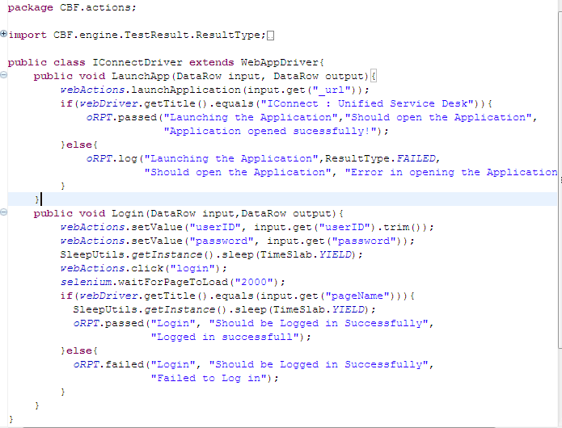

Creation of Object Repository

  - Create Shared Object Repository

Maintain shared object repository with object identification details in uiMap.xls. This is shared across all test cases for a given application. Following is a sample uiMap file.

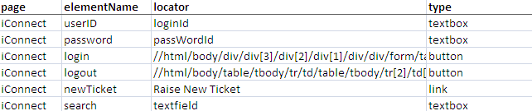

  - Associate Object Repository

Update the path of ObjectRepository in the config properties file with the OR map file path.

Creation of reusable components in module driver file
Every action identified for the application is defined in the Module Driver as a function. These components contain scripts to invoke actions on controls and also track the validation in the application.

Example:
Following is an action for Login to application. Login component requires user name and password values. Every reusable component accepts two parameters. Parameters are “input” and “ouput”. Input parameter is dictionary object which contains testdata of the component.

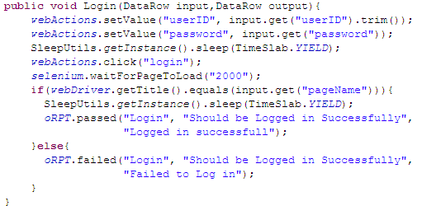
webActions = Object of the Web Application Driver Class
Step 1: Sets value in userId field
Step 2: Sets the value in password field
Step 3 : Click on “login” button
Step 4 : Verification and reporting results

All such business components will be designed and added to the module driver. These modules together will comprise of a scenario (test case scenario). Hence, allowing us to perform all business processes by breaking them down into components and reusing them in different scenarios.

Creation of testcase in excel file
CBF is a data driven testing automation framework where test input values are read from data files. The different data files in CBF are Master Data and Centralized data Table(CDT) and Test Case specific data sheet. The data is then loaded into variables in action code in the coded scripts.
Test Case file contains the Reference, Variables, Iterations, Steps sheets

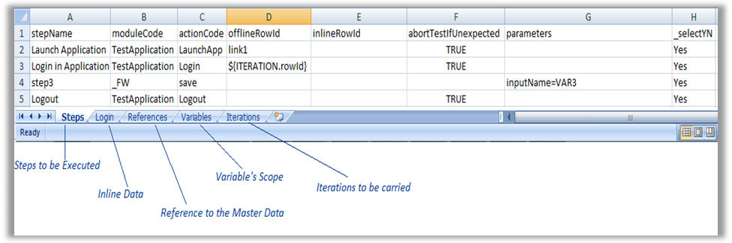
Fig 4.2.4(a) Test Case

Conventions:
The steps containing sheet must be named as “Steps”.
1st row must be same as shown in fig.

‘Steps’ sheet: (TC file)
Column Names:
stepName: User friendly name
moduleCode: module name
actionCode: action name
offlineRowId: rowId of a table from CDT
inlineRowId: inline rowid
parameters: to access or to store parameters
_selectYN : test step to be executed or not

‘Login’ sheet: Inline data (This sheet name will vary as per the action code)
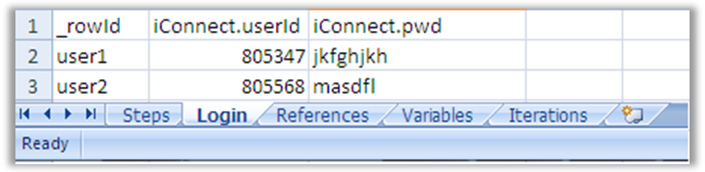
Fig 4.2.4(b) Inline Reference

Conventions:
1st column name must be _rowId.
If you give inline row reference then it over-rides the offline row reference.
‘References’ Sheet: (TC file)

Refers to the Master table
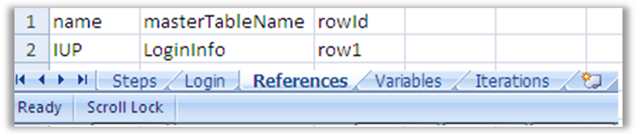
Fig 4.2.4(c) Master Data
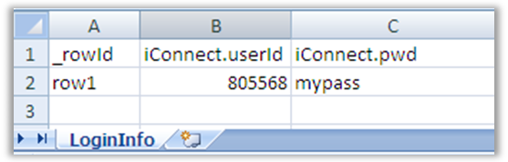
Fig 4.2.4(d) Master Reference

Conventions:
Sheet Name must be “References”.
Column-Names must be same as shown in diagram.

Column Names:

name: reference name
masterTableName: table from a master data excel
rowId: rowid of a table in master data excel.

This is how you can refer:
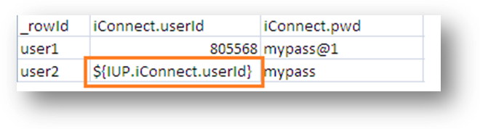
Syntax: ${ReferenceName.column_name}

‘Variable’ Sheet: (TC file)
Stores values in variables
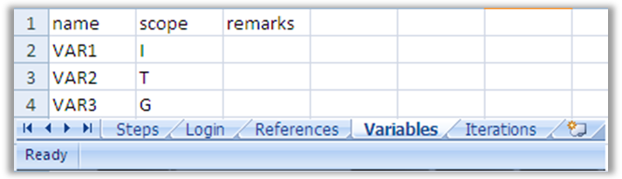
Fig 4.2.4(e) Variables
Convention:
Sheet Name must be “Variables”.
Column-Names must be same as shown in diagram.

Column Names:
name : variable name
scope: I-Iteration , T- Test Case , G- Global (Across Test Cases)

How to store value in
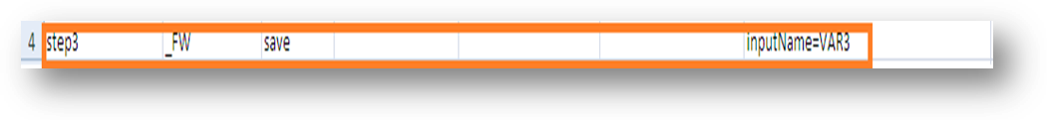
This is how you have to write a step in your test case.
VAR3 is just a variable name declared in Variables sheet with the scope.

How to use that variable:
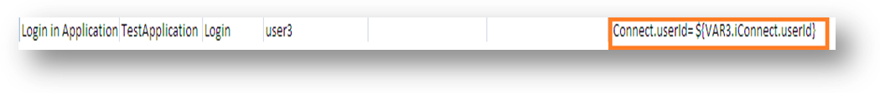
Syntax: column_name= ${VAR3.columnName}

‘Iterations’ sheet: (TC file)
Iterations with multiple inputs
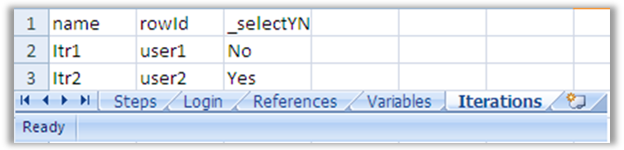
Fig 4.2.4(f) Iteration

Convention:
Sheet Name must be “Iterations”.
Column-Names must be same as shown in diagram.

Column Names:
name: iteration variable name
rowId: rowId
_selectYN: Decision whether to execute the iteration.

Usage:
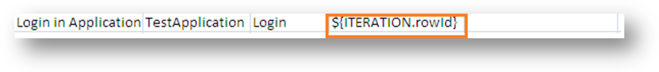
Syntax: ${ITERATION.rowId} (this is a FINAL string) (use as it is)

Test Data:

CDT:
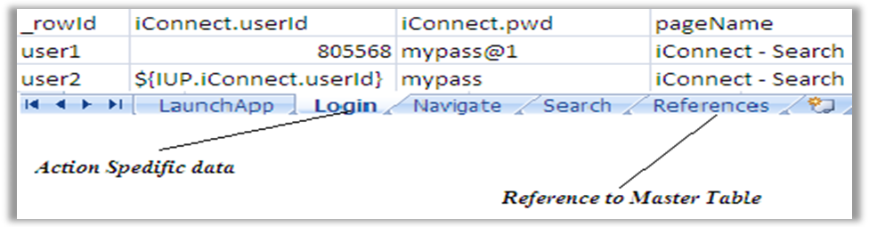
Fig 4.2.4(g) Test Data
Test Set:

List of test cases to be executed
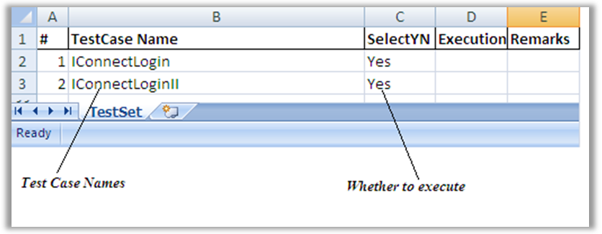
Fig 4.2.4(h) Test Set

Conventions:

Sheet name must be “TestSet”
Column-Names must be same.

Composing a Test Case:
TC:
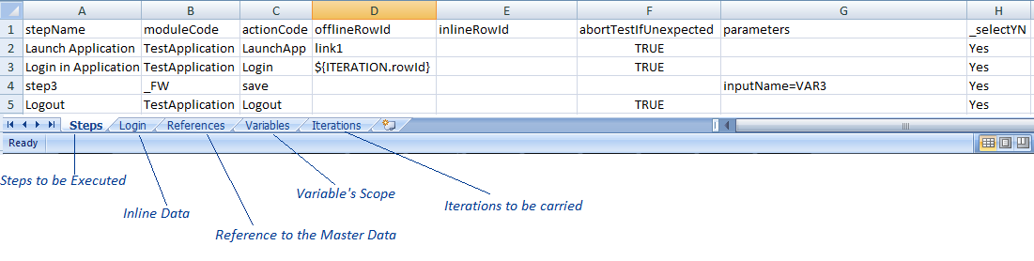
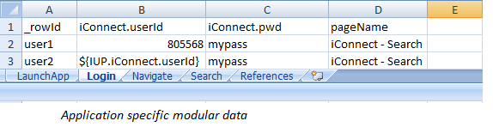CDT
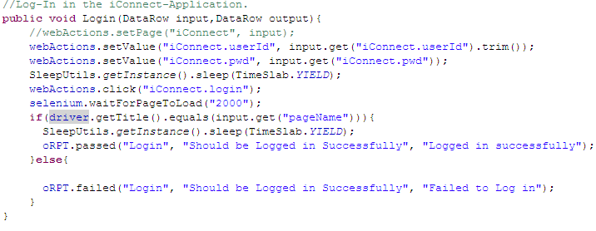
Test Script

- As you can see, the action code from TC file should be same as Sheet Name from a Data File and the same string should be present as a Method name in Test Script.
- ModuleCode should be same as TestData excel file name but without sub-string “Data”.
Eg. If Excel file name is AppData then module code will be App.

Pre Execution activities

Execution and Reporting

How to execute

Step 1: Open the Test Set.xls file from Lab folder

Step 2: Update the SelectYN colum value to Yes|Y|yes. Select the test cases to be executed from the existing Test Set and then execute the test set.

SummaryReport.xls – Summarized excel showing the status of all the test cases and steps executed in this batch.

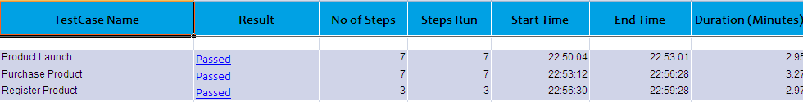

Execution Results
Once the execution of the test scripts is over, it’s now time to review the results. The results will be displayed as either Passed or Failed in the Test Summary Report.
Test cases which are marked as Failed should be re – executed.
Note:
- Rename the existing Log Folder in the C Drive with a logical name e.g. “First Run”, “Second Run” and so on (This is to ensure that you have the artifacts for all the executions)
- Also ensure that all the data dependent test cases are supplied with the necessary data.
Step 1: Update the SelectYN column in TestSet.xls to Y for failed test cases and run the test set.

Test Management

Integration with test management tool <if any>

Utilities and Accelerators

Util 1

Standards and Guidelines

Framework Standards.

Standard for Class File
Every Class file has minimum following entities.
- Class name is “<java file name>”
- Method “Factory<ClassName>”
- Open and Close Method
- Class_Initialize method

Coding Standards

Naming convention for Objects
Specify logical names for objects

Naming convention for Variables

Guideline for Data Table
- CDT File (Centralized Data Table file) is named same as module driver file
  - Sheets of CDT file represents data for components of module driver file. Sheet name is same as action name and action sheet has testdata for its action.
  - First column in each sheet is “_rowId”. It is applicable to CDT file, Master data file and Test.

Naming convention of Test Cases
- Test Case name is starting with “Auto” e.g. Auto_TestCaseInsurance.xls

Naming convention of Reusable components
- Specify logical name as Action name which is related to application area.
- Specify only Alphanumeric and Underscore characters in Action name
- Space is not allowed anywhere in action name.
- Avoid underscore in beginning of the action name.
- Specify first character in Action name
- Example for Action name is : Login

