Orient Bell Hackathon Solution Architecture and Explanation



Venkatesh Radhakrishnan

Laxminarayen N V

Mohammed Noordeen

INDEX

Architecture 3

Flask APP 4

Overview 4

Architecture 4

Explanation 4

Sample of App run 5

Tableau Dashboard with insights 6

Overview 6

Architecture 6

Explanation 6

Sample of Screen shot from the component 7

New Product Launch Segmentation 7

Overview 7

Architecture 7

Explanation 7

Sample of Screen shot from the component 8

### 

Solution Approach

Overview

The Solution was first implemented in R but then we wanted the code to be platform independent, so we translated the code in python.

* AWS CloudWatch Event Rule
* AWS Lambda function

### Architecture

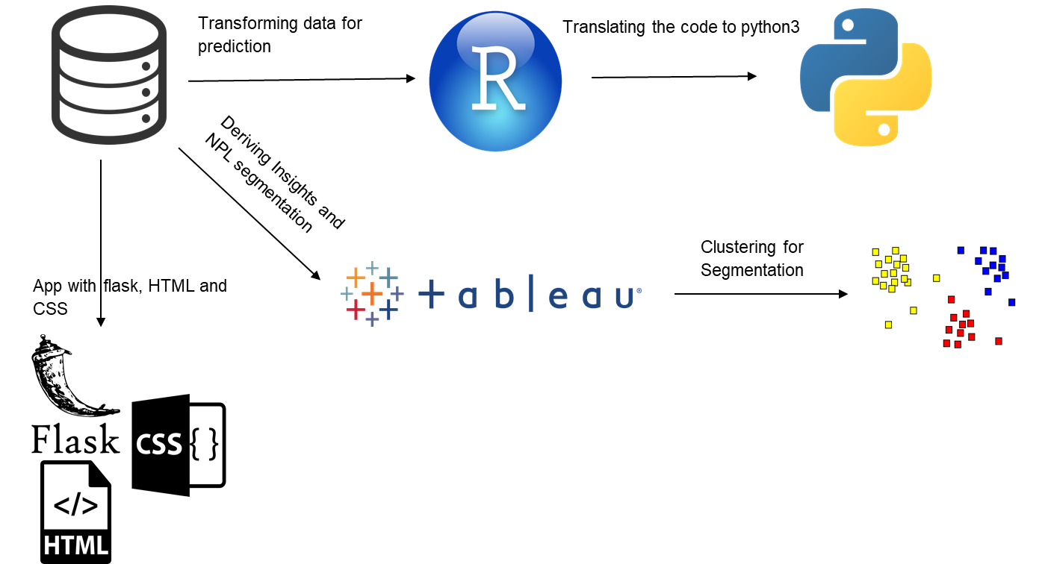

Explanation

* The solution for the prediction is written in R first using all the features in the data. The R code can be opened using R studio or any other IDE of choice
* The same was then converted into python to provide platform flexibility to the organization
* On the other hand, a dashboard was built with the same data. Sample insights are attached with in the folder **Dashboard & Insights.**
* Five Important numerical features were then selected and then using flask a web app is built so that anybody can make use of this

# Flask APP

### Overview

Flask is a popular Python web framework, meaning it is a third-party Python library used for developing web applications.

However, deploying a flask application that has been built with your main Python installation can be a bad idea sometimes. Furthermore, it is not advisable to even start creating a web app using your main Python installation. Because you use Python for many other things, there can be a lot going in that installation.

You can then create a virtual environment.

python –m venv virtual

venv here is the name of the virtual environment

### Architecture

### 

### Explanation

* After we have our virtual environment set up we start it by using the command

Activate venv in the command prompt

* Navigate to the **flask_APP** folder
* Install all the necessary packages from the **requirements.txt** which is also located in the same folder by using the command

pip install -r requirements.txt

* Now run the app.py using the command

Python app.py

* Note all the steps listed above are for windows

### Sample of App run

Activating the virtual environment called dash



Dash Activated:

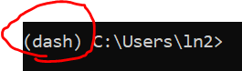

Running the app:

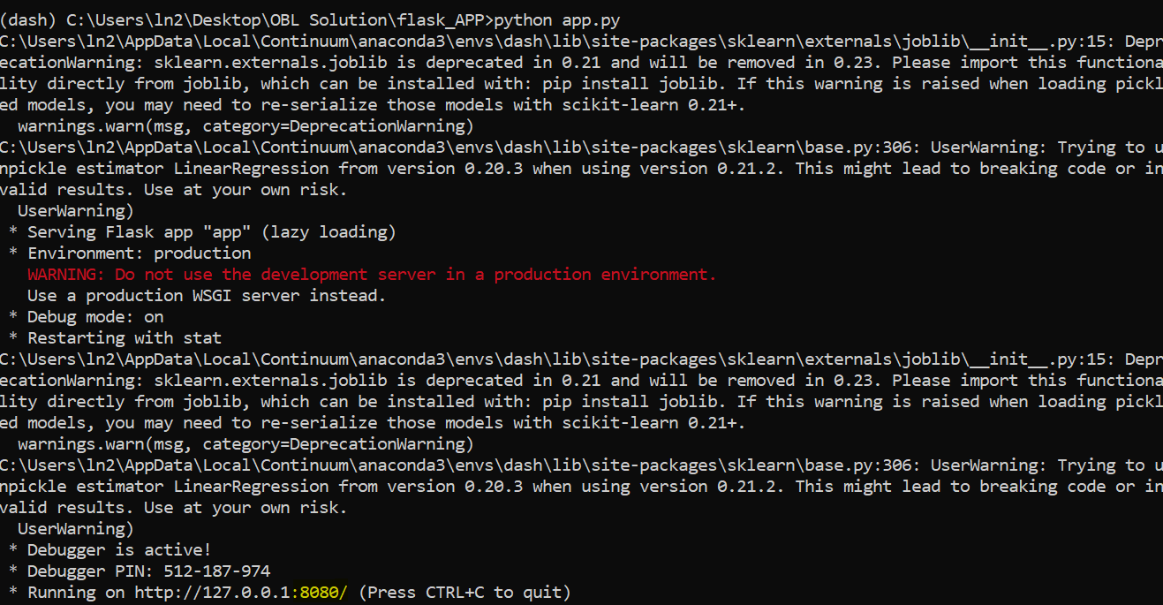

Now the app is active in port: 127.0.0.1:8080

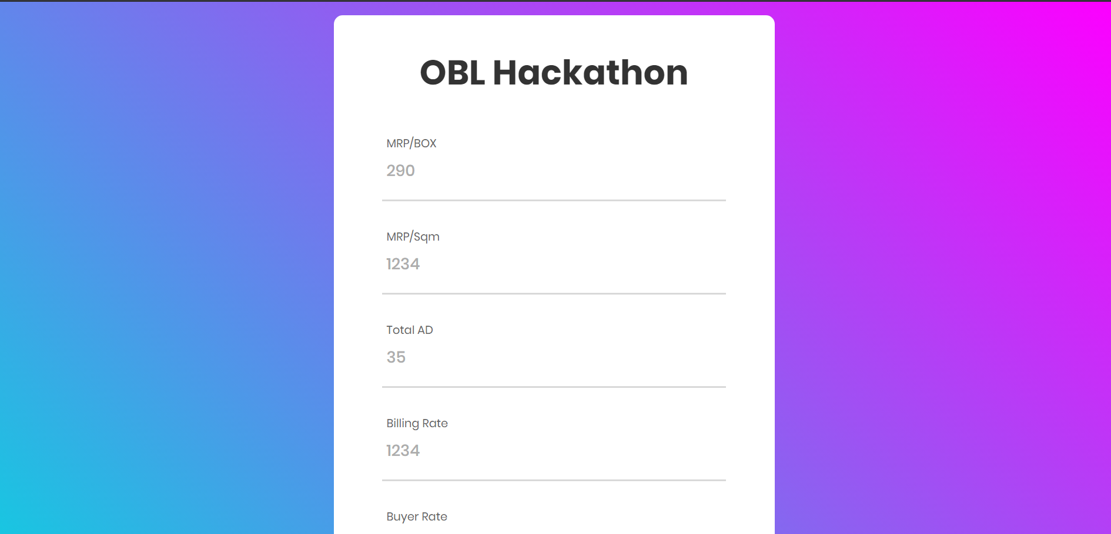

# Tableau Dashboard with insights

### Overview

Tableau is a powerful and fastest growing data visualization tool used in the Business Intelligence Industry. It helps in simplifying raw data into the very easily understandable format.

### Architecture

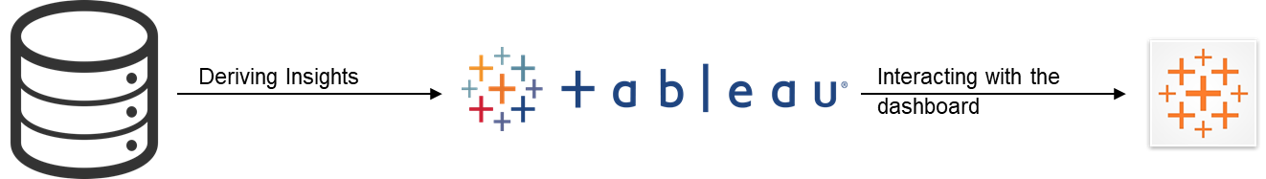

### Explanation

* We read the data into the tableau and then we have created visualizations that would help us in understanding the actionable insights needed to make an effective business decision
* Here all the visualizations are created using the tableau version 2019.3
* Tableau is a paid tool and to make effective use of it we will need to keep updating the versions and get the license for the same. If not we can make use of a Tableau reader just to open it and interact with it. Any version any platform no issues

### Sample of Screen shot from the component

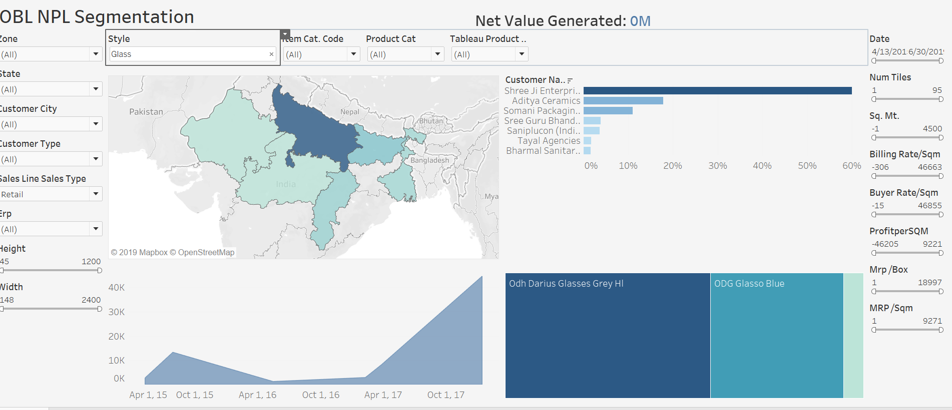

# New Product Launch Segmentation

### Overview

**Clustering** is the task of dividing the population or data points into a number of groups such that data points in the same groups are more similar to other data points in the same group and dissimilar to the data points in other groups.

### Architecture

### 

### Explanation

* Tableau was again used to cluster the population into categories
* These clusters can be selected separately one by one and viewed as per requirement
* We read the data into the tableau and then we have created visualizations that would help us in understanding the actionable insights needed to make an effective business decision
* Here all the visualizations are created using the tableau version 2019.3
* Tableau is a paid tool and to make effective use of it we will need to keep updating the versions and get the license for the same. If not we can make use of a Tableau reader just to open it and interact with it. Any version any platform no issues

### Sample of Screen shot from the component

