BLACKROCK FINANCIAL RISK ANALYSIS
Python & Jupyter Notebook Project Report
Financial Transaction Analysis, Customer Behavior and Risk Identification
Prepared by: Laxmi Dongre
Tools: Python, Jupyter Notebook, Pandas, NumPy, Matplotlib, SciPy


1. Executive Summary
This project analyzes transaction-level financial data to understand transaction patterns, customer and account behavior, financial segmentation, cash-flow behavior, overdrafts, large withdrawals, balance volatility, anomalies, and combined risk indicators. Python and Jupyter Notebook were used for data preparation, analysis, visualization, and statistical testing.
The dataset contains 192 accounts. Key findings include 172 inactive/dormant accounts (89.58%), 20 active accounts, 15 high-frequency low-balance accounts, 3 near-zero balance accounts, 54 large withdrawal transactions, 46 high-volatility accounts, 7 anomalous transactions, and 18 high-risk accounts.

2. Project Objective
- Analyze transaction patterns by type, month, and year.
- Understand account activity and customer financial behavior.
- Segment accounts by activity, balance, and transaction volume.
- Identify risky behavior such as overdrafts and frequent large withdrawals.
- Measure balance volatility and detect unusual transactions.
- Combine risk indicators to identify high-risk accounts.
- Apply statistical tests to validate important findings.
- Provide practical business recommendations.

3. Dataset Description
The dataset contains transaction-level information including TransactionID, CustomerID, AccountID, AccountType, TransactionType, Product, Firm, Region, Manager, TransactionDate, TransactionAmount, AccountBalance, RiskScore, CreditRating, TenureMonths, Year, Month, Month_Number, TransactionCategory, and TransactionMonth.
Category | Examples
Identifiers | TransactionID, CustomerID, AccountID
Transaction | TransactionType, TransactionAmount, TransactionDate
Account | AccountType, AccountBalance, TenureMonths
Risk | RiskScore, CreditRating
Business | Product, Firm, Region, Manager
Derived | Year, Month, TransactionCategory, TransactionMonth

4. Tools and Technologies
- Python – programming and analysis.
- Jupyter Notebook – interactive analysis and documentation.
- Pandas – cleaning, grouping, aggregation and pivot tables.
- NumPy – numerical calculations.
- Matplotlib – visualization.
- SciPy – hypothesis testing and correlation.

5. Data Preparation
The data was inspected for structure and data types. Transaction dates were converted to datetime format. Transaction categories were used to distinguish Credit, Debit, and Transfer activity. Transaction Month and Year fields supported time-based analysis. Credit and debit amount fields were prepared for account-level calculations.
- Checked column names and data types.
- Converted TransactionDate to datetime.
- Created monthly and yearly analysis fields.
- Separated credit and debit amounts.
- Prepared account-level summary tables.

6. Task 2 – Transaction Analysis

6.1 Monthly Transaction Analysis
Monthly Credit, Debit, Transfer, and Net_Transaction values were calculated. The analysis showed that debit activity was generally higher than credit activity across many months. The monthly trend helps identify periods of higher outflow and supports cash-flow monitoring.
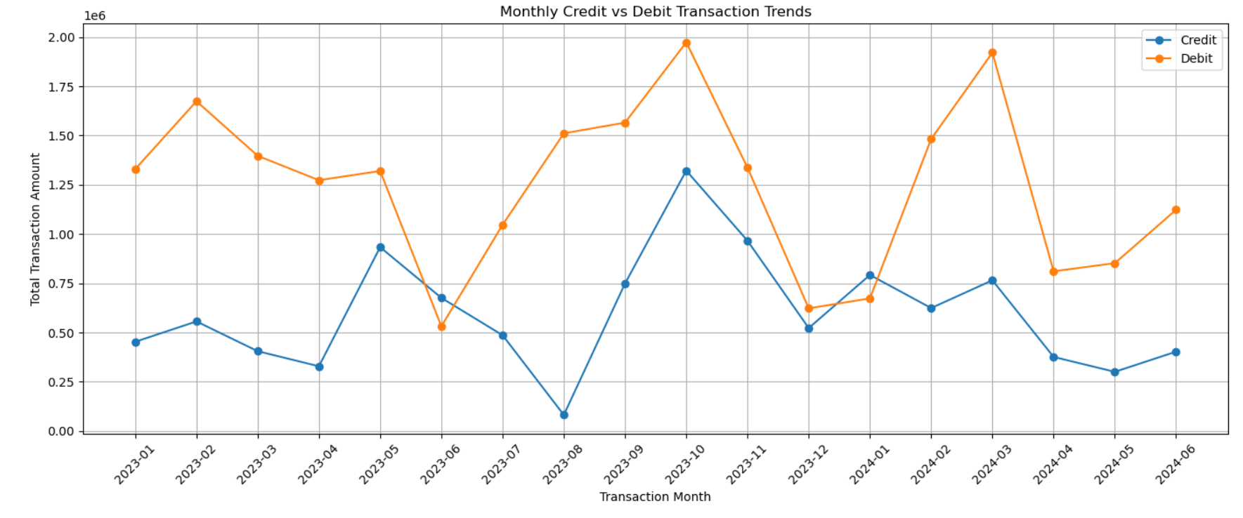

6.2 Yearly Transaction Analysis
Year | Credit | Debit | Transfer | Net Transaction
2023 | 7,482,764 | 15,584,570 | 7,407,147 | -8,101,805
2024 | 3,262,322 | 6,863,625 | 3,001,066 | -3,601,303
Debit activity was substantially higher than credit activity in both analyzed years. The negative net transaction values describe the transaction position represented in the dataset and should not be interpreted as company profit or loss.
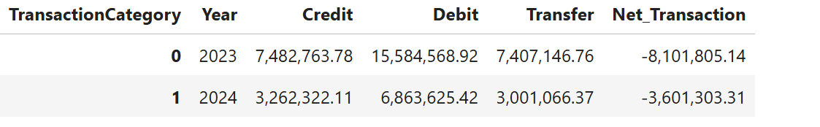

7. Task 3 – Customer and Account Behavior

7.1 Account Activity Status
Category | Accounts | Percentage
Active | 20 | 10.42%
Inactive/Dormant | 172 | 89.58%
Total | 192 | 100%
The high proportion of inactive or dormant accounts is a major customer-engagement finding. Targeted reactivation campaigns could improve account engagement.

7.2 Activity-Level Segmentation
Activity Level | Account Count | Percentage
High | 45 | 23.44%
Medium | 68 | 35.42%
Low | 79 | 41.15%
Accounts were grouped into High, Medium, and Low activity based on transaction frequency. Low-activity accounts formed the largest group.

7.3 Financial Segmentation
High Balance was defined as Average Balance ≥ 85,165.73 and High Volume as Total Transaction Volume ≥ 295,923.08. These thresholds are the 75th-percentile values from the account summary.
Financial Segment | Accounts | Percentage
Low Balance - Low Volume | 105 | 54.69%
Low Balance - High Volume | 39 | 20.31%
High Balance - Low Volume | 39 | 20.31%
High Balance - High Volume | 9 | 4.69%
The largest segment is Low Balance–Low Volume. Only 9 accounts are High Balance–High Volume, making this a small but potentially valuable segment.

7.4 Net Inflow Analysis
Net inflow was calculated as total credit minus total debit. Mean net inflow was -60,953.69, median -54,384.92, minimum -395,419.95, and maximum 284,230.60. The negative average indicates that debit activity exceeded credit activity for many accounts.

7.5 High-Frequency Low-Balance Accounts
15 accounts were identified, representing 7.81% of all accounts. Their mean balance was approximately 55,698.76 and mean transaction frequency was approximately 6.87. These accounts may require monitoring because frequent activity is combined with relatively low balances.

7.6 Near-Zero Balance Accounts
Three accounts were identified as near-zero balance accounts, representing 1.56% of all accounts. Their mean balance was approximately 25,201.00.

8. Task 4 – Financial Risk Analysis

8.1 Large Withdrawals
54 large withdrawal transactions were identified. Eight accounts were classified as having frequent large withdrawals. Frequent high-value withdrawals can require additional review because they may affect liquidity or indicate unusual behavior.

8.2 Overdraft Incidents
17 accounts showed at least one negative-balance incident. ACC78589 recorded two incidents, while the other identified accounts recorded one incident each.

8.3 Balance Volatility
Balance volatility was measured using standard deviation and coefficient of variation. 46 accounts were flagged as high-volatility accounts, representing 23.96% of all accounts. ACC78589 had the highest observed coefficient of variation at approximately 2.52.

8.4 Anomaly Detection
The IQR method was applied to transaction amounts. Q1 was 34,600.68, Q3 was 73,485.55, IQR was 38,884.87, lower limit was -23,726.62, and upper limit was 131,812.85. Seven transactions were identified as anomalous. These should be reviewed rather than automatically treated as fraudulent.

8.5 Combined High-Risk Accounts
Multiple risk indicators were combined into Risk_Flag_Count, including high net inflow, frequent large withdrawals, high volatility, and overdraft behavior. 18 accounts were classified as high-risk. ACC94907 had the highest Risk_Flag_Count of 3.

9. Task 5 – Data Visualization
- Monthly Credit vs Debit Trend.
- Yearly Credit vs Debit Comparison.
- Activity Level Distribution.
- Financial Segment Distribution.
- Top 10 High Net Inflow Accounts.
- High-Risk Customer Chart.
- Transaction Amount Box Plot.
- Balance Volatility Distribution.
- Dormant vs Active Accounts.
- Transaction Type Distribution.

10. Task 6 – Statistical Analysis

10.1 Deposit vs Withdrawal T-Test
An independent two-sample t-test compared deposit and withdrawal transaction amounts. T-statistic = 2.1382 and p-value = 0.0331. Since p < 0.05, the null hypothesis was rejected. There is statistically significant evidence of a difference between average deposit and withdrawal transaction amounts.

10.2 Account Balance vs Transaction Amount Correlation
Pearson correlation produced r = -0.0752 and p = 0.0335. Since p < 0.05, the relationship is statistically significant under the selected test. However, the correlation magnitude is extremely small and negative, indicating a very weak practical relationship. Account balance alone is not a strong predictor of transaction amount.

11. Key Findings
- 89.58% of accounts were inactive or dormant.
- Debit activity was substantially higher than credit activity in both analyzed years.
- 105 accounts were Low Balance–Low Volume.
- 15 accounts were high-frequency and low-balance.
- 3 accounts had near-zero balances.
- 54 large withdrawal transactions were identified.
- 17 accounts showed overdraft incidents.
- 46 accounts were flagged for high balance volatility.
- 7 anomalous transactions were identified using IQR.
- 18 accounts were classified as high-risk.

12. Business Recommendations
- Monitor accounts with multiple risk flags rather than relying on a single indicator.
- Review frequent large withdrawals for expected customer behavior.
- Monitor overdraft-prone accounts and consider suitable alerts.
- Review high-volatility accounts for unusual balance movements.
- Investigate anomalous transactions through normal review procedures.
- Develop targeted engagement campaigns for 172 dormant/inactive accounts.
- Create a monitoring dashboard for high-risk accounts, outflows, anomalies, and activity.
- Use customer segmentation to tailor strategies for different account groups.

13. Conclusion
The project demonstrates how Python-based financial analytics can transform transaction-level data into actionable risk insights. The analysis identified widespread account inactivity, debit-heavy transaction behavior, multiple forms of financial risk, unusual transactions, and a set of high-risk accounts. These findings can support focused monitoring, customer engagement, liquidity awareness, and risk-management decisions.

14. Video Link: - https://www.loom.com/share/014f067de73e42f985248ff33e191afe

