DHL LOGISTICS OPTIMIZATION FOR DELIVERY ROUTES
Prepared Using: MySQL Workbench 8.0

Table of Contents
1. Project Overview
2. Project Objectives
3. Dataset Description
4. Task 1 – Data Cleaning & Preparation
5. Task 2 – Delivery Delay Analysis
6. Task 3 – Route Optimization
7. Task 4 – Warehouse Performance
8. Task 5 – Delivery Agent Performance
9. Task 6 – Shipment Tracking Analytics
10. Task 7 – Advanced KPI Reporting
11. Overall Findings
12. Business Recommendations
13. Conclusion

1. Project Overview
This project analyzes DHL logistics operations using SQL to identify shipment delays, optimize delivery routes, evaluate warehouse and delivery agent performance, and generate key performance indicators (KPIs) for operational improvement. The analysis supports data-driven decisions that can improve service reliability, delivery efficiency, and cost management.

2. Project Objectives
- Analyze shipment delay patterns and operational bottlenecks.
- Optimize delivery routes using transit-time and efficiency measures.
- Evaluate warehouse performance and identify locations requiring operational improvement.
- Measure delivery agent performance using on-time delivery and service indicators.
- Generate logistics KPIs for management monitoring.
- Recommend practical improvements to strengthen on-time delivery and cost efficiency.

3. Dataset Description
The project uses five relational datasets: Orders, Routes, Warehouses, Delivery Agents, and Shipments. Together, these tables provide order-level, route-level, warehouse-level, agent-level, and shipment-tracking information required for logistics analysis.
Orders: Contains order-level delivery details such as order date, route, warehouse, order amount, delivery type, and payment mode.
Routes: Contains source and destination locations, countries, distance, and expected average transit time.
Warehouses: Contains warehouse locations, daily capacity, and manager information.
Delivery Agents: Contains agent details including assigned zone, experience, and customer rating.
Shipments: Contains pickup and delivery dates, delivery status, delay hours, feedback, and operational tracking information.
This project analyzes DHL logistics operations using SQL to identify shipment delays, optimize delivery routes, evaluate warehouse and delivery agent performance, and generate KPIs for operational improvement.

Task 1: Data Cleaning & Preparation

Objective
Cleaned duplicate records, validated dates, handled missing values, and checked referential integrity.

Explanation
The SQL queries for this task were executed successfully in MySQL Workbench. The results were used to evaluate logistics performance and identify operational bottlenecks.

Business Insight
The database was successfully cleaned and validated, improving data quality for analysis.

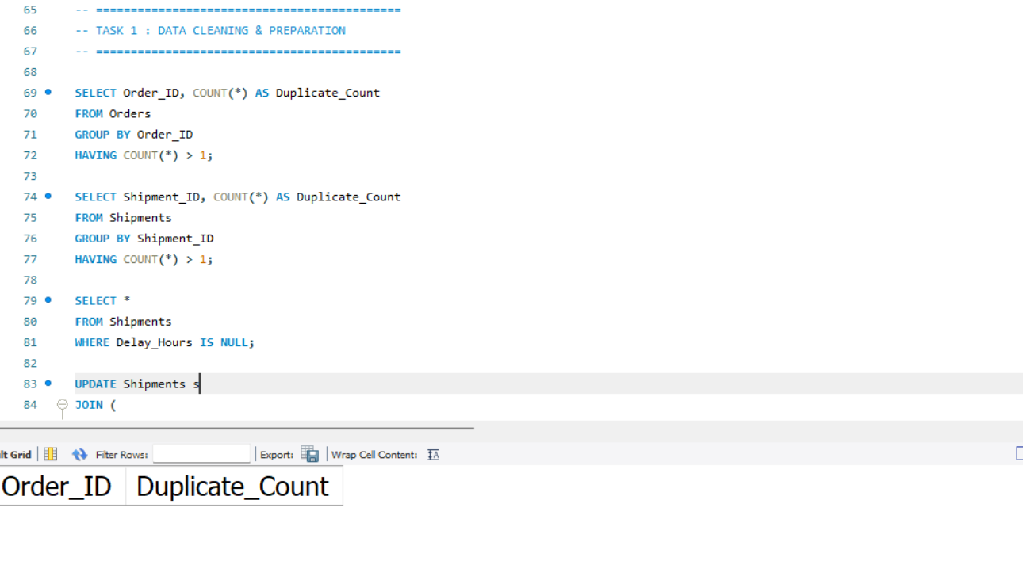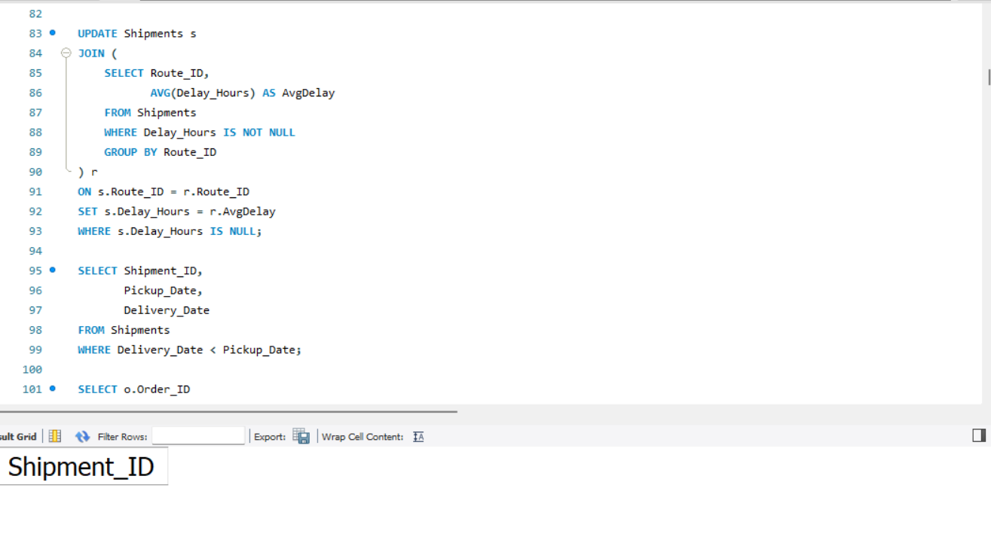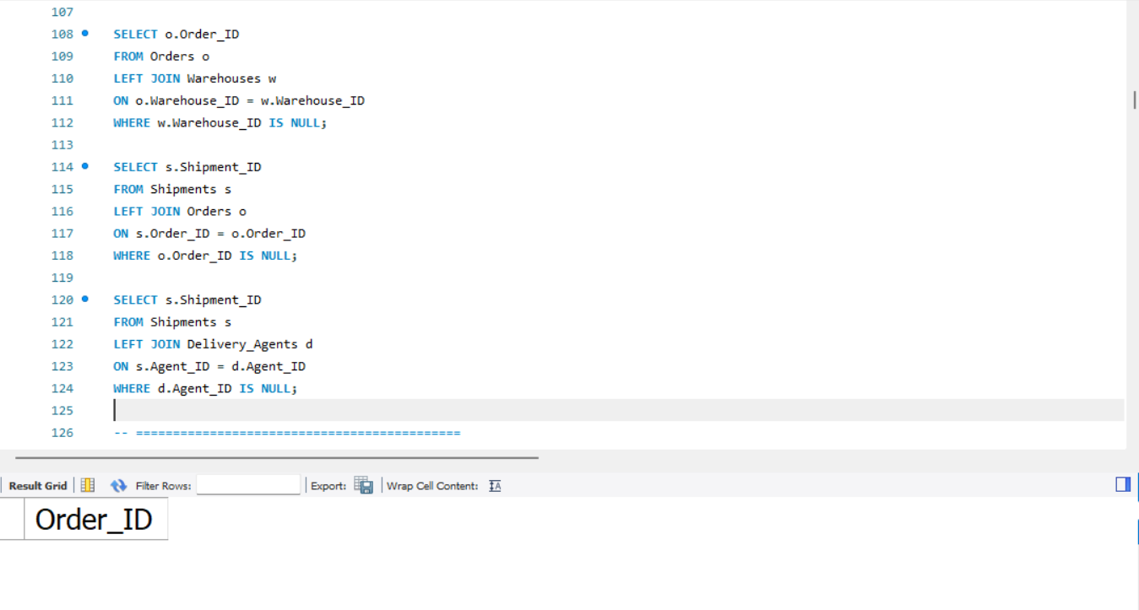Task 2: Delivery Delay Analysis

Objective
Calculated shipment duration, ranked delayed routes and compared Express vs Standard deliveries.

Explanation
The SQL queries for this task were executed successfully in MySQL Workbench. The results were used to evaluate logistics performance and identify operational bottlenecks.

Business Insight
Delay analysis highlighted high-delay routes requiring operational attention.
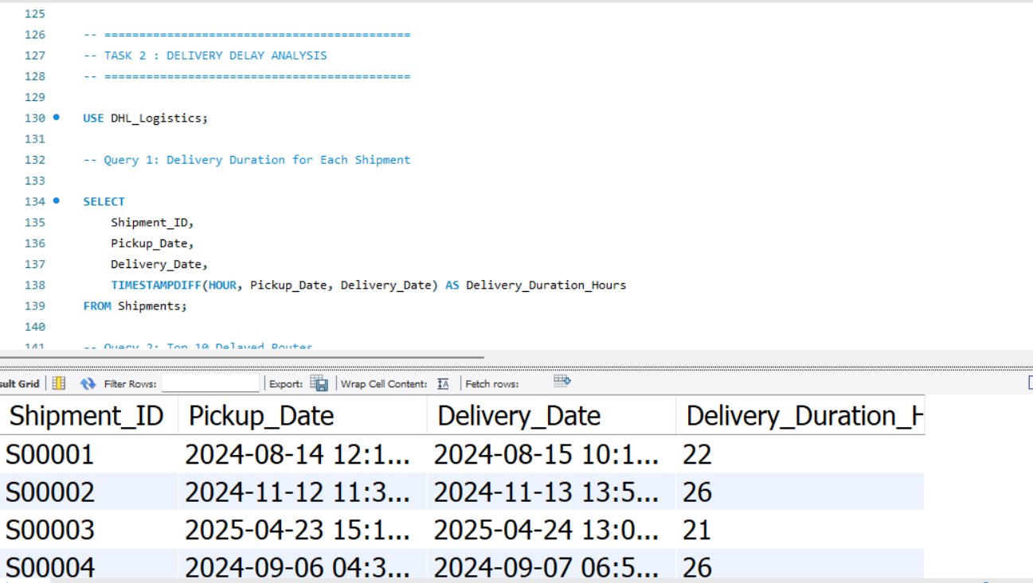
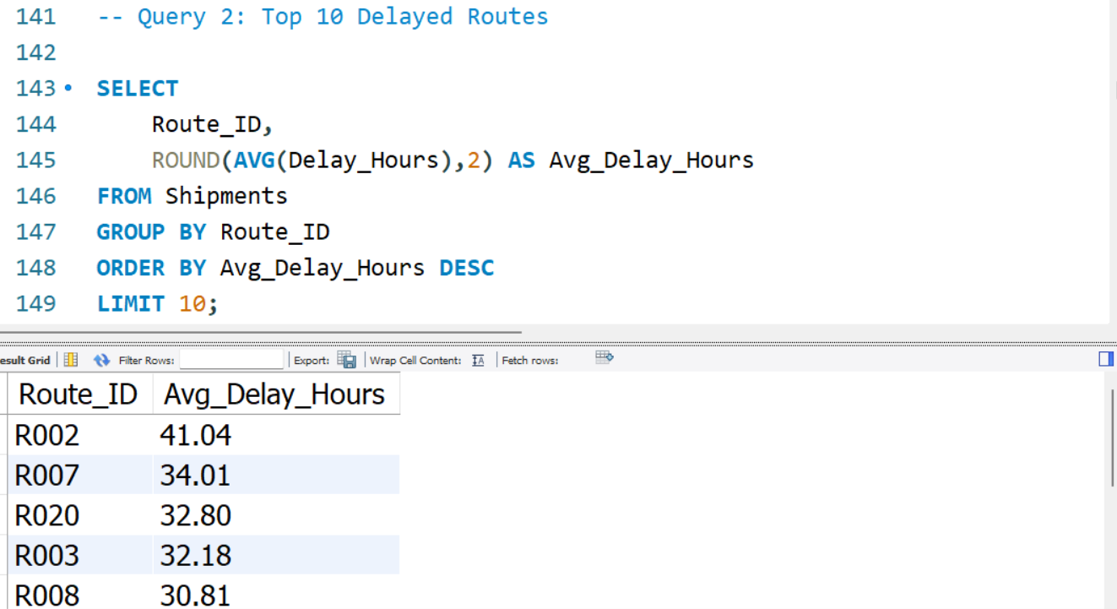

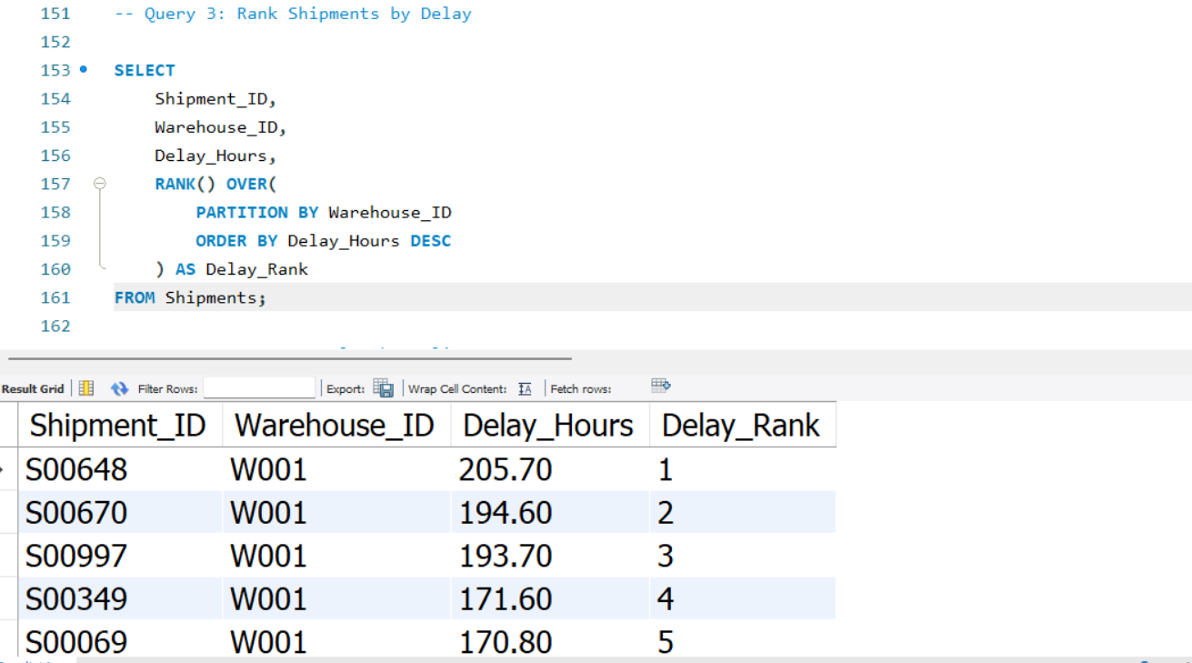
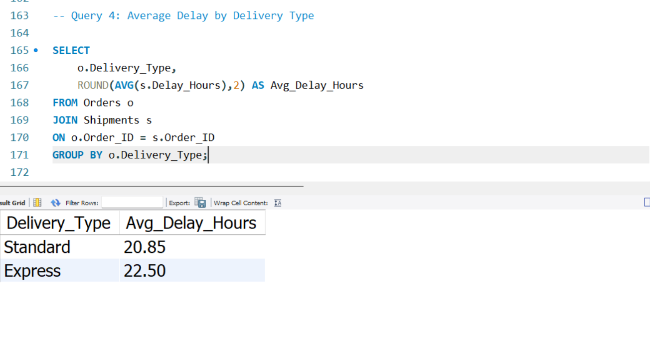
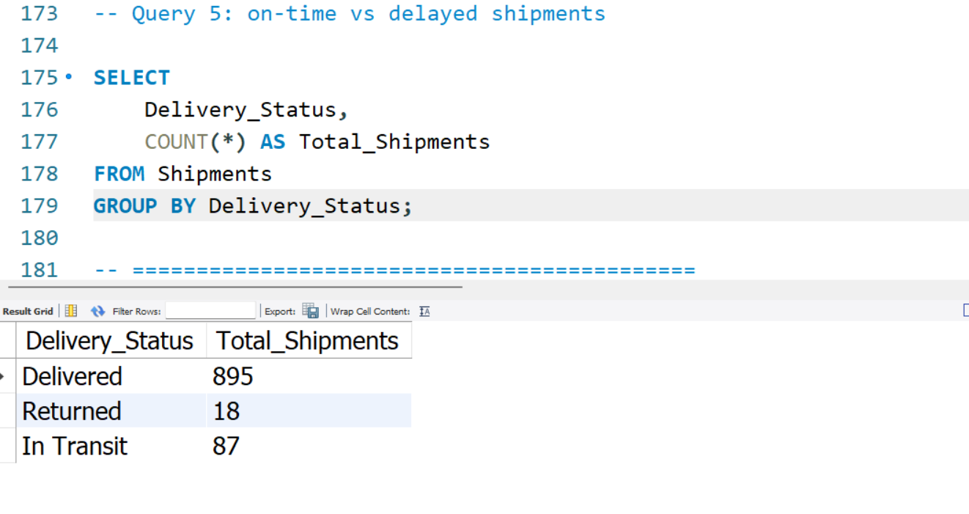

Task 3: Route Optimization

Objective
Measured transit time, efficiency ratio, worst-performing routes and delayed shipment percentage.

Explanation
The SQL queries for this task were executed successfully in MySQL Workbench. The results were used to evaluate logistics performance and identify operational bottlenecks.

Business Insight
Low-efficiency routes should be redesigned and monitored.

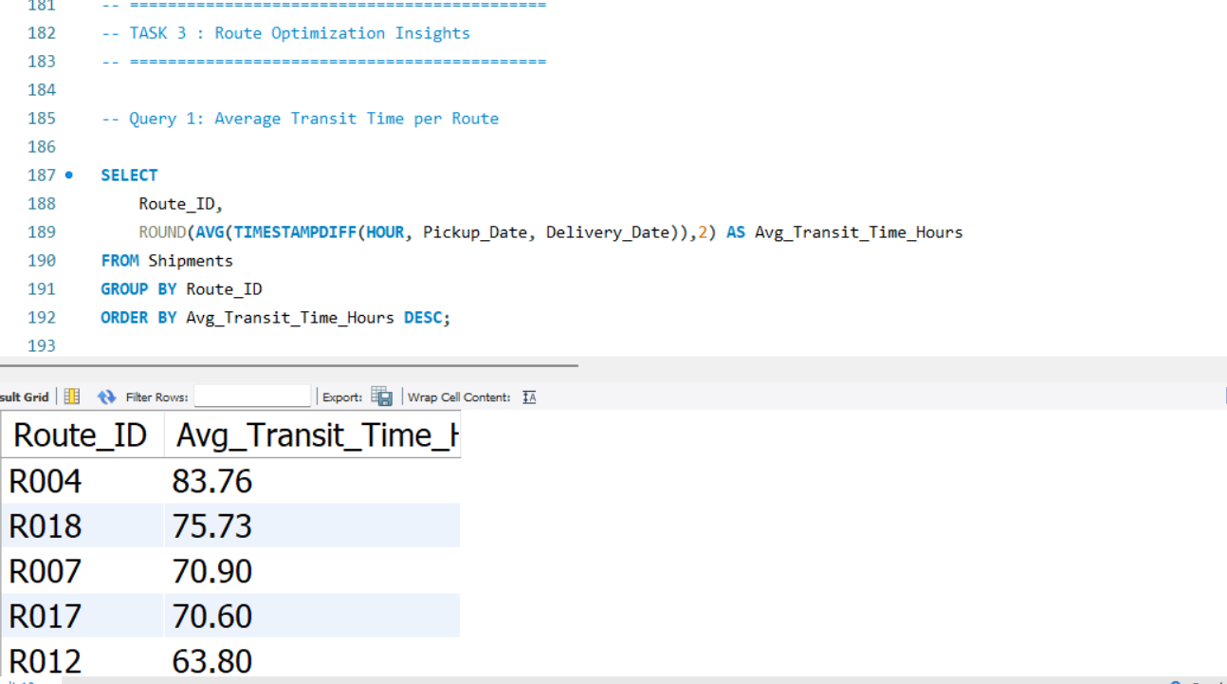

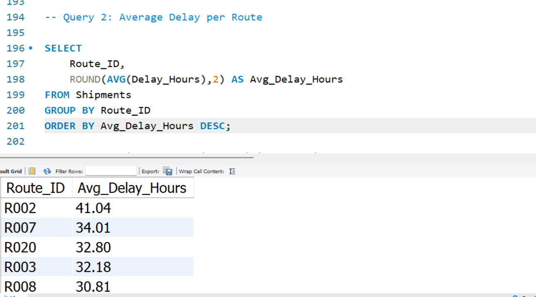

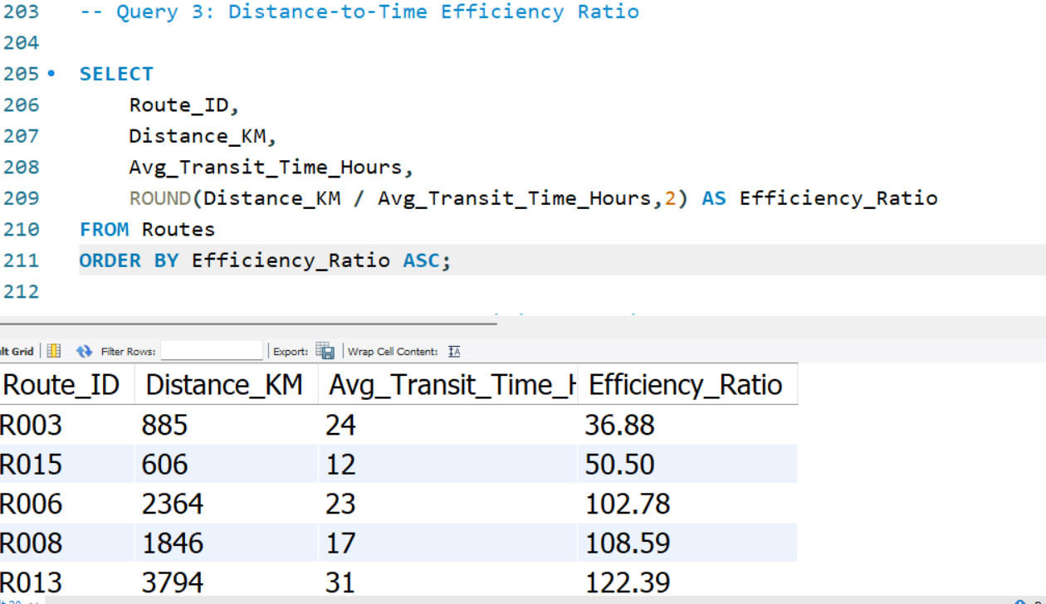

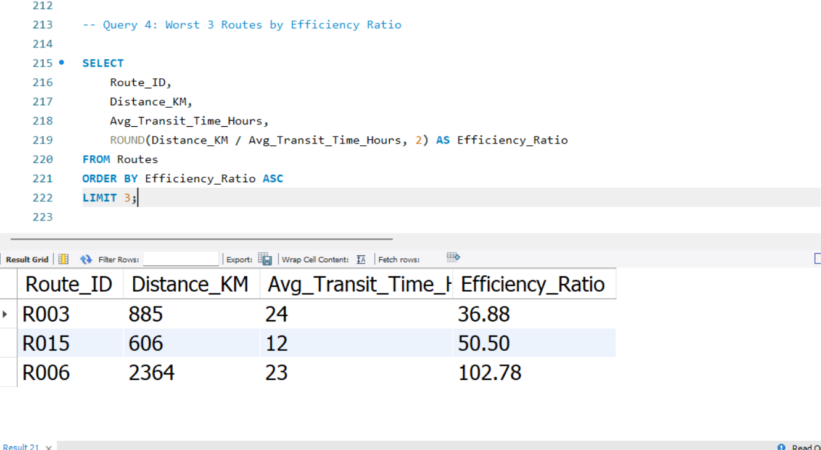

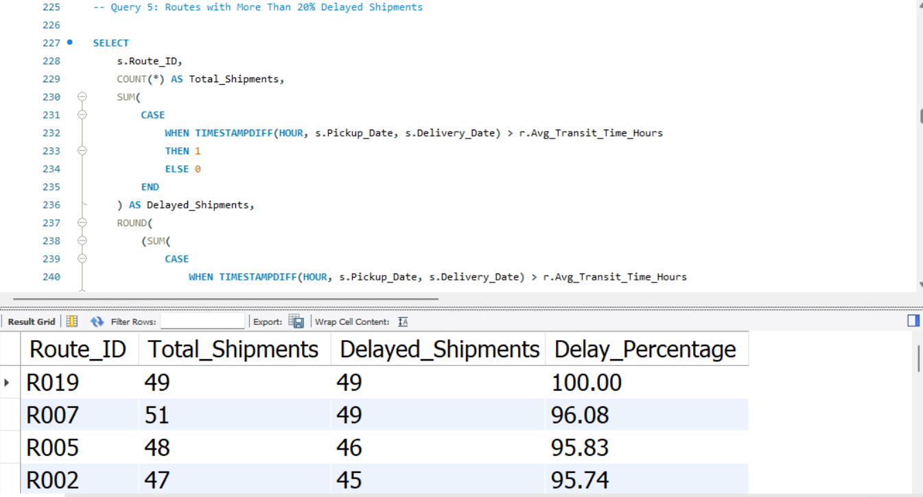

Task 4: Warehouse Performance

Objective
Compared warehouse delays, delayed shipments and on-time rankings.

Explanation
The SQL queries for this task were executed successfully in MySQL Workbench. The results were used to evaluate logistics performance and identify operational bottlenecks.

Business Insight
Certain warehouses consistently exceeded the global average delay and require process optimization.
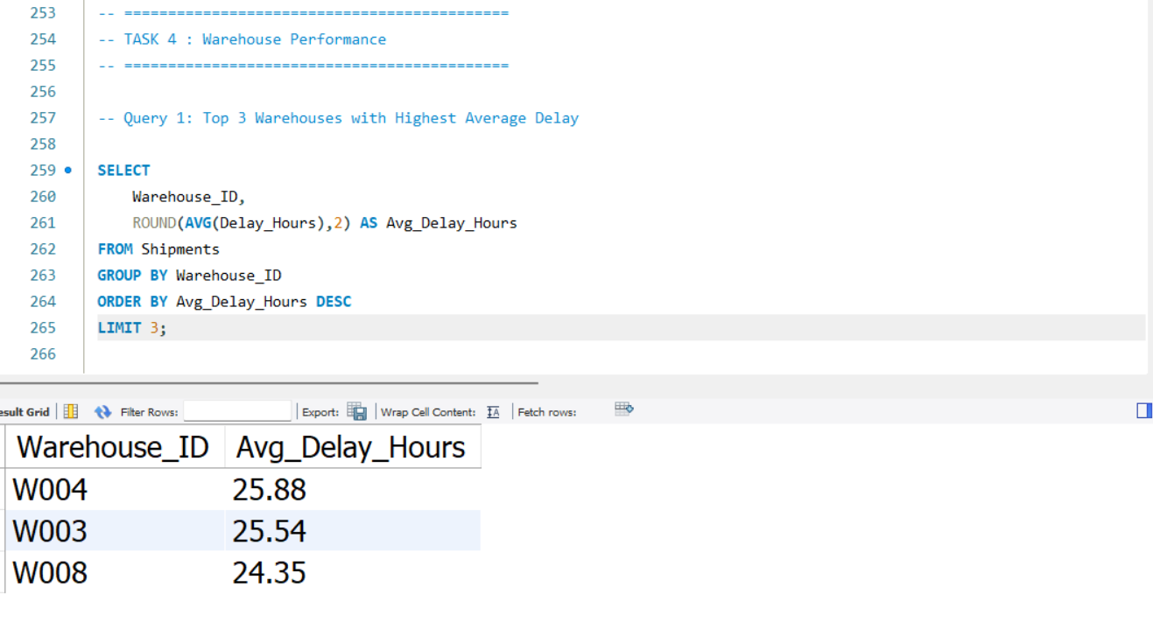

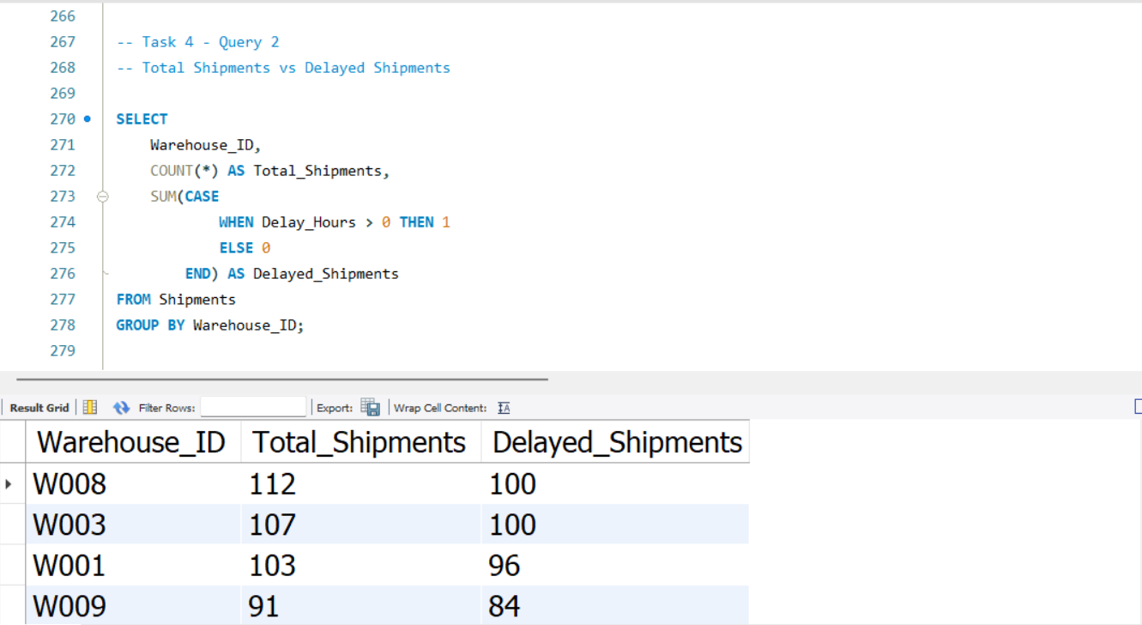

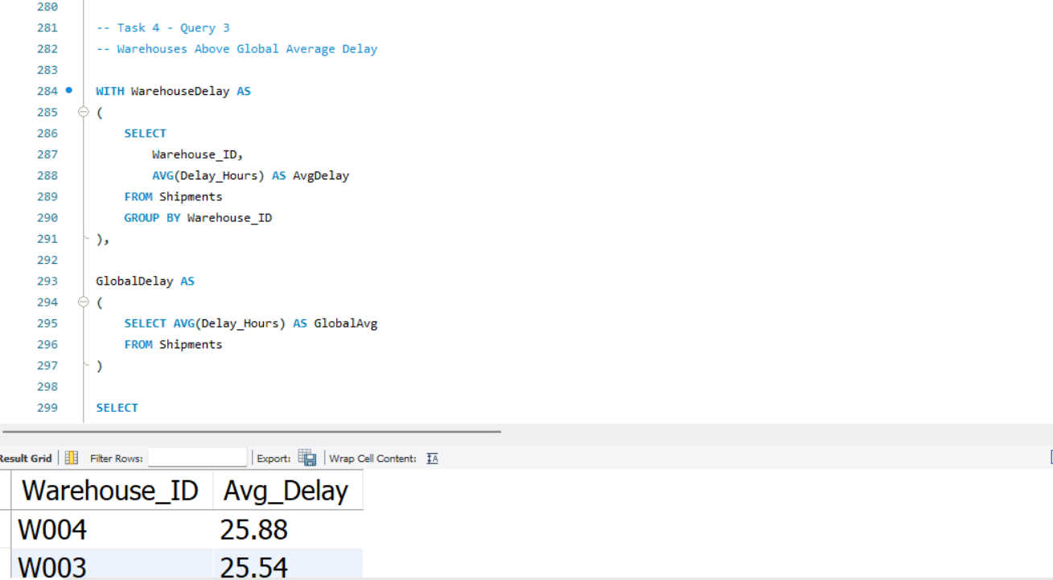

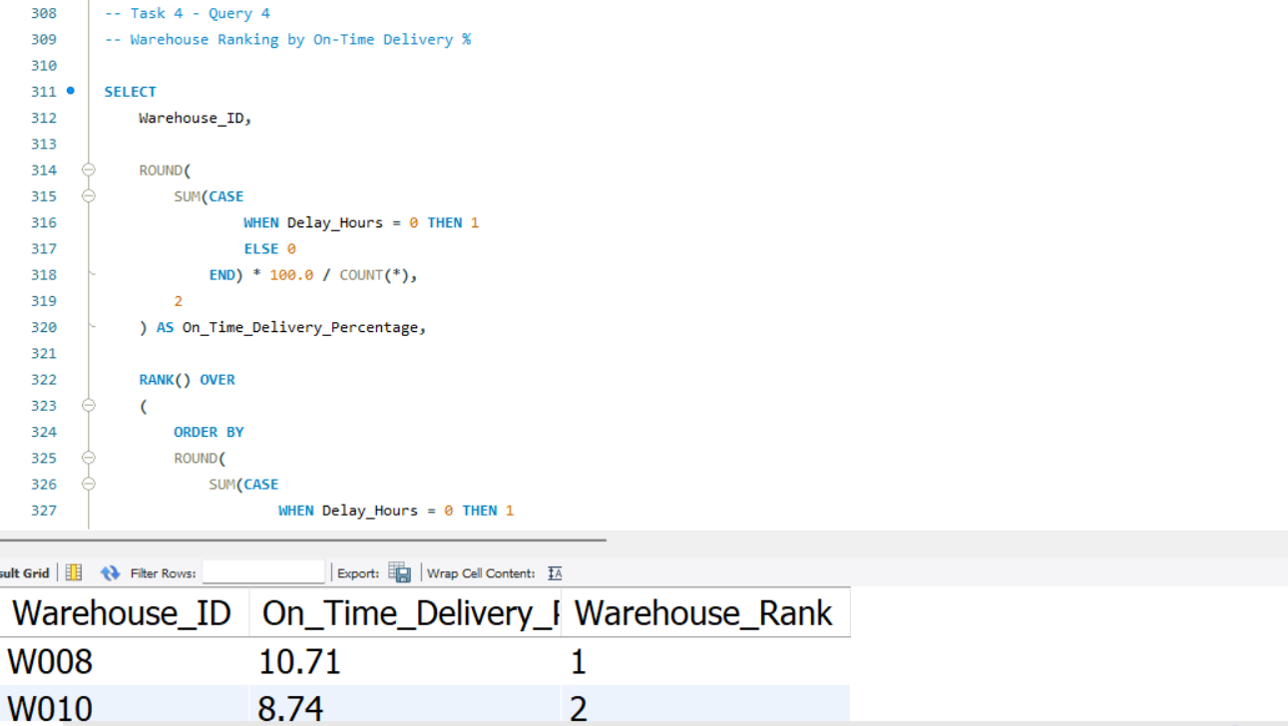

Task 5: Delivery Agent Performance

Objective
Ranked agents by on-time percentage and compared ratings and experience.

Explanation
The SQL queries for this task were executed successfully in MySQL Workbench. The results were used to evaluate logistics performance and identify operational bottlenecks.

Business Insight
Low-performing agents require training while top performers can be used as benchmarks.
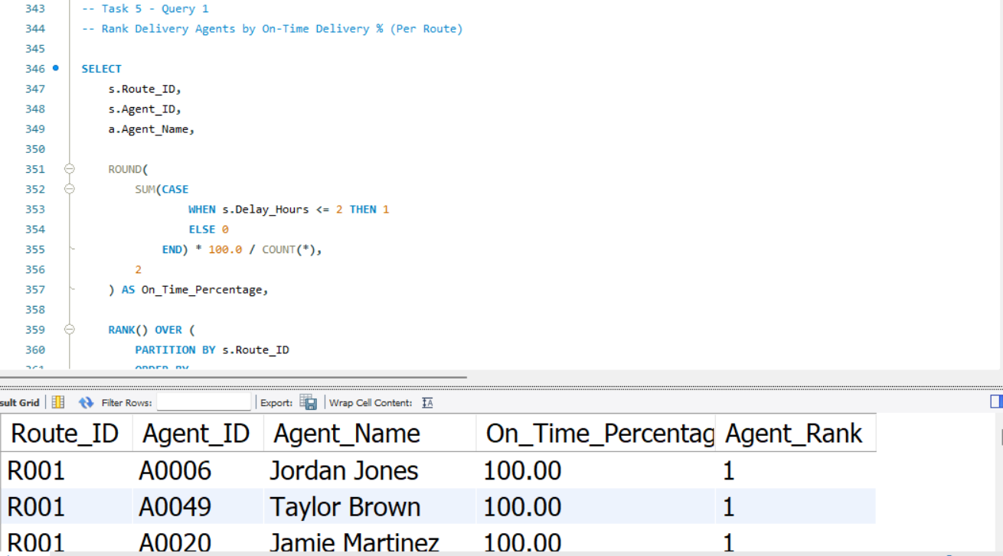

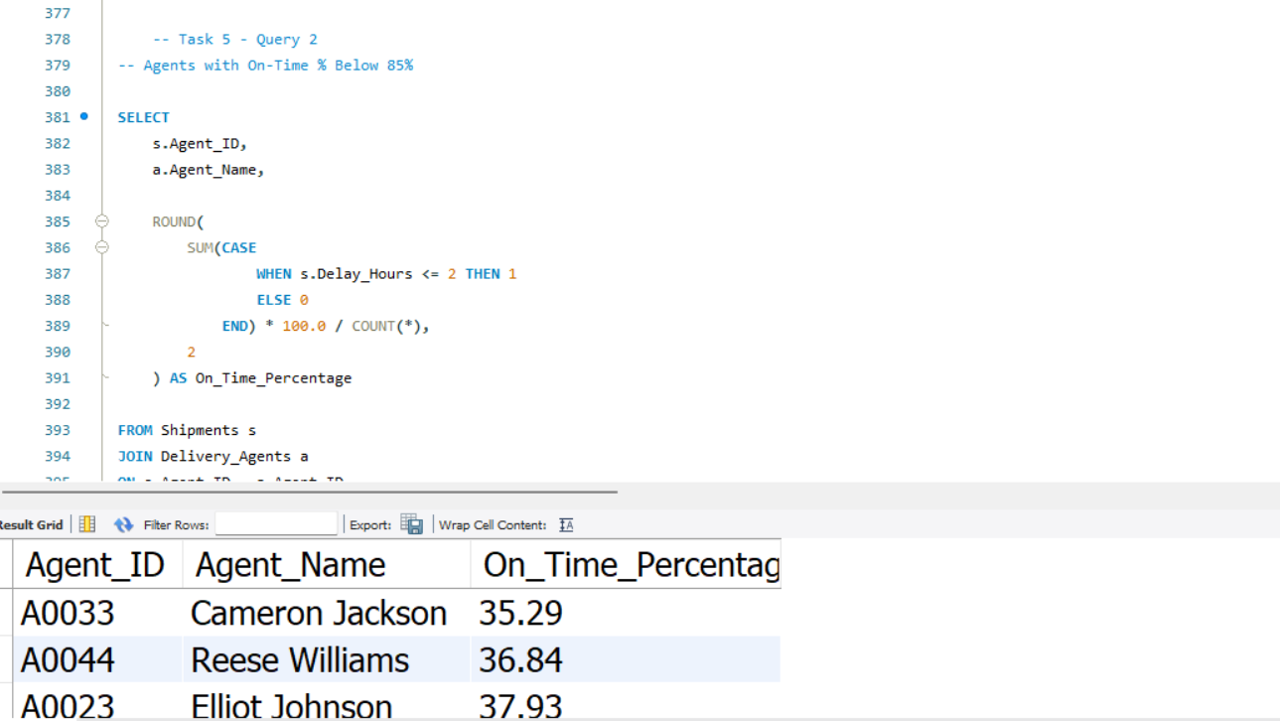

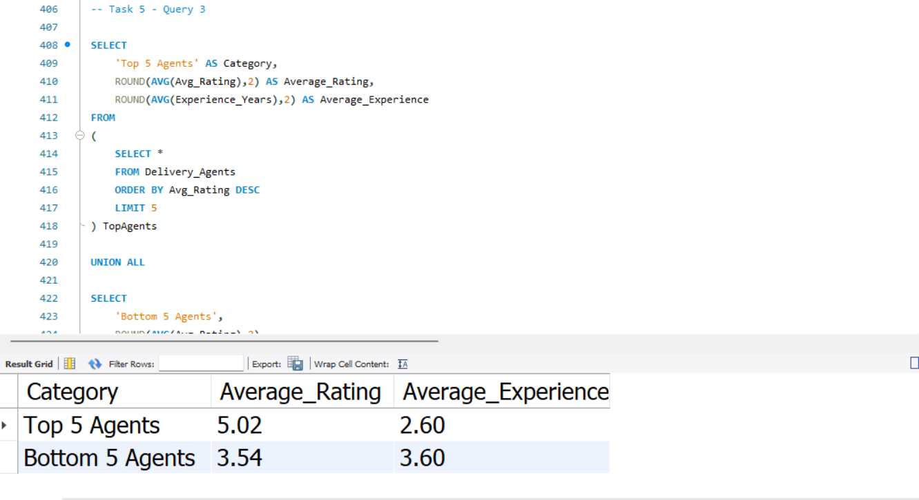

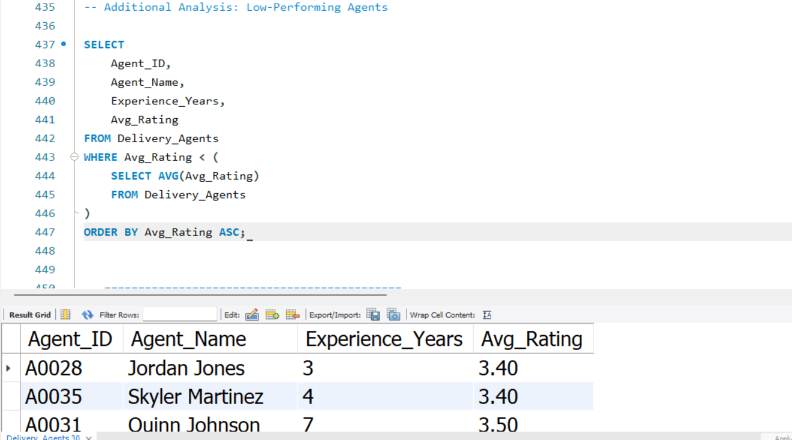

Task 6: Shipment Tracking Analytics

Objective
Analyzed shipment status, in-transit routes and highly delayed shipments.

Explanation
The SQL queries for this task were executed successfully in MySQL Workbench. The results were used to evaluate logistics performance and identify operational bottlenecks.

Business Insight
Routes with many in-transit shipments should be monitored closely.
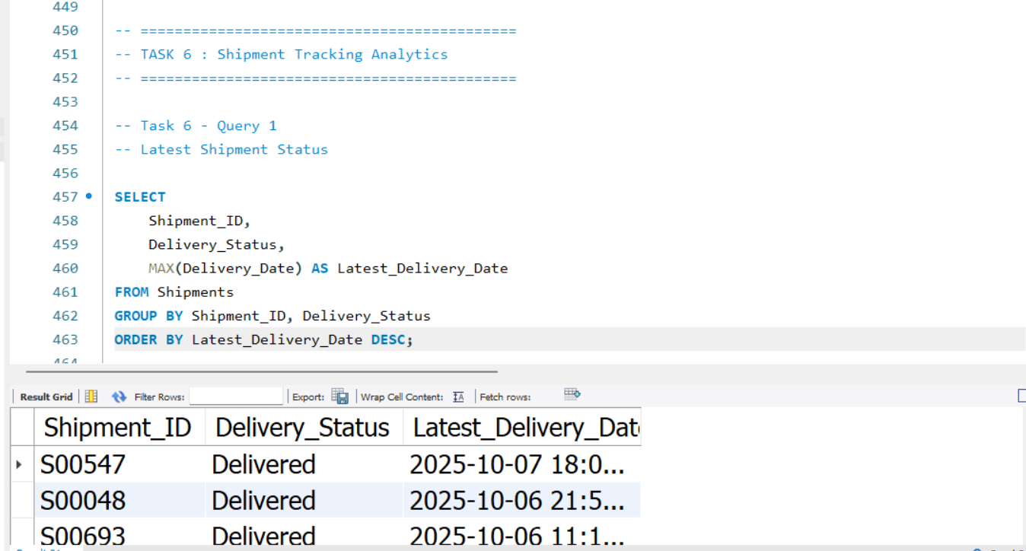

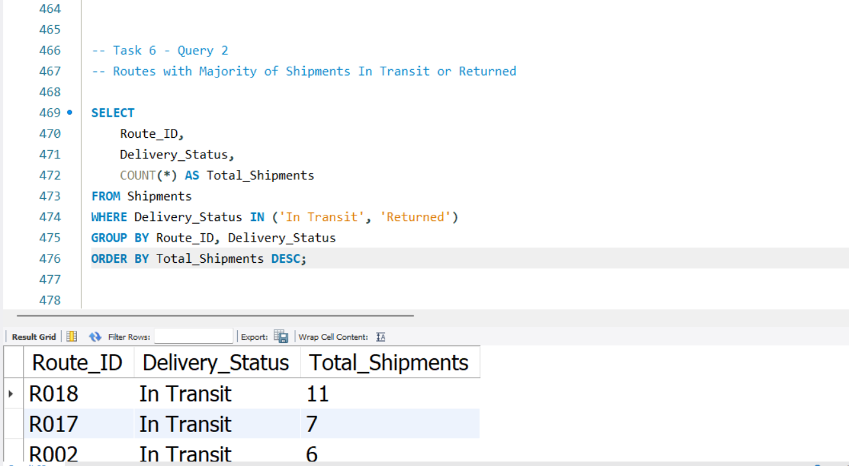

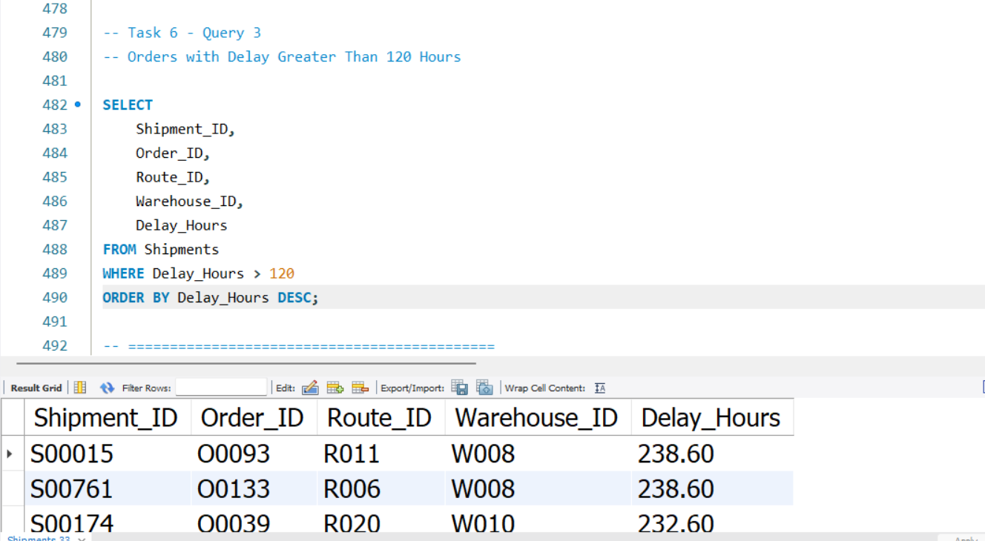

Task 7: KPI Reporting

Objective
Calculated delivery delay by country, on-time percentage, average route delay and warehouse utilization.

Explanation
The SQL queries for this task were executed successfully in MySQL Workbench. The results were used to evaluate logistics performance and identify operational bottlenecks.

Business Insight
KPIs provide management with a quick overview of logistics performance.

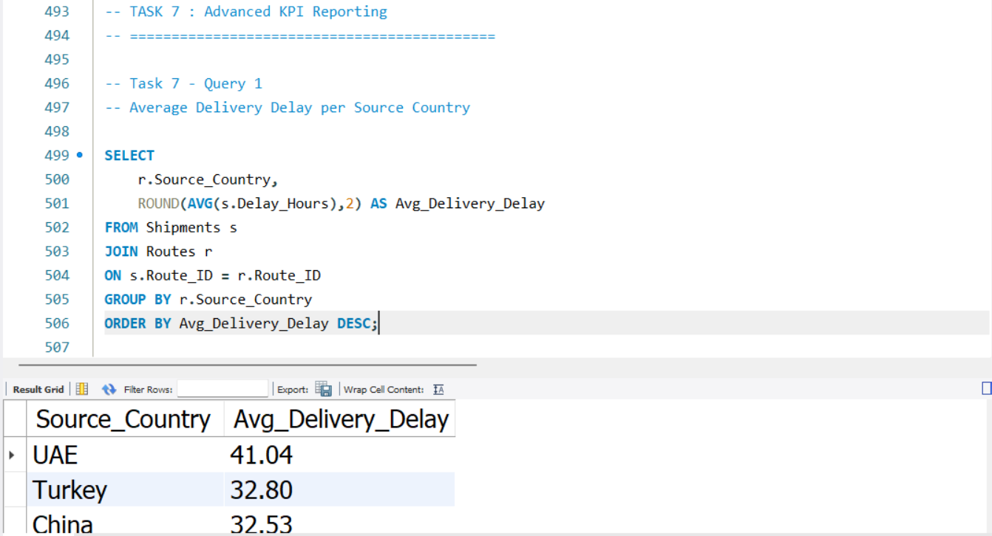

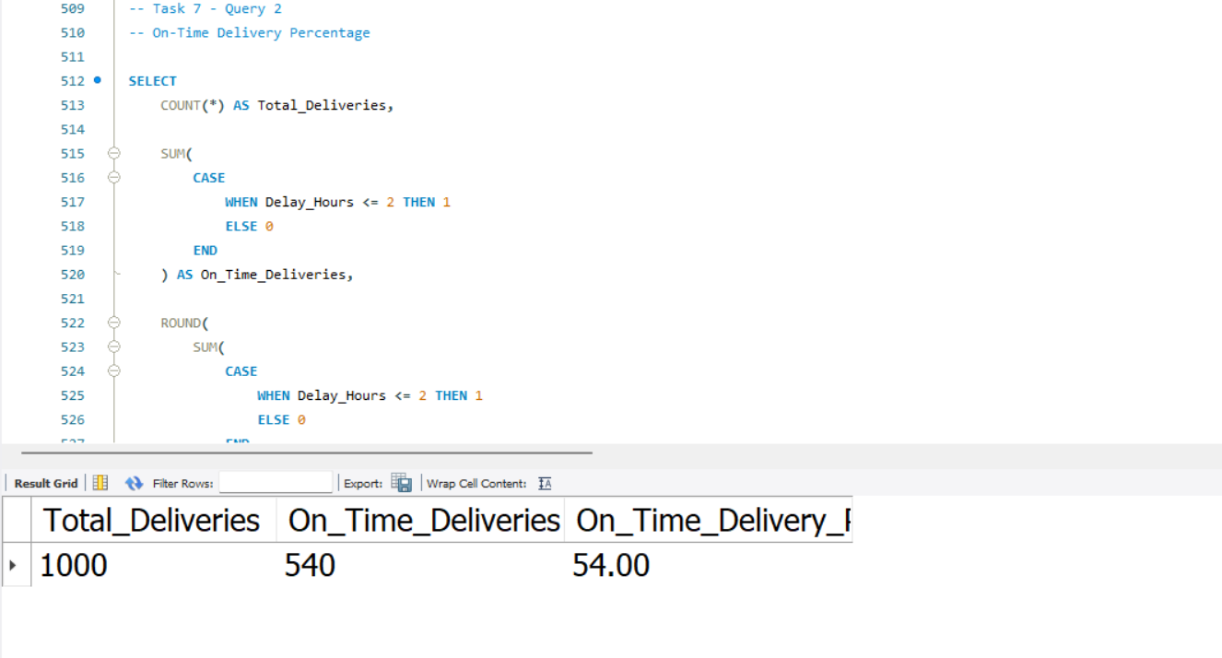
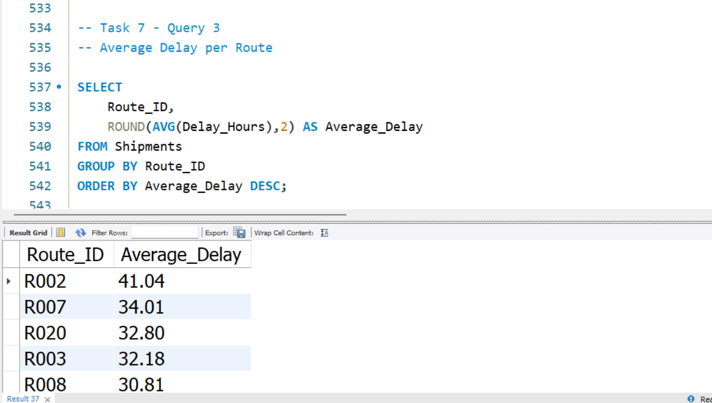

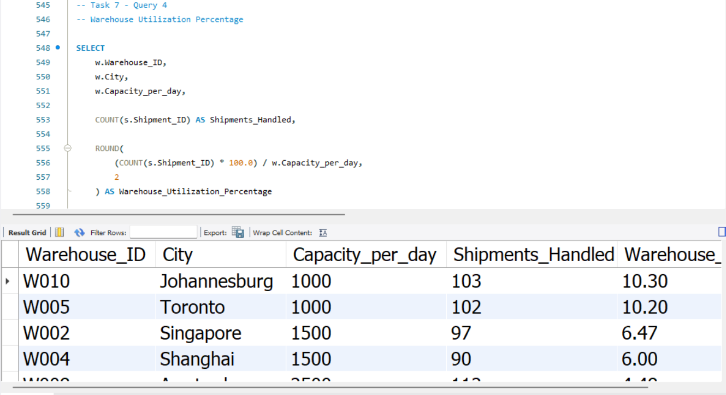

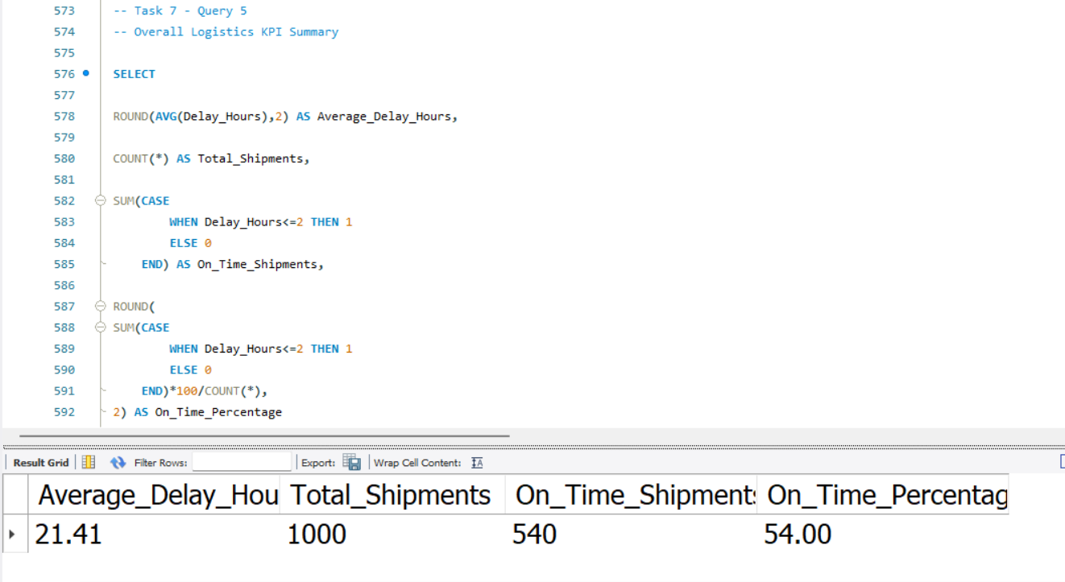

Overall Recommendations
• Optimize high-delay routes.
• Improve warehouse scheduling and staffing.
• Monitor delivery agents with on-time performance below target.
• Use predictive analytics for route planning.
• Improve customs coordination and shipment visibility.
• Track KPIs regularly using SQL dashboards.

Conclusion
SQL analysis successfully identified delivery delays, inefficient routes, warehouse bottlenecks and agent performance issues. Implementing the recommendations can improve on-time delivery, reduce operational costs and increase customer satisfaction.

Overall Findings
The SQL analysis provides a structured view of DHL logistics performance across data quality, delivery delays, route efficiency, warehouse operations, delivery agents, shipment status, and KPIs. The combined findings indicate that operational improvements should focus on delay-prone routes, warehouse processes, agent performance, shipment visibility, and regular KPI monitoring.

Business Recommendations
- Optimize high-delay routes by reviewing transit patterns, route schedules, and hub combinations.
- Improve warehouse scheduling and staffing, especially at locations with consistently high average delays.
- Monitor delivery agents whose on-time performance falls below the target and provide targeted training or workload balancing.
- Use predictive analytics and historical delay patterns to anticipate potential disruptions and proactively reroute shipments.
- Improve customs coordination and shipment visibility for international deliveries to reduce avoidable bottlenecks.
- Track logistics KPIs regularly through SQL-based reporting or dashboards to support continuous operational improvement.

Conclusion
The SQL-driven logistics analytics project demonstrates how structured operational data can be transformed into actionable insights for DHL. By identifying delivery delays, inefficient routes, warehouse bottlenecks, and differences in delivery agent performance, the analysis supports targeted operational improvements. Implementing the recommendations can help strengthen on-time delivery, reduce unnecessary costs, improve shipment visibility, and enhance customer satisfaction.

