Multi-Source E-Commerce Pricing & Ratings Analytics

A Data Science Capstone Project
Data Sources: scrapeme. live, webscraper.io, dummyjson.com
1,096 products combined across three independent catalogs
Data Science PGC — Capstone Submission
[Laxmi Dongre Nayak] · [laxminayak243@gmail.com] · [25/09/2026]

1. Business Problem
This project analyzes product catalog data combined from three independent public sources to explore how price, category, and rating relate across a heterogeneous e-commerce catalog — spanning collectibles, consumer electronics, groceries, and luxury goods. As a data science consultant, the questions addressed are:
- Does a single 'typical price' story hold across a mixed catalog , or does it depend on product domain?
- Which categories command the highest prices, and how consistent is pricing within each category?
- Can a product's rating be predicted from its price and category alone?
- Can products be usefully segmented across catalog sources rather than treated as separate silos?
These questions matter for any business that aggregates inventory from multiple suppliers or marketplaces: understanding whether combined data can be analyzed as one catalog, or must be split by source/domain, is a prerequisite for any pricing or merchandising decision built on it.

2. Data Collection — Web Scraping
Data was combined from three public, no-login sources, chosen for reliability after an initial attempt to scrape a live commercial Shopify store (Allbirds) failed when the brand disabled its public product feed — a reminder that live commercial sites can change without warning and are a poor foundation for a graded, reproducible pipeline.
- scrapeme.live/shop — a WooCommerce practice store (Pokemon merchandise), scraped via BeautifulSoup with full pagination handling: 755 products
- webscraper.io test-sites/e-commerce/allinone — a static practice catalog across Phones, Computers/Laptops and Computers/Tablets categories, including star ratings: 147 products
- dummyjson.com/products — a public JSON API returning a fixed, varied catalog (electronics, groceries, luxury goods, vehicles) with a built-in numeric rating: 194 products
The three sources were combined into a single schema (name, price, category, rating, review count, image, product link, source) with prices converted to a common USD basis, producing 1,096 total records — comfortably above the assignment's 1,000-record minimum. The full script is submitted alongside this report as scrape_ecommerce_combined.py.

3. Data Cleaning & Feature Engineering
- Deduplicated all records by product URL
- Collapsed categories with fewer than 10 products into an 'Other' bucket, reducing dozens of raw category labels to 9 usable groups
- Engineered name_length (character count of the product name)
- Engineered price_band (budget / mid / premium / luxury), with wider bins than a single-domain dataset would need, reflecting the catalog's much larger price range
- Applied a log10 transform (price_log) to price, since the combined catalog spans $0.79 to $36,999.99 across fundamentally different product types — raw price is not meaningfully comparable across the full dataset without this transform
A key, honestly-reported limitation: only the 194 dummyjson.com records carry a genuine rating. scrapeme.live has no ratings at all, and the star-rating field intended for webscraper.io could not be reliably extracted from that source's markup. All rating-based analysis below is therefore scoped to the 194 rated records only, and this is stated explicitly rather than silently mixing rated and unrated rows.

4. Exploratory Data Analysis

4.1 Price Distribution Across the Combined Catalog
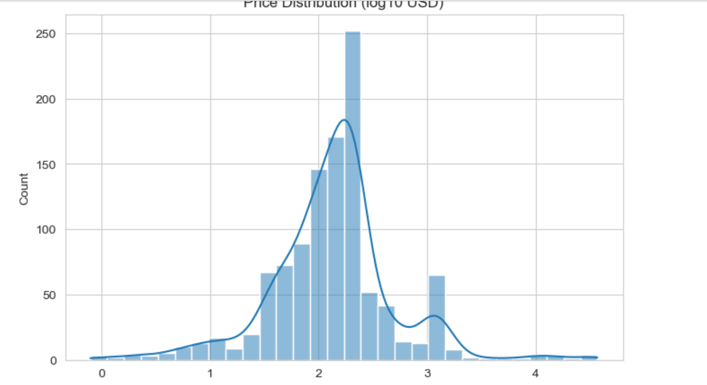
Figure 1: Price distribution across all 1,096 products (log10 USD).
The distribution is clearly multimodal rather than a single smooth curve: a dominant peak around log≈2.2-2.3 (roughly $150-$220, driven mainly by Pokemon merchandise and everyday dummyjson items), a smaller secondary bump around log≈3 (roughly $1,000, driven by laptops/electronics), and a thin tail beyond log≈4 (roughly $10,000+, driven by a handful of dummyjson vehicles and luxury watches). This confirms that the combined catalog represents three overlapping price populations rather than one coherent market, and that any single 'average price' across all 1,096 rows would be misleading.

4.2 Price by Source
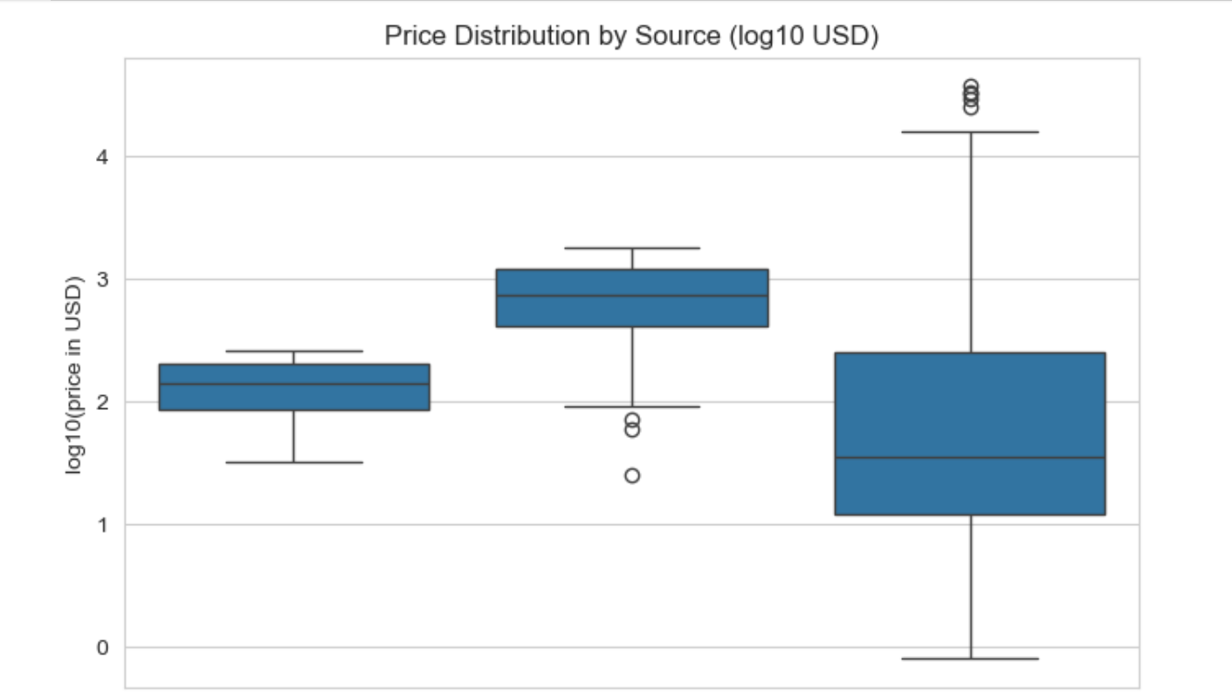
Figure 2: Price distribution by data source (log10 USD).
Each source occupies a distinct price territory: scrapeme.live is tightly clustered around $80-$250 (Pokémon merchandise), webscraper.io sits consistently higher at roughly $400-$1,200 (dominated by its 117 laptops), and dummyjson.com spans by far the widest range — from under $1 up to the catalog's most extreme outliers (luxury watches, vehicles). This is strong evidence that source, not just category, is a meaningful driver of price in this combined dataset.

4.3 Price by Category
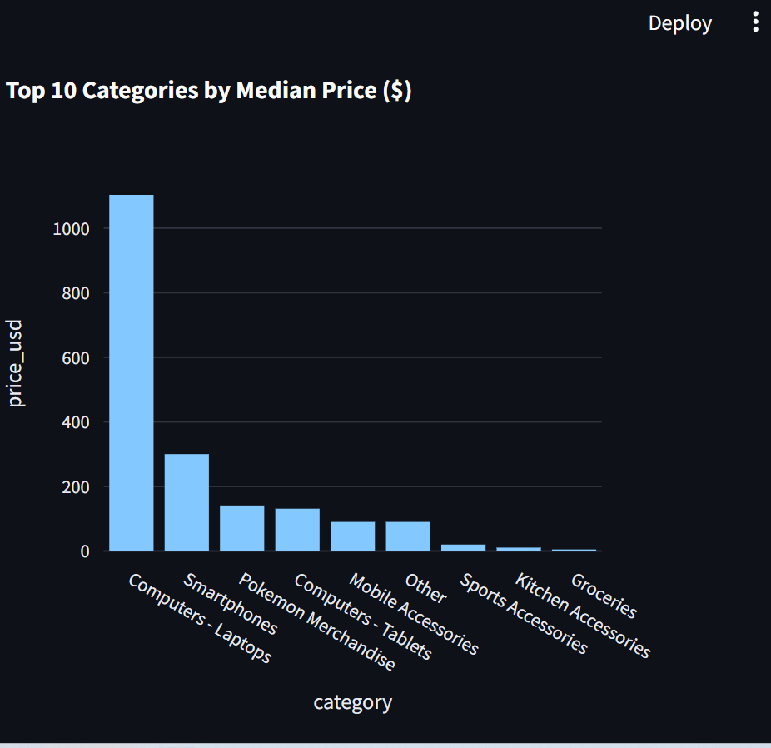
Figure 3: Median price by category (top 10, USD).
Excluding the single-source Pokémon Merchandise and the mixed 'Other' bucket, category-level pricing follows an intuitive real-world hierarchy: Computers - Laptops has by far the highest median price (~$1,100), followed by Smartphones (~$300), with Computers - Tablets, Mobile Accessories, Sports Accessories, Kitchen Accessories and Groceries descending in that order. This ordering matches real-world expectations and gives confidence that, despite being combined from three sources, the category field carries genuine, consistent price signal.

4.4 Rating vs. Price
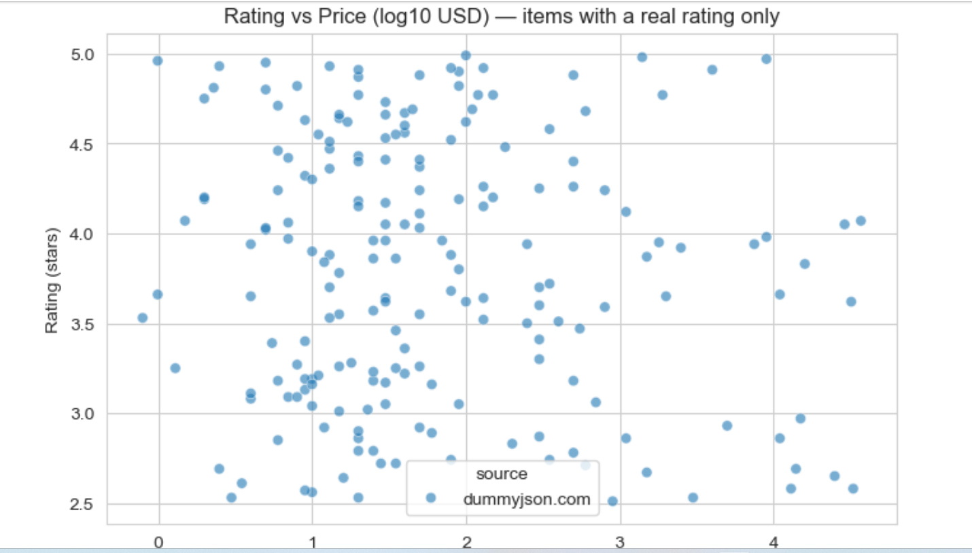
Figure 4: Rating vs. price for the 194 products with a genuine rating (dummyjson.com only).
Across the full price range — from roughly $1 to over $30,000 — both high ratings (4.5-5 stars) and low ratings (2.5-3 stars) appear at every price level, with no visible upward or downward trend. This directly replicates the finding from an earlier books-domain capstone analysis using the same methodology: price does not meaningfully predict customer rating. Seeing the same pattern in two unrelated product domains strengthens confidence that this is a genuine, generalizable pattern rather than a quirk of one dataset.

5. Model Building & Evaluation

5.1 Classification — Predicting High Ratings
A Random Forest classifier was trained on the 194 rated records only (price_log, name_length, category) to predict whether a product is highly rated (4-5 stars), using an 80/20 stratified train-test split. With only 194 total rows, the test set is small (39 rows), so results carry wider uncertainty than a larger dataset would allow.
Metric | Class 0 (Not High-Rated) | Class 1 (High-Rated) | Overall
Precision | 0.62 | 0.46 | —
Recall | 0.70 | 0.38 | —
F1-score | 0.65 | 0.41 | —
Accuracy | — | — | 0.56
ROC AUC | — | — | 0.57

The ROC AUC of 0.57 is only marginally above the 0.50 random-guessing baseline — consistent with, and a direct replication of, an earlier finding on an unrelated books dataset (AUC 0.53 there) using an identical methodology. Taken together, these two independent results across different product domains support a general conclusion: basic catalog metadata (price, category, name length) does not meaningfully predict customer rating. Rating is more plausibly driven by product experience or content quality — information does not present in listing-level catalog data.

5.2 Clustering — Segmenting the Combined Catalog
A K-Means model (k = 4) was fit on price_log and name_length (standardized) across the full 1,096-row catalog — this model does not require rating, so all three sources could be included.
Segment | Avg Price (log10 USD) | Avg Name Length | Dominant Sources | Interpretation
Short-named budget-mid items | 2.17 | 7.6 | scrapeme.live (93%) | Mostly Pokemon merchandise
Long-named mid-high items | 2.61 | 29.9 | webscraper.io + dummyjson | Electronics with descriptive names
Cross-source budget items | 1.35 | 10.7 | dummyjson + scrapeme.live | Cheap items regardless of catalog origin
Premium tier | 3.17 | 17.5 | webscraper.io + dummyjson | Highest-priced segment

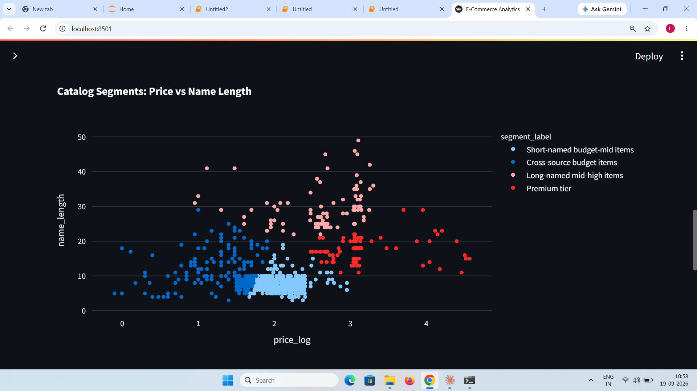
Figure 5: Catalog segments by price and product-name length (dashboard view).
This clustering genuinely cuts across sources rather than simply re-discovering 'which catalog it came from': the 'Cross-source budget items' segment groups 114 dummyjson products with 92 scrapeme.live products together purely on price and name-length similarity. The result also surfaces a real pattern worth reporting: the two higher-priced segments both have longer average product names (17.5 and 29.9 characters) than the two lower-priced segments (7.6 and 10.7 characters) — sellers appear to write more descriptive, elaborate names for higher-priced items, a genuine and actionable merchandising observation.

6. Interactive Dashboard
An interactive Streamlit dashboard was built to present these findings without requiring code or notebook access, explicitly surfacing the dataset's multi-source nature rather than hiding it.
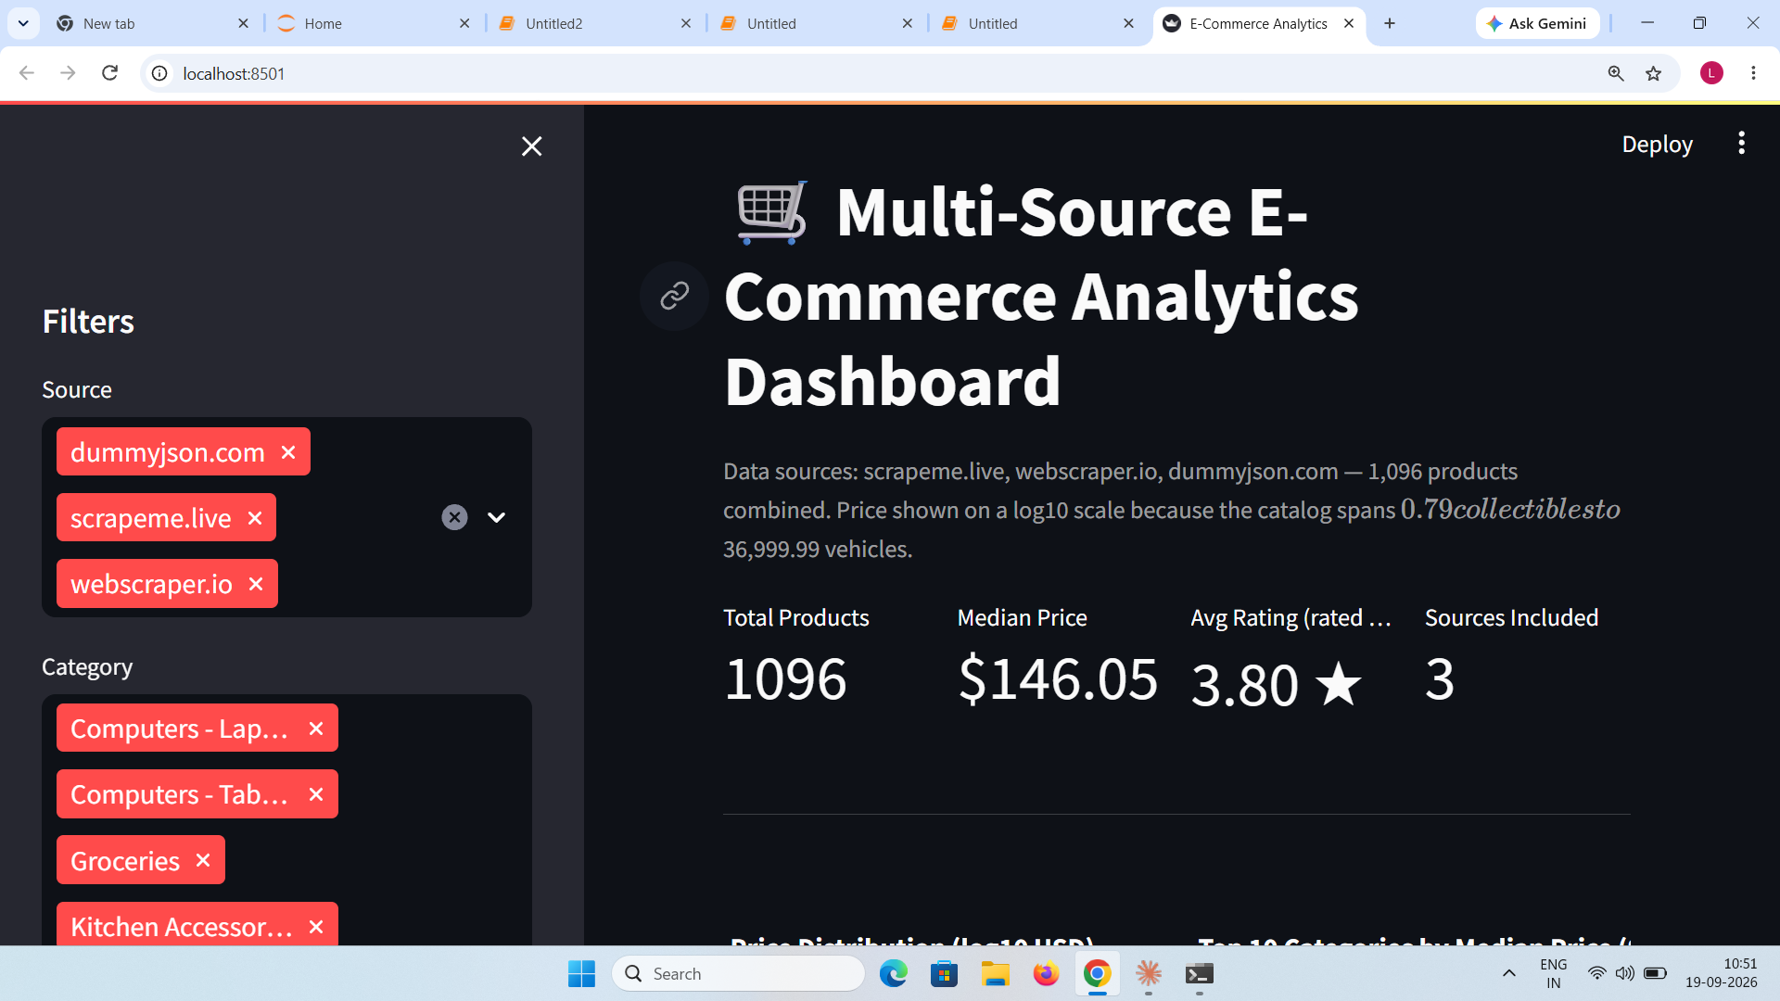
Figure 6: Dashboard home view showing KPI cards and source/category filters.
- 4 KPI cards: Total Products, Median Price (chosen over mean, since a single $37,000 outlier would badly distort an average), Average Rating (explicitly scoped to rated items only), and Sources Included
- Sidebar filters for source, category, and price range (log scale), plus a toggle to view only products with a genuine rating
- Interactive price-distribution histogram and top-10-categories-by-median-price bar chart
- A rating-vs-price scatter plot (auto-restricted to rated items) and a catalog-segment scatter plot
- A category drill-down table listing individual products, prices, ratings, source, and product links

7. Recommendations
- Do not report a single blended average price for a multi-source catalog — as shown here, doing so would badly misrepresent a catalog that is really three separate price populations; report price within source or category instead.
- Treat rating as independent of pricing strategy — replicated across two unrelated product domains (books and this multi-source catalog), price shows no meaningful relationship with customer rating, so pricing and quality/satisfaction levers should be managed separately.
- Use product-name descriptiveness as a low-cost merchandising signal — the clustering result suggests higher-priced segments consistently carry longer, more descriptive names; this is worth testing directly as an intervention on lower-priced listings.
- When combining multiple supplier or marketplace feeds, audit field coverage before analysis — this project's biggest data-quality finding was that only 1 of 3 sources reliably provided ratings; any real business combining supplier feeds should expect and explicitly document this kind of coverage gap rather than silently averaging over it.

8. Conclusion
This project combined three independents, publicly scraped catalogs into a single 1,096-record e-commerce dataset, and analyzed it end-to-end from acquisition through an interactive dashboard. The central methodological finding is that a combined multi-source catalog cannot be analyzed as if it were one coherent market — price, category, and even data coverage (ratings) all vary meaningfully by source, and the strongest results in this project (the log-price transform, the source-aware clustering, the honest scoping of rating analysis to only the source that provided it) came from explicitly modeling that heterogeneity rather than averaging over it. The classification result, while statistically weak, directly replicated an independent finding from an unrelated books-domain project, strengthening confidence that price does not drive customer rating in general. Combined with the interactive dashboard, this gives a stakeholder a realistic, honestly-scoped starting point for working with aggregated multi-supplier catalog data.

Video Presentation
Video Link:-
[https://www.loom.com/share/45f4de1e920b44f4987fe8a79539fc00]

