Retail Customer Retention Analytics – Target
Project Report Template

1. Project Overview
This project analyzes customer retention using Power BI by integrating customer demographics, transactions, loyalty, store, and churn data to identify churn drivers and improve retention.

2. Project Objective
Develop an interactive multi-page Power BI dashboard to monitor churn, repeat purchases, loyalty effectiveness, promotions, store performance, and Customer Lifetime Value (CLV).

3. Dataset Description
Datasets used:
• Customer_Demographics
• Customer_Transactions
• Store_Locations
• Loyalty_Program
• Churn_Labelled_Customers

4. Task 1 – Data Cleaning & Modeling
Describe:
• Imported all CSV files into Power BI.
• Removed duplicates.
• Handled missing values.
• Corrected data types.
• Created Membership_Duration, Transaction_Year and Transaction_Month.
• Built relationships.
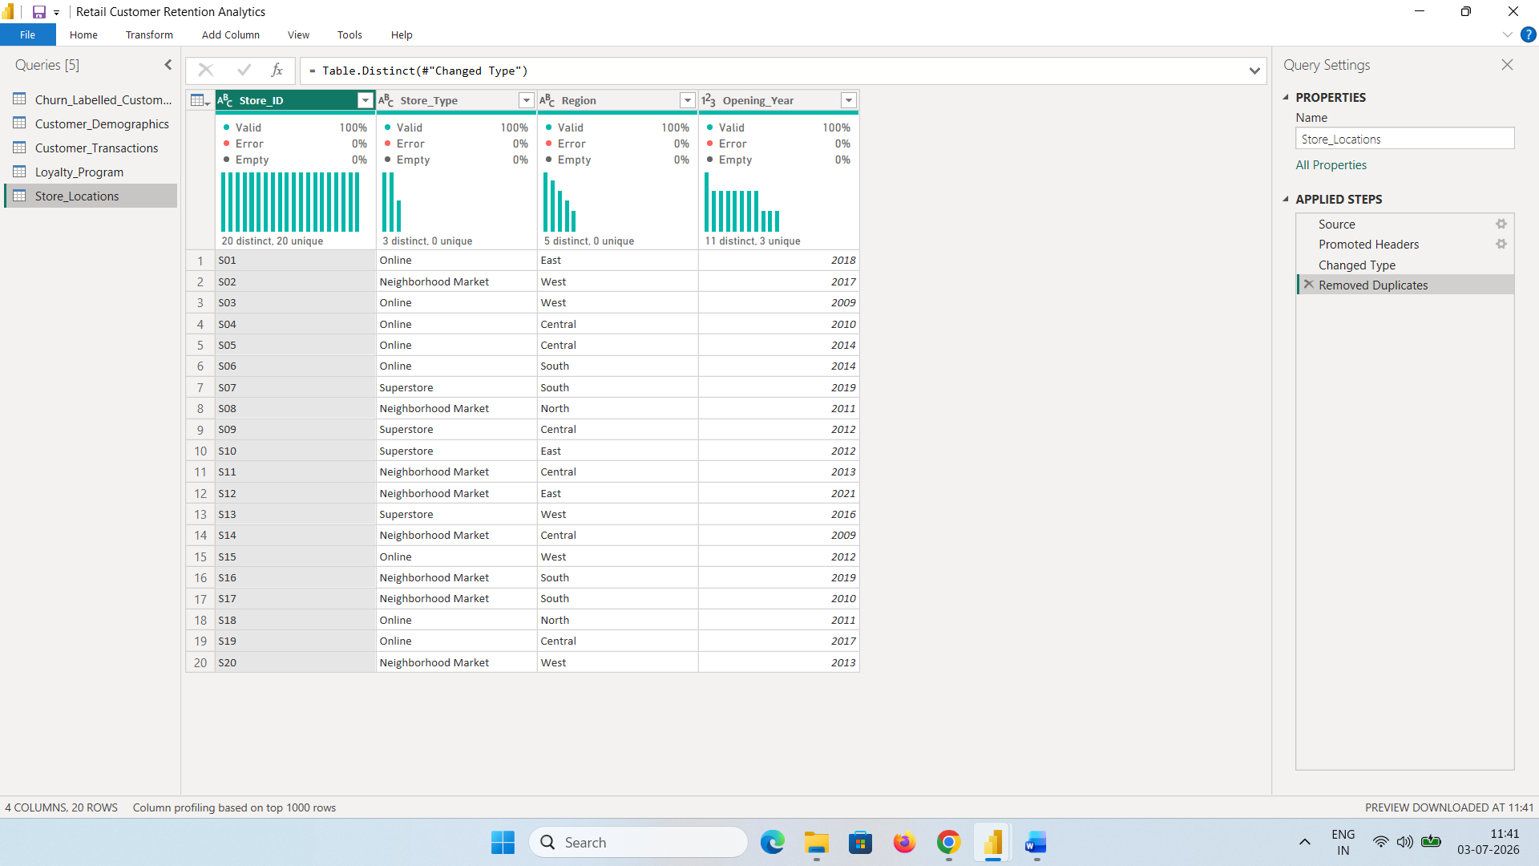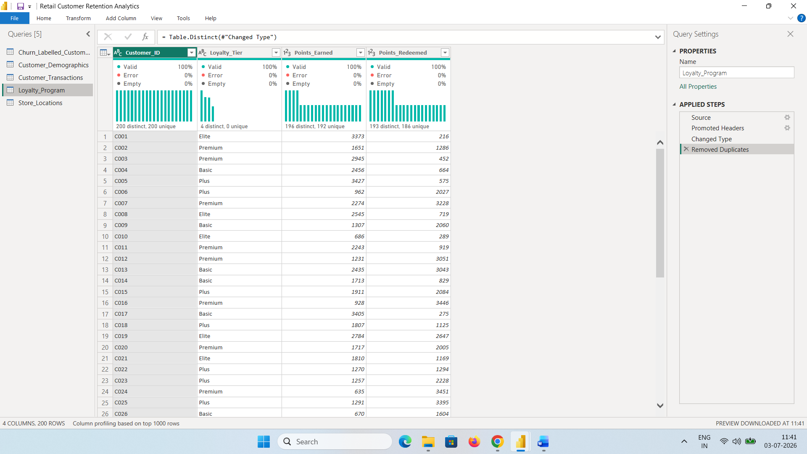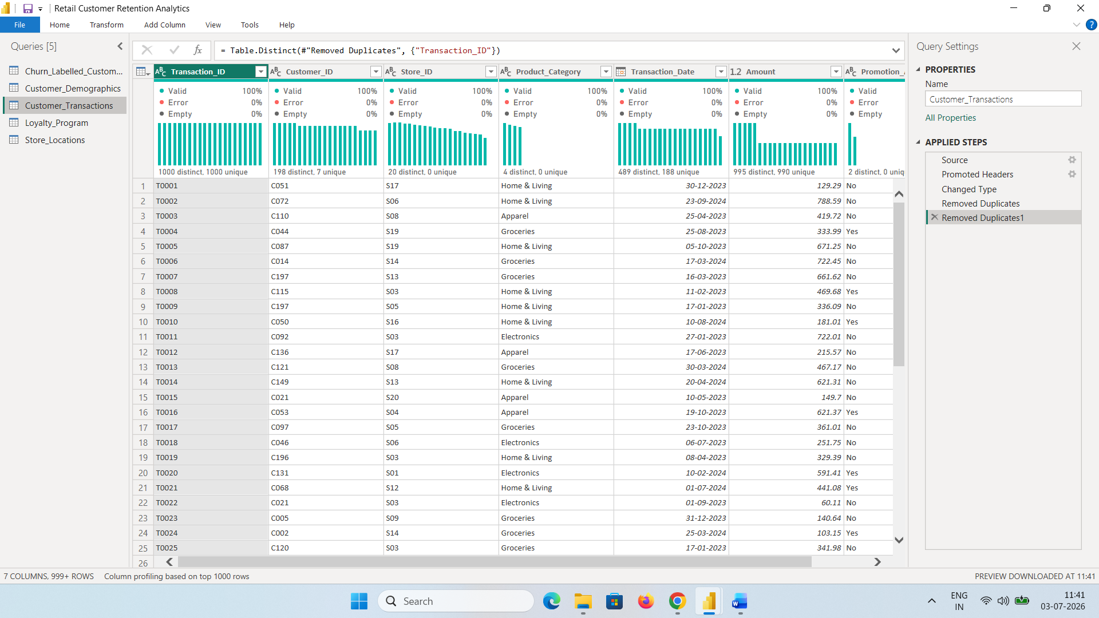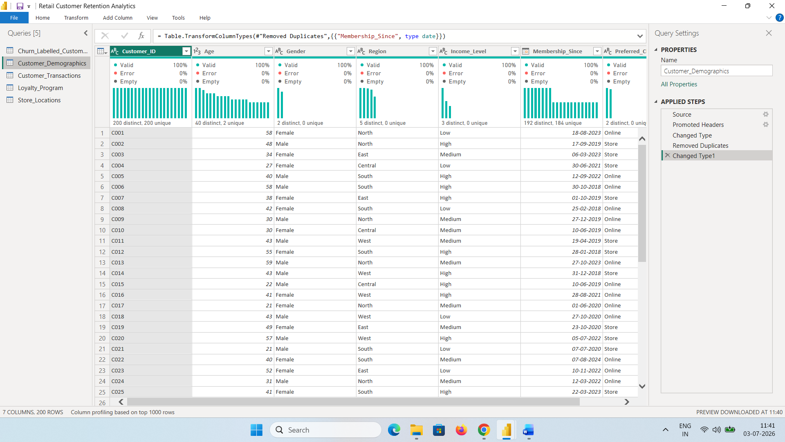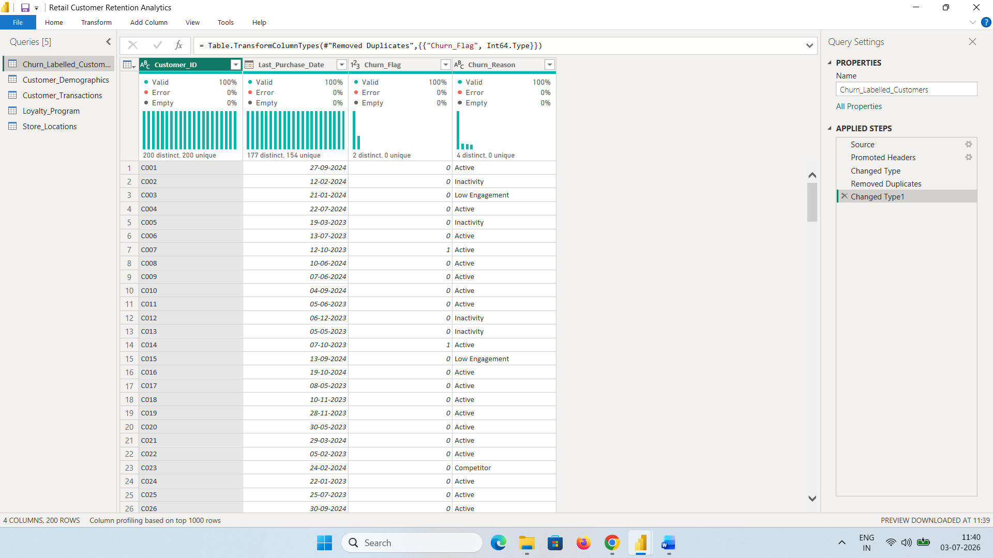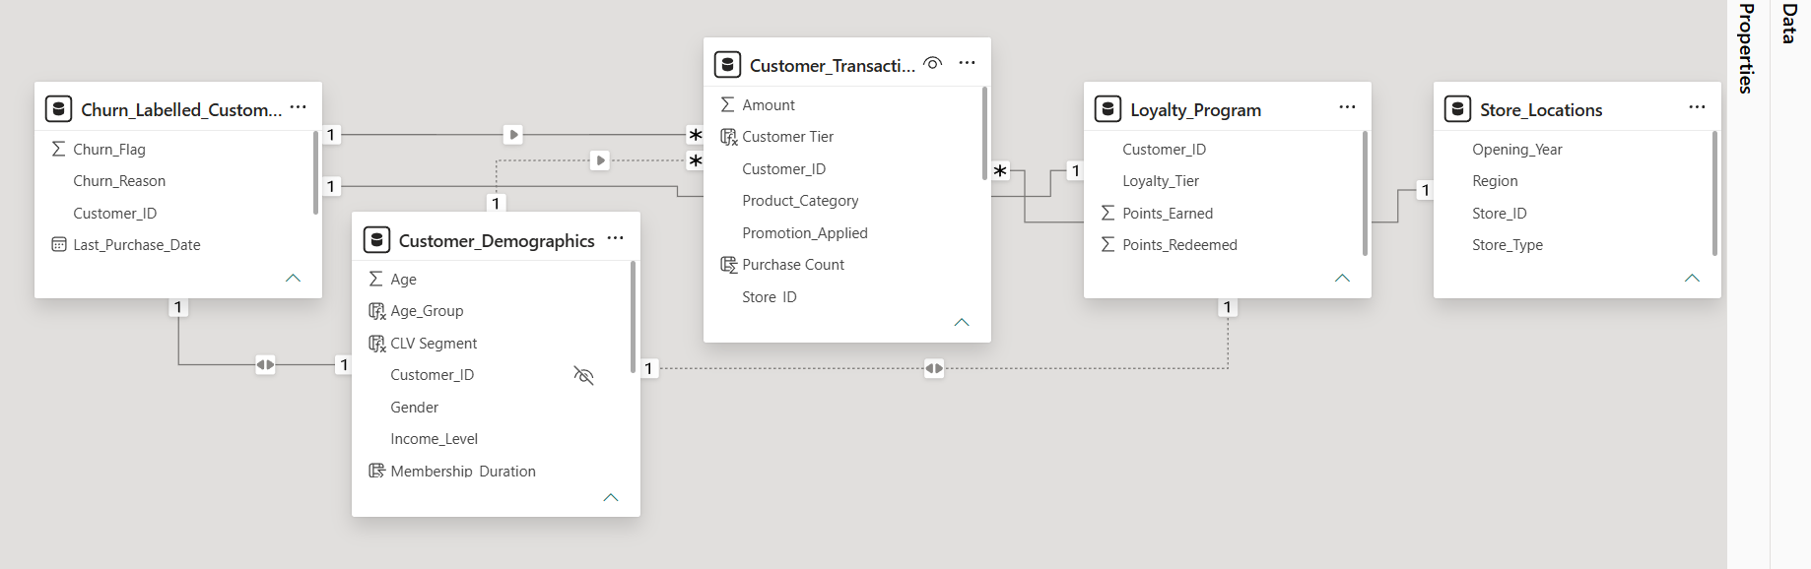

5. Task 2 – Churn & Retention Analysis
Measures Created:
• Total Customers
• Churned Customers
• Churn Rate %
• Repeat Customers
Dashboard:
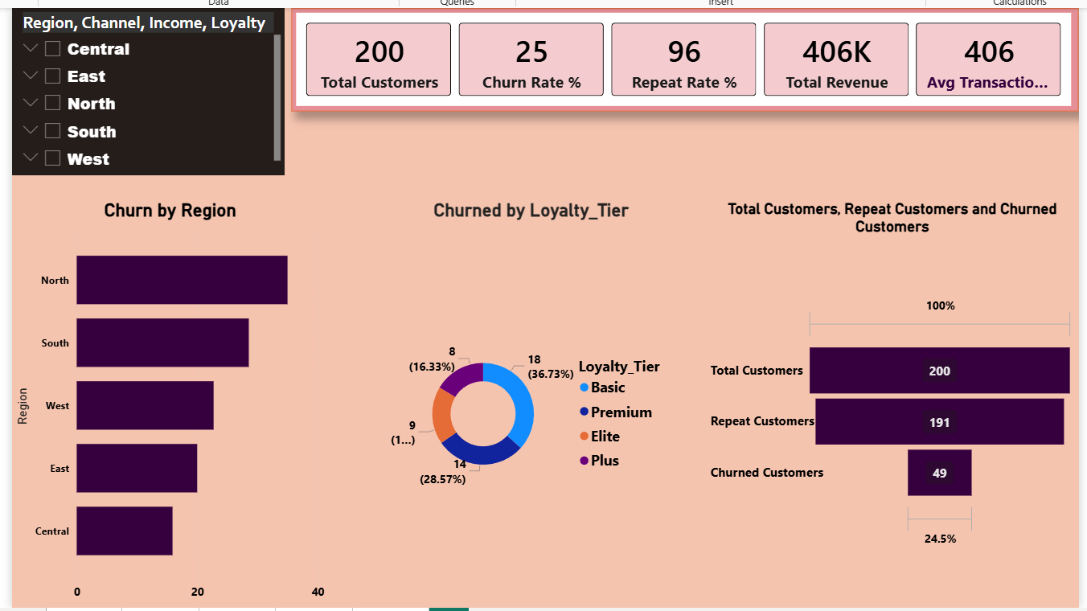
Sample Insights (replace with your actual values):
• Region with highest churn requires targeted retention.
• Higher loyalty tiers generally show lower churn.
• Online/Store comparison identifies stronger retention channel.

6. Task 3 – Repeat Purchase Analysis
Insights:
• High-tier customers generate more repeat purchases.
• Loyal customers contribute significantly to revenue.
• Electronics/Apparel/Home & Living (replace with actual) is the leading category among loyal customers.

7. Task 4 – Promotion & Loyalty Impact
Dashboard:
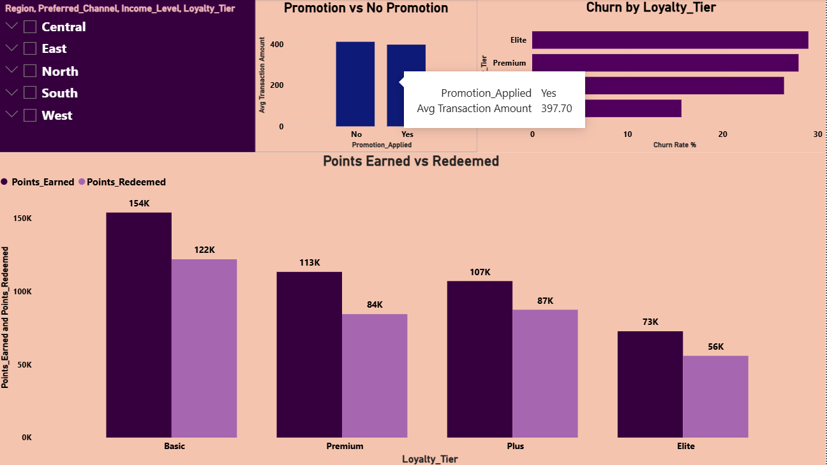
Sample Insights:
• Promotions improve average purchase value.
• Premium and Elite members earn and redeem more points.
• Basic members may need additional engagement.

8. Task 5 – Store & Channel Performance
Dashboard:
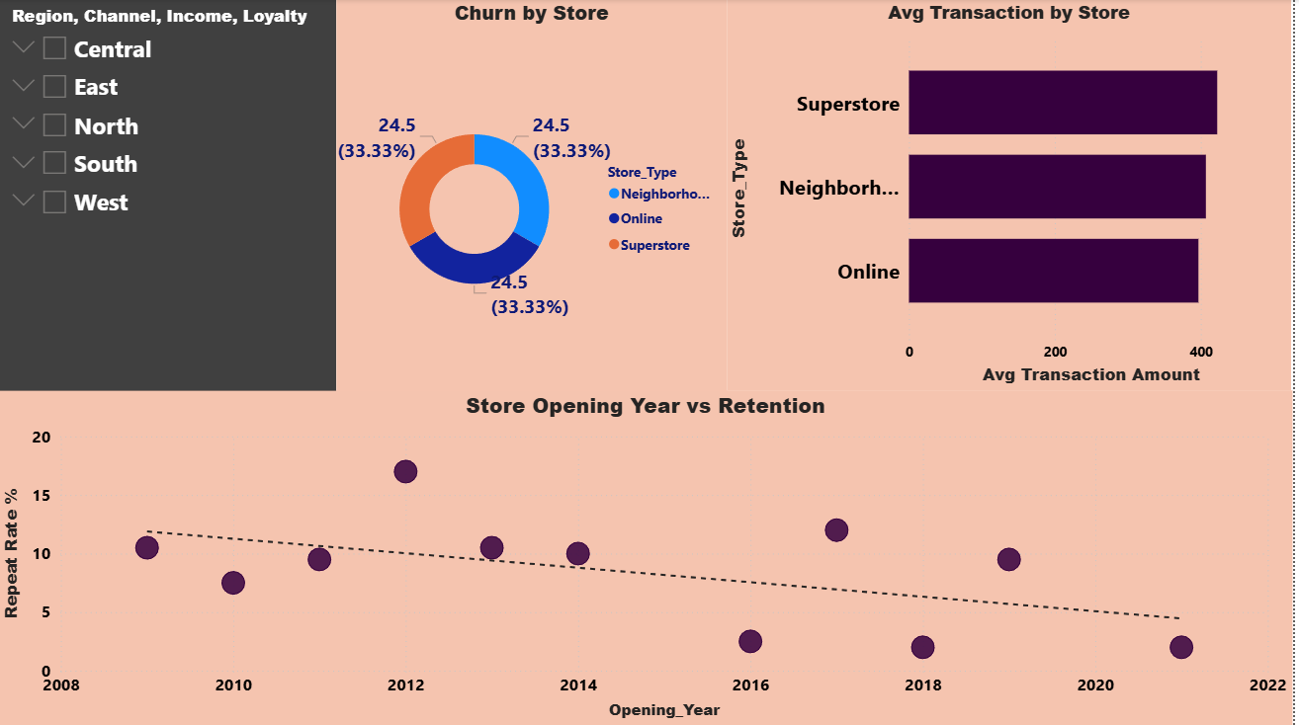
Sample Insights:
• Compare average transaction amount by store type.
• Identify store types with higher churn.
• Evaluate relationship between store age and retention.

9. Task 6 – CLV Analysis
Dashboard:
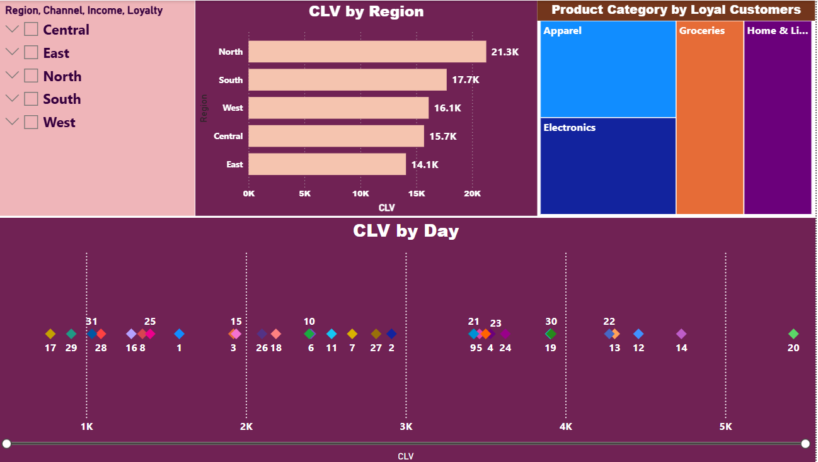
Sample Insights:
• High CLV customers should be prioritized.
• Recent purchasers generally show higher CLV.
• Premium tiers tend to contribute more lifetime value.

10. Executive Summary
Overall, the dashboard provides a consolidated view of customer retention, loyalty, promotions, store performance, and customer value. The analysis supports data-driven decision-making for improving customer engagement and reducing churn.

11. Business Recommendations
1. Prioritize retention campaigns for high-risk and Basic-tier customers.
2. Increase personalized promotions and loyalty rewards.
3. Strengthen underperforming regions/channels using targeted marketing.
4. Focus on retaining high-CLV customers through exclusive benefits.

12. Dashboard
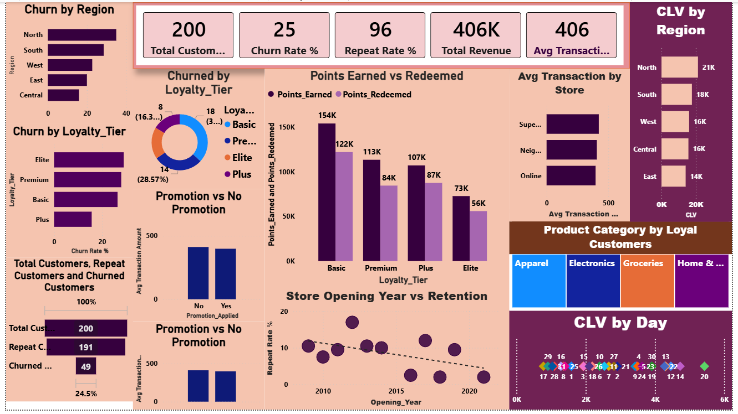

13. Video Link
Google Drive video link here:
https://www.loom.com/share/16362f29c08f4597a2748322c88c44ed

14. Conclusion
The Power BI dashboard transforms raw retail data into actionable insights that help Target identify churn patterns, improve loyalty engagement, optimize promotions, and increase customer lifetime value.

