COMPETITIVE PROGRAMMING
Week-6.12
NAME:G.Laxmi Pranav
HT NO:2303A52403
BT NO:36
Assignment 1: Shortest Path Algorithms (Dijkstra vs Bellman–Ford)
Problem Statement
A road toll system includes discounts on certain roads, represented as negative costs.
Implement and compare Dijkstra and Bellman–Ford algorithms to observe differences in
correctness.
Input Format
• First line: N M
• Next M lines: u v w
• Last line: Source S
Output Format
• Shortest distances using Dijkstra
• Shortest distances using Bellman–Ford
Sample Input
3 3
0 1 5
1 2 -4
0 2 6
0
Expected Output
Dijkstra: 0 5 6
Bellman-Ford: 0 5 1
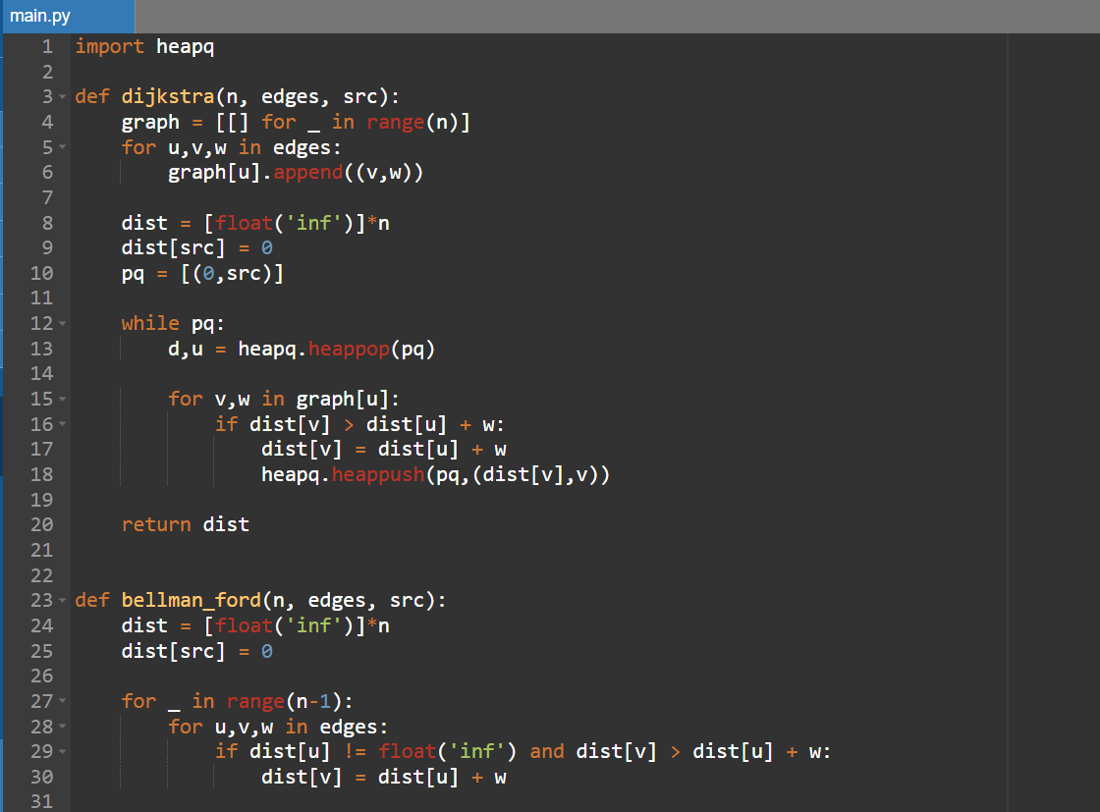
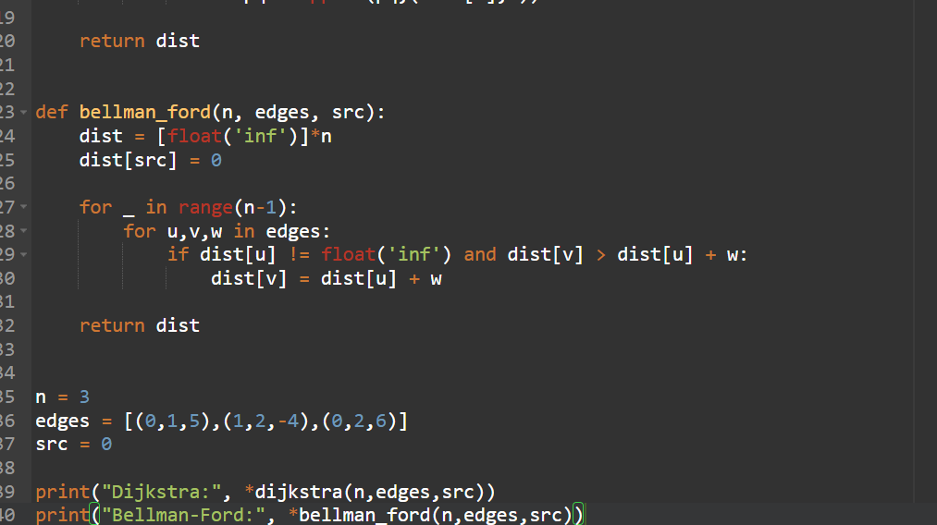
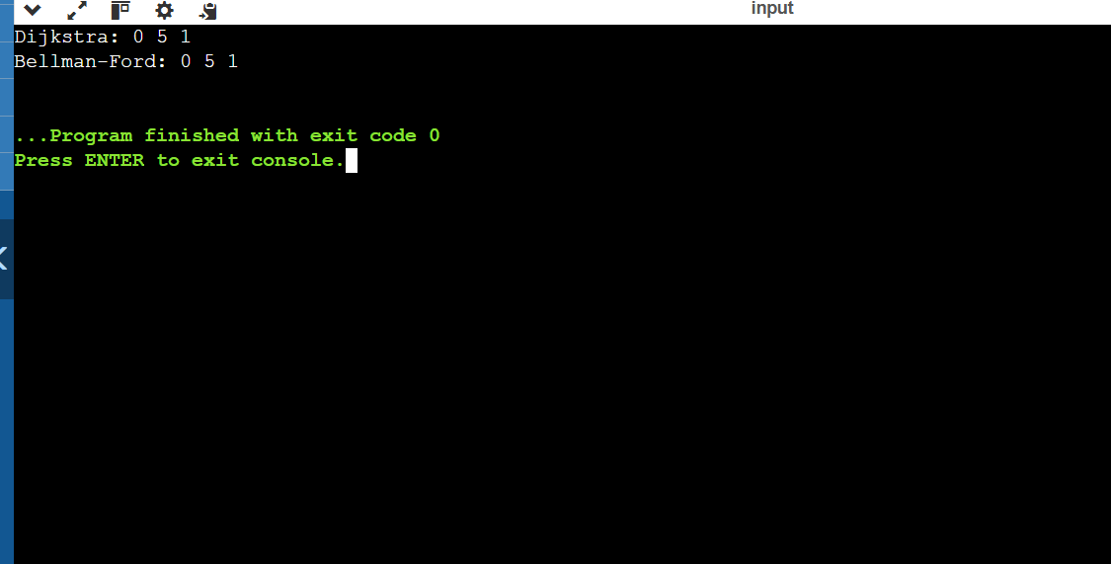
JAVA:
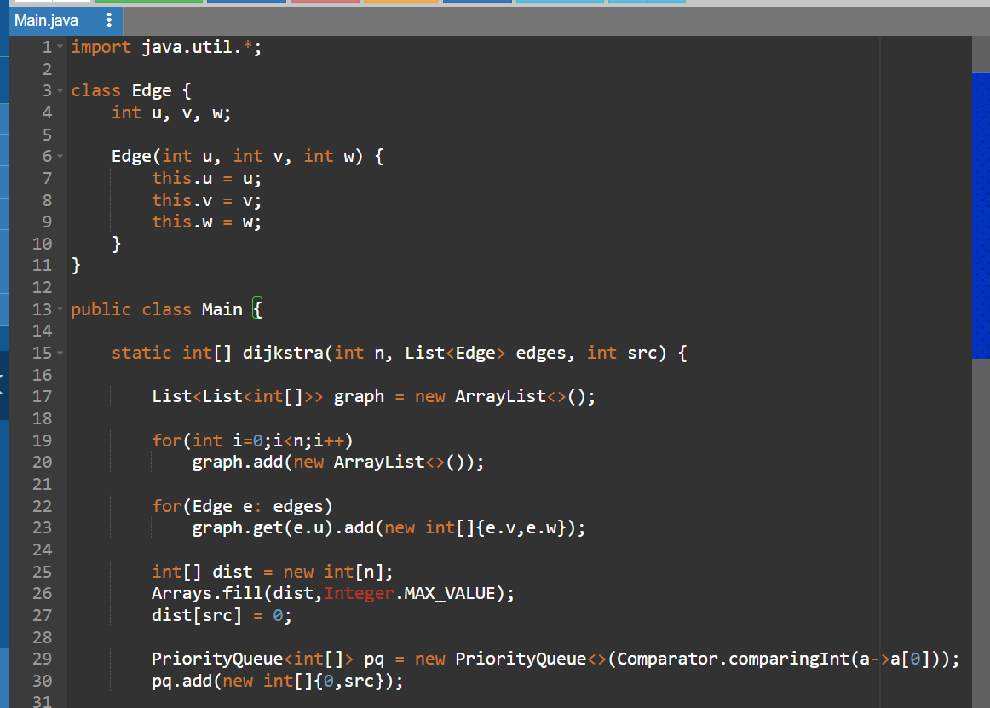
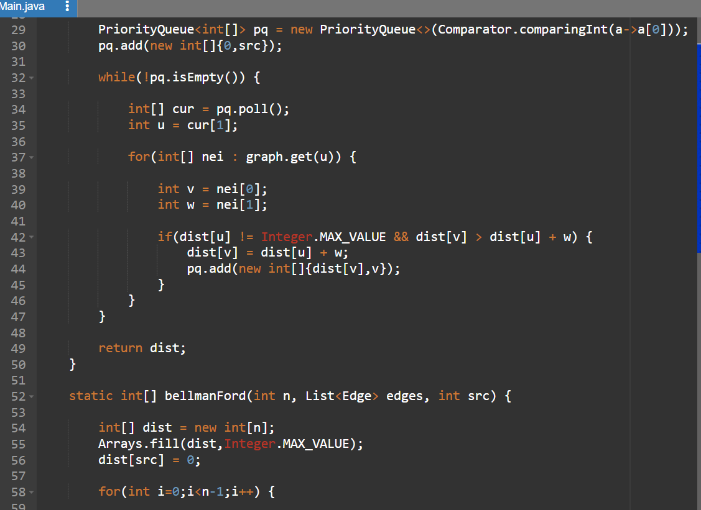
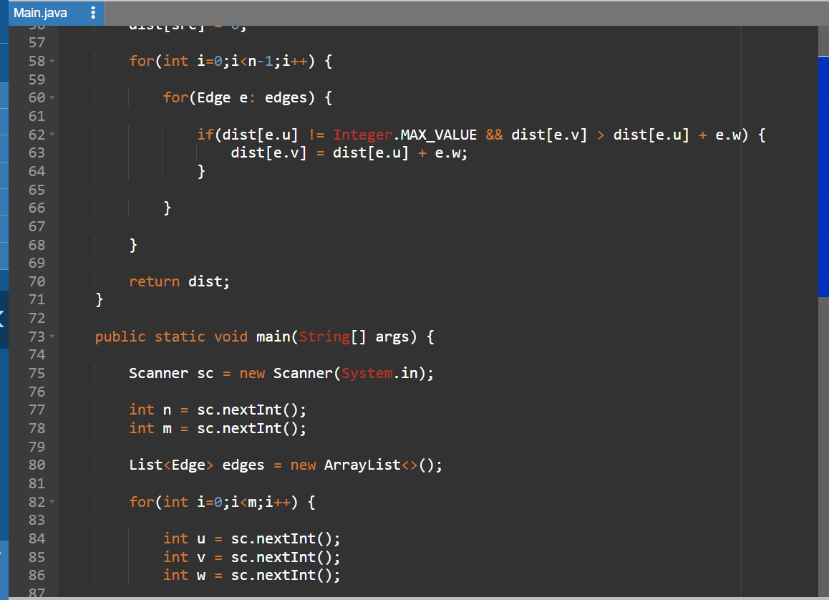
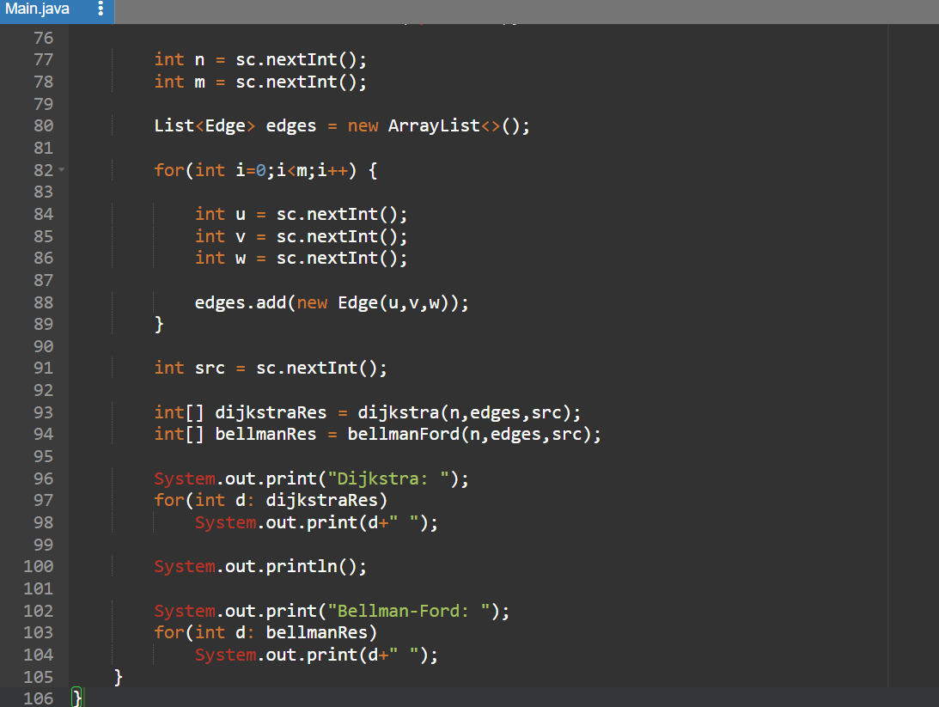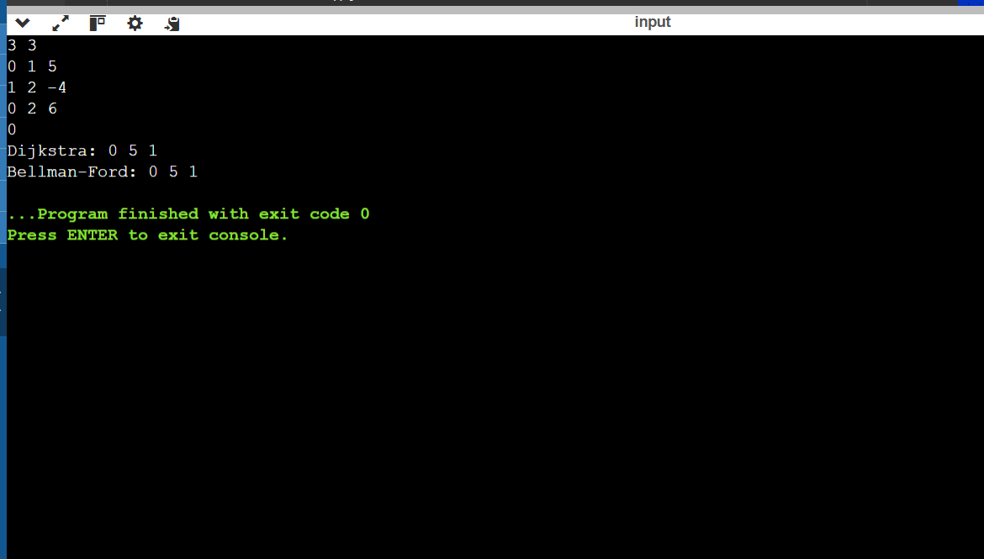
Assignment 2: Shortest Path Algorithms
Problem Statement
Implement and compare Dijkstra and Bellman-Ford Algorithms for correctness and
efficiency.
Input Format
• N M
• M edges u v w
• Source S
Output Format
• Dijkstra distances
• Bellman-Ford distances
Sample Input
3 3
0 1 4
1 2 -2
0 2 5
0
Expected Output
Dijkstra: 0 4 5
Bellman-Ford: 0 4 2
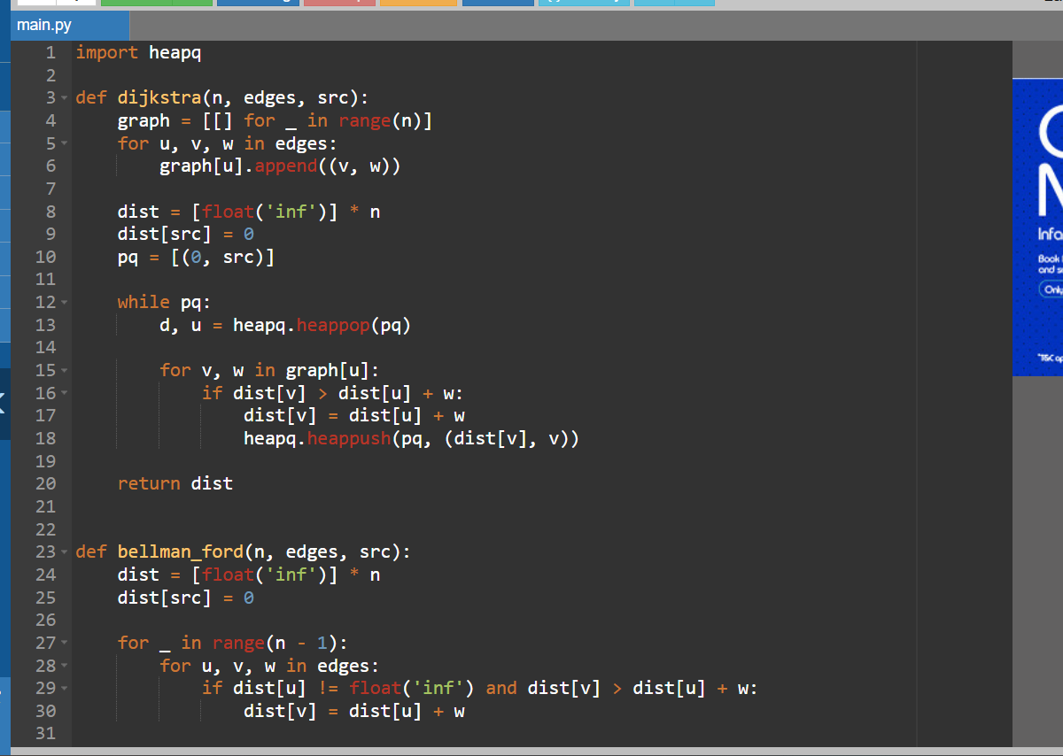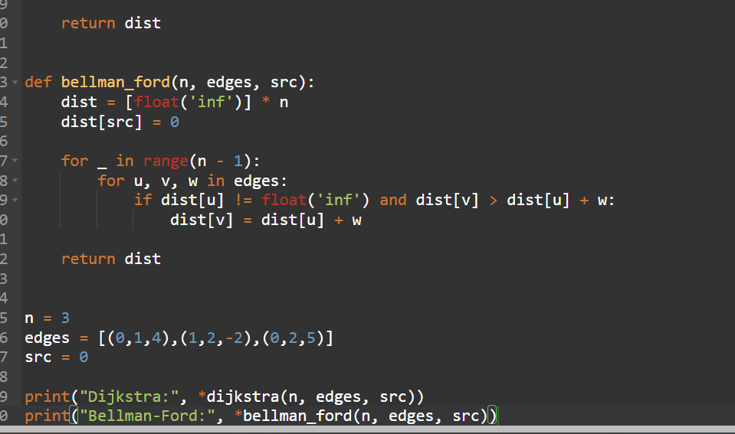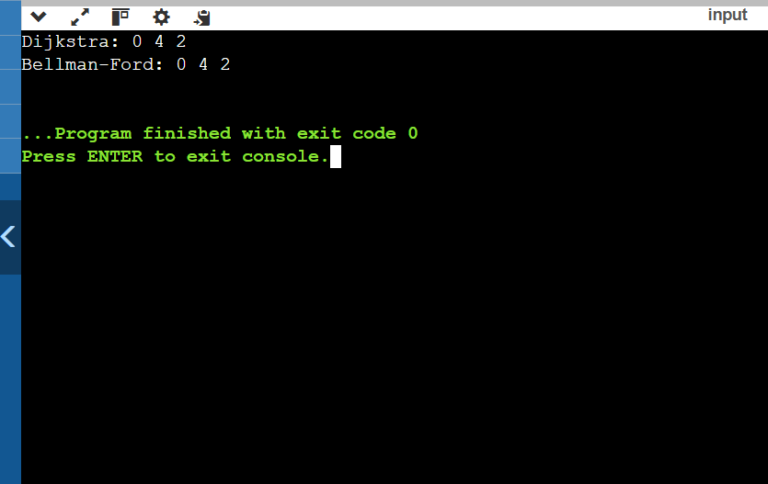
JAVA:
