**1.What are the two values of the Boolean data type? How do you write them?**

**Ans-**

A Boolean data type is declared with the bool key word and can only take the values true or false, when the value is returned, **true = 1 and false = 0** or yes / no

**True and False**, using Capital EX: True, False

**2. What are the three different types of Boolean operators?**

**Ans-**

There are three logical operators that are used to compare value. they evaluate expression down to Boolean values, returning either True or False, these operators are **AND, OR, or NOT**

**3. Make a list of each Boolean operator's truth tables (i.e., every possible combination of Boolean values for the operator and what it evaluates).**

**Ans-**

True is 1 and False is 0

**Truth Table for AND**A B output  
0 0 0  
0 1 0  
1 0 0  
1 1 1  
**Truth Table for OR**A B output  
0 0 0  
0 1 1  
1 0 1  
1 1 1

**Truth Table for NOT**  
A output  
0 1  
1 0

**4. What are the values of the following expressions?**

(5 > 4) and (3 == 5)

not (5 > 4)

(5 > 4) or (3 == 5)

not ((5 > 4) or (3 == 5))

(True and True) and (True == False)

(not False) or (not True)

**Ans-**

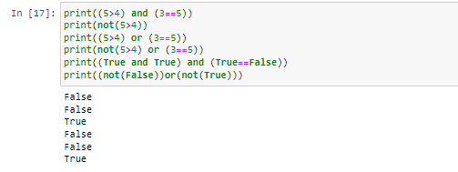

**5. What are the six comparison operators?**

**Ans-**

**1 Equal to ==**

**2 not equal to !=**

**3 Less than <**

**4 Greater than >**

**5 less than or equal to <=**

**6 Greater than or equal to >=**

**6. How do you tell the difference between the equal to and assignment operators? Describe a condition and when you would use one.**

**Ans-**

The “=” is an assignment operator used to assign the value on the right to the variable on the left.

THE “==” Operator checks whether the two given operands are equal or not if so, it returns true. Otherwise, it returns false.

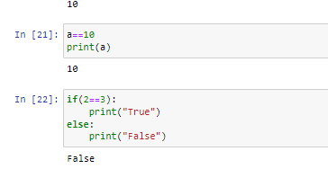

**7. Identify the three blocks in this code:**

spam = 0

if spam == 10:

print('eggs')

if spam > 5:

print('bacon')

else:

print('ham')

print('spam')

print('spam') **Ans-**

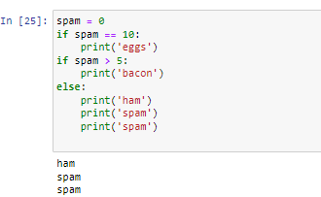

**8. Write code that prints Hello if 1 is stored in spam, prints Howdy if 2 is stored in spam, and prints Greetings! if anything else is stored in spam.**

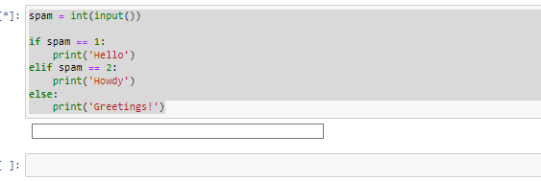

**9.If your programme is stuck in an endless loop, what keys you’ll press?**

**Ans-**

You can stop an infinite loop with CTRL + C.

**10. How can you tell the difference between break and continue?**

**Ans-Break:** In the break statement, the control exits from the loop

It is used to stop the execution of the loop at a specific condition

**Continue:** In the continue statement, the control remains within the loop

It is used to skip a particular iteration of the loop

**11. In a for loop, what is the difference between range (10), range (0, 10), and range (0, 10, 1)?**

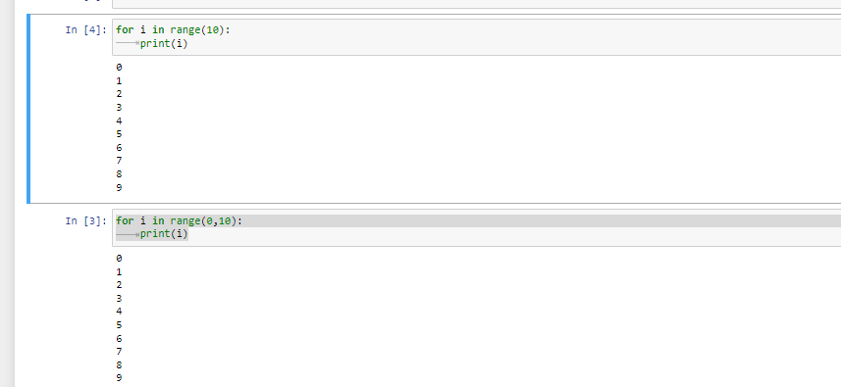

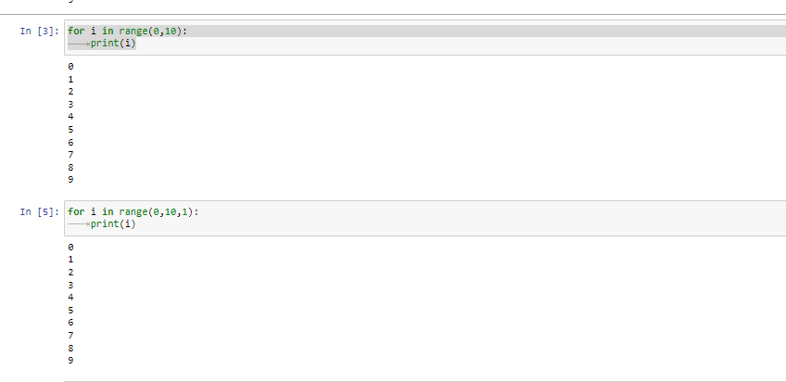

The range (10) call ranges from 0 up to (but not including) 10, range (0, 10) tells the loop to start at 0, and range (0, 10, 1) tells the loop to increase the variable by 1 on each iteration.

**12. Write a short program that prints the numbers 1 to 10 using a for loop. Then write an equivalent program that prints the numbers 1 to 10 using a while loop.**

**Ans-**

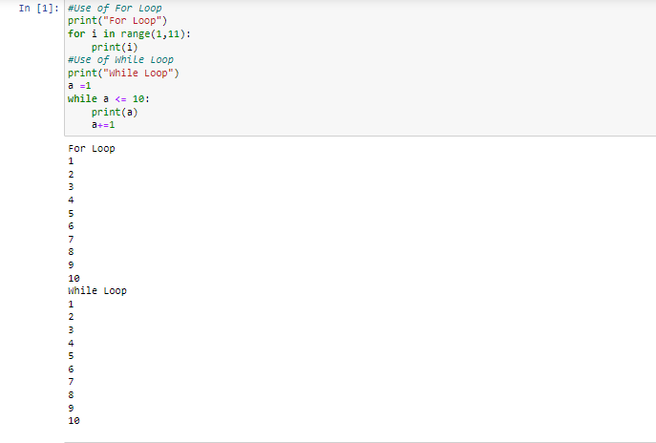

13. If you had a function named bacon() inside a module named spam, how would you call it after importing spam?

**Ans-**

The function can be called with spam. bacon()