1. **What does an empty dictionary's code look like?**

**Ans-**

An empty dictionary's code looks like **two curly brackets: {}**

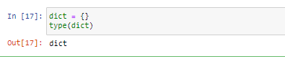

1. **What is the value of a dictionary value with the key 'foo' and the value 42?**

**Ans-**

The value of a dictionary value with the key 'foo' and the value 42 is {'foo': 42}

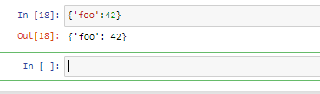

1. **What is the most significant distinction between a dictionary and a list?**

**Ans-**

Most significant difference:  
List - items in list are Ordered  
Dictionary : item in dictionary are unordered

1. **What happens if you try to access spam['foo'] if spam is {'bar': 100}?**

**Ans-**

We get a Key Error error.

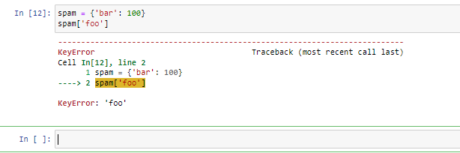

1. **If a dictionary is stored in spam, what is the difference between the expressions 'cat' in spam and 'cat' in spam.keys()?**

**Ans-**

There is no difference. The in operator checks whether a value exists as a key in the dictionary.

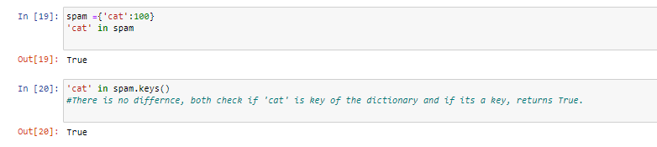

1. **If a dictionary is stored in spam, what is the difference between the expressions 'cat' in spam and 'cat' in spam.values()?**

**Ans-**

'cat' in spam checks whether there is a 'cat' key in the dictionary, while 'cat' in spam.values() checks whether there is a value 'cat' for one of the keys in spam.

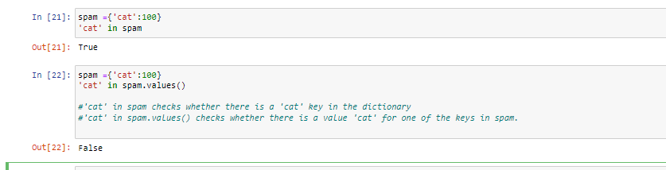

**7. What is a shortcut for the following code?**

**if 'color' not in spam:**

**spam['color'] = 'black'**

**Ans-**

spam.setdefault('color', 'black')

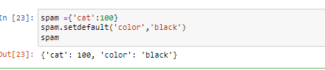

1. **How do you "pretty print" dictionary values using which module and function?**

**Ans-**

pprint.pprint()

The module used is the pprint module within which we have the pprint function of the same name.

