20 May

**Python Basic – 1**

**Q.1. What are keywords in python? Using the keyword library, print all the python keywords.**

**Ans-**

Python has a set of keywords that are reserved words that cannot be used as variable names, function names, or any other identifiers:

Keyword Description

and A logical operator

as to create an alias

assert for debugging

break to break out of a loop

class to define a class

continue to continue to the next iteration of a loop

def to define a function

del To delete an object

elif Used in conditional statements, same as else if

else Used in conditional statements

except Used with exceptions, what to do when an exception occurs

False Boolean value, result of comparison operations

finally Used with exceptions, a block of code that will be executed no matter if there is an exception or not

for to create a for loop

from to import specific parts of a module

global to declare a global variable

if to make a conditional statement

import to import a module

in to check if a value is present in a list, tuple, etc.

is to test if two variables are equal

lambda to create an anonymous function

None Represents a null value

nonlocal to declare a non-local variable

not A logical operator

or A logical operator

pass A null statement, a statement that will do nothing

raise to raise an exception

return to exit a function and return a value

True Boolean value, result of comparison operations

try to make a try...except statement

while to create a while loop

with Used to simplify exception handling

yield to end a function, returns a generator

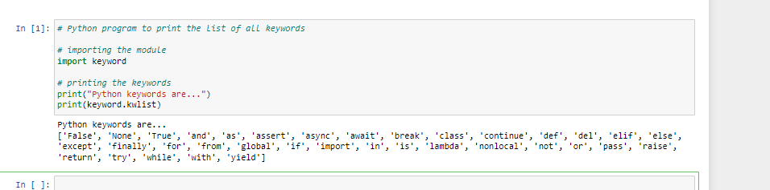

**Q.2. What are the rules to create variables in python?**

**Ans-**

Rules for Python variables:

A variable name must start with a letter or the underscore character.

A variable name cannot start with a number.

A variable name can only contain alpha-numeric characters and underscores (A-z, 0-9, and _ )

Variable names are case-sensitive (age, Age and AGE are three different variables)

**Q.3. What are the standards and conventions followed for the nomenclature of variables in python to improve code readability and maintainability?**

**Ans-**

Use variable names that relate to your code, like instead of a,b,c use name such as name, school, marks

You can't use spaces on variable names so use underscore. Such as new_var

Put first letter of every word capital for better readability like

New_Home

**Q.4. What will happen if a keyword is used as a variable name?**

**Ans-**

We cannot use a keyword as a variable name, function name, or any other identifier. They are used to define the syntax and structure of the Python language. All the keywords except True, False and None are in lowercase and they must be written as they are.

**Q.5. For what purpose def keyword is used?**

**Ans-**

The def keyword is used to create, (or define) a function.

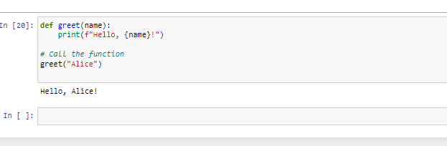

**Q.6. What is the operation of this special character ‘\’?**

**Ans-**

Punctuation marks and other symbols are examples of special characters.

...

Keyboard special characters.

Key/symbol Explanation

\ Backslash or reverse solidus.

/ Forward slash, solidus, virgule, whack, and mathematical division symbol.

~ Tilde.

` Acute, backquote, backtick, grave, grave accent, left quote, open quote, or a push.

! Exclamation mark, exclamation point, or bang.

@ Ampersat, arobase, asperand, at, or at symbol.

**Q.7. Give an example of the following conditions:**

**(i) Homogeneous list**

**(ii) Heterogeneous set**

**(iii) Homogeneous tuple**

A homogeneous list is where the elements are restricted to a specific type such as a list of Person objects, a list of String objects, a list of Book objects, and so forth.

Heterogeneous Element with Python Set

Python sets can store heterogeneous elements in it, i.e., a set can store a mixture of string, integer, Boolean, etc. datatypes.

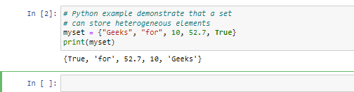

Tuples are immutable, and usually contain a heterogeneous sequence of elements that are accessed via unpacking (see later in this section) or indexing (or even by attribute in the case of named tuples). Lists are mutable, and their elements are usually homogeneous and are accessed by iterating over the list.

**Q.8. Explain the mutable and immutable data types with proper explanation & examples.**

**Ans-**

**Mutable Objects**

A mutable object can be changed after it is created

**Examples:** List, Set, Dictionary

Mutable objects are not considered as thread-safe in nature

Mutable Objects are slower to access, as compared to immutable objects

Mutable objects are useful when we need to change the size or contents of our object

Changing mutable objects is a cheaper operation in terms of space and time

**Immutable Objects**

An immutable object cannot be changed after it is created

**Ex:** tuples, int, float, bool, frozen set.

Immutable objects are regarded as thread-safe in nature

Immutable objects are faster to access when compared to mutable objects

Immutable objects are best suitable when we are sure that we don't need to change them at any point in time.

Changing immutable objects is an expensive operation since it involves creating a new copy for any changes made.

Q.9. Write a code to create the given structure using only for loop.

*

***

*****

*******

*********

Ans-

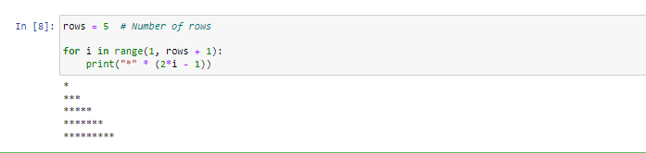

Q.10. Write a code to create the given structure using while loop.

|||||||||

|||||||

|||||

|||

|

