21 May

**Python Basic – 2**

**Q.1. Create two int type variables, apply addition, subtraction, division and multiplications**

**and store the results in variables. Then print the data in the following format by calling the**

**variables:**

First variable is __ & second variable is __.

Addition: __ + __ = __

Subtraction: __ - __ = __

Multiplication: __ * __ = __

Division: __ / __ = __

Ans-

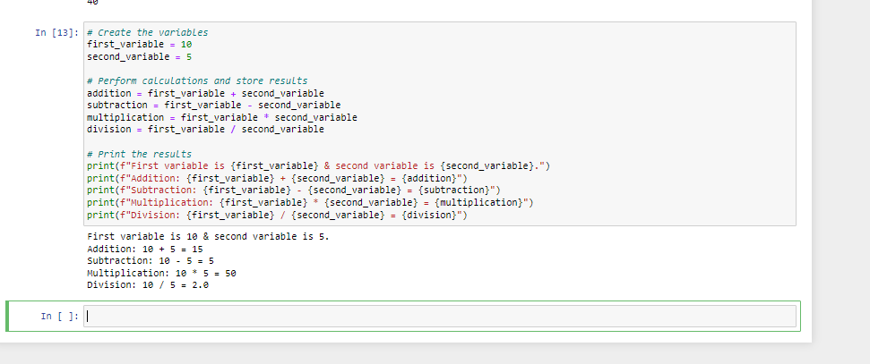

**Q.2. What is the difference between the following operators:**

**(i) ‘/’ & ‘//’**

**(ii) ‘**’ & ‘^’**

Ans-

Difference between ‘/’ & ‘//’:

‘/’ is a division operator which perform division between two operands and returns float value

Whereas ‘//’ is a floor division operator which perform division and returns the integer quotient

Difference between ‘**’ & ‘^’

‘**’ is an exponential operator it raises left operand to the power of right operand whereas

‘^’ is a bit-wise XOR operator which performs binary representation of the operands.

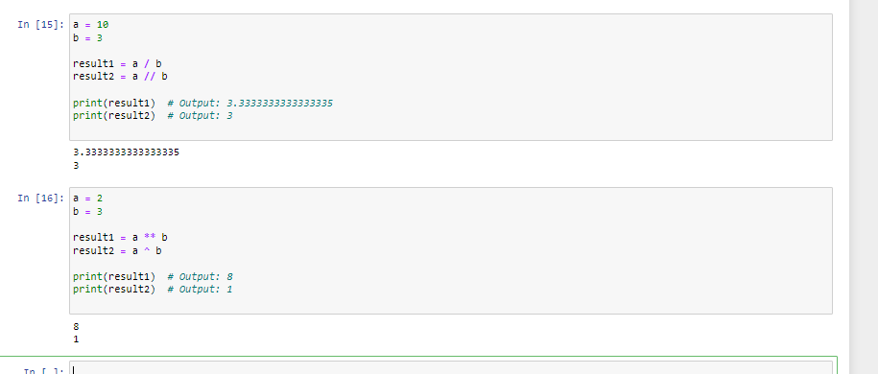

**Q.3. List the logical operators.**

**Ans-**

Logical operators are used to perform logical operations on Boolean values or expressions. there are three operators

Operator Name Example result

&& AND. True only if both operands are true. 0 (only one is true)

|| OR. True if either operand is true. 1 (the first test is true)

∼ NOT. Changes true to false and false to true. 1 (the strings are not equal)

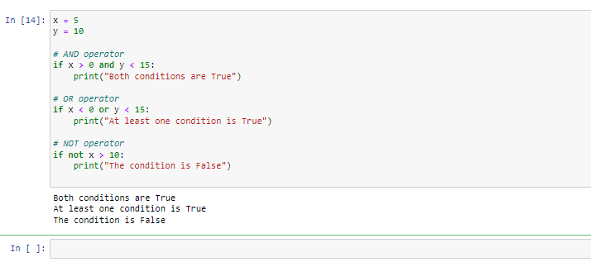

**Q.4. Explain right shift operator and left shift operator with examples.**

**Ans-**

The bitwise shift operators are the right-shift operator ( >> ), which moves the bits of an integer or enumeration type expression to the right, and the left-shift operator ( << ), which moves the bits to the left.

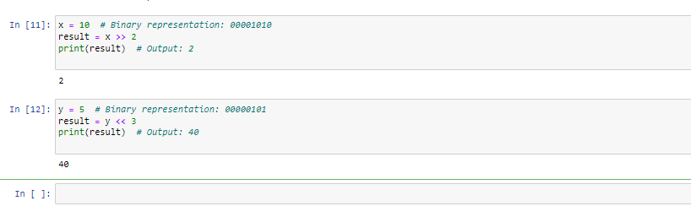

Q.5**. Create a list containing int type data of length 15. Then write a code to check if 10 is**

**present in the list or not.**

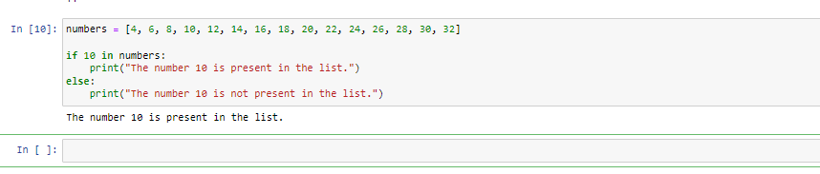

In this example, we have created a list called ‘numbers’ containing 15 integer values then the code checks if the number 10 is present in the list using the ‘in’ operator. If the number 10 is found the list, it prints” The number 10 is present in the list. “Otherwise, it prints “The number 10 is not present in the list.”