AITO WORKFLOW GENERATOR
Software Architecture & Technical Design Document
Version 1.0
Prepared for implementation of the React + ASP.NET Core + SQL architecture
Document Status: Baseline Architecture
Classification: Internal Use

Document Control
Field | Value
Document title | AITO Workflow Generator - Software Architecture & Technical Design Document
Version | 1.0
Status | Baseline for implementation
Primary audience | Developers, technical leads, reviewers and future maintainers
System scope | React frontend, ASP.NET Core backend, SQL Server/Azure SQL, Microsoft Entra ID and Microsoft Graph
Source system | Existing React application with direct SharePoint integration

Revision History
Version | Date | Description | Owner
1.0 | July 2026 | Initial architecture baseline for backend introduction and SharePoint-to-SQL migration | Project Team

Approvals
Role | Name | Decision | Date
Technical Lead | To be completed | Pending
Project Manager | To be completed | Pending
Security/Cloud Reviewer | To be completed | Pending

Table of Contents
Open the document in Microsoft Word and select References > Table of Contents to insert or refresh the automatic table of contents. All chapters use Word heading styles and are ready for automatic navigation.

1. Project Overview

1.1 Introduction
The AITO Workflow Generator is a role-driven productivity application that helps users discover recommended activities, understand how artificial intelligence tools can assist those activities, assemble a personalized workflow, save and share workflow selections, generate huddle content, and export the resulting guidance to PowerPoint or interactive HTML. The current React user interface is already mature and contains the expected end-user behavior. The architecture described in this document introduces a dedicated ASP.NET Core backend and a relational database without redesigning or discarding the existing user experience.
The central architectural change is the removal of direct SharePoint access from the browser. The React application will communicate only with a protected backend API. The API will enforce business rules, ownership, authorization, validation, logging and database access. Reference data and user-generated workflow data will be stored in SQL Server during local development and Azure SQL in deployed environments.

1.2 Business Problem
The existing implementation successfully demonstrates the product capabilities, but its data-access model places SharePoint-specific responsibilities inside the frontend. This creates tight coupling between UI code and storage technology, requires browser-side Graph and SharePoint permissions, makes ownership rules harder to enforce consistently, and limits the ability to introduce robust transactions, normalized relationships, integration testing and centralized observability.
The target architecture addresses these concerns while retaining the existing workflows and presentation. It creates a stable service boundary that can support future administration, reporting, notifications, audit requirements and additional AI-assisted features without exposing database or platform details to the browser.

1.3 Objectives
- Preserve every existing UI feature and user-facing behavior unless an explicitly approved change is introduced.
- Separate the React application and ASP.NET Core API into independently buildable and deployable applications.
- Apply Clean Architecture so that business use cases do not depend directly on EF Core, SQL Server, Microsoft Graph or Azure hosting.
- Replace SharePoint lists with a normalized SQL schema managed through Entity Framework Core migrations.
- Use Microsoft Entra ID for user authentication and protected API access.
- Enforce workflow ownership and sharing authorization in the backend, using the Entra object ID as the authoritative user identifier.
- Create a production-ready foundation for monitoring, testing, CI/CD, secure configuration and Azure deployment.

1.4 Scope
This document covers the target architecture for the Workflow Builder, reference data, workflow history, workflow sharing, people search, required and other huddles, preview tabs, PowerPoint export, HTML export, authentication, authorization, logging, validation, error handling, local SQL Server development, Azure SQL deployment and migration from SharePoint. It defines responsibilities and integration boundaries; it does not provide feature implementation code.

1.5 Out of Scope for the Initial Release
- A general-purpose admin portal for editing all reference data.
- Server-side document generation when the existing browser-based export remains sufficient.
- Real-time notifications or event-driven messaging.
- Cross-tenant workflow sharing.
- Replacing the existing visual design system.

2. Existing System Architecture

2.1 Current Runtime Model
The current application is a Vite-based React and TypeScript single-page application. It authenticates users through Microsoft Entra ID using MSAL and directly calls Microsoft Graph to read and write SharePoint lists. The lists contain roles, AI tools, workflow buckets, activities, activity-to-tool mappings and, depending on the feature version, saved workflows and shares. Client-side services translate Graph responses into UI models.
Current component | Current responsibility
React pages and components | Render the complete user experience and coordinate feature interactions.
MSAL configuration | Authenticates users and acquires Microsoft Graph tokens.
SharePoint/Graph service classes | Read and write list items and map SharePoint fields.
Local state/localStorage | Stores temporary selections and, for some functionality, workflow history.
SharePoint lists | Persist reference data and selected user data.
Browser export utilities | Generate PowerPoint and HTML outputs.

2.2 Existing Feature Inventory
- Role selection with existing role-to-huddle mappings.
- Workflow buckets and activity cards.
- Activity filtering, selection, duration calculation and workflow summary.
- AI tool badges, beginner prompts, advanced prompts, suggested outputs and business outcome content.
- Saved workflow history, naming, descriptions, Save As, favorites, deletion and restore behavior.
- Sharing dialogs, recipient selection, Shared With Me, Shared By Me and revoke behavior.
- Required huddles and Other Huddles.
- Audience selection, primary and secondary tools, jobs-to-be-done context, scenarios, prompts, dependencies and MCEM stages.
- Preview tabs for Overview, AI Tools, Activities and Reflection.
- PowerPoint export and interactive HTML export, including prompt copy actions and collapsible scenarios.

2.3 Current Limitations
- The frontend is coupled to SharePoint list names, field names, IDs and Graph response structures.
- Storage permissions are requested in the browser even when users only need application-level access.
- Business rules and authorization checks can be duplicated across components and services.
- Multi-record operations such as saving a workflow and its activities are not naturally transactional.
- Schema evolution is governed by list configuration rather than versioned database migrations.
- Centralized logging, request correlation, API-level auditing and integration testing are limited.
- Future consumers such as mobile applications, automation jobs or reporting services cannot reuse a stable API contract.

3. Architecture Drivers and Quality Attributes

3.1 Primary Drivers
Driver | Architectural response
Preserve the current UI | Use an incremental strangler-style migration that replaces data services feature by feature.
Introduce backend ownership | All persistent operations are performed through ASP.NET Core application use cases.
Reduce SharePoint dependency | Use SQL as the system of record and retain SharePoint only as a temporary migration source.
Secure user data | Validate Entra access tokens and enforce ownership and sharing rules on the server.
Support future change | Use Clean Architecture and contract DTOs so storage and external-service details remain replaceable.
Develop frontend and backend in parallel | Define stable API contracts and vertical feature slices.

3.2 Quality Attributes
Security is achieved through Microsoft Entra ID, backend authorization, minimal permissions, managed identity and server-side validation. Maintainability is achieved through feature organization, inward dependencies, clear contracts and one responsibility per layer. Reliability is supported by transactions, database constraints, idempotent migrations, health checks and centralized exception handling. Performance is supported by server-side filtering, efficient EF Core projections, indexes, React Query caching and debounced people search. Observability is supported by correlation IDs, structured logs, Application Insights and explicit health checks.

3.3 Architectural Constraints
- The existing React UI must remain the visual baseline.
- The backend uses ASP.NET Core Web API and C#.
- Persistence uses Entity Framework Core with SQL Server locally and Azure SQL in Azure.
- Authentication uses Microsoft Entra ID.
- People search uses Microsoft Graph through a backend abstraction.
- PowerPoint and HTML generation remain client-side unless future requirements justify server-side generation.
- The initial implementation follows Clean Architecture with Api, Application, Domain, Infrastructure and Contracts projects.

4. Proposed High-Level Architecture
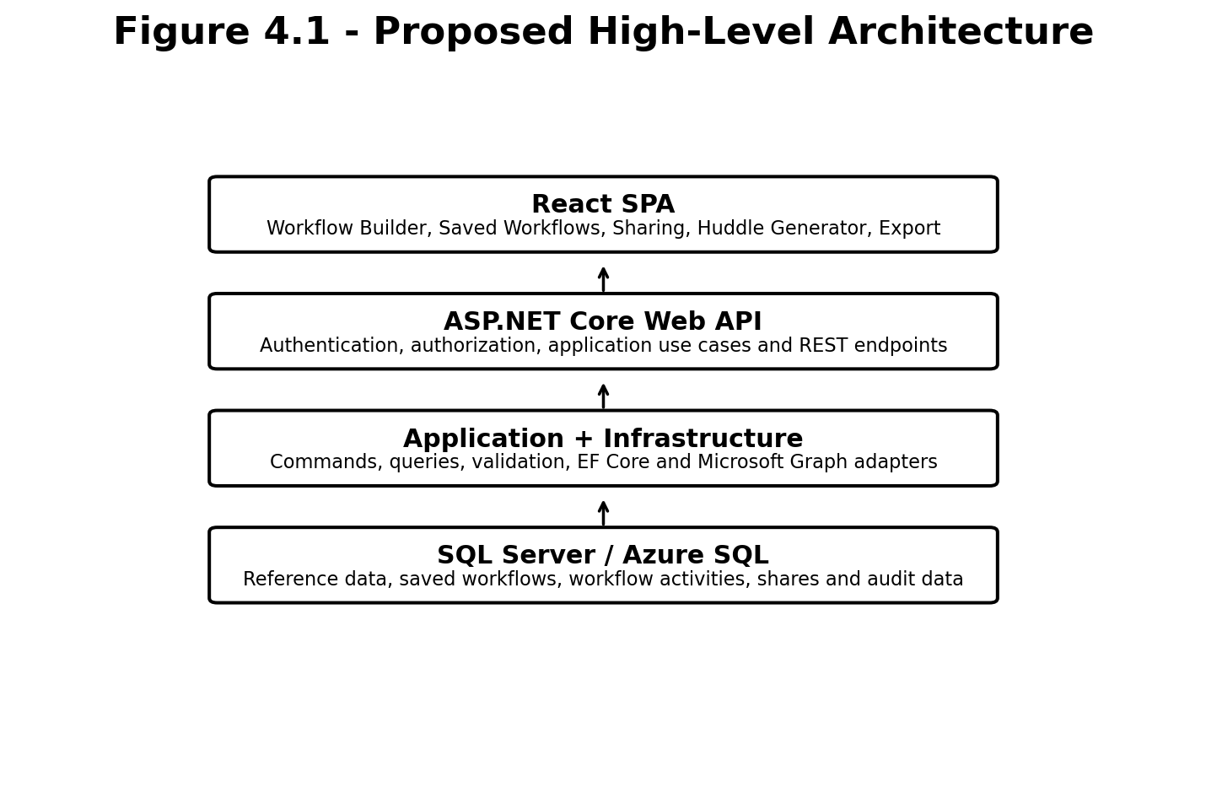
Figure 4.1 Proposed high-level runtime architecture

4.1 Runtime Responsibilities
Layer | Responsibilities | Must not contain
React SPA | Rendering, navigation, client validation, access-token acquisition, API consumption, cache management, temporary UI state and browser exports. | SQL credentials, SharePoint list IDs, ownership decisions or direct database logic.
ASP.NET Core API | REST delivery, token validation, authorization policies, request contracts, middleware, Swagger and HTTP response mapping. | Core business rules inside controllers or direct UI-specific behavior.
Application | Commands, queries, handlers, validators, mapping, interfaces and use-case orchestration. | EF Core implementation details, SQL statements, HTTP controllers or Azure SDK calls.
Domain | Entities, value concepts, enums and domain rules. | Framework dependencies, persistence or network technology.
Infrastructure | EF Core, SQL access, Microsoft Graph, current-user implementation, telemetry adapters and external service integrations. | Presentation logic.
SQL Database | Reference data, workflow ownership, selected activities, sharing records and audit data. | UI state or presentation layout configuration that does not require persistence.

4.2 Communication Protocols
The browser communicates with the API through HTTPS and JSON. Every protected request carries a bearer access token issued by Microsoft Entra ID for the backend API audience. The backend communicates with SQL through EF Core and with Microsoft Graph through an infrastructure adapter. No database connection string or Graph storage implementation is exposed to React.

4.3 Deployment Independence
Frontend and backend are versioned and deployed independently. The frontend is configured with the backend base URL and API scope. The backend is configured with allowed origins, Entra values, database connectivity and external-service options. Independent deployment allows API fixes, database migrations and UI updates to be released through separate pipelines while preserving explicit compatibility through API contracts.

5. Clean Architecture Design
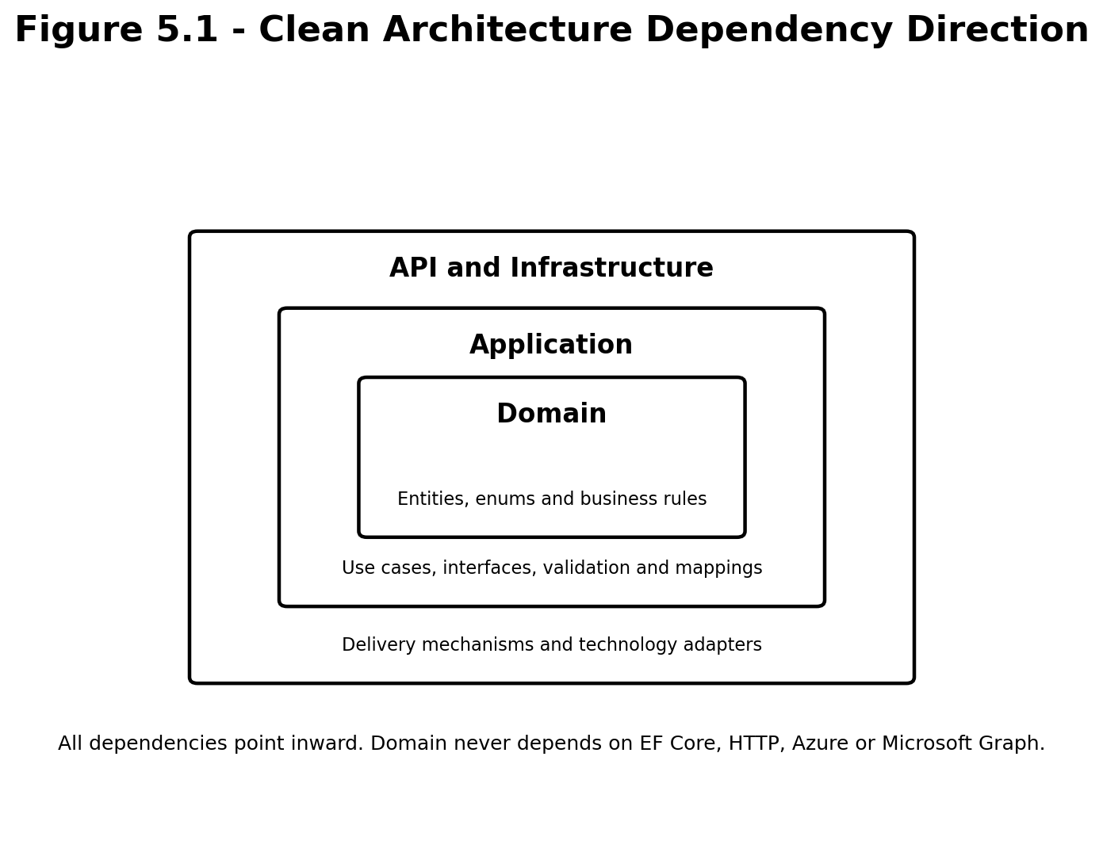
Figure 5.1 Clean Architecture dependency direction

5.1 Solution Projects
Project | Primary contents | References
AitoWorkflowGenerator.Domain | Entities, enums, domain exceptions and invariant-related behavior. | No project references.
AitoWorkflowGenerator.Application | Use cases, commands, queries, handlers, validators, mappings and abstraction interfaces. | Domain.
AitoWorkflowGenerator.Infrastructure | ApplicationDbContext, EF configurations, migrations, Microsoft Graph and external-service implementations. | Application and Domain.
AitoWorkflowGenerator.Contracts | HTTP request and response DTOs shared at the delivery boundary. | Should remain lightweight and independent of EF entities.
AitoWorkflowGenerator.Api | Controllers, authentication, authorization, middleware, dependency registration and OpenAPI. | Application, Infrastructure and Contracts.
UnitTests | Fast tests for handlers, domain rules, validators and mappings. | Application and Domain.
IntegrationTests | API and persistence tests against the composed application. | Api and Infrastructure.

5.2 Dependency Rules
- Domain does not reference EF Core, ASP.NET Core, Azure SDKs, Microsoft Graph or any infrastructure package.
- Application depends on Domain and expresses required external behavior through interfaces such as IApplicationDbContext, ICurrentUserService and IPeopleDirectoryService.
- Infrastructure implements Application interfaces and contains all technology-specific code.
- API translates HTTP requests into application commands and queries and translates results into HTTP responses.
- Controllers never query ApplicationDbContext directly and never return tracked EF entities.
- Contracts contain only externally meaningful request and response shapes.
- Frontend code depends on API contracts conceptually, not on database tables or SharePoint field names.

5.3 Feature Slice Organization
Within the Application project, code is organized by business feature rather than by a global collection of commands and handlers. For example, the Workflows feature contains SaveWorkflow, UpdateWorkflow, DeleteWorkflow, ToggleFavorite, GetMyWorkflows and GetWorkflowById folders. Each folder contains the request object, handler, validator and mapping required by that use case. This keeps related implementation close together and makes parallel development easier.

5.4 Transaction Boundaries
Use cases that create or update multiple relational records must execute within one database transaction. Saving a workflow creates the workflow record and its selected activity records as one logical operation. Sharing creates one share record only after ownership, recipient and uniqueness checks pass. Deleting a workflow must apply the configured cascade behavior to selected activities and shares without leaving orphan records.

6. Frontend Architecture

6.1 Frontend Responsibilities
The frontend remains responsible for presentation and interaction. It does not decide whether a user owns a workflow, whether a workflow may be shared or whether a recipient is authorized to view it. Those decisions are always repeated and enforced in the backend. Client-side validation improves usability but is not considered a security boundary.

6.2 Proposed Folder Structure
src/
app/ application bootstrap, router, providers and query client
auth/ MSAL configuration, protected routes and token helpers
api/ shared HTTP client, error model and endpoint constants
features/
workflow-builder/ role, activities, filters, selection and summary
saved-workflows/ history, save, update, favorite, delete and restore
workflow-sharing/ share dialogs, shared views and revoke
people/ directory search and recipient models
huddle/ required/other huddles, previews, scenarios and exports
components/ cross-feature layout and feedback components
hooks/ reusable non-feature-specific hooks
lib/ library wrappers and shared configuration
types/ truly cross-feature TypeScript types
utils/ pure utility functions
assets/ logos, icons and images
styles/ global styling and design tokens

6.3 Application Bootstrap
File | Responsibility
src/main.tsx | Creates the React root and delegates provider composition.
src/app/providers.tsx | Composes MSAL, React Query, router and global error boundaries.
src/app/router.tsx | Defines public and protected routes and page-level lazy loading.
src/app/queryClient.ts | Defines caching, retry, stale-time and mutation defaults.
src/api/apiClient.ts | Adds the API base URL, bearer token, JSON handling and standardized error conversion.
src/api/apiError.ts | Represents validation, unauthorized, forbidden, not-found, conflict and server errors consistently.

6.4 Data Fetching and Cache Strategy
React Query is the source of truth for server data. Roles, AI tools, workflow buckets, activities, saved workflows, shared workflows and people-search results are loaded through feature-specific query hooks. Query keys must be stable and include all filter values. Mutations invalidate or update only the affected cache entries. Reference data may use longer stale times because it changes infrequently, whereas workflow history is refreshed after save, update, favorite, delete or share operations.
Temporary selections such as the active role, selected activities, active filters, current workflow step, selected audience and MCEM stages remain client state. Existing Jotai atoms may continue to manage this state, but they must not duplicate authoritative server records. Derived values such as total duration should be calculated from selected activity data rather than persisted separately in the browser.

6.5 API Layer
Each feature owns small API functions such as getActivities, saveWorkflow, toggleFavorite and shareWorkflow. These functions contain endpoint paths and contract mapping but no component behavior. Hooks wrap the functions and expose loading, success and error states. Components consume hooks and remain focused on rendering and user interaction.

6.6 Workflow Builder
The Workflow Builder preserves role selection, role mapping, activity filtering, bucket grouping, activity cards, tool badges, prompts, business outcome content, activity selection, selected-workflow summary and total duration. Reference data is requested from the backend. Selection remains local until the user saves a workflow. Existing components should be moved gradually into the feature folder and modified only where SharePoint-specific data mapping or service calls currently exist.

6.7 Saved Workflows and History
Saved-workflow pages use API queries for the current user. Save, Save As, update, favorite and delete actions use mutations. The workflow ID returned by the backend is the persistent identity. Opening a saved workflow restores the role and activity identifiers into the Workflow Builder state. Duplicate-name conflicts are represented as HTTP 409 responses and displayed through the existing dialogs without storing fallback copies in localStorage.

6.8 Workflow Sharing and People Search
The sharing feature combines a debounced people-search query with backend sharing mutations. Search results contain object ID, display name and email. The user selects a recipient, adds an optional message and submits the share. Shared With Me and Shared By Me are independent queries. Revoking a share invalidates both relevant lists. The frontend never determines authorization from displayed owner values; it handles forbidden responses from the API.

6.9 Huddle Generator
The Huddle Generator remains a presentation-rich feature. Required huddles, Other Huddles, audience selection, primary and secondary tools, jobs-to-be-done context, scenarios, prompts, dependencies, MCEM stages and the Overview, AI Tools, Activities and Reflection preview tabs are retained. Business data that must be centrally managed or shared is loaded from the API. Pure layout definitions and export styling remain in the frontend.

6.10 Export Architecture
PowerPoint and HTML generation use dedicated presentation models. UI components map their current state into a serializable export model containing workflow name, role, audience, MCEM stages, activities, tools, scenarios, prompts and reflection content. Export functions do not call APIs or read global state directly. This keeps exports testable and prevents layout logic from leaking into page components. HTML generation must escape or sanitize user-entered content and must never include access tokens or runtime configuration.

6.11 Frontend Error and Feedback Model
Condition | Expected UI response
Initial query loading | Show a meaningful loading state without removing the surrounding page context.
Empty data | Show an empty state that explains what the user can do next.
401 Unauthorized | Trigger token renewal or sign-in flow.
403 Forbidden | Explain that the user does not have access; do not retry automatically.
404 Not Found | Show that the workflow or share no longer exists.
409 Conflict | Display duplicate workflow name or duplicate sharing guidance.
Unexpected API error | Show a stable error message and include a correlation ID when available.

7. Backend Architecture

7.1 API Layer
The API project is the composition root and HTTP boundary. Program.cs registers authentication, authorization, CORS, Swagger, application services, infrastructure services, middleware, health checks and telemetry. Controllers are thin. They validate route and basic model-binding concerns, dispatch application commands or queries and return standard responses. API controllers do not contain business calculations, SQL queries or Microsoft Graph calls.

7.2 Application Layer
The Application project contains the system use cases. Commands change state; queries return data without changing state. Handlers orchestrate domain entities and application abstractions. Validators reject invalid names, missing identifiers, empty activity selections, unsupported filters and malformed requests. Mapping code projects domain or EF query results into response models while avoiding accidental exposure of persistence details.
Feature | Commands | Queries
Reference Data | Administrative commands may be added later. | GetRoles, GetAiTools, GetWorkflowBuckets, GetActivities, GetActivityById.
Workflows | SaveWorkflow, UpdateWorkflow, DeleteWorkflow, ToggleFavorite. | GetMyWorkflows, GetWorkflowById, GetFavoriteWorkflows.
Workflow Shares | ShareWorkflow, RevokeWorkflowShare. | GetSharedWithMe, GetSharedByMe.
People | None in the initial release. | SearchPeople.
Huddles | Only if centrally managed huddle definitions are introduced. | Queries may reuse roles, activities, tools and workflow data.

7.3 Domain Layer
Domain entities represent persistent business concepts rather than database rows alone. UserWorkflow owns its selected activities and identifies its owner through the Entra object ID. WorkflowShare represents permission granted to one recipient for one workflow. Activity belongs to one role and one workflow bucket and has many AI tools through the mapping entity. Domain behavior should enforce invariant-related rules where appropriate, while application handlers enforce use-case and authorization rules that require current-user or database information.

7.4 Infrastructure Layer
Infrastructure contains ApplicationDbContext, entity configurations, migrations, design-time context creation, seed services, current-user implementation, Microsoft Graph people search and any Azure integrations. It implements the interfaces defined by Application. EF configurations define explicit table names, keys, column lengths, indexes, relationships and delete behaviors. Query handlers may use IApplicationDbContext with projections; a generic repository is not required when it would only duplicate EF Core.

7.5 Contracts Layer
Contracts define the external shapes accepted and returned by the API. They are versionable and independent of EF entities. SaveWorkflowRequest contains the name, description, role external ID and selected activity external IDs. It never accepts owner object ID or audit timestamps. WorkflowResponse returns stable identifiers and display information required by the frontend. Separate summary responses prevent list endpoints from returning unnecessary detail.

7.6 Middleware Pipeline
- Correlation ID middleware accepts or generates a request identifier and includes it in logs and responses.
- Exception-handling middleware converts known application exceptions into stable Problem Details responses.
- HTTPS redirection and security headers are applied according to the deployment environment.
- Authentication validates the bearer token.
- Authorization applies endpoint or resource-level policies.
- Controllers dispatch application requests.
- Structured request telemetry is emitted without logging access tokens or sensitive request content.

7.7 Validation and Error Handling
Error category | HTTP status | Example
Validation failure | 400 Bad Request | Empty workflow name or no selected activities.
Authentication required | 401 Unauthorized | Missing or invalid access token.
Authorization failure | 403 Forbidden | A non-owner attempts to update or revoke.
Resource missing | 404 Not Found | Workflow ID does not exist or is not visible to the user.
Conflict | 409 Conflict | Duplicate workflow name or active duplicate share.
Unexpected failure | 500 Internal Server Error | Unhandled database or external-service failure.

7.8 Current User Service
ICurrentUserService exposes the authenticated user object ID, email, display name and roles. The object ID claim is the authoritative identity used for workflow ownership, favorites, shares and recipient matching. Email and display name are stored as useful snapshots for display and audit purposes but are not used as the primary security key because they may change.

7.9 Logging and Observability
All logs use structured properties such as CorrelationId, UserObjectId, WorkflowId, ShareId, Endpoint and Outcome. Personal information is minimized. Access tokens, SQL connection strings, authorization headers and exported document content are never logged. Application Insights receives request telemetry, dependency telemetry and exceptions in Azure. Health checks distinguish API liveness from readiness and database connectivity.

8. Database Architecture

8.1 Database Role
SQL Server is the local development database and Azure SQL is the deployed relational database. Entity Framework Core migrations are the authoritative schema history. SSMS is used to inspect and query local data, not to manually maintain production schema. The database stores reference data and user-generated workflow data. It does not store temporary filters, selected preview tabs or export layout configuration.

8.2 Core Tables
Table | Purpose | Important relationships
Roles | Defines supported seller or manager roles and descriptive metadata. | One role has many activities and many user workflows.
AiTools | Defines available AI tools, display descriptions and presentation metadata. | Many-to-many with activities through ActivityAiTools.
WorkflowBuckets | Groups activities into workflow stages or categories. | One bucket has many activities.
Activities | Stores the activity catalog, prompts, outcome and classification data. | Belongs to a role and bucket; maps to many AI tools.
ActivityAiTools | Join table between activities and AI tools. | Composite uniqueness on ActivityId and AiToolId.
UserWorkflows | Stores a named workflow owned by one Entra user. | Has many selected activities and workflow shares.
UserWorkflowActivities | Stores one selected activity and ordering information for a workflow. | Belongs to a workflow and references an activity.
WorkflowShares | Grants one recipient access to one workflow. | Belongs to UserWorkflow; unique active share per recipient.

8.3 Key Design Decisions
- Relationships are normalized rather than stored as JSON arrays.
- External business identifiers may be retained for migration compatibility, while relational primary keys remain internal.
- User ownership uses Entra object ID; email is a display snapshot.
- CreatedAtUtc and UpdatedAtUtc use UTC values.
- Frequently filtered columns such as OwnerObjectId, RecipientObjectId, RoleId and WorkflowBucketId receive indexes.
- Delete behaviors are explicit. Deleting a workflow removes selected-activity and share rows; deleting reference data that is in use is restricted.
- A concurrency token may be used on UserWorkflows to prevent lost updates when multiple clients edit the same record.

8.4 Conceptual Relationships
Role has many Activities. WorkflowBucket has many Activities. Activity and AiTool form a many-to-many relationship through ActivityAiTools. UserWorkflow belongs to one owner and one selected role. UserWorkflow and Activity form a many-to-many relationship through UserWorkflowActivities, which may also retain selection order. UserWorkflow has many WorkflowShares. Each WorkflowShare identifies one recipient and optional sharing message.

8.5 Migration and Seed Strategy
The initial migration creates all core tables, relationships, indexes and audit columns. Reference data may be seeded from controlled JSON files or imported from validated SharePoint exports. Production deployment uses reviewed idempotent migration scripts. Application startup must not automatically apply destructive production migrations. Import routines generate reconciliation reports that compare source rows, imported rows, skipped rows, duplicates and unresolved relationships.

8.6 Data Retention and Auditing
The initial audit model records creation and last update timestamps. Workflow owner and share recipient snapshots support operational troubleshooting. If formal compliance requirements later demand full change history, the architecture can add an audit table or SQL temporal tables without changing frontend contracts. Soft deletion is not required by default; it should be introduced only if product or compliance requirements require recovery or historical retention.

9. Authentication and Authorization
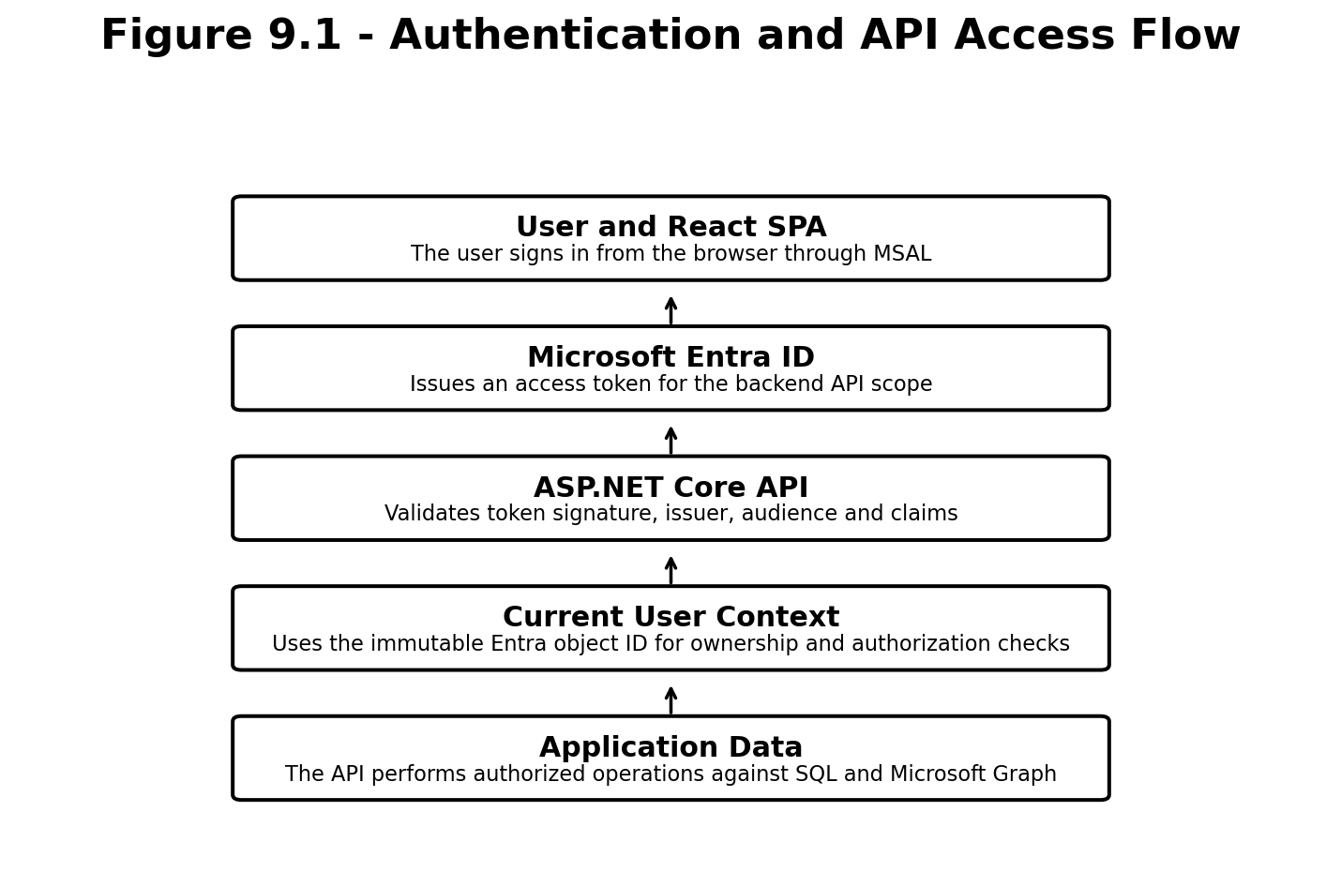
Figure 9.1 Authentication and protected API flow

9.1 App Registrations
Use separate Microsoft Entra app registrations for the React SPA and backend Web API. The SPA registration contains approved redirect URIs and requests the delegated API scope exposed by the backend registration. The backend validates tokens for its own audience. Graph permissions required for people search are implemented according to the tenant-approved delegated or on-behalf-of approach and are not used to provide direct SharePoint data access from React.

9.2 Authentication Flow
- The user opens the React application and initiates sign-in.
- MSAL redirects or opens the Microsoft Entra sign-in experience.
- After successful authentication, React acquires an access token for the backend API scope.
- The shared API client adds the token as a bearer token.
- The backend validates issuer, audience, lifetime and signature.
- Claims are exposed through ICurrentUserService for application authorization decisions.

9.3 Authorization Rules
Operation | Required rule
Read reference data | Authenticated user unless the organization approves anonymous access.
Create workflow | Authenticated user; owner is always derived from the token.
Update/delete/favorite workflow | Current user must be the workflow owner.
Share/revoke share | Current user must own the workflow.
Read Shared With Me | Current user object ID must match the share recipient object ID.
Read Shared By Me | Current user must own the underlying workflow.
Open a shared workflow | User must be the owner or have an active share.
Search people | Authenticated user and tenant-approved Graph permission.

9.4 Security Boundaries
Frontend route protection is a user-experience feature, not an authorization boundary. Every protected backend endpoint performs authorization independently. Request bodies are never trusted for owner identity. Database-level constraints reinforce uniqueness and relationships, but application authorization remains mandatory. Secrets are held in development user secrets or environment configuration locally and in Azure Key Vault or protected App Service settings in Azure.

10. Key Request Flows
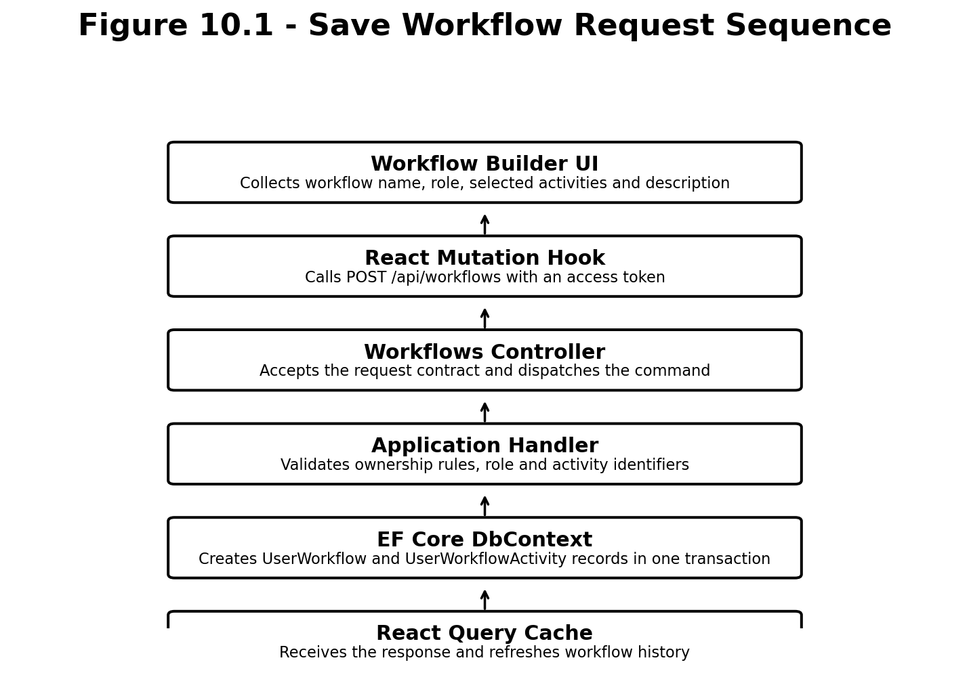
Figure 10.1 Save workflow request sequence

10.1 Save Workflow
The frontend validates that a role and at least one activity are selected. The backend validates the request again, resolves role and activities from authoritative reference data, checks duplicate-name rules for the current owner, calculates server-trusted values such as total duration if required, and saves the workflow and selected activities in one transaction. The response contains the persistent workflow ID and normalized activity information.
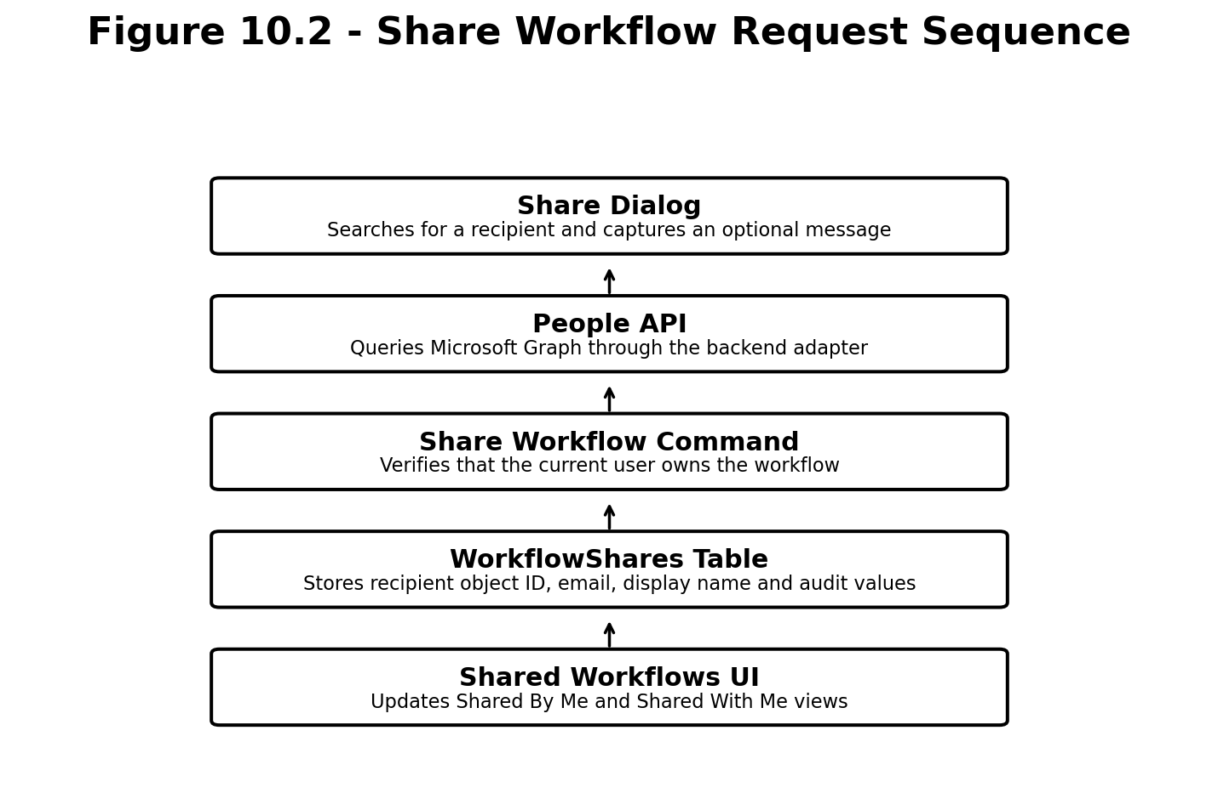
Figure 10.2 Share workflow request sequence

10.2 Share Workflow
People search returns tenant directory results through the backend. When the user submits a share, the backend confirms workflow ownership, prevents sharing to invalid recipients according to product rules, checks the unique workflow-recipient constraint and stores a share record. The recipient sees the workflow through Shared With Me; no duplicate copy of the underlying workflow is created.

10.3 Load Activities
React requests activities using role and optional filter parameters. The API validates filters and dispatches a query. EF Core projects only the fields required by the response, including AI-tool mappings. Read queries use no-tracking behavior. React Query caches the response using a query key that includes all filters, and the existing activity cards render the returned data.

10.4 Delete Workflow
The API first loads the workflow with the minimum fields required for authorization. If the current user is not the owner, the API returns a forbidden response without revealing unnecessary information. When authorized, deletion removes the workflow and related selected-activity and share rows according to the configured cascade behavior. React removes or invalidates the workflow from history and shared views.

11. Azure Deployment Architecture
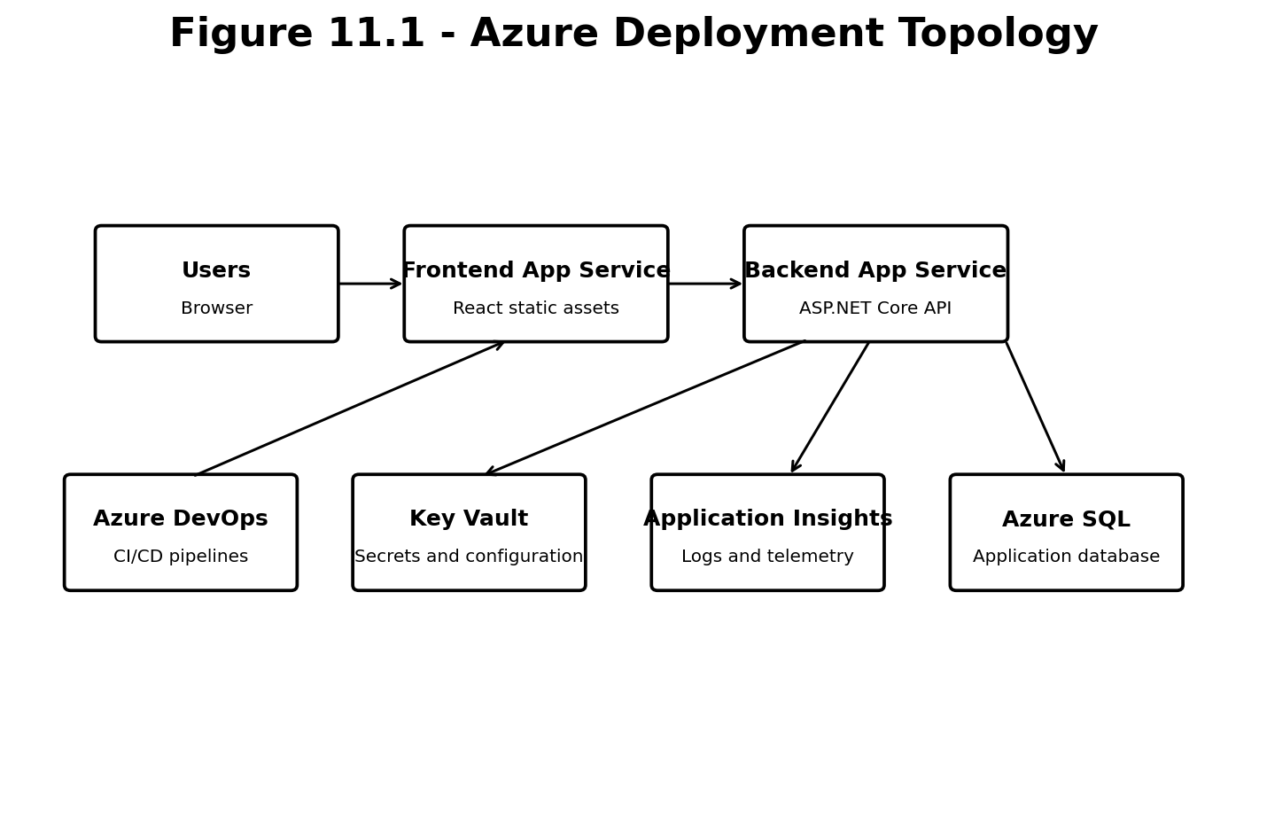
Figure 11.1 Azure deployment topology

11.1 Azure Resources
Resource | Purpose
Frontend App Service | Hosts the built React application and serves SPA routes and static assets.
Backend App Service | Hosts the ASP.NET Core API and uses managed identity where supported.
Azure SQL Database | Stores relational application data.
Application Insights | Captures requests, dependencies, exceptions, traces and availability signals.
Log Analytics Workspace | Supports centralized querying and operational dashboards.
Key Vault | Stores secrets or certificates that must not be placed in source control or plain configuration.
Microsoft Entra ID | Authenticates users and protects the API.
Azure DevOps | Builds, tests, packages and deploys frontend, backend and database changes.

11.2 Network and Access Model
The frontend calls only the approved API endpoint, potentially through the organization API Management route when direct App Service access is restricted. The API must correctly support CORS for approved origins. If private endpoints are used for the backend or Azure SQL, the hosting and API Management resources require the corresponding network integration. Azure SQL access should use managed identity where organizational policy and platform configuration permit it.

11.3 CI/CD Separation
Frontend and backend pipelines are independent. The frontend pipeline installs dependencies, performs linting and type checking, runs tests, builds the Vite application and publishes a deployable artifact. The backend pipeline restores packages, builds, runs unit and integration tests, publishes the API and creates a deployment artifact. Database migrations are generated and reviewed as an idempotent script or controlled deployment step. Environment-specific configuration is injected during deployment rather than committed to source control.

11.4 Environment Configuration
Frontend setting | Backend setting
VITE_API_BASE_URL | ConnectionStrings__DefaultConnection
VITE_AZURE_CLIENT_ID | AzureAd__TenantId
VITE_AZURE_TENANT_ID | AzureAd__ClientId
VITE_API_SCOPE | AzureAd__Audience or exposed API identifier
VITE_REDIRECT_URI | Cors__AllowedOrigins
No SharePoint list variables | Microsoft Graph settings for people search

12. Cross-Cutting Architecture

12.1 Exception Handling
A single exception-handling middleware converts known application exceptions into standardized Problem Details responses and records unexpected failures with a correlation ID. Controllers do not duplicate try/catch blocks. Frontend error handling maps status and error code to feature-specific messages while retaining a generic fallback.

12.2 Validation
Validation exists at multiple appropriate levels. React validates immediate form usability. Application validators enforce request requirements. Domain entities protect local invariants. Database constraints guarantee relational integrity and uniqueness. These layers complement rather than replace one another.

12.3 Performance
- Use projections rather than loading full entity graphs for list endpoints.
- Use AsNoTracking for read-only EF queries.
- Apply server-side filtering and indexes to activity, owner and recipient queries.
- Cache infrequently changing reference data through React Query.
- Debounce people search and require a minimum search length.
- Avoid serializing large prompt or export models on endpoints that only require summaries.
- Measure with Application Insights before adding distributed caching or more complex infrastructure.

12.4 Testing Strategy
Test level | Coverage
Unit tests | Validators, mappings, domain methods and application handlers with mocked abstractions.
Integration tests | API authentication behavior, authorization, EF configurations, database constraints and complete request flows.
Frontend unit/component tests | Selection logic, derived duration, dialogs, filters and export mappers.
End-to-end tests | Sign-in, load activities, save workflow, restore, share, revoke and exports in a controlled environment.
Migration verification | Row counts, duplicate detection, relationship reconciliation and representative workflow comparison.

12.5 Accessibility and Usability
The architecture preserves semantic markup, keyboard access, focus management, accessible dialog behavior, clear loading states and error announcements. Exported HTML should remain navigable and should not rely solely on color to communicate meaning. Accessibility requirements are primarily implemented in the frontend, while stable API errors support understandable user messaging.

13. Migration and Incremental Delivery Strategy

13.1 Incremental Replacement
The application should not be rewritten in one release. Existing UI features continue to work while each SharePoint-backed data area is replaced by an API-backed equivalent. A feature is switched only after database, backend, frontend and regression verification are complete. This approach reduces risk and provides clear rollback points.

13.2 Recommended Sequence
- Create solution foundation and local frontend-to-health-endpoint communication.
- Create core SQL schema and EF migrations.
- Configure Microsoft Entra authentication for SPA and API.
- Move roles, AI tools, workflow buckets, activities and mappings to SQL-backed reference-data APIs.
- Connect the Workflow Builder to the new APIs and remove its SharePoint dependency.
- Implement SQL-backed workflow history and replace local or SharePoint persistence.
- Implement people search through the backend and then workflow sharing.
- Connect all Huddle Generator data dependencies to API-backed models while preserving UI behavior.
- Refactor PowerPoint and HTML exporters around clean presentation models.
- Import existing SharePoint data, reconcile results and disable SharePoint writes.
- Deploy frontend, API and Azure SQL, then perform production readiness validation.

13.3 Migration Data Mapping
Source concept | Target representation
SharePoint Role lookup/text | Roles row and Activity.RoleId foreign key.
Workflow Bucket value | WorkflowBuckets row and Activity.WorkflowBucketId.
ToolName mapping | AiTools row and ActivityAiTools join record.
ActivityIdsJson | One UserWorkflowActivity row per activity.
SharePoint person field | RecipientObjectId, RecipientEmail and RecipientDisplayName.
Choice values | Validated enum or normalized string values agreed before migration.

14. Architecture Decisions
Decision | Rationale | Consequence
Keep the React UI | The interface is already implemented and validated. | Migration focuses on data and service boundaries rather than visual rework.
Add a dedicated API | Centralizes security, business logic and persistence. | Requires API contracts, hosting and backend CI/CD.
Use SQL instead of SharePoint as system of record | Provides relational integrity, transactions, migrations and efficient querying. | Existing data must be transformed and reconciled.
Use Clean Architecture | Protects business use cases from frameworks and external services. | Introduces more projects and requires disciplined dependency rules.
Use Entra object ID for ownership | Object ID is stable and appropriate for authorization. | Email and display name are treated as snapshots only.
Keep exports in the browser initially | Existing export functionality works and avoids unnecessary server complexity. | Large or centrally stored exports may require a future server-side service.
Use backend Graph integration for people search | Hides directory implementation and permissions from feature code. | Requires approved Graph authentication flow in the API.

15. Risks and Mitigations
Risk | Impact | Mitigation
SharePoint source data contains inconsistent values | Imports may fail or produce incorrect relationships. | Run validation and reconciliation reports; maintain explicit mapping tables.
Role and activity mappings differ between Workflow and Huddle features | Existing behavior may regress. | Create a complete feature inventory and representative regression dataset before migration.
Graph permissions are not approved | People search and sharing recipient lookup may be blocked. | Confirm delegated/OBO approach early and provide a controlled fallback based on approved directory data.
Private network or APIM routing omits SPA assets/routes | Deployed application may show blank pages or routing failures. | Test /assets paths, favicon and client routes through the approved gateway.
Frontend and backend contracts drift during parallel development | Integration delays and runtime errors. | Version contracts, use OpenAPI and agree request/response examples before implementation.
Migration cutover permits writes to both systems | Data divergence occurs. | Define a short freeze/cutover window and disable SharePoint writes after verification.
Overengineering delays delivery | Implementation becomes complex without proven need. | Keep initial design focused; introduce caching, events or server export only after measured requirements.

16. Production Readiness Criteria
- All existing feature paths pass regression testing against representative data.
- No React service calls SharePoint for production functionality.
- API endpoints validate tokens and enforce ownership/sharing rules.
- Database migrations are reviewed, repeatable and applied through a controlled deployment process.
- Application Insights receives request, dependency and exception telemetry.
- CORS allows only approved origins.
- Secrets and connection values are not committed to source control.
- Managed identities and database permissions follow least privilege.
- Health endpoints distinguish liveness and database readiness.
- Backup, retention and restore expectations for Azure SQL are agreed.
- Operational runbooks cover common authentication, database, Graph and deployment failures.

17. Future Evolution
The architecture can evolve without changing the fundamental browser-to-API boundary. Potential additions include an admin module for reference data, workflow templates, notification services, richer audit history, usage analytics, reporting dashboards, server-side export storage, approval workflows and AI-generated workflow recommendations. Event-driven processing or Azure Service Bus should be introduced only when asynchronous work, integration reliability or long-running operations create a clear requirement.

Appendix A - Complete Feature Regression Checklist
- ☐ Authentication and sign-out
- ☐ Protected routing
- ☐ Role selection
- ☐ Workflow bucket loading
- ☐ Activity loading
- ☐ Role-based activity filtering
- ☐ Category, priority, frequency and tool filtering
- ☐ Activity selection and deselection
- ☐ Total duration
- ☐ Selected workflow summary
- ☐ Beginner and advanced prompts
- ☐ AI tool badges and mappings
- ☐ Save workflow
- ☐ Save As
- ☐ Update workflow
- ☐ Delete workflow
- ☐ Favorite/unfavorite
- ☐ Workflow history
- ☐ Restore saved workflow
- ☐ People search
- ☐ Share workflow
- ☐ Shared With Me
- ☐ Shared By Me
- ☐ Revoke share
- ☐ Required huddles
- ☐ Other huddles
- ☐ Audience selection
- ☐ Primary and secondary tools
- ☐ Jobs-to-be-done context
- ☐ Scenarios and prompts
- ☐ Who is it for
- ☐ What is it
- ☐ Dependencies
- ☐ MCEM stages
- ☐ Overview preview
- ☐ AI Tools preview
- ☐ Activities preview
- ☐ Reflection preview
- ☐ Copy prompt
- ☐ Collapsible scenarios
- ☐ PowerPoint export
- ☐ HTML export
- ☐ Loading states
- ☐ Empty states
- ☐ Unauthorized and forbidden states
- ☐ Not-found and conflict states

Appendix B - Glossary
Term | Meaning
API | Application Programming Interface exposed by the ASP.NET Core backend.
CQRS | Separation of commands that change state from queries that read state.
DTO | Data Transfer Object used as an API request or response contract.
EF Core | Entity Framework Core, the object-relational mapper used by the backend.
Entra ID | Microsoft identity platform used for user sign-in and API protection.
MSAL | Microsoft Authentication Library used by the React SPA.
OBO | On-Behalf-Of flow used when an API calls another API for the signed-in user.
SPA | Single-page application executed in the browser.
System of record | The authoritative storage location for application data; Azure SQL in the target architecture.
Workflow share | A permission record that grants a recipient access to an owner’s saved workflow.

Appendix C - Proposed Repository Layout
AITO-Workflow-Generator/
backend/
AitoWorkflowGenerator.sln
src/
AitoWorkflowGenerator.Api/
AitoWorkflowGenerator.Application/
AitoWorkflowGenerator.Domain/
AitoWorkflowGenerator.Infrastructure/
AitoWorkflowGenerator.Contracts/
tests/
AitoWorkflowGenerator.UnitTests/
AitoWorkflowGenerator.IntegrationTests/
frontend/
src/
app/
auth/
api/
features/
components/
hooks/
lib/
types/
utils/
assets/
styles/
database/
diagrams/
deployment/
seed-data/
docs/
architecture/
postman/
scripts/
README.md

Appendix D - Architecture Review Sign-Off Checklist
- Frontend and backend responsibilities are approved.
- Clean Architecture project references are approved.
- Final feature inventory matches the existing application.
- SQL schema concepts and migration ownership are approved.
- Authentication app-registration approach is approved.
- People-search Graph permission approach is approved.
- Azure hosting and network route are approved.
- SharePoint is confirmed as migration-only after cutover.
- Production readiness criteria have named owners.

Appendix E - Initial API Endpoint Inventory
Area | Method and route | Purpose
Health | GET /api/health | Liveness and optional readiness status.
Roles | GET /api/roles | Return supported roles.
AI Tools | GET /api/ai-tools | Return AI tool reference data.
Workflow Buckets | GET /api/workflow-buckets | Return workflow bucket reference data.
Activities | GET /api/activities | Return filtered activity summaries.
Activities | GET /api/activities/{id} | Return activity details and AI-tool mappings.
Workflows | GET /api/workflows | Return workflows owned by the current user.
Workflows | GET /api/workflows/{id} | Return an owned or actively shared workflow.
Workflows | POST /api/workflows | Save a new workflow.
Workflows | PUT /api/workflows/{id} | Update an owned workflow.
Workflows | DELETE /api/workflows/{id} | Delete an owned workflow.
Workflows | PATCH /api/workflows/{id}/favorite | Toggle or set favorite state.
Shares | POST /api/workflows/{id}/shares | Share an owned workflow.
Shares | GET /api/workflow-shares/shared-with-me | Return workflows shared with the current user.
Shares | GET /api/workflow-shares/shared-by-me | Return shares created from owned workflows.
Shares | DELETE /api/workflow-shares/{shareId} | Revoke an owned workflow share.
People | GET /api/people?search={text} | Search the tenant directory through Microsoft Graph.

Appendix F - File and Component Ownership Guide
Area | Representative files | Ownership rule
Frontend bootstrap | main.tsx, app/providers.tsx, app/router.tsx | Global composition only; no feature business logic.
Frontend API | api/apiClient.ts and feature api functions | HTTP, token and contract mapping only.
Frontend features | workflow-builder, saved-workflows, workflow-sharing, huddle | Each feature owns its pages, hooks, components, types and API functions.
Backend API | Program.cs, Controllers, Middleware, Authorization | HTTP delivery and composition root.
Application | Features/*, Abstractions/*, Behaviors/* | Use cases and interfaces; no framework-specific persistence.
Domain | Entities, Enums, Exceptions | Core concepts and invariants.
Infrastructure | Persistence, Identity, MicrosoftGraph | Technology implementations.
Contracts | Requests and Responses | Stable external API shapes.
Database artifacts | Migrations, deployment scripts, seed data | Schema history and controlled environment deployment.
Architecture documentation | docs and architecture folders | Living decisions updated with relevant code changes.

Appendix G - Local and Azure Environment Model
Concern | Local development | Azure environments
Frontend host | Vite development server | Frontend App Service or approved static hosting route.
Backend host | Visual Studio/Kestrel | Backend App Service, optionally routed through API Management.
Database | SQL Server LocalDB or local SQL Server inspected through SSMS | Azure SQL Database.
Identity | Tenant app registrations with localhost redirect URI | Environment-specific redirect URIs and approved API scopes.
Secrets | User Secrets and ignored environment files | App Service settings and Key Vault.
Telemetry | Console and development logs | Application Insights and Log Analytics.
CORS | Explicit localhost origin | Explicit deployed frontend origins.
Database migration | Developer-generated EF migration applied to local database | Reviewed idempotent script or controlled pipeline step.
Graph access | Approved developer tenant permissions | Tenant-approved delegated/OBO or application access model.

The development environment must be easy to reproduce without requiring production credentials. A developer should be able to clone the repositories, configure documented local settings, create the database through migrations, load approved seed data, sign in through the development app registration and run both applications side by side.
Azure configuration must avoid build-time dependence on developer machines. Environment-specific values are provided through pipeline variables and service configuration. The production database identity is separate from the migration identity where practical, and the runtime identity receives only the permissions required for normal application behavior.

Appendix H - Part 1 Architecture Definition of Done
- ☐ The React-to-API-to-SQL target flow is approved.
- ☐ Frontend and backend are confirmed as independently buildable applications.
- ☐ The Clean Architecture solution projects and allowed project references are approved.
- ☐ Every existing application capability is represented in the feature regression checklist.
- ☐ The owner of every major responsibility is identified as frontend, backend, database or external platform.
- ☐ Microsoft Entra app-registration boundaries and the backend API scope are agreed.
- ☐ The use of Entra object ID for ownership and sharing authorization is agreed.
- ☐ SQL Server locally and Azure SQL in Azure are confirmed as the target system of record.
- ☐ SharePoint is confirmed as a temporary migration source and not a permanent runtime dependency.
- ☐ The initial API endpoint inventory is suitable for parallel frontend and backend planning.
- ☐ Core database tables and relationships are approved before EF migrations begin.
- ☐ PowerPoint and HTML exports are confirmed as client-side capabilities for the initial release.
- ☐ People search is confirmed as a backend-mediated Microsoft Graph integration.
- ☐ Azure hosting, API routing, CORS and telemetry responsibilities have identified owners.
- ☐ Architecture risks and mitigations have been reviewed with the technical lead.
- ☐ This document is stored in source control and will be updated through normal pull-request review.

