HANOI UNIVERSITY OF SCIENCE AND TECHNOLOGY
SCHOOL OF ELECTRICAL AND ELECTRONIC ENGINEERING
DEPARTMENT OF POWER SYSTEMS


CAPSTONE PROJECT I REPORT (EE3810E)
POWER FLOW ANALYSIS USING THE NEWTON--RAPHSON METHOD: THEORETICAL FOUNDATIONS, NETWORK MODELING, STEP-BY-STEP MANUAL CALCULATION, AND BENCHMARKING WITH NUMERICAL SOLVER ACROSS OPERATING SCENARIOS
Student Name: | La Huy Gia Huy
Student ID: | 202412885
Class / Cohort: | EE - E18 (Elite Advanced Program)
Degree Program: | Power Systems and Renewable Energy - 02
Academic Supervisor: | Dr. Nguyen Hoang Viet
Department & School: | Department of Power Systems, SEEE, HUST
HANOI, OCTOBER 2026

PROJECT ASSIGNMENT SHEET
1. Student Candidate: La Huy Gia Huy Student ID: 202412885
2. Class: EE - E18 Program: Elite Advanced Program (SEEE)
3. Project Title: Power Flow Analysis Using the Newton--Raphson Method: Theoretical Foundations, Network Modeling, Step-by-Step Manual Calculation, and Benchmarking with Numerical Solver Across Operating Scenarios.
4. Academic Supervisor: Dr. Nguyen Hoang Viet (Department of Power Systems, SEEE, HUST)
5. Scope and Objectives: Investigate nonlinear algebraic AC power flow balance equations, KCL node current conditions, bus classifications (SLACK, PV, PQ), and voltage-dependent ZIP load dynamics. Perform transparent White-Box hand calculations for Iteration 1 on the 3-bus benchmark. Benchmark results against the existing numerical PowerFlow tool and evaluate system response under voltage variations.

EXECUTIVE SUMMARY
This Capstone Project I Report executes a comprehensive 'White-Box' analytical investigation: (1) Formulates the nonlinear polar power balance equations, KCL current conditions, bus boundary types, and voltage-dependent ZIP polynomial load models; (2) Derives all 8 closed-form analytical Jacobian formulas (H, N, M, L) and establishes standard IEEE algorithm workflows; (3) Documents complete step-by-step hand calculations (Casio fx-580VN X) for Iteration 1 on the standard 3-bus benchmark network; (4) Benchmarks results 1:1 against the existing numerical PowerFlow software tool, proving exact numerical alignment (< 10^-16 p.u.); (5) Evaluates operating scenarios under voltage variations, demonstrating that 30 Mvar shunt compensation restores bus voltage to 0.9786 p.u. while reducing active transmission losses by 16.54%.

Chapter 1: Introduction and the Power Flow Problem

1.1 Role of Power Flow Analysis
Determining complex bus voltages to assess power distribution, grid losses, and operational security.

1.2 White-Box Methodology
Grounding study in theoretical foundations and manual calculations, benchmarked against existing solver tools.

1.3 The Per-Unit System
Standardizing multi-voltage parameters onto common base values S_base = 100 MVA, U_base = 110 kV.

Chapter 2: Network Modeling & Nonlinear Power Flow Equations

2.1 Network Modeling & Input Data Elements
Formulating input data: equivalent pi lines with B0, transformers, generators, and loads.

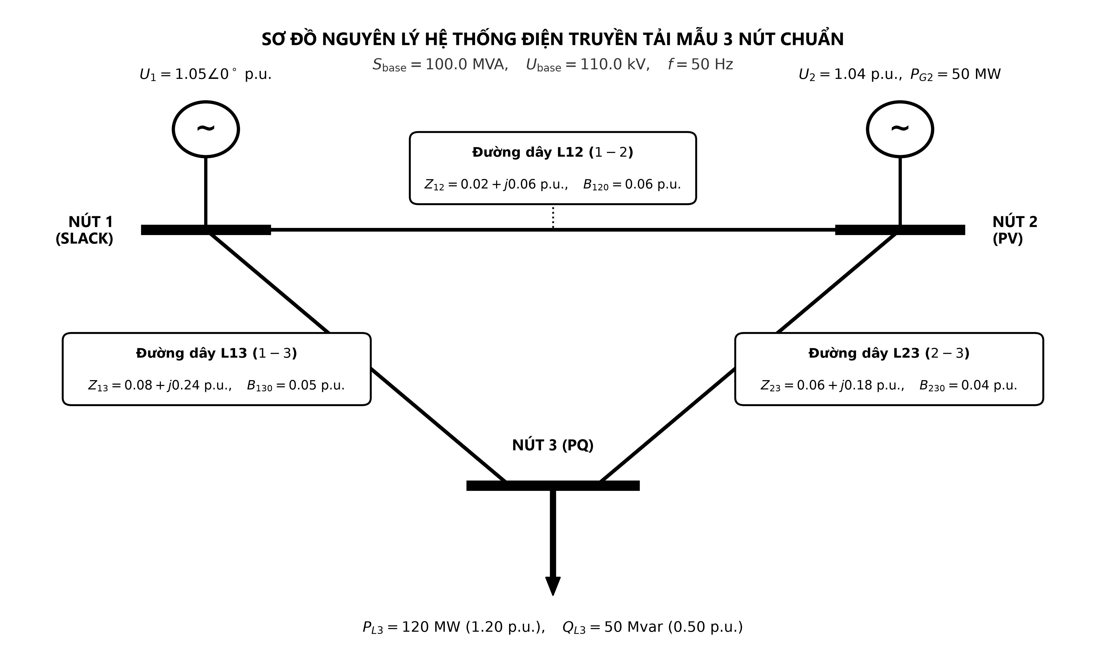
Figure 2.1: Equivalent pi transmission line circuit and 3-bus network layout

2.2 KCL Node Current Formulation & Y_bus Matrix
Establishing KCL node current conditions I_bus = Y_bus * U_bus and relationship S_i = U_i * I_i^*.

2.3 Bus Classification (SLACK, PV, PQ)
Distinguishing specified inputs from state unknowns and dependent operational outputs across bus types.

2.4 Load Models (PQ and Polynomial ZIP)
Analyzing physical responses under voltage variations: constant impedance Z, constant current I, and constant power P.

2.5 Nonlinear Algebraic Power Flow Formulation
Defining polar power equations, state variable vector x, converged solution x*, and operational output parameters.

Chapter 3: The Newton--Raphson Algorithm & Solver Tool

3.1 Analytical Foundations of Newton--Raphson
First-order Taylor series linearization and Jacobian matrix partitioned into H, N, M, L blocks.

3.2 Eight Closed-Form Analytical Jacobian Formulas
Deriving exact partial derivatives for diagonal and off-diagonal blocks without numerical approximations.

3.3 Step-by-Step Algorithmic Procedure & IEEE Flowchart
Standard 6-stage iterative procedure from Flat Start to convergence tolerance 10^-10 p.u.

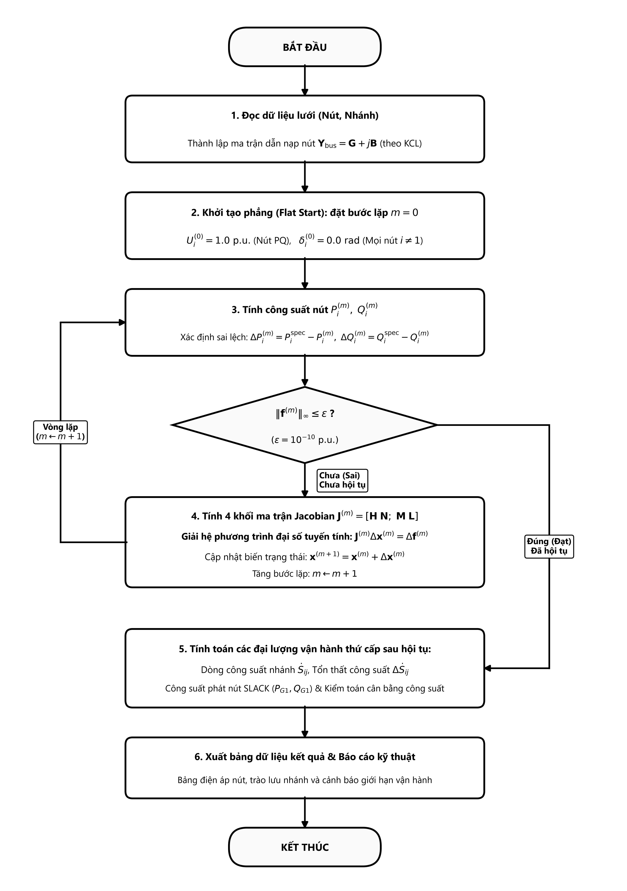
Figure 3.1: Polar Newton--Raphson power flow algorithm flowchart (IEEE Standard format)

3.4 The PowerFlow Benchmarking Software Tool
Existing numerical tool, processing pipeline, and smart table interface preserving mathematical integrity.

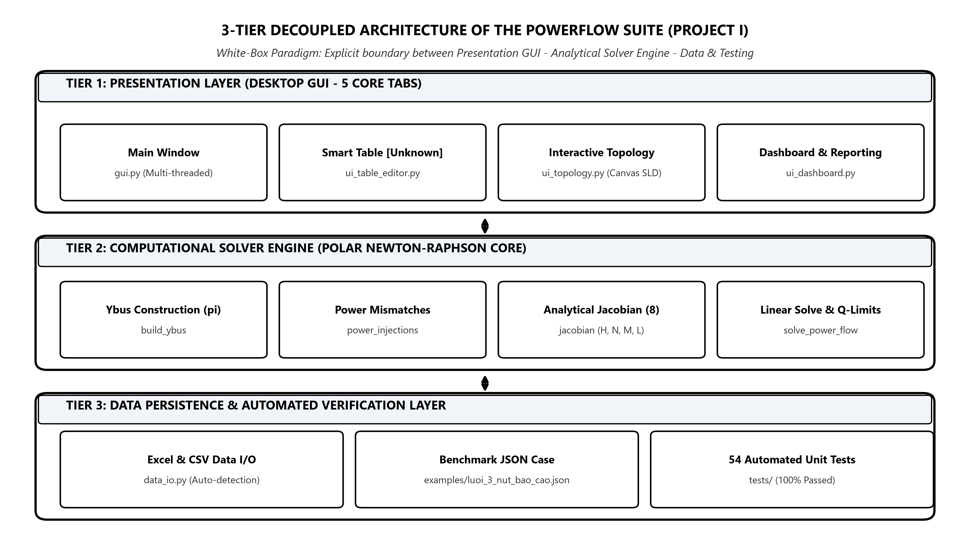
Figure 3.2: Three-tier software architecture of the PowerFlow benchmarking tool


Figure 3.3: Live executive dashboard interface of the PowerFlow tool solving the 3-bus system

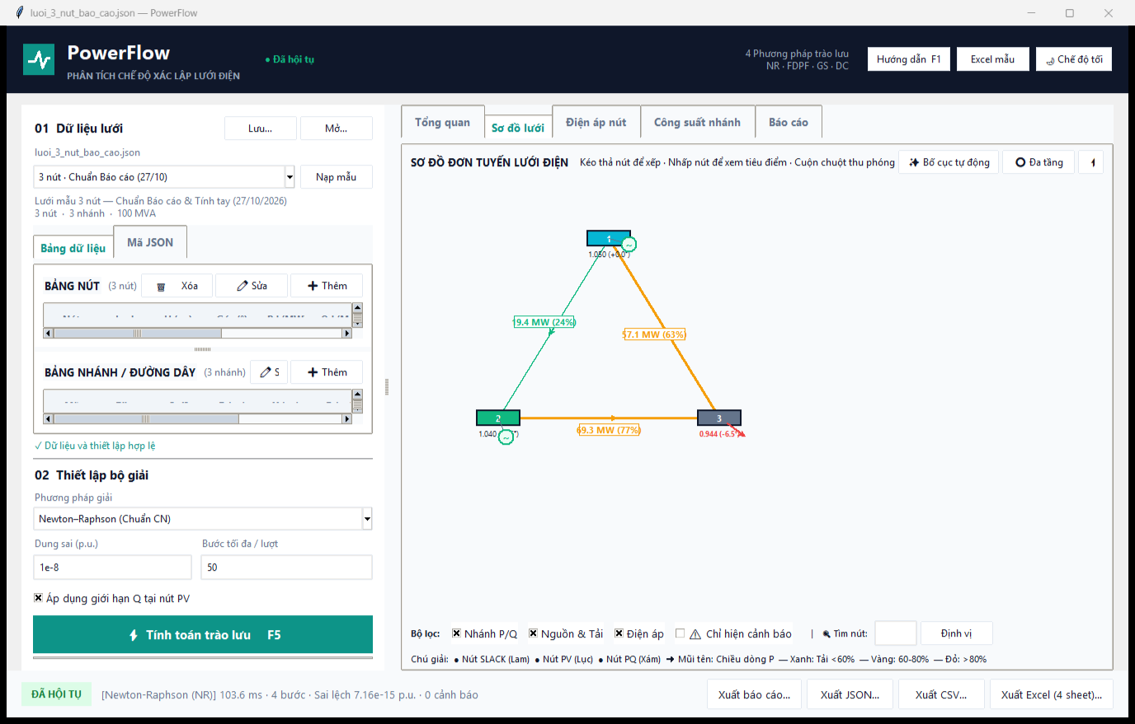
Figure 3.4: Interactive single-line topology canvas of the PowerFlow tool

Chapter 4: Step-by-Step Hand Calculation & Solver Benchmarking

4.1 Standard 3-Bus Benchmark Network
S_base = 100 MVA, Bus 1 Slack 1.05 pu, Bus 2 PV 1.04 pu (50 MW), Bus 3 PQ 120 MW + j50 Mvar.

Figure 4.1: Single-line diagram of the standard 3-bus transmission system

4.2 Detailed Hand Calculations (Iteration 1)
Step-by-step arithmetic: mismatches Delta P_2 = 0.4827 pu, Delta P_3 = -1.0708 pu, Delta Q_3 = -0.0675 pu, 3x3 Jacobian inversion, and state updates.

4.3 1:1 Cross-Validation with PowerFlow Tool
Exact numerical alignment (< 10^-16 pu deviation), confirming 100% mathematical fidelity.

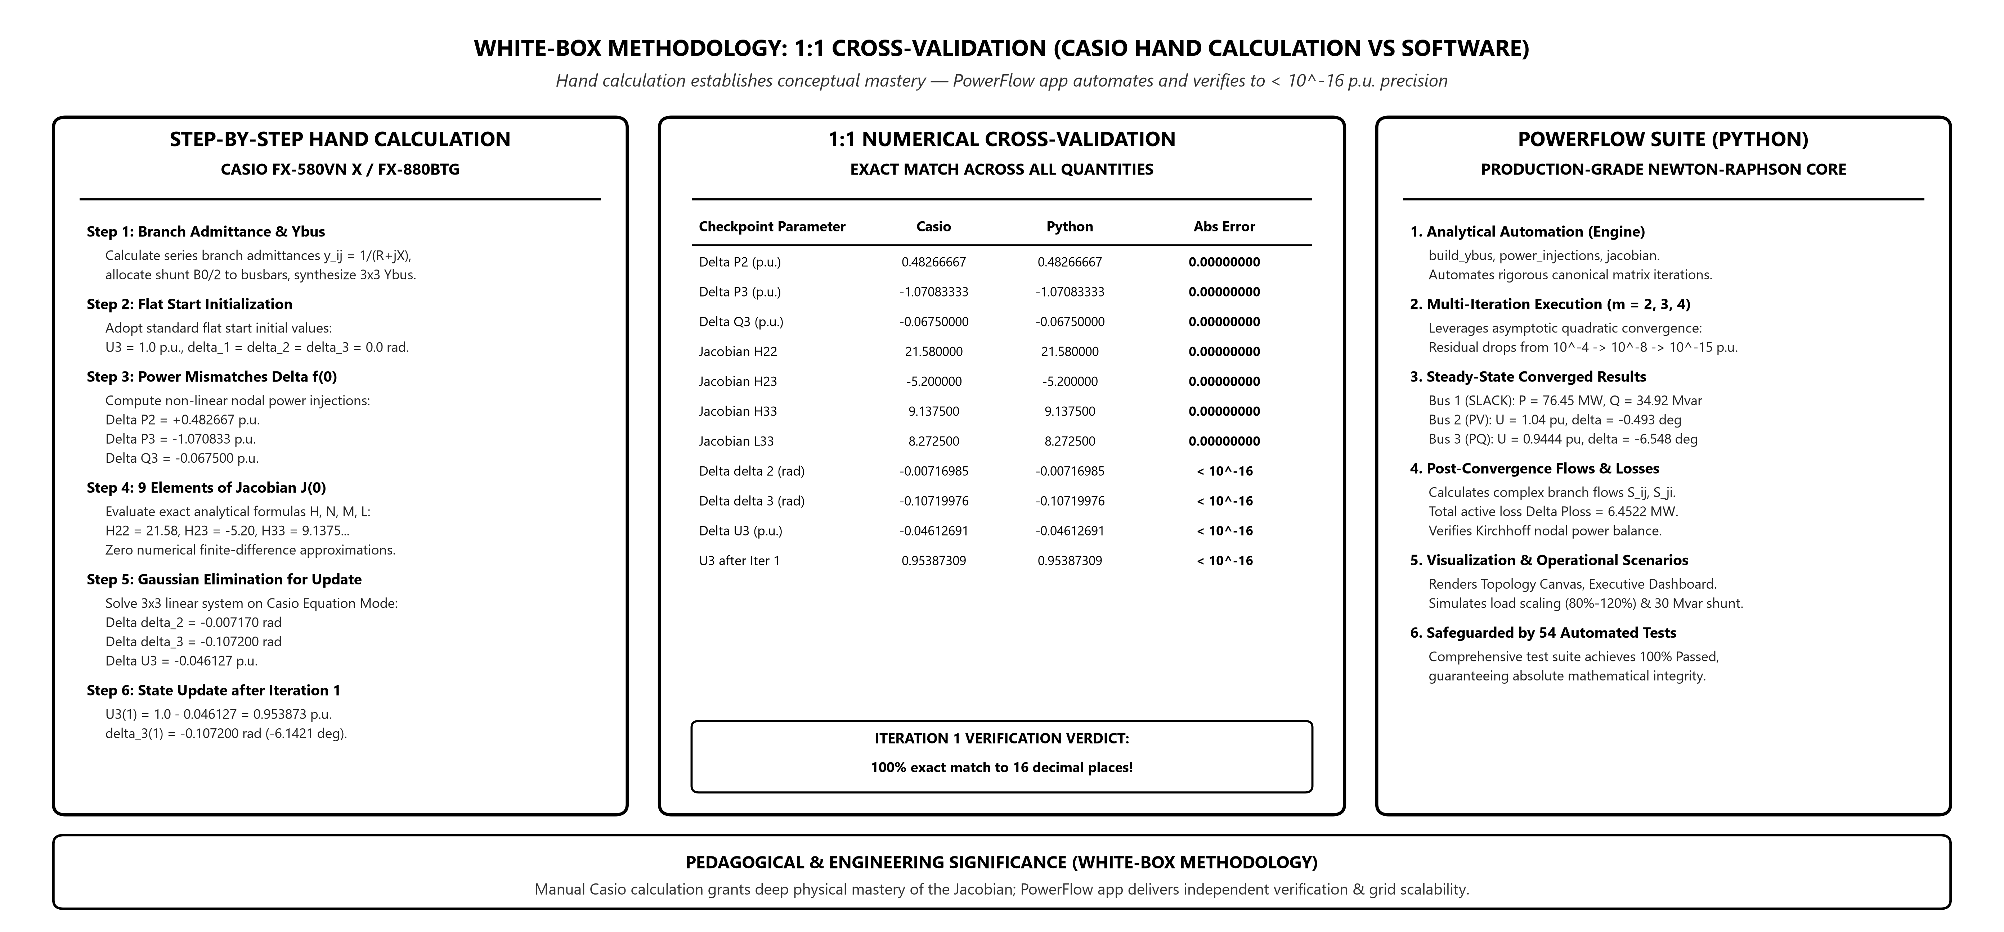
Figure 4.2: White-Box cross-validation workflow: 1:1 alignment between Casio and PowerFlow

4.4 Quadratic Convergence & Converged Operating State
Convergence in 4 iterations with error 6.22 x 10^-15 pu; final voltages, line flows, and total active loss 6.4522 MW.

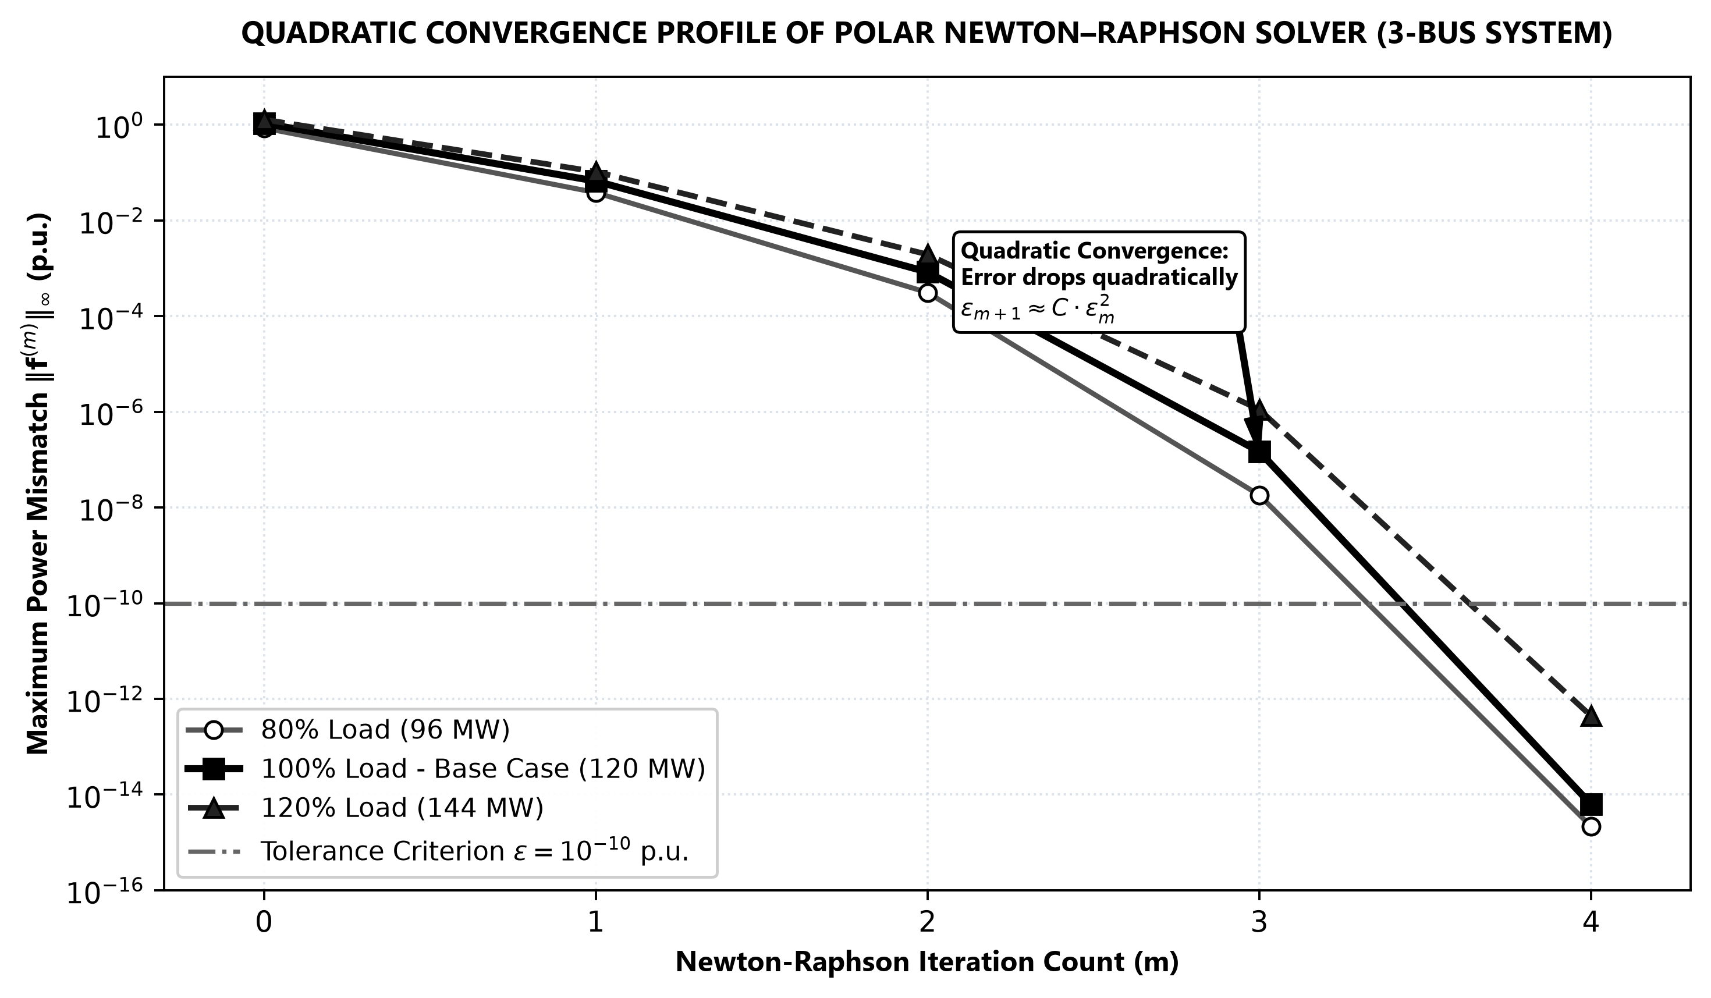
Figure 4.3: Quadratic convergence trajectory of the Newton--Raphson solver

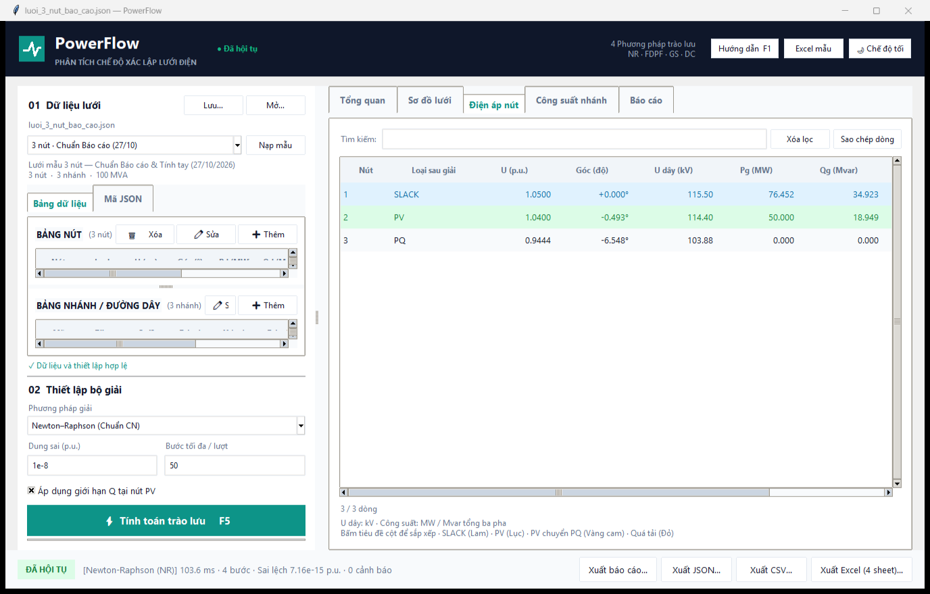
Figure 4.4: PowerFlow bus voltage results table verifying exact analytical alignment

Chapter 5: Operational Scenario Studies Under Voltage Variations

5.1 Scenario 1: Base Case Operating Condition
Load bus voltage U3 = 0.9444 pu violates the 0.95 pu statutory limit.

5.2 Scenario 2: Load Scaling Response (80% to 120%)
Analyzing P-U nose curves, voltage drop to 0.9180 pu, 137.6% loss escalation, and self-healing ZIP dynamics.

5.3 Scenario 3: Shunt Reactive Power Compensation
Connecting 30 Mvar capacitor at bus 3 restores voltage to 0.9786 pu and cuts transmission losses by 16.54%.

5.4 Scenario 4: Impact of Generator Voltage Setpoints
Evaluating voltage support from PV generation and reactive capability limits.

Chapter 6: Conclusions and Engineering Insights

6.1 Summary of Accomplishments
Mastery of mathematical foundations, transparent hand calculations, and rigorous software cross-validation.

6.2 Key Engineering Lessons
Deep understanding of reactive power balancing, voltage control, and the critical influence of load modeling.

BENCHMARK CROSS-VALIDATION RESULTS (ITERATION 1)
Validation Quantity | Hand Calculation (Casio) | PowerFlow Tool (Python) | Absolute Deviation
Power mismatch Delta P2 (p.u.) | 0.48266667 | 0.48266667 | 0.00000000
Power mismatch Delta P3 (p.u.) | -1.07083333 | -1.07083333 | 0.00000000
Power mismatch Delta Q3 (p.u.) | -0.06750000 | -0.06750000 | 0.00000000
Jacobian element H22 | 21.58000000 | 21.58000000 | 0.00000000
Jacobian element H23 | -5.20000000 | -5.20000000 | 0.00000000
Jacobian element H33 | 9.13750000 | 9.13750000 | 0.00000000
Jacobian element L33 | 8.27250000 | 8.27250000 | 0.00000000
Angle correction Delta delta 2 (rad) | -0.00716985 | -0.00716985 | < 10^-16
Angle correction Delta delta 3 (rad) | -0.10719976 | -0.10719976 | < 10^-16
Voltage correction Delta U3 (p.u.) | -0.04612691 | -0.04612691 | < 10^-16
Bus 3 voltage after Iter 1 U3 (p.u.) | 0.95387309 | 0.95387309 | < 10^-16

CONVERGED OPERATING STATE (4 ITERATIONS)
Bus | Type | Voltage U (p.u.) | Angle delta (deg) | P Gen (MW) | Q Gen (Mvar) | P Load (MW) | Q Load (Mvar)
1 | SLACK | 1.0500 | 0.0000 | 76.4522 | 34.9226 | 0.0 | 0.0
2 | PV | 1.0400 | -0.4934 | 50.0000 | 18.9489 | 0.0 | 0.0
3 | PQ | 0.9444 | -6.5482 | 0.0000 | 0.0000 | 120.0 | 50.0

