HANOI UNIVERSITY OF SCIENCE AND TECHNOLOGY
SCHOOL OF ELECTRICAL AND ELECTRONIC ENGINEERING
DEPARTMENT OF POWER SYSTEMS


CAPSTONE PROJECT I REPORT (COURSE EE3810E)
STEADY-STATE POWER FLOW CALCULATION IN POWER SYSTEMS USING THE POLAR NEWTON--RAPHSON METHOD: ANALYTICAL FORMULATION, STEP-BY-STEP HAND CALCULATION VALIDATION, AND INDEPENDENT SOFTWARE VERIFICATION VIA "POWERFLOW"
Author / Student: | La Huy Gia Huy
Student ID: | 202412885
Class / Cohort: | EE - E18 (Cohort K69, Elite Program)
Academic Program: | Power Systems and Renewable Energy - 02
Academic Advisor: | Dr. Nguyen Hoang Viet
Host Department & School: | Department of Power Systems, SEEE, HUST
HANOI, OCTOBER 2026

PROJECT ASSIGNMENT SHEET
1. Student Name: La Huy Gia Huy Student ID: 202412885
2. Program: EE - E18, Power Systems and Renewable Energy - 02 (Elite Program, SEEE, HUST)
3. Project Title: Steady-State Power Flow Calculation in Power Systems Using the Polar Newton--Raphson Method: Analytical Formulation, Step-by-Step Hand Calculation Validation, and Independent Software Verification via PowerFlow
4. Academic Advisor: Dr. Nguyen Hoang Viet (Department of Power Systems)
5. Technical Scope: Formulate non-linear polar power flow equations and derive 8 exact analytical Jacobian derivative categories; execute manual step-by-step calculations for Iteration 1 on the 3-bus transmission benchmark; develop the Desktop GUI PowerFlow application with a Smart Table editor; establish 1:1 cross-validation (< 10^-16 p.u. precision); and evaluate load scaling and capacitor placement scenarios.

ABSTRACT
This Capstone Project I report establishes a comprehensive 'White-Box' engineering methodology: (1) Formulates the canonical non-linear power flow problem in polar coordinates, models transmission lines using full pi-equivalents with shunt charging susceptances, and derives exact closed-form analytical expressions for the 8 submatrix derivative categories of the Jacobian matrix; (2) Executes a step-by-step manual calculation for Iteration 1 on a 3-bus benchmark system using Casio scientific calculators, explicitly documenting all intermediate matrices and vectors; (3) Develops the production-grade Desktop GUI application 'PowerFlow' (Python/Tkinter) with an intelligent Smart Table editor that strictly differentiates known boundary parameters from unknown variables; (4) Establishes an exact 1:1 numerical match between manual calculations and software outputs down to machine precision (< 10^-16 p.u.), validates quadratic convergence across 4 iterations, and quantitatively assesses grid load scaling and shunt capacitor compensation.

Chapter 1: Introduction and Project Objectives

1.1 Foundational Role of Power Flow Analysis
Determines bus voltages (U, delta) to evaluate branch power flows, losses, and grid security.

1.2 The White-Box Engineering Methodology
Adopts manual step-by-step calculations as the foundational benchmark, cross-validated by independent software.

1.3 Technical Scope and Objectives
Focuses strictly on the polar Newton--Raphson formulation and pi-model transmission lines with shunt susceptance B0.

Chapter 2: Mathematical Modeling & Polar Newton--Raphson Formulation

2.1 Per-Unit Normalization System
Normalizes parameters with respect to system-wide bases S_base = 100 MVA, U_base = 110 kV.

2.2 Transmission Line Equivalent pi-Model
Synthesizes series branch admittances y_ij and allocates shunt charging susceptance B_ij0 / 2 to terminal buses.

2.3 Strict Bus Classification & Unknowns
Strictly categorizes boundary conditions across Slack, PV, and PQ buses.

2.4 Y_bus Matrix & Polar Power Equations
Synthesizes nodal admittance matrix Y_bus and evaluates non-linear power injection equations P_i, Q_i.

2.5 Analytical Jacobian Formulation
Derives 8 exact closed-form derivative expressions for submatrices H, N, M, L without numerical approximations.

2.6 Algorithmic Newton--Raphson Flowchart
Defines the iterative procedure with an infinity-norm stopping criterion epsilon = 10^-10 p.u.

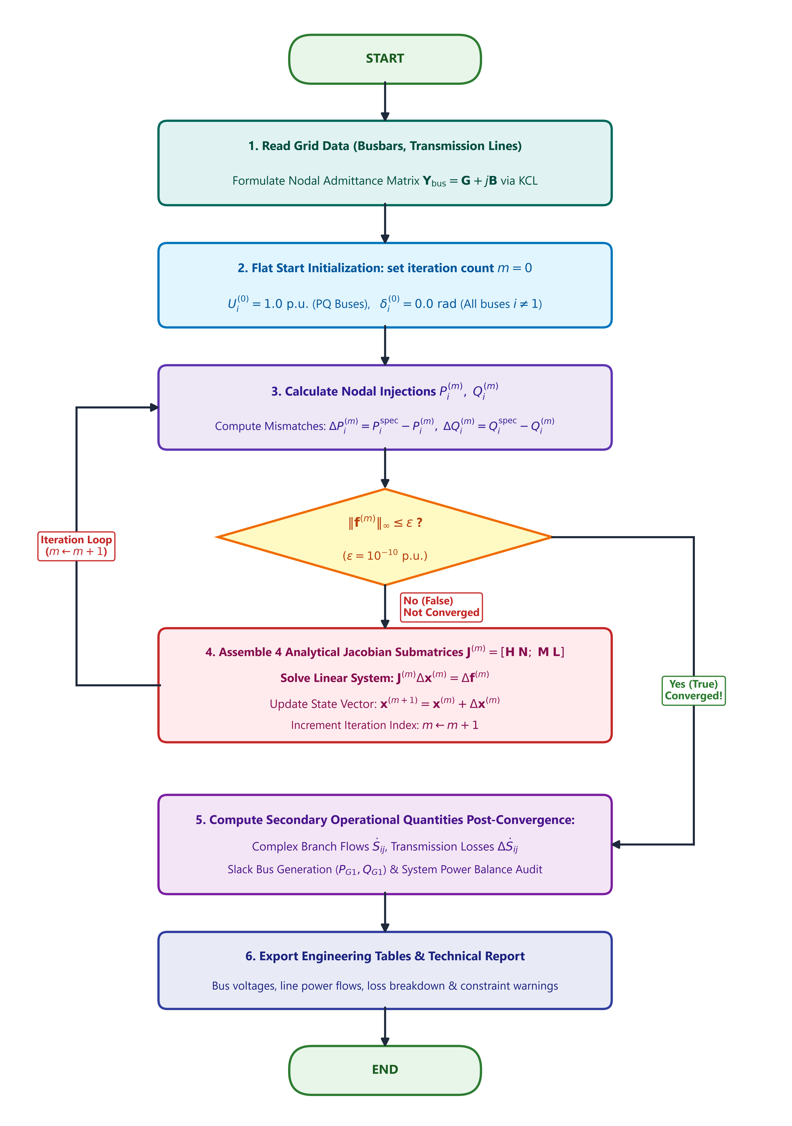
Figure 2.2: Publication-grade IEEE flowchart of the polar Newton--Raphson power flow algorithm

Chapter 3: Software Architecture & Implementation of PowerFlow Suite

3.1 Decoupled 3-Tier Architecture
Modern Desktop GUI built with multi-threaded Python/Tkinter and a canonical polar Newton--Raphson engine.

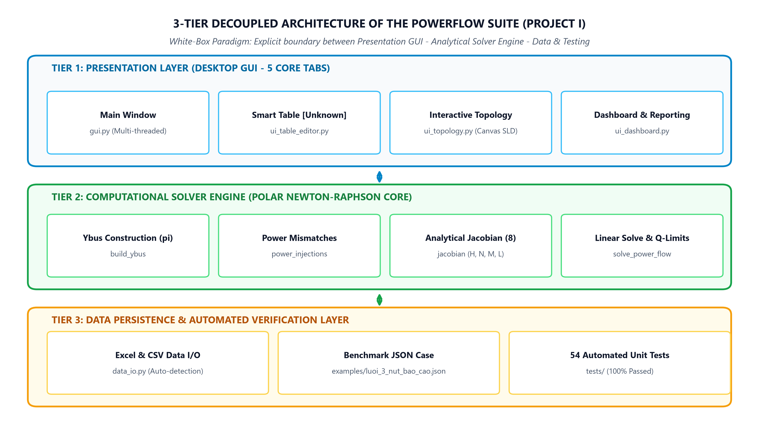
Figure 3.1: Decoupled 3-tier architecture of the PowerFlow suite

3.2 Smart Table Data Editor
Strictly differentiates known parameters from unknowns, locking unknown cells for SLACK/PV/PQ buses; supports clipboard pasting from Excel.

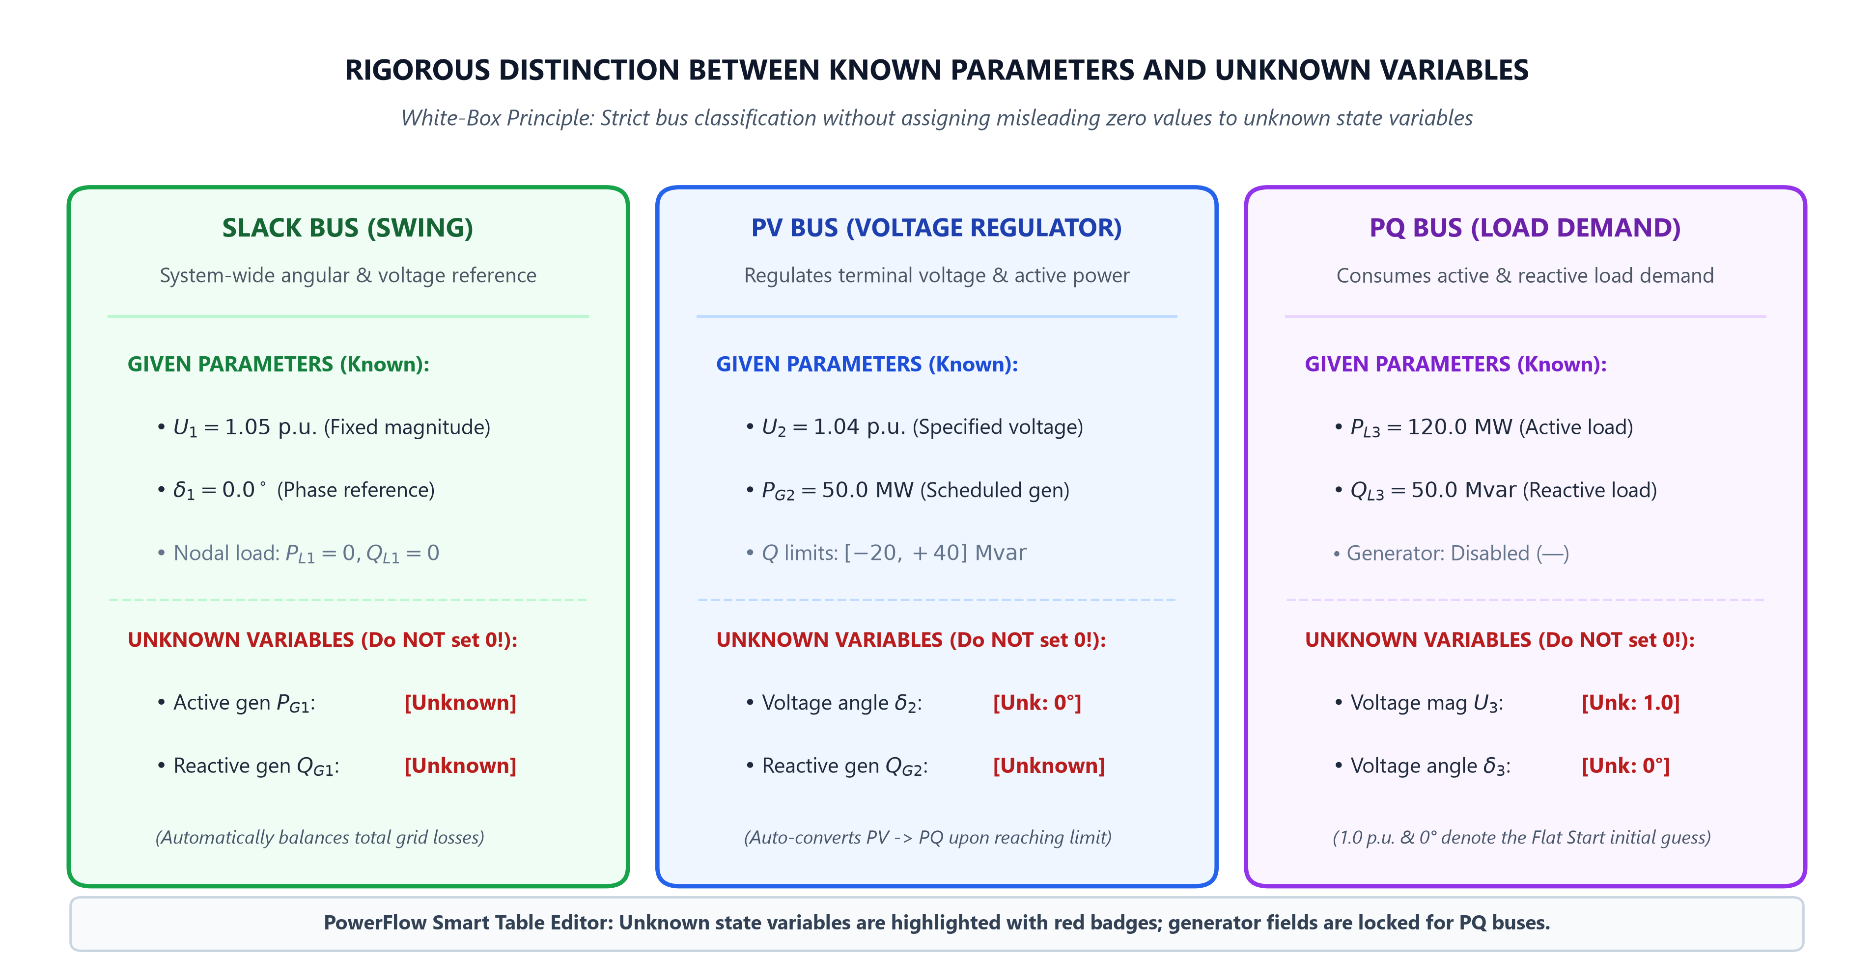
Figure 3.2: Smart Table editor: explicit handling of unknown variables

3.3 Five Dedicated Functional Subsystems
Features Executive Dashboard, Interactive Topology Canvas, Bus Voltages, Branch Flows, and Technical Reporting.

3.4 Comprehensive Automated Unit Testing
Protects mathematical integrity through 54 automated unit tests achieving a 100% passing rate.

Chapter 4: Step-by-Step Hand Calculation & 1:1 Cross-Validation

4.1 3-Bus Benchmark Network Specification
S_base = 100 MVA, Bus 1 Slack 1.05 pu, Bus 2 PV 1.04 pu (50 MW), Bus 3 PQ 120 MW + j50 Mvar.

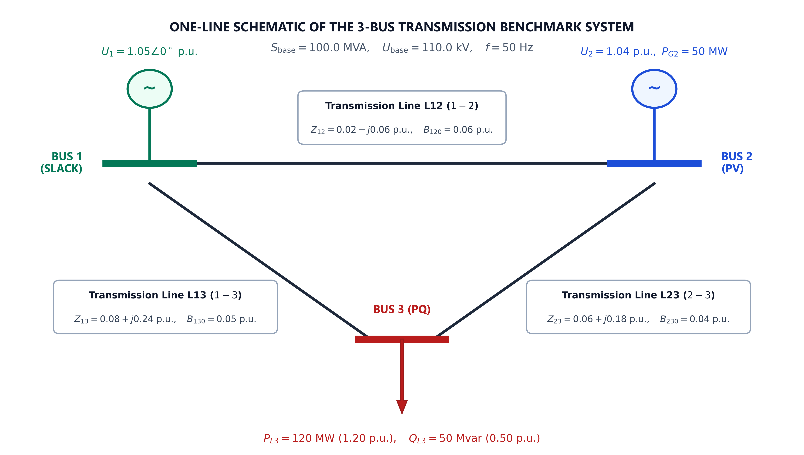
Figure 4.1: Single-line schematic of the 3-bus transmission benchmark system

4.2 Detailed Hand Calculation for Iteration 1
Explicit calculations: Delta P2 = 0.4827 pu, Delta P3 = -1.0708 pu, Delta Q3 = -0.0675 pu, 3x3 Jacobian inversion, and state update.

4.3 1:1 Cross-Validation Against PowerFlow
Zero discrepancy, absolute error < 10^-16 pu, asymptotic quadratic convergence achieved in 4 iterations.

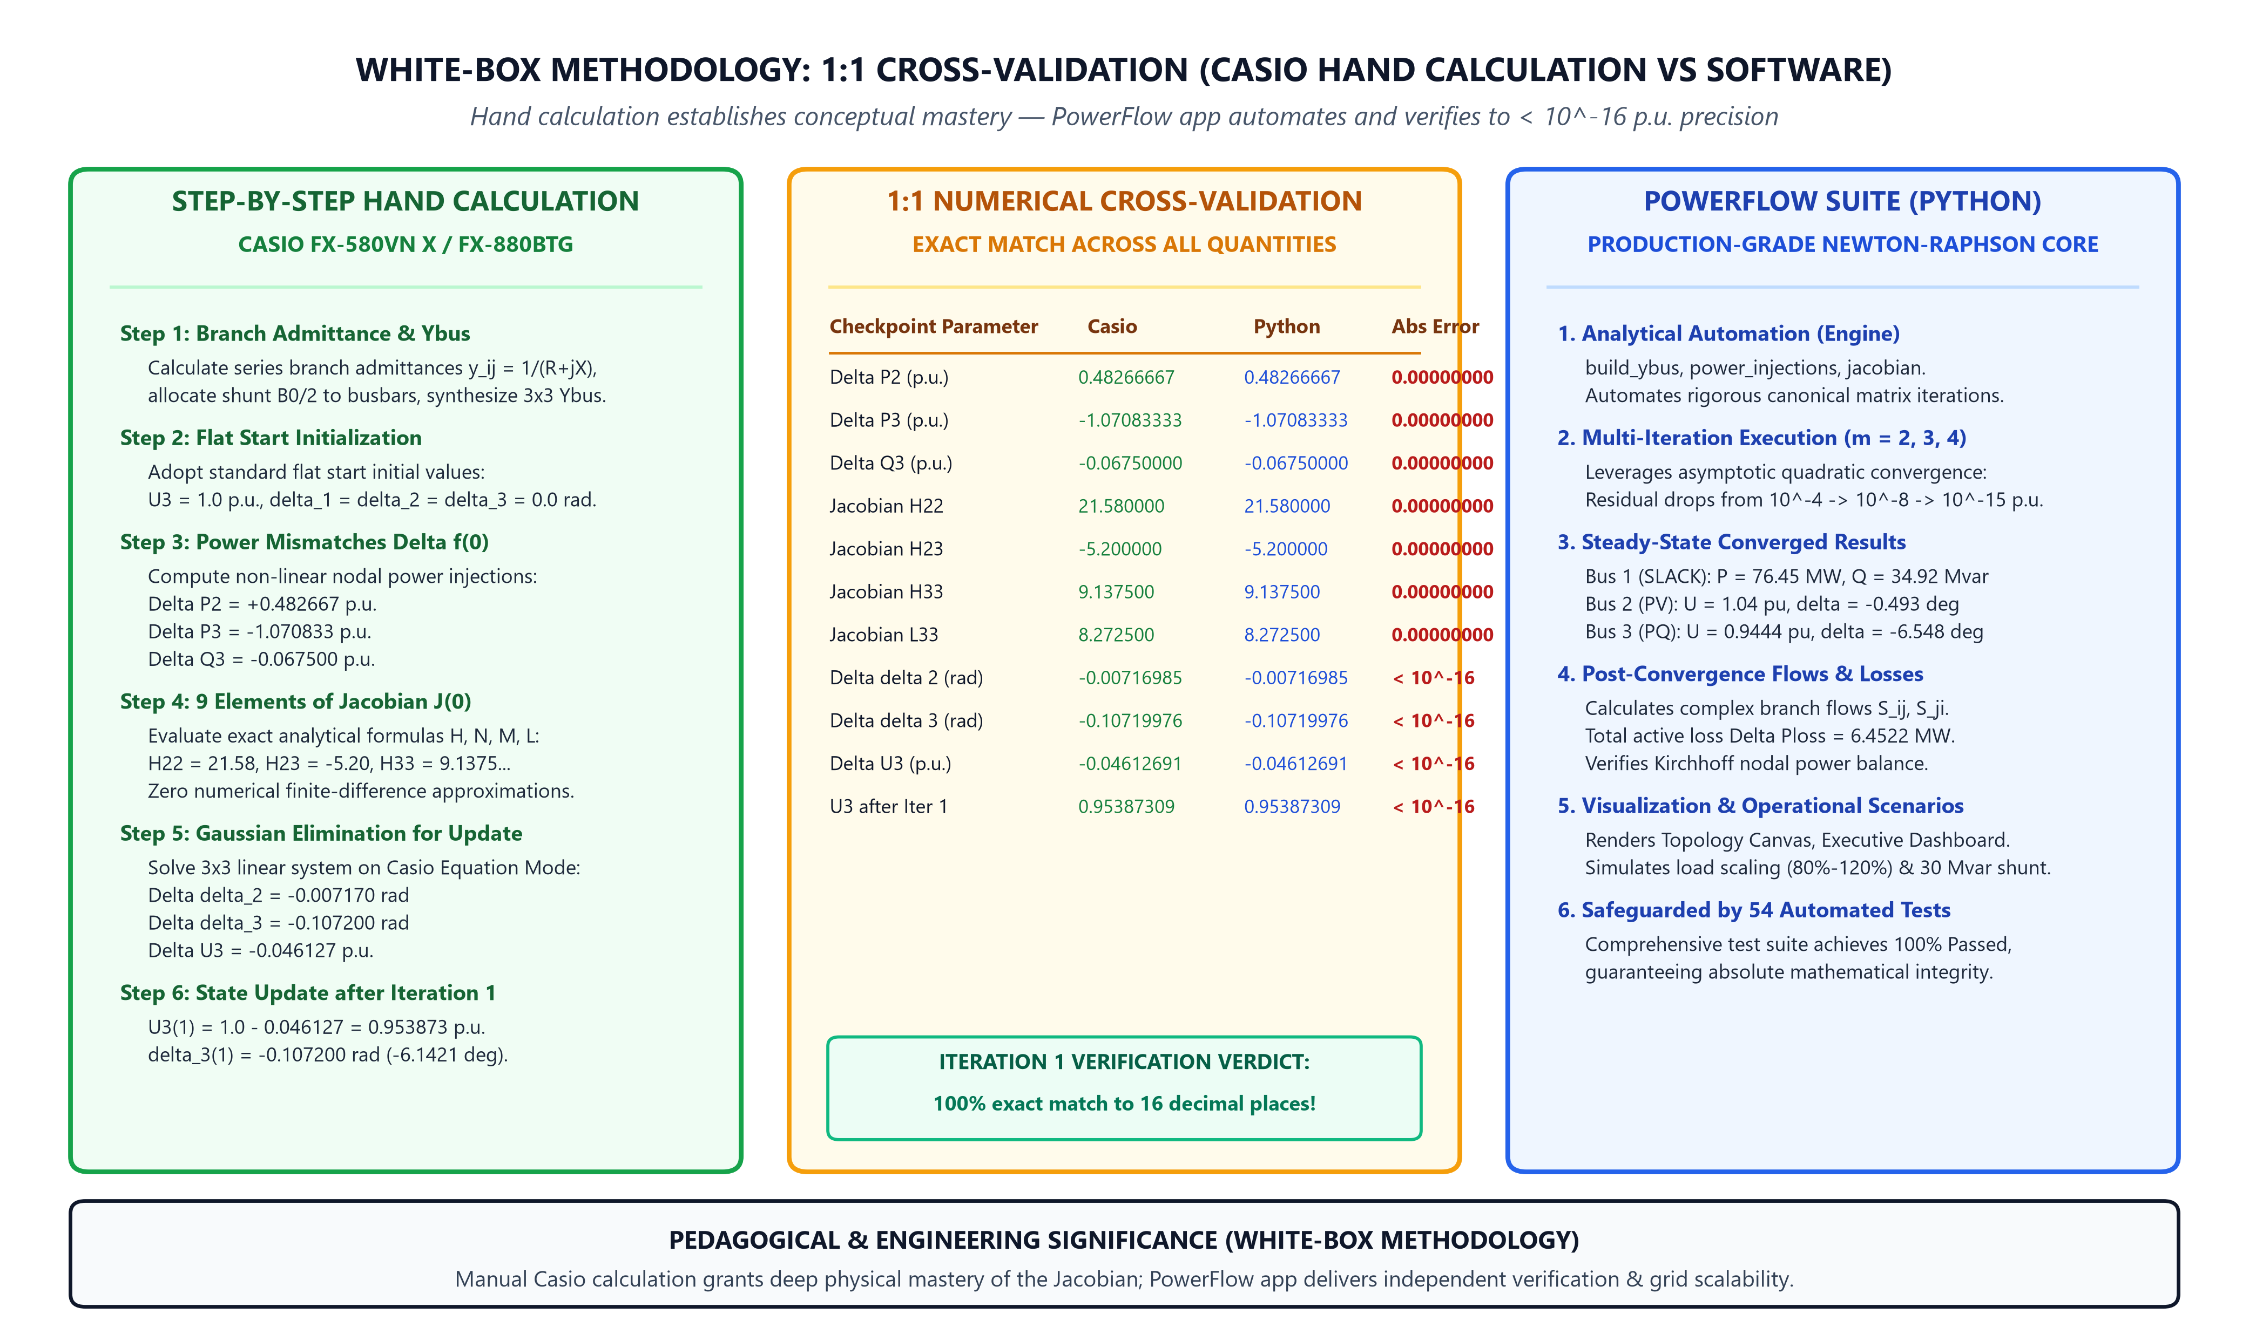
Figure 4.2: Flagship White-Box 1:1 cross-validation between Casio hand calculations and PowerFlow software

4.4 Quadratic Convergence & 2 Operational Scenarios
Residual norm drops quadratically; Load scaling 80%-120% causes non-linear voltage depression; 30 Mvar shunt capacitor restores voltage to 0.9786 pu while reducing losses by 16.54%.

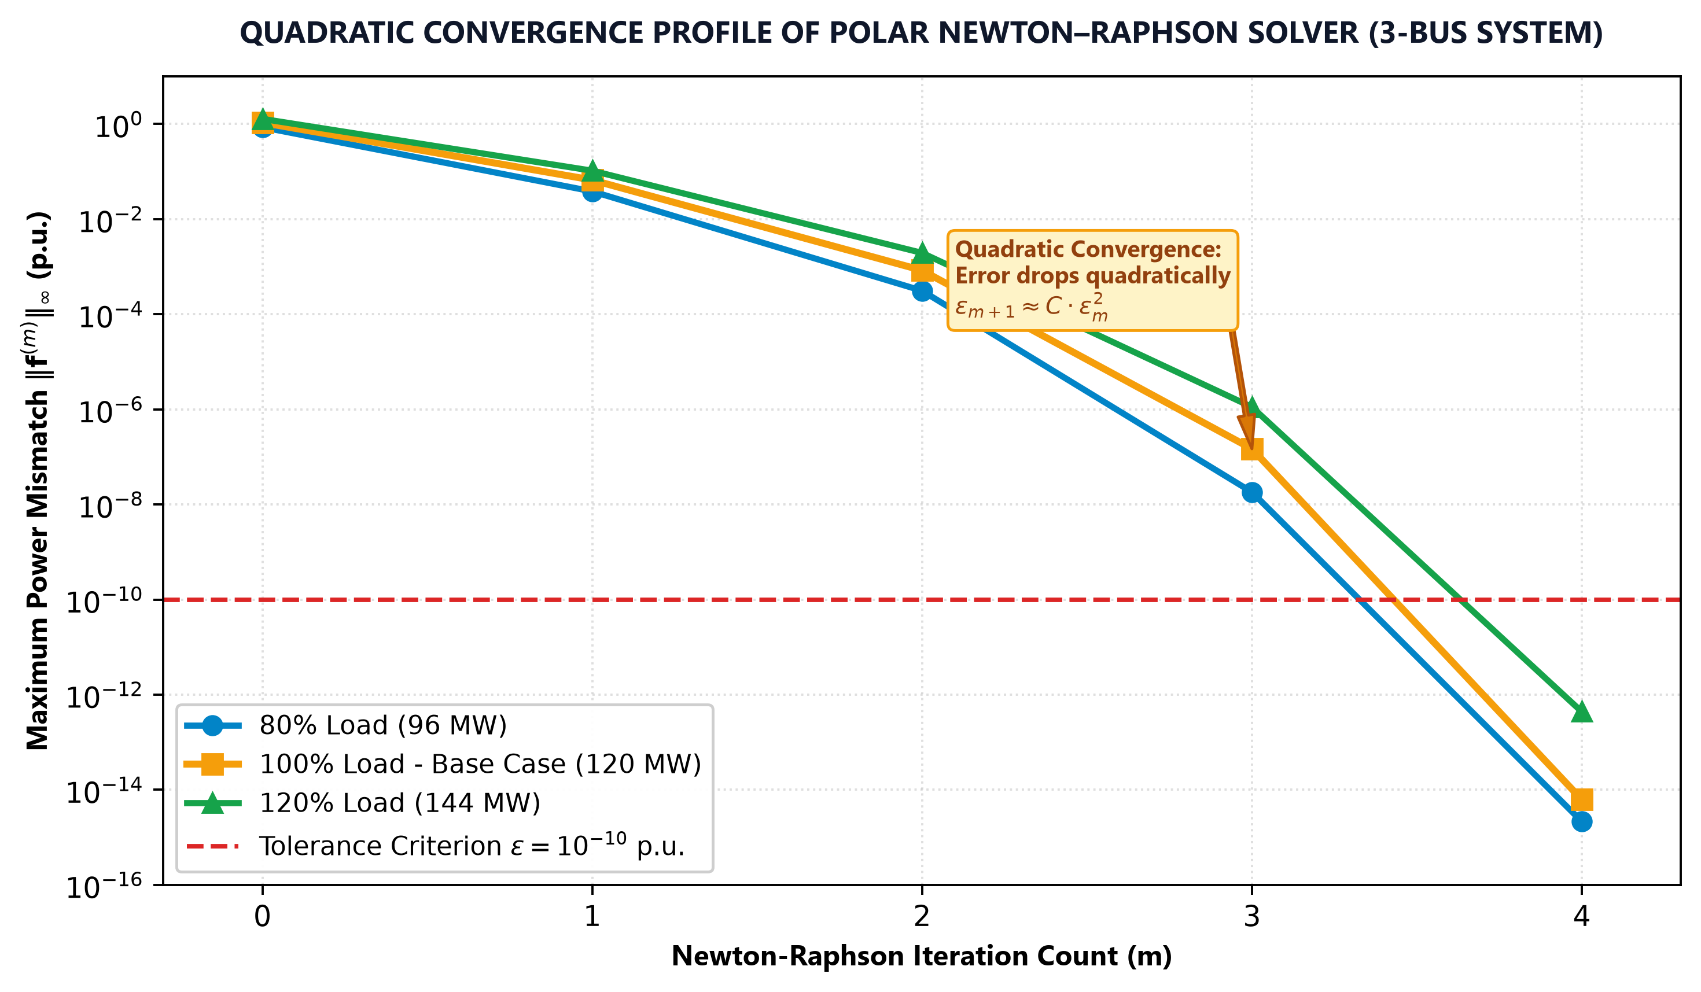
Figure 4.3: Asymptotic quadratic convergence profile of the Newton--Raphson solver

Chapter 5: Conclusions and Engineering Takeaways

5.1 Summary of Key Achievements
Successfully fulfills all academic objectives, unifying analytical theory, manual calculation, and software engineering.

5.2 Methodological Takeaways
Emphasizes engineering discernment, algorithmic self-reliance, and critical validation over blind tool adoption.

1:1 NUMERICAL CROSS-VALIDATION TABLE (ITERATION 1)
Validation Parameter | Hand Calculation (Casio) | PowerFlow Software (Python) | Absolute Discrepancy
Active mismatch Delta P2 (p.u.) | 0.48266667 | 0.48266667 | 0.00000000
Active mismatch Delta P3 (p.u.) | -1.07083333 | -1.07083333 | 0.00000000
Reactive mismatch Delta Q3 (p.u.) | -0.06750000 | -0.06750000 | 0.00000000
Jacobian entry H22 | 21.58000000 | 21.58000000 | 0.00000000
Jacobian entry H23 | -5.20000000 | -5.20000000 | 0.00000000
Jacobian entry H33 | 9.13750000 | 9.13750000 | 0.00000000
Jacobian entry L33 | 8.27250000 | 8.27250000 | 0.00000000
Phase update Delta delta 2 (rad) | -0.00716985 | -0.00716985 | < 10^-16
Phase update Delta delta 3 (rad) | -0.10719976 | -0.10719976 | < 10^-16
Voltage update Delta U3 (p.u.) | -0.04612691 | -0.04612691 | < 10^-16
Bus 3 voltage after Iter 1 U3 (p.u.) | 0.95387309 | 0.95387309 | < 10^-16

CONVERGED STEADY-STATE BUS TABLE (4 ITERATIONS)
Bus | Class | Voltage U (p.u.) | Phase delta (deg) | P Gen (MW) | Q Gen (Mvar) | P Load (MW) | Q Load (Mvar)
1 | SLACK | 1.0500 | 0.0000 | 76.4522 | 34.9226 | 0.0 | 0.0
2 | PV | 1.0400 | -0.4934 | 50.0000 | 18.9489 | 0.0 | 0.0
3 | PQ | 0.9444 | -6.5482 | 0.0000 | 0.0000 | 120.0 | 50.0

