1. **Create Resource Group**

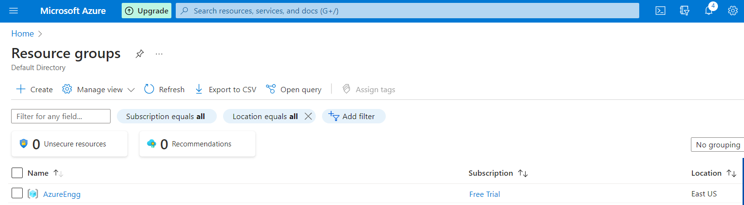

1. **Create Storage Account**

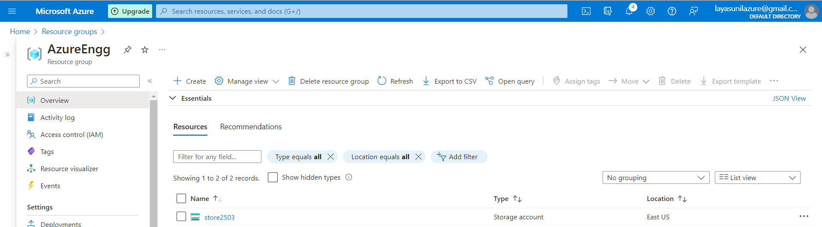

1. **Create 2 Containers – Structured and Semi-Unstructured**

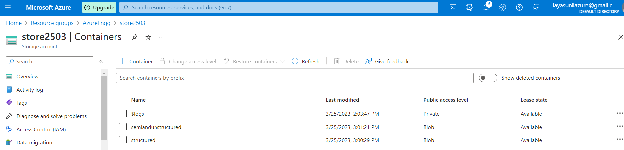

1. **Upload structured data - excel file – employees.xlsx**

**Semi-structured – JSON file – input.json**

**Unstructured – Image file - 26_03_2017.jpg**

