-- 1

create table person (slno int, name varchar(20), place varchar(20), dob date);

-- 2

insert into person

values(1002, 'hitesh','delhi', '2000-05-01'),

(1001, 'ritesh','mumbai','1998-07-12'),(1005, 'balan','kochi','1999-11-05');

-- 3

select tablespace_name, file_name from information_schema.files

where tablespace_name like '%person%';

-- 4

select * from person

where slno = 1001;

-- 5

explain select *

from person

where slno =1001;

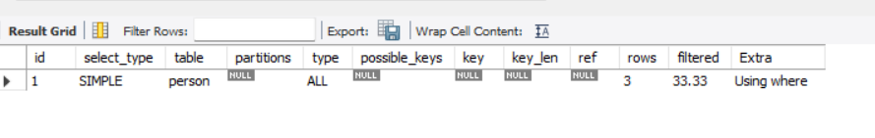

-- 6

create index slno_idx on person(slno);

explain format=tree

select *

from person

where slno =1001;

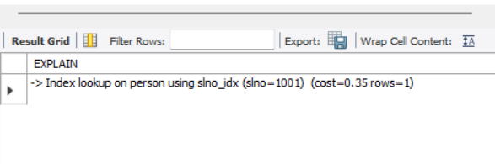

-- 7

alter table person

add constraint pk_person

primary key(slno);

explain format=tree

select *

from person

where slno =1001;

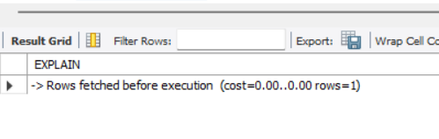

-- 8 observations

-- 5

Here type of query is simple and out of 3 rows one row is fetched using where condition. since the probability is one third, filtered is showing 33.33%

-- 6

After creating index on slno the index look up is being used here using slno_idx and cost is 0.35

-- 7

After creating slno as primary key cost has reduced to 0, as primary key index is being used here. so primary key is more optimised option available.