ASSIGNEMENT – WEATHER

1. Create "weather" external table under /user/training/weather

CREATE EXTERNAL TABLE IF NOT EXISTS weather_1 (WBANNO int, LST_DATE DATE, CRX_VN FLOAT, LONGITUDE FLOAT,LATITUDE FLOAT,T_DAILY_MAX FLOAT,T_DAILY_MIN FLOAT,
T_DAILY_MEAN FLOAT,T_DAILY_AVG FLOAT,P_DAILY_CALC FLOAT,SOLARAD_DAILY String,SUR_TEMP_DAILY_TYPE FLOAT, SUR_TEMP_DAILY_MAX FLOAT,
SUR_TEMP_DAILY_MIN FLOAT,SUR_TEMP_DAILY_AVG FLOAT,RH_DAILY_MAX FLOAT, RH_DAILY_MIN FLOAT,RH_DAILY_AVG FLOAT,SOIL_MOISTURE_5_DAILY FLOAT,
SOIL_MOISTURE_10_DAILY FLOAT, SOIL_MOISTURE_20_DAILY FLOAT, SOIL_MOISTURE_50_DAILY FLOAT, SOIL_MOISTURE_100_DAILY FLOAT,
SOIL_TEMP_5_DAILY FLOAT, SOIL_TEMP_10_DAILY FLOAT, SOIL_TEMP_20_DAILY FLOAT, SOIL_TEMP_50_DAILY FLOAT, SOIL_TEMP_100_DAILY FLOAT)
COMMENT 'Weather Details'
ROW FORMAT DELIMITED
FIELDS TERMINATED BY ','
LINES TERMINATED BY '\n'
STORED AS TEXTFILE;

2. Load the data from ~/futurence_hadoop-pyspark/labs/dataset/weather to /user/training/weather

load data local inpath '/home/laya/Codes/weather_data.csv' overwrite into table weather_1;

3. Display the weather data

SELECT * FROM weather_1 LIMIT 10;

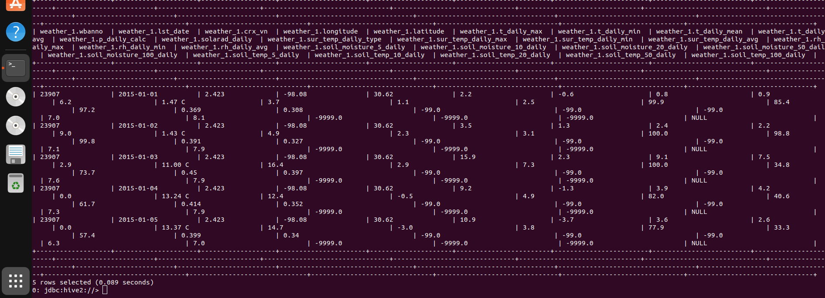

4. Display Max, Min weather

SELECT MAX(t_daily_max)as max, MIN(t_daily_min) as min
FROM weather_1;

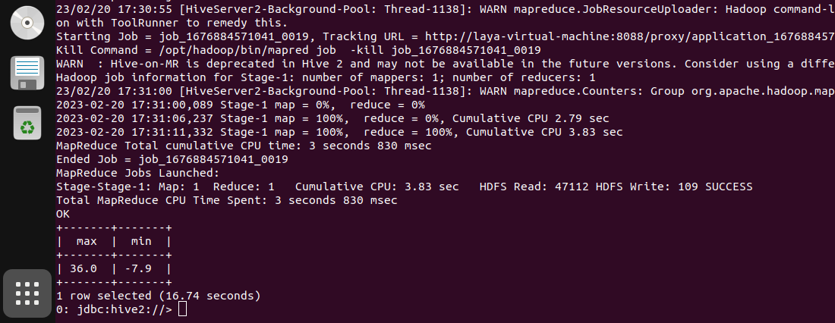
5. Display month wise Max and Min weather

SELECT DATE_FORMAT(lst_date, 'MMMMM'),MAX(t_daily_max), MIN(t_daily_min)
FROM weather_1
GROUP BY DATE_FORMAT(lst_date, 'MMMMM');

