ASSIGNMENT 3 - CUSTOMERS-TRANSACTIONS

CREATE TABLE IF NOT EXISTS Customers
(cust_id int, last_name String, first_name String, age int, profession String)
COMMENT 'customers details'
ROW FORMAT DELIMITED
FIELDS TERMINATED BY ','
LINES TERMINATED BY '\n'
STORED AS TEXTFILE;

CREATE TABLE IF NOT EXISTS Transactions
(trans_id int, trans_date date, cust_id int, amount double, Category String, desc String, city String, State String, pymt_mode String)
COMMENT 'transactions details'
ROW FORMAT DELIMITED
FIELDS TERMINATED BY ','
LINES TERMINATED BY '\n'
STORED AS TEXTFILE;

load data inpath ‘/user/hive/dataset/customers.txt’ overwrite into table customers;

load data inpath ‘/user/hive/dataset/trans_out.txt’ overwrite into table transactions;

1) No of transactions by customer

select c.cust_id , count(trans_id) from customers c inner join transactions t on c.cust_id=t.cust_id group by c.cust_id;
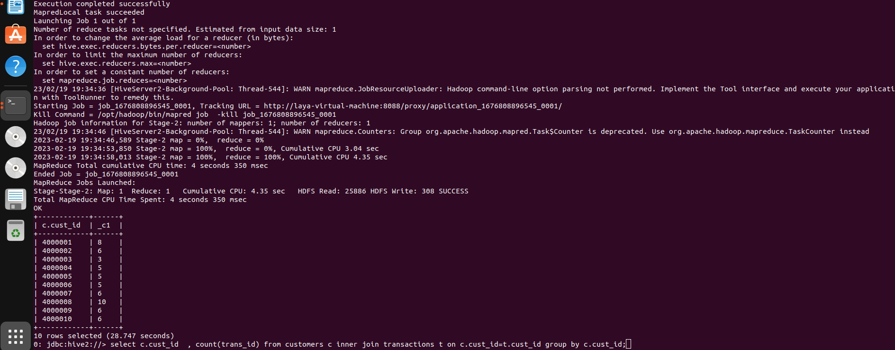

2) Total transaction amount by customer
select c.cust_id ,round(sum(amount),4) from customers c left join transactions t on c.cust_id=t.cust_id group by c.cust_id;

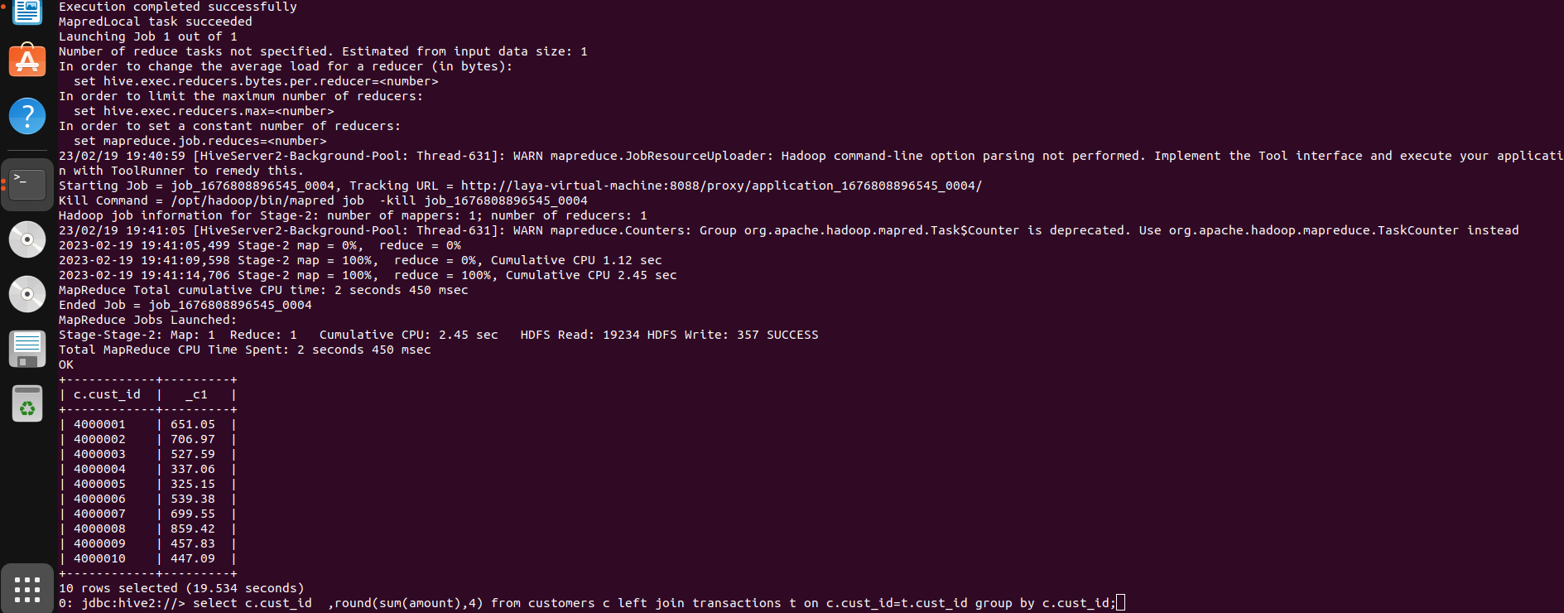

3) Get top 3 customers by transaction amount

select c.cust_id ,round(sum(amount),4)
from customers c left join transactions t on c.cust_id=t.cust_id
group by c.cust_id
order by sum(amount) desc
limit 3;

OR

select cust_id, _c1 from
(select c.cust_id ,round(sum(amount),4), dense_rank()over(order by sum(amount)desc) from customers c left join transactions t on c.cust_id=t.cust_id group by c.cust_id) a
where _c2<=3;

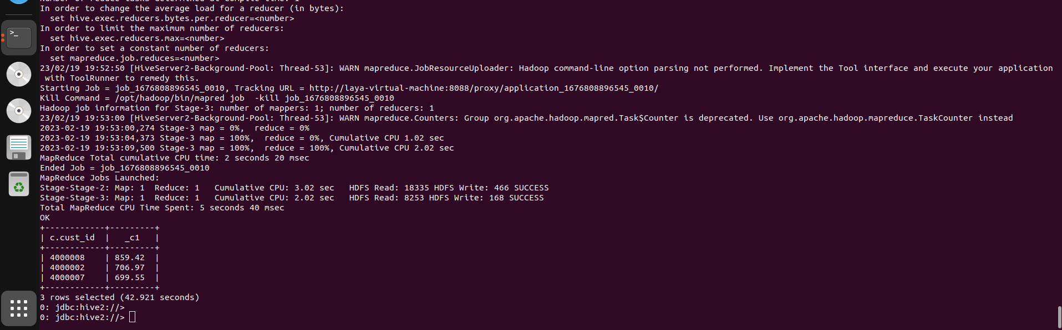

4) No of transactions by customer and mode of payment

select c.cust_id , t.pymt_mode, count(trans_id)
from customers c left join transactions t on c.cust_id=t.cust_id
group by c.cust_id, t.pymt_mode;

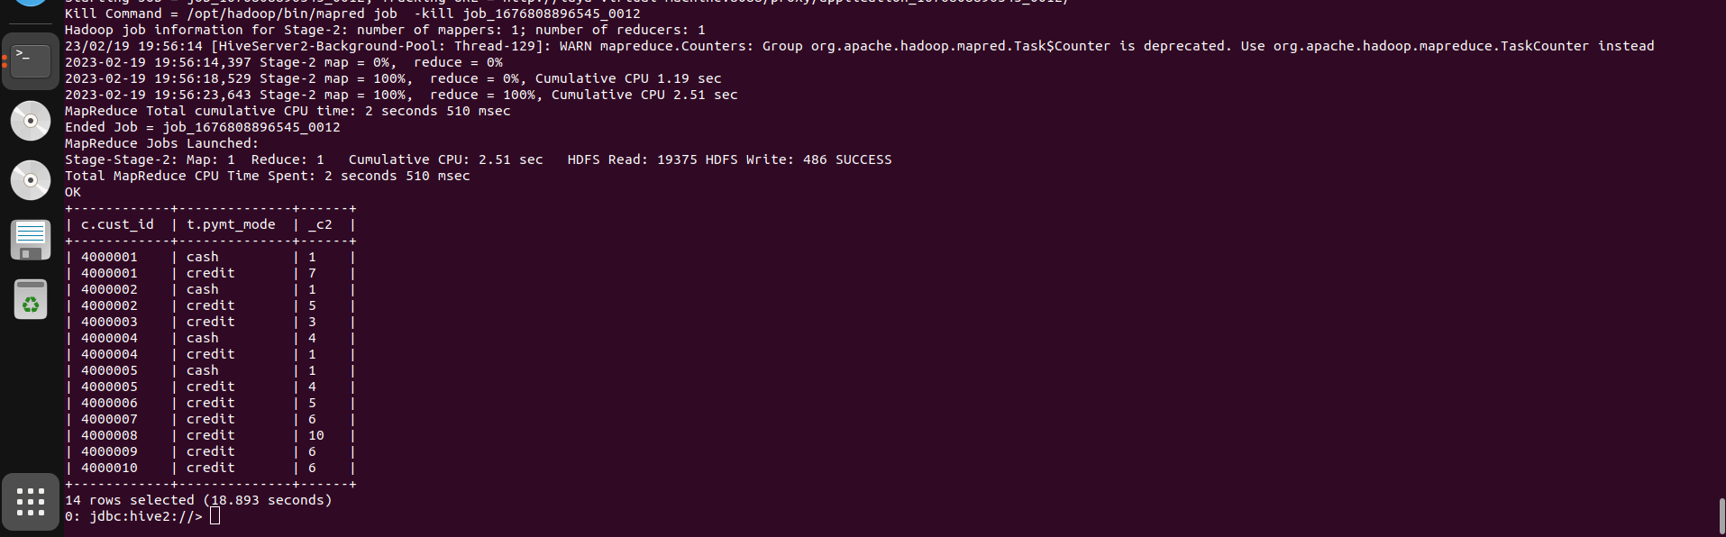

5) Get top 3 cities which has more transactions

select city, count(trans_id)
from transactions
group by city order by count(trans_id) desc limit 3;

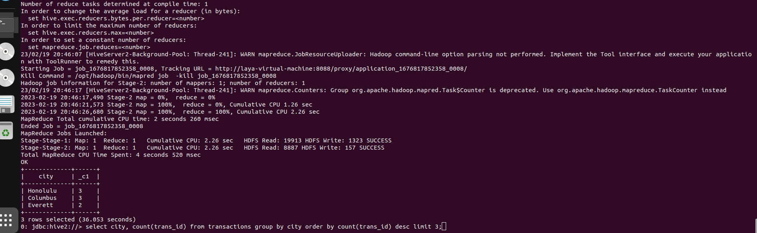

6) Get month wise highest transaction

select month(trans_date), max(amount) from transactions group by month(trans_date);

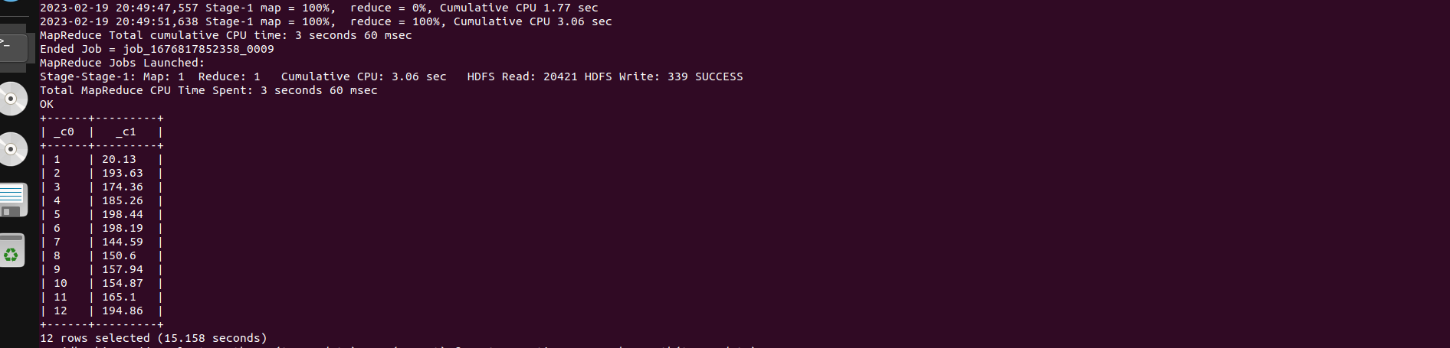

7) Get sample transactions

select * from transactions tablesample(10 percent);

