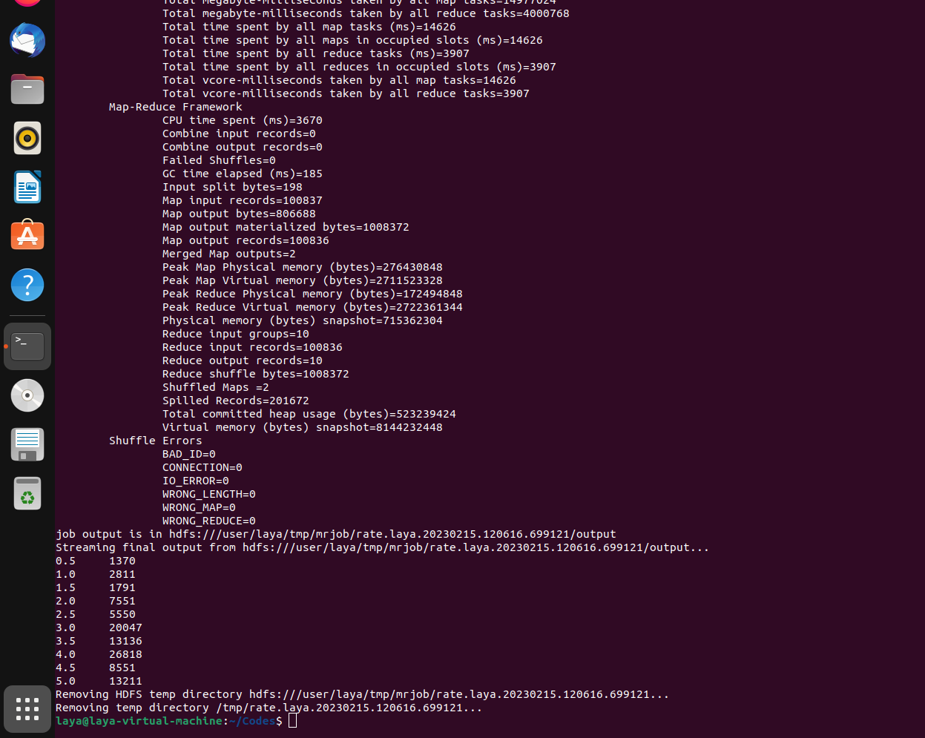
OUTPUT -- RATE.PY

python3 rate.py -r hadoop hdfs://localhost:9000/user/training/ratings.csv

