**Sample, n = 366, α = 0.05, 5% significance level, The degrees of freedom (df), n-2 = 364.**

**Here we are using 2 tailed test.**

**=T.INV.2T(0.05, 364) = 1.966503**

1. **Hypothesis 1: Average Discount Impact:-**

* **Null Hypothesis(H0):** There is no significant impact of the average discount on the success rate of payments.
* **Alternative Hypothesis(H1):** Changes in the average discount affect the success rate of payments.

The correlation coefficient is -0.040151483 and it is less than the critical value which indicates a very weak negative correlation between the average discount and the success rate of payments.

**The correlation coefficient is less than the critical value we can ignore H1.**

It fails to reject the null hypothesis(H0) and concludes that there is no significant impact of the average discount on the success rate of payments.

Therefore, H1 can be ignored in favor of H0.

1. **Hypothesis 2: Out-of-Stock Items Impact: -**

* **Null Hypothesis (H0):** The number of out-of-stock items per restaurant does not affect the success rate of payments.
* **Alternative Hypothesis(H1):** Variations in the number of out-of-stock items per restaurant influence the success rate of payments.

The correlation coefficient is 0.05168603 and it is less than the critical value. The correlation coefficient is not statistically significant. So, we can ignore H1 and accept H1.

Therefore, variations in the number of out-of-stock items per restaurant do not significantly influence the success rate of payments.

1. **Hypothesis 3: Average Packing Charges Impact: -**

* **Null Hypothesis(H0):** There is no relationship between average packing charges and the success rate of payments.
* **Alternative Hypothesis(H1):** Fluctuations in average packaging charges affect the success rate of payments.

The correlation coefficient is: -0.05221 and it is less than the critical value. The correlation coefficient is not statistically significant. So, we can ignore H1 and accept H1.

Therefore, variations in average packaging charges do not appear to influence the success rate of payments.

1. **Hypothesis 4: Average Delivery Charges Impact: -**

* **Null Hypothesis(H0):** Average delivery charges do not impact the success rate of payments.
* **Alternative Hypothesis(H1):** Changes in average delivery charges influence the success rate of payments.

The correlation coefficient is 0.100530671 and it is less than the critical value. The correlation coefficient is not statistically significant. So, we can ignore H1 and accept H1.

Therefore, changes in average delivery charges do not appear to influence the success rate of payments.

1. **Hypothesis 5: Average Cost for Two Impact: -**

* **Null Hypothesis(H0):** There is no association between the average cost for two and the success rate of payments.
* **Alternative Hypothesis(H1):** Variations in the average cost for two affect the success rate of payments.

The correlation coefficient is -0.057454543 and it is less than the critical value which indicates a very weak negative correlation between the average discount and the success rate of payments. The correlation coefficient is less than the critical value we can ignore H1.

Therefore, variations in the average cost for two do not appear to affect the success rate of payments.

**Fluctuation in Traffic: -**

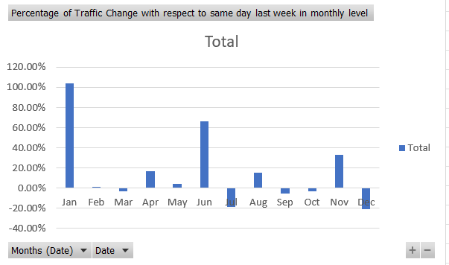

* Top of Form

From this graph Traffic in January month is high and in December month it is low.

**Fluctuation in Overall Conversion: -**

**The standard deviation of L2M:** -15.67962929

**The standard deviation of M2C:** - 19.72758573

**The standard deviation of C2P:** - 12.31330314

**The standard deviation of P20:** - 10.23641248

The standard deviation for M2C is high. So, M2C is more fluctuating. The factor behind this fluctuation is the Menu.