

**Name : layal abed**

**Student ID : 1220480**

**Section : 3**

**Dr : Yazan Abu Farha**

MUX REPORT AND MODULE 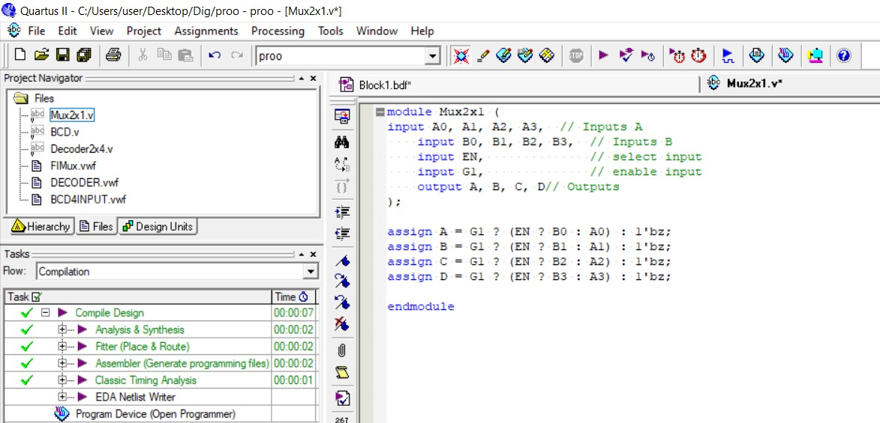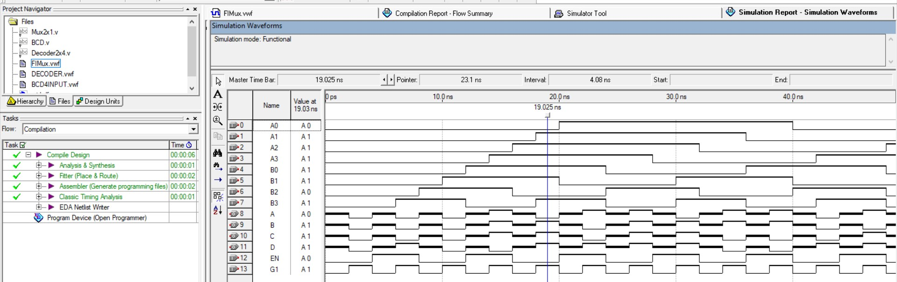

**Multiplexers:**

Selecting data is an essential function in digital systems

Functional blocks that perform selecting are called multiplexers.

A Multiplexer (or Mux) is a combinational circuit that has: Multiple data inputs (typically 2n) to select from An n-bit select input S used for control One output Y.

The n-bit select input directs one of the data inputs to the output.

BCD REPORT AND MODULE 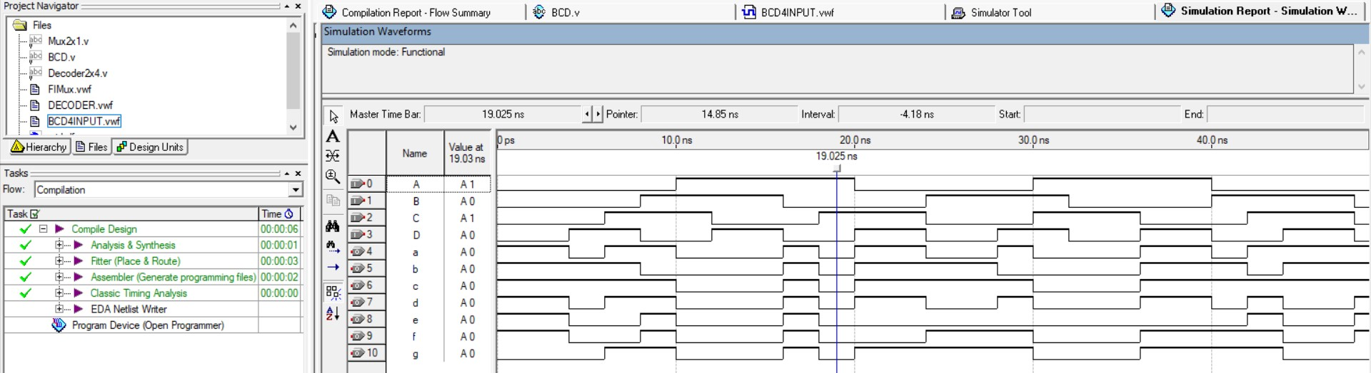

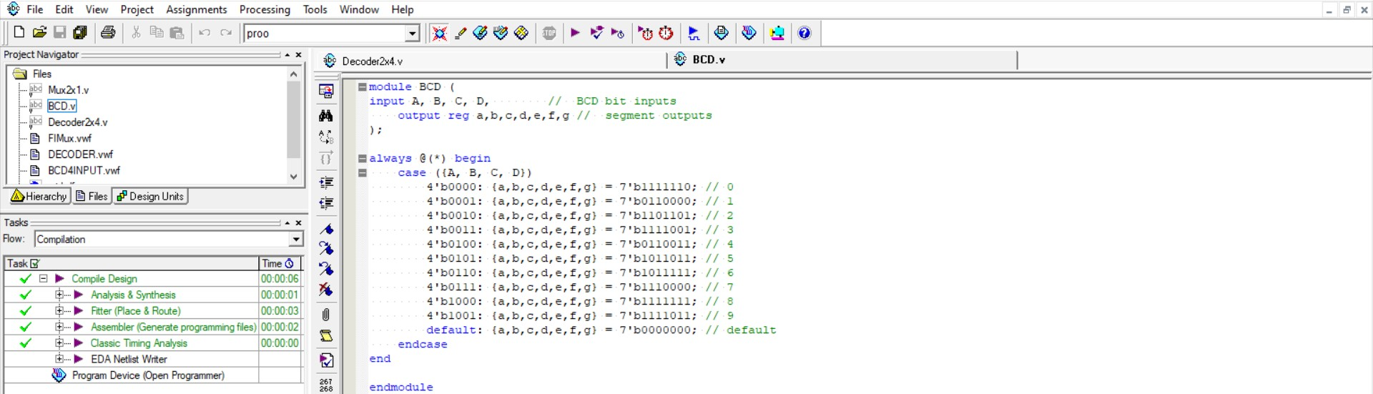

**Seven-Segment Display:**

 Made of Seven segments: light-emitting diodes (LED)

 Found in electronic devices: such as clocks, calculators, etc.

**BCD to 7-Segment Decoder:**

 Accepts as input a BCD decimal digit (0 to 9)

 Generates output to the seven LED segments to display the BCD digit

 Each segment can be turned on or off separately

DECODER REPORT AND MODULE 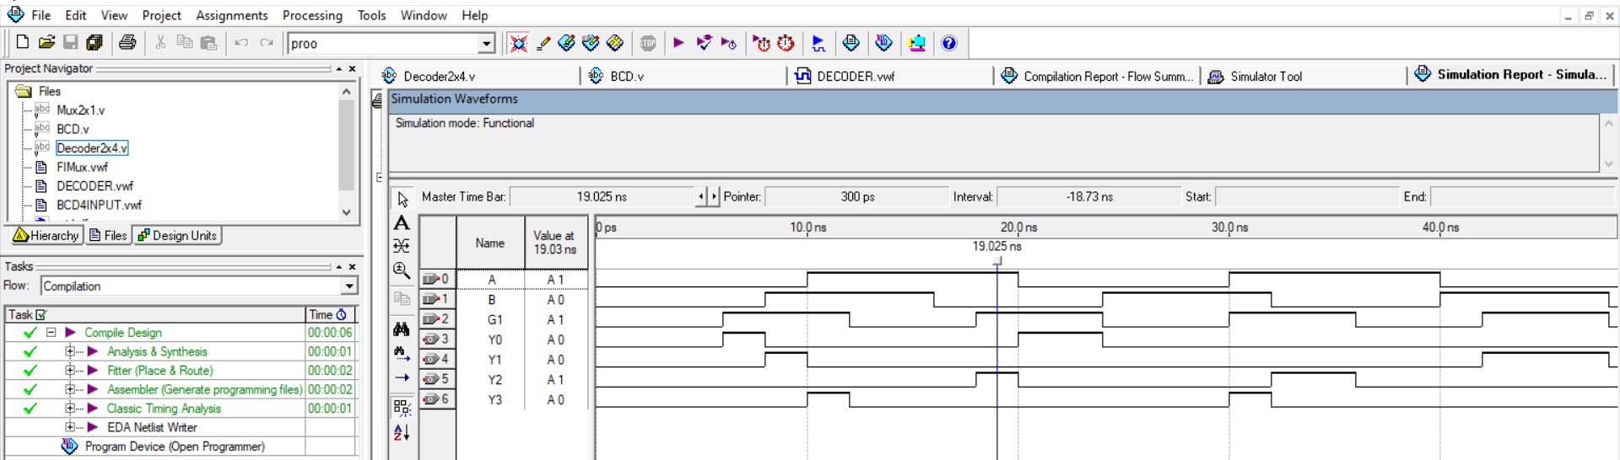

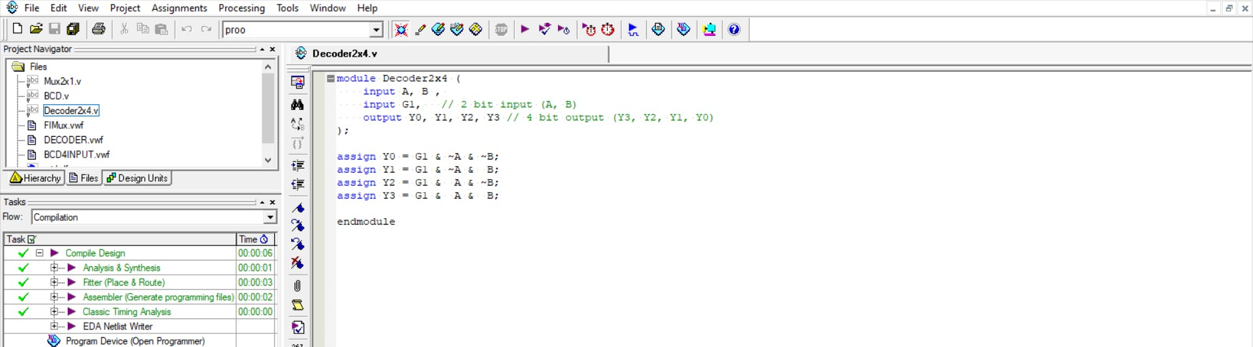

**Decoder:**

The decoder has an output for each possible code value

The n-to-2n decoder has n inputs and 2n outputs

Depending on the input code, only one output is set to logic 1

The conversion of input to output is called decoding

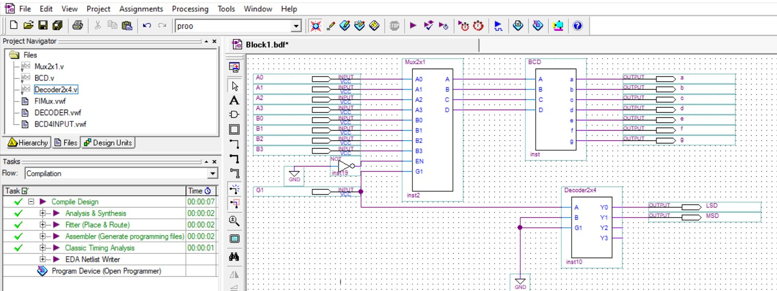

Uses of circuits:

MUX 2X1: used to select between two different data sources and output one of them And It can be used to switch the data path based on the control signal.

BCD_7Segment_driver : Converting binary data into a visual form that can be easily understood and It is used in digital clocks, calculators, and other electronic devices that need to display numbers.

Decoder2x4:Line Selection: Used in circuits that need to activate one of several lines based on a specific code.and Used in digital circuits to access specific memory cells ,also Used in multitasking systems to determine the active tasks.