NP User manual

# Preparing the hardware

To use the system you will need the following:

|  |  |
| --- | --- |
| 1  3  2  0 | |
| 0- NP project after wiring process | 1- webcam USB  2- Power plug / USB C 3A/5V  3- Power plug / USB 2A/5V |
| **Figure**: All of the NP hardware | |

# Powering the system on

|  |
| --- |
|  |
| **Figure:** Power plug location on NP project |

*“That’s all you need to do to* ***power******ON*** *the system!”*

The system will take approximately **30 seconds** to be ready.

## Connecting to the NodeRED dashboard

If the board is connected to the same local network as your phone or PC, use its IP address to access the NodeRED dashboard at the following URL. Of course, replace **NP_IP** by the ip address of the board.

For the NodeRED dashboard UI interface:

<http://[NP_IP]:1880/ui>

For the NodeRED flows administration interface:

<http://[NP_IP]:1880>

# Powering the system off

To power off the system you have several options. **You should avoid disconnecting the power from the Raspberry Pi 4** **board without having shut down the OS gracefully.** In fact you risk an SDCARD corruption which means the system won’t boot again.

To shut down the system gracefully you have 2 possibilities:

1. **Pressing the poweroff button** and when the system is off, pulling the power plug.
2. Entering the **sudo poweroff** command in the serial terminal or SSH console.

# NodeRED dashboard IHM

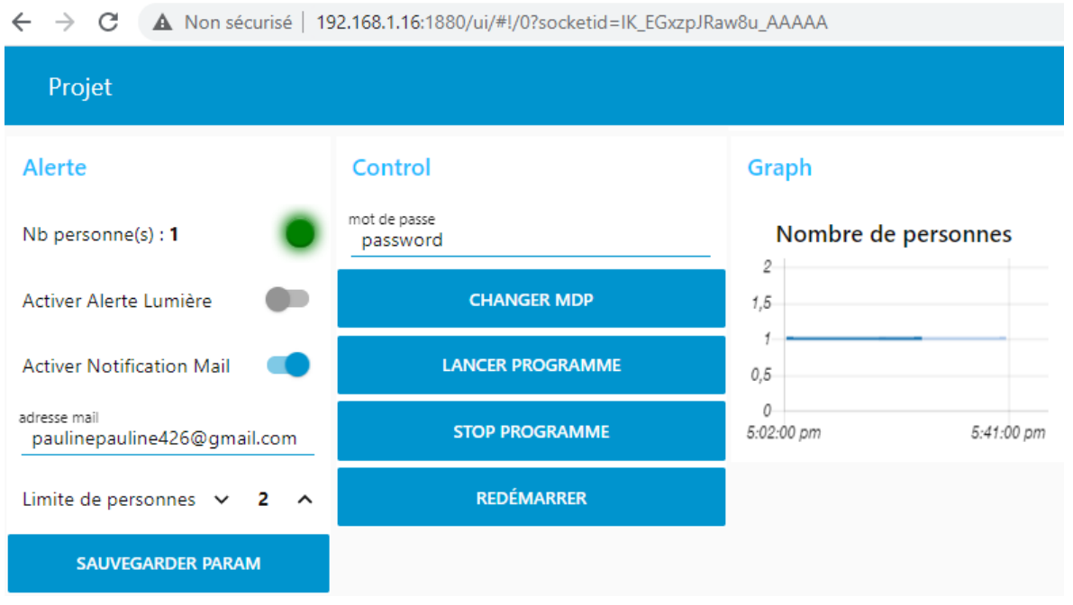



Number of person detected

The **red or green** light is based on the limit of person per/location and it is a representation of the relay state.

I have set the limit to 0

Light goes red to indicate that the limit is reached.

You can enable or not the relay/light alert by switching the button. Same thing with the alert by mail.





You have some buttons that permit you to Restart the Raspberry board in case of malfunction / Start/Stop the project. They will turn off/on all the needed programs

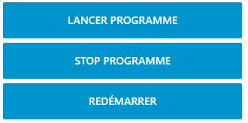

You can have some information about the number of person in the location at a specific time.

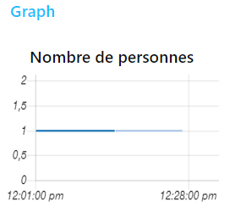

### Automatic Start/End time configuration

Connect to for this part: <http://[NP_IP]:1880>

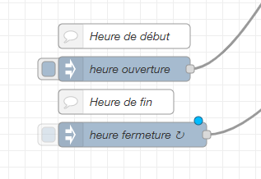

flow nodes

To perform this configuration, you need to find this both nodes.

* double-click on it

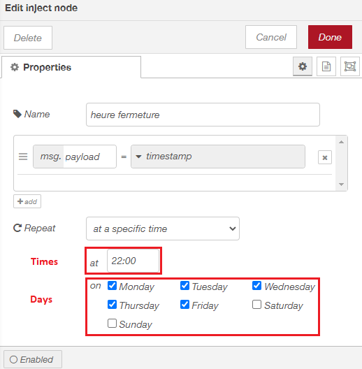

you just need to change information about times/days on both nodes that you need and redeploy the flow.

### Mail configuration

Mail alert are sent by this address: [projet.personne.polytech@gmail.com](mailto:projet.personne.polytech@gmail.com)

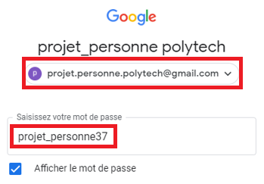

flow node

To configure where mails are sent to, you just must type your mail address on the “adresse mail” text field and save the configuration

