1.a.EXCHANGE OF TWO VALUES USING THIRD VARIABLE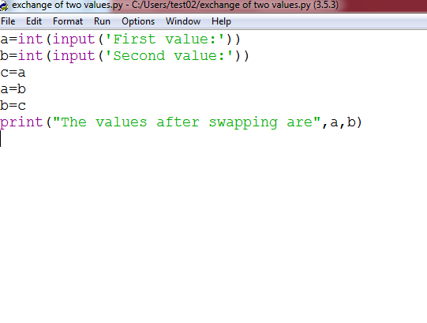

OUTPUT:

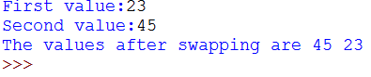

b.EXCHANGE OF VALUES USING COMMA OPERATOR

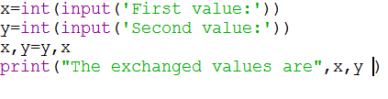

OUTPUT:

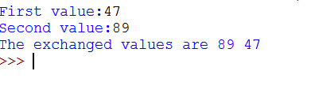

C.EXCHANGE OF VALUES USING ARITHMETIC OPERATOR

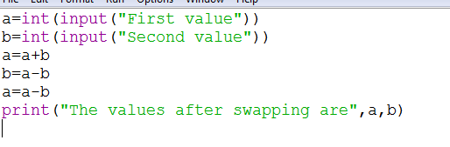

OUTPUT:

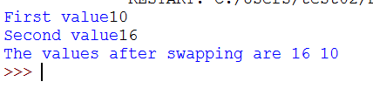

d.EXCHANGE OF VALUES USING XOR OPERATOR

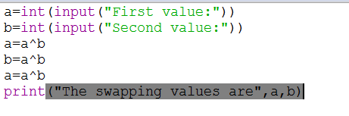

OUTPUT:

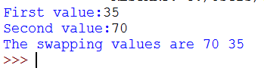

2.a.CIRCULATING THE LIST OF VALUES USING IN-BUILD FUNCTION

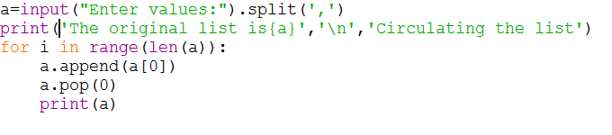

OUTPUT:

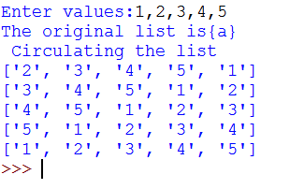

b.CIRCULATING THE LIST OF VALUES USING SLICING OPERATOR

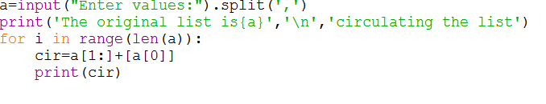

OUTPUT:

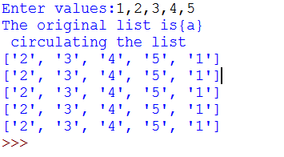

3.CALCULATE THE DISTANCE BETWEEN TWO POINTS

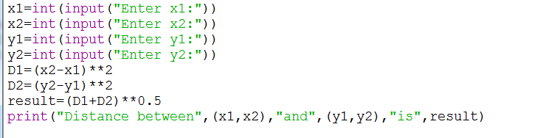

OUTPUT:

