SkillBridge



UNIVERSITY OF INFORMATION TECHNOLOGY

SEPTEMBER 2026

Course Name: CST-4105 Enterprise Applications Development using Java
Project Title: SkillBridge
Group Members
- [Mg Lin Htet Aung]
  - Student ID: [2465]
  - Email: [linnhtetaung@uit.edu.mm]
- [Ma Htet Yadana Myo]
  - Student ID: [2460]
  - Email: [Email Address]
- [Ma Htet Shoon Lae Aung]
  - Student ID: [2360]
  - Email: [Email Address]
- [Ma Eaint Hmue Nge]
  - Student ID: [2406]
  - Email: [eainthmuenge@uit.edu.mm]
- [Ma Myintzu Khaing]
  - Student ID: [2431]
  - Email: [myintzukhaing@uit.edu.mm]
- [Ma Zar Le Tun]
  - Student ID: [2456]
  - Email: [zarlitun@uit.edu.mm]

Supervisor:
Department: Faculty of Computer Science
Submission Date:

Contents
Introduction 6
Project Planning and Requirement Analysis 9
System Design and Architecture 13
Development Environment Setup 16
Screen Layout and Design 20
Conclusion and Reflection 23
Appendices 27

1. Introduction 6
1.1 Overview 6
1.2 Project Scope 7
1.3 Objectives 7
2. Project Planning and Requirement Analysis 9
2.1 Functional vs. Non-Functional Requirements 9
2.2 Creating Use Cases and User Stories 11
3. System Design and Architecture 15
3.1 System Architecture Design 16
3.2 Database Design: ER diagrams 17
4. Development Environment Setup 18
4.1 Tools and technologies 18
4.2 Development Environment 19
4.3 Coding Standards 20
5. Screen Layout and Design 22
6. Conclusion and Reflection 25
6.1 Project Summary 25
6.2 Challenges and Solutions 25
6.3 Lessons Learned 26
6.4 Future Enhancements 26
7. Appendices 29
7.1 Screen Design 29
7.2 References 30

1.Introduction
In today's digital era, many people possess valuable skills but lack affordable opportunities to learn new ones or share their expertise. Most online learning platforms require monetary payments, making quality education inaccessible to many students and lifelong learners. Additionally, people who are willing to teach often have limited ways to exchange their knowledge for meaningful rewards.
SkillBridge is a peer-to-peer skill exchange platform that enables users to learn and teach skills within a collaborative community. Instead of relying only on financial transactions, SkillBridge introduces three flexible exchange methods: Skill Points, Skill Swap, and Volunteer Teaching. New users receive starter Skill Points upon registration, which can be used to request learning sessions. Users can also earn additional points by teaching others, referring new users and contributing reviews, creating a sustainable learning ecosystem.
1.1 Overview
SkillBridge is a peer-to-peer learning platform designed to connect people who want to learn skills with people who are willing to teach them. The system allows users to act as both learners and mentors depending on the skills they want to learn or teach.
Users can create profiles, list their skills, discover suitable mentors, create teaching sessions, manage their availability, and book learning sessions. The platform also includes a skill-point system that allows users to exchange points for learning sessions. An escrow mechanism is used to temporarily hold points during a session to provide greater protection for users.
In addition to normal paid-by-points learning sessions, SkillBridge supports skill exchange and volunteer learning activities. Users can participate in a discussion forum, leave reviews and ratings after completed sessions, receive notifications, and report problems through the dispute system.
The system is developed using a modern full-stack architecture. The frontend provides an interactive and responsive user interface, while the Spring Boot backend provides REST APIs and handles business logic, authentication, authorization, and database operations.
1.2 Project Scope
The system includes:
- User registration and authentication
- User profile management
- Mentor and skill discovery
- Teaching-session creation
- Date and time availability management
- Session booking and scheduling
- Skill-point wallet and escrow
- Skill exchange and volunteer sessions
- Discussion forum
- Reviews and ratings
- Notifications and administrative moderation
1.3 Objectives
The main objectives of the SkillBridge project are:
- To connect learners with suitable peer mentors.
- To provide a simple platform for teaching and learning.
- To support flexible session scheduling.
- To reward users through skill points.
- To protect points through escrow.
- To encourage collaboration through skill exchange and volunteering.
- To provide secure, maintainable, and scalable software.
- To perform project planning and requirement analysis.

2. Project Planning and Requirement Analysis
2.1 Functional vs. Non-Functional Requirements
2.1.1 Functional Requirements
Functional requirements describe what the SkillBridge system should do.
- Users can register, log in, and log out.
- Users can update their profiles.
- Mentors can create sessions with skills, levels, teaching modes, and availability.
- Learners can search and filter mentors.
- Learners can select only available dates and times.
- Users can book, accept, cancel, complete, or dispute sessions.
- The system manages wallet balances, held points, earned points, and transactions.
- Users can create forum posts, comments, likes, and volunteer requests.
- Users can rate and review completed sessions.
- Administrators can moderate users, sessions, disputes, and platform settings.
2.1.2 Non-Functional Requirements
Non-functional requirements describe how the system should operate.
- Secure JWT-based authentication.
- Passwords and secrets must never be exposed.
- Responsive design for desktop and mobile devices.
- Clear and accessible user interface.
- Fast page loading and efficient API requests.
- Reliable database transactions and migration management.
- Validation on both frontend and backend.
- Maintainable modular architecture.
- Error handling and logging.
- Protection against unauthorized access and invalid requests.
2.2 Creating Use Cases and User Stories
Use cases describe how different types of users interact with SkillBridge. The main actors are Learner, Mentor, and Administrator.

2.2.1 Learner Use Cases
A learner can:
- Register and log in.
- Search for mentors by skill.
- Filter mentors based on available information.
- View a mentor's profile.
- View teaching skills and skill levels.
- View available dates and times.
- Book a learning session.
- Pay using skill points.
- Request a skill exchange.
- View wallet balance and transaction history.
- Cancel or dispute sessions when necessary.
- Review a mentor after completing a session.
2.2.2 Mentor Use Cases
A mentor can:
- Create a teaching session.
- Select skills that they can teach.
- Specify their learning goals.
- Set their skill levels.
- Select teaching modes.
- Define available dates and time slots.
- View incoming session requests.
- Accept or reject session requests.
- Complete teaching sessions.
- Receive skill points.
- View wallet transactions.
- Receive reviews from learners.

2.2.3 Administrator Use Cases
An administrator can:
- Manage user accounts.
- Monitor platform activities.
- Review reported disputes.
- Moderate sessions and forum content.
- Manage platform settings.
- Control user permissions when necessary.
2.3 User Stories
2.3.1 Example Learner Stories
- As a learner, I want to search for mentors by skill.
- As a learner, I want to view a mentor’s teaching level and availability.
- As a learner, I want to book a session at an available time.
- As a learner, I want to pay using skill points or skill exchange.
- As a learner, I want to view my wallet and transaction history.
- As a learner, I want to review a mentor after completing a session.
2.3.2 Example Mentor Stories
- As a mentor, I want to create a teaching session.
- As a mentor, I want to specify what I can teach.
- As a mentor, I want to specify what I want to learn.
- As a mentor, I want to set my skill levels and available schedules.
- As a mentor, I want to accept or reject session requests.
2.3.3 Example Administrator Stories
- As an administrator, I want to review reported disputes.
- As an administrator, I want to manage users and platform settings.
- As an administrator, I want to monitor system activity.
Use Case Diagram
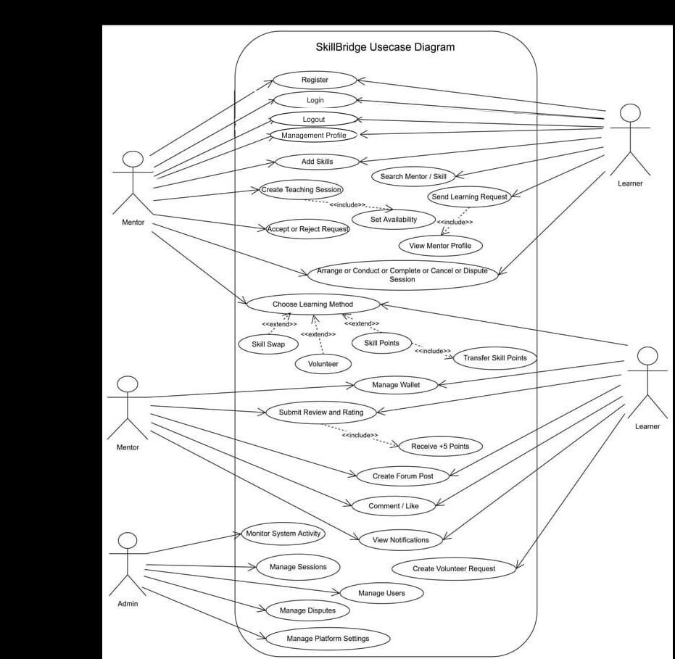
Figure 2.2 Use Case Diagram for SkillBridge
3. System Design and Architecture
3.1 System Architecture Design
SkillBridge uses a full-stack client-server architecture consisting of a frontend, backend, and database.
SkillBridge uses a full-stack client-server architecture:
- The React frontend provides the user interface.
- The TanStack Router manages client-side navigation.
- TanStack Query manages API requests and cached data.
- The Spring Boot backend exposes REST APIs.
- Spring Security handles authentication and authorization.
- Spring Data JPA communicates with PostgreSQL.
- Flyway manages database schema migrations.
- The frontend and backend communicate through HTTP and JSON APIs.
The backend follows a layered architecture:
- Controller Layer
Receives HTTP requests and returns responses to the frontend.
- Service/Application Layer
Contains business logic such as session booking, wallet operations, and user management.
- Domain/Entity Layer
Represents the main objects and entities used by the system.
- Repository/Infrastructure Layer
Handles communication between the application and database.
- Database Layer
Stores users, skills, sessions, wallets, transactions, reviews, and other system data.
System Architecture Design Diagram
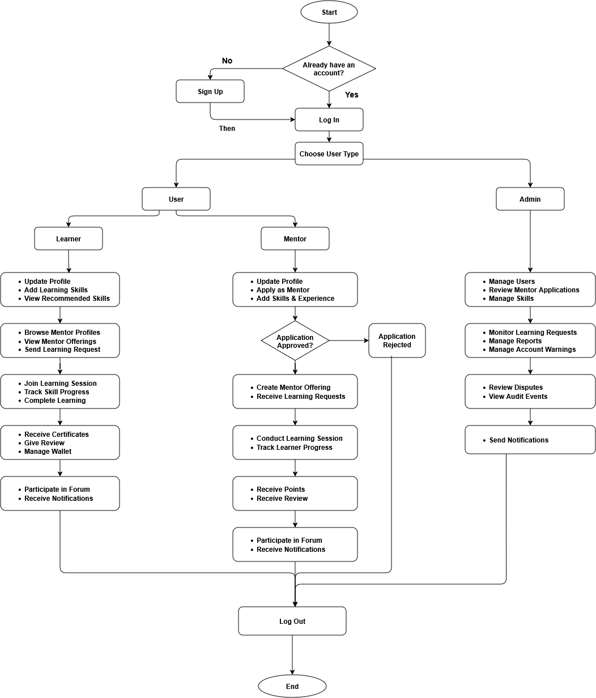
Figure 3.1 System Architecture Design of SkillBridge
3.2 Database Design: ER Diagrams
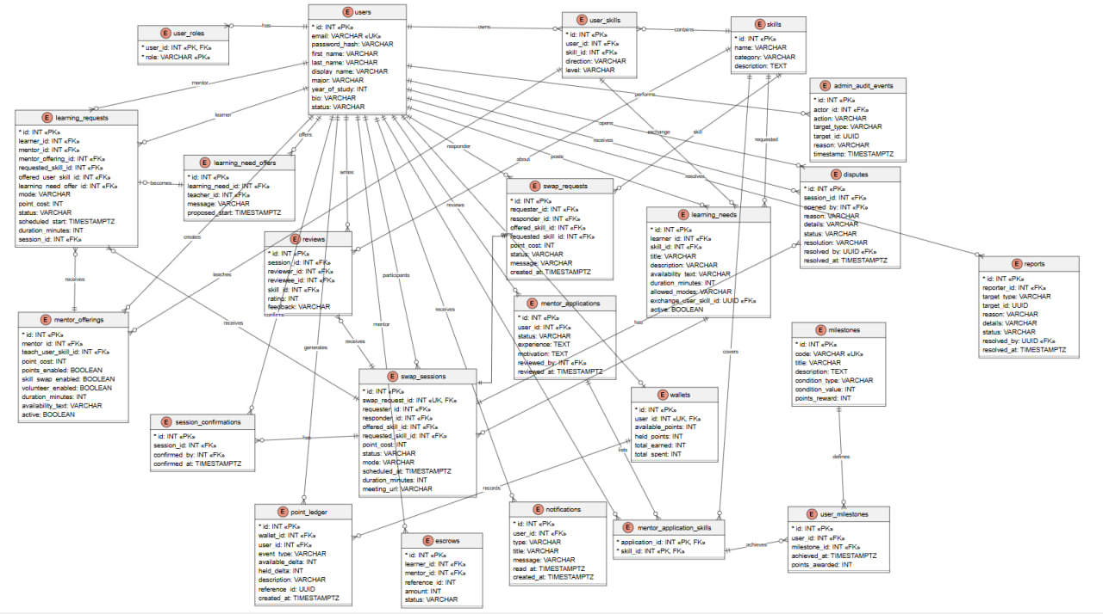
Figure 3.2 ER Diagram of SkillBridge
4. Development Environment Setup
4.1 Tools and Technologies
Area | Technologies
Frontend | React 19, TypeScript, Vite
Navigation | TanStack Router
API/Data Management | TanStack Query
UI Styling | Tailwind CSS
UI Components | Radix UI
Icons | Lucide React
Backend | Java 25 , Spring Boot
Web Framebook | Spring MVC
Security | Spring Security , JWT
Database Access | Spring Data JPA
Validation | Spring Validation
Database | PostgreSQL
Database Migration | Flyway
API Documentation | Springdoc OpenAPI, Swagger UI
Testing | JUnit, Mockito, Spring Boot Test, Vitest, React Testing Library
Build Tool | Maven
Development Tools | Visual Studio Code / IntelliJ IDEA, Git, GitHub, PowerShell
Browser Tools | Browser Developer Tools

4.2 Development Environment
The development environment requires the following software:
- Java 25
- Node.js 22.22.2 or later
- npm
- PostgreSQL 16 or later
- Git
- Visual Studio Code or IntelliJ IDEA
- A modern web browser
After cloning the project repository, frontend dependencies are installed using:
</> Bash
npm install
The backend environment file is created from the example configuration:
</> PowerShell
Copy-Item backend\.env.example backend\.env
The database URL, database username, database password, and secure JWT secret are then configured in the environment file.
The backend can be built using:
</> PowerShell
cd backend
.\mvnw.cmd clean install -DskipTests
The backend can be started using:
</> PowerShell
.\mvnw.cmd "-Dfrontend.skip=true" spring-boot:run
The API runs on port 9095, while management and health endpoints run on port 9096.
The frontend is started separately using:
</> Bash
npm run dev
The frontend runs at: http://localhost:3000
This setup allows the frontend and backend to run independently while communicating through REST APIs.
4.3 Coding Standards
Coding standards were established to make the project consistent, readable, secure, and maintainable.

Java Standards
- Follow standard Java naming conventions.
- Use meaningful class, method, and variable names.
- Organize code into controllers, services, repositories, entities, DTOs, and mappers.
- Keep business logic inside the appropriate service layer.
- Use validation for incoming data.
- Handle exceptions appropriately.

TypeScript and React Standards
- Use TypeScript types and interfaces.
- Avoid unnecessary use of any .
- Create reusable React components.
- Keep components focused on specific responsibilities.
- Use consistent naming conventions.
- Use Prettier for formatting.
- Use ESLint for identifying code-quality problems.

Security Standards
- Validate input on both frontend and backend.
- Protect API endpoints from unauthorized users.
- Never expose passwords, database credentials, or JWT secrets.
- Store sensitive configuration in .env.
- Never commit secrets to GitHub.

Version Control Standards
Git and GitHub are used for version control.
The project follows practices such as:
- Using separate Git branches for development.
- Making descriptive commit messages.
- Reviewing changes before merging.
- Keeping the repository free of sensitive credentials.

Testing Standards
Important application functionality should be tested using unit and integration tests. Backend testing uses JUnit, Mockito, and Spring Boot Test, while frontend testing uses Vitest and React Testing Library.
5. Screen Layouts and Design
The main screens include:
- Login and registration screen
- Dashboard
- Find Mentors page
- Create Session dialog
- Mentor profile and session-request dialog
- My Sessions page
- Wallet page
- Settings/profile page
- Volunteer Forum page
- Admin Portal

Design Principles
The interface follows several design principles:
- Responsive layout
- Sidebar navigation
- Top navigation bar
- Cards and badges
- Dialog-based forms
- Search and filter controls
- Calendar and time-slot selectors
- Consistent typography and spacing
- Accessible labels
- Readable color contrast
- Reusable UI components
The mentor session flow displays the mentor’s exact teaching skills, learning goals, skill levels, teaching modes, and available time slots. Learners can only select dates and times provided by that mentor.
5.1 Screen Layouts and Design
6. Conclusion and Reflection
6.1 Project Summary
SkillBridge is a peer-to-peer learning platform that integrates mentoring, skill exchange, session scheduling, volunteer learning, reviews, discussion forums, and skill-point management into one system.
The platform allows users to become both learners and mentors. Learners can search for suitable mentors, select available time slots, book sessions, and use skill points for learning. Mentors can create teaching sessions, manage their availability, and receive skill points for their teaching activities.
The use of a modern React frontend, Spring Boot backend, and PostgreSQL database provides a structured foundation for the application. Security mechanisms, validation, role-based access control, wallet transactions, and escrow are included to improve the reliability and safety of the platform.
6.2 Challenges and Solutions
The challenges and solutions for SkillBridge are as shown:
- Synchronizing frontend and backend data: It is solved using typed API services and React Query.
- Scheduling conflicts: It is solved using mentor-defined availability and restricted learner time selection.
- Point security: It is solved with wallet transactions and escrow.
- Complex permissions:It is solved with role-based access control.
- Database evolution:It is solved using Flyway migrations.
- Responsive design:It is solved using reusable React components and Tailwind CSS.
6.3 Lesson Learned
Several important lessons were learned during the development of SkillBridge.
- Clear requirements are important before development.
Understanding system requirements early helps reduce unnecessary changes during development.
- Modular architecture improves maintainability.
Separating controllers, services, repositories, and other components makes the system easier to understand and modify.
- Validation should be performed on both sides.
Frontend validation improves user experience, while backend validation provides additional security and reliability.
- Consistent API contracts are important.
Clear communication between frontend and backend reduces data-related errors.
- Testing improves software quality.
Unit and integration testing help identify problems before they reach users.
- Version control is essential for teamwork.
Git and GitHub make it easier for developers to collaborate and track changes.
- User data and credentials must be protected.
Sensitive information should never be exposed or committed to a public repository.
6.4 Future Enhancements
Although SkillBridge provides the main functionality required for peer-to-peer learning, several features could be added in the future.

Real-Time Chat
A real-time messaging system could allow learners and mentors to communicate directly before and during sessions.

Email and Push Notifications
Additional notification methods could inform users about bookings, cancellations, session reminders, and other important events.

Video Meeting Integration
Video conferencing could be integrated so users can conduct online teaching sessions directly through the platform.

Advanced Mentor Recommendations
An intelligent recommendation system could recommend mentors based on a user's skills, learning goals, previous sessions, ratings, and preferences.

Recurring Sessions
Users could schedule repeated sessions instead of creating each session individually.

Calendar Synchronization
Integration with external calendar services could help users manage their SkillBridge sessions alongside their personal schedules.

Analytics and Progress Tracking
Users could view their learning progress, completed sessions, earned points, teaching statistics, and skill development.

Mobile Application
A dedicated mobile application could provide easier access to SkillBridge from smartphones and tablets.

Additional Payment Integration
Future versions could support additional payment methods for services that are not covered by the skill-point system.
7. Appendices
7.1 Screen Design
7.2 References
- React Documentation. React Official Documentation.
- TypeScript Documentation. TypeScript Official Documentation.
- Vite Documentation. Vite Official Documentation.
- TanStack. TanStack Router Documentation.
- TanStack. TanStack Query Documentation.
- Spring. Spring Boot Documentation.
- Spring. Spring Security Documentation.
- Spring. Spring Data JPA Documentation.
- PostgreSQL Global Development Group. PostgreSQL Documentation.
- Red Gate. Flyway Documentation.
- Tailwind CSS. Tailwind CSS Documentation.
- Project source code and API documentation

