DSG1_T3_Progress_Update
Team: MHOB
Project Name: PathEats
Route-Aware Food Discovery Platform
Team member: Leng Layhok, Kong LeakSmey, Keo Seavpav

1. Requirements

Development Methodology: Agile (Scrum)
PathEats spans 5 domains (Consumer, Vendor, Global Admin, Business Assistance, Developer Admin) requiring parallel development. Agile enables:
- Iterative delivery — working increments every sprint
- Parallel feature work — via feature branches merged into dev
- API-first contracts — agree on endpoints before implementation
- Layered architecture — Route → Controller → Service → Repository → DB
- Daily integration — feature branches merge --no-ff into dev

Functional Requirements & User Stories
ID | Requirement | User Story | Status
FR-01 | User registration & login with JWT | As a user, I want to register/log in to access platform features | Done
FR-02 | Route-based vendor search (origin → destination) | As a consumer, I want to enter origin/destination to find food vendors along my route | Done
FR-03 | Filter vendors by cuisine, price, open status | As a consumer, I want to filter vendors to narrow down choices | Done
FR-04 | Vendor detail view (menu, hours, photos, reviews) | As a consumer, I want to view vendor details before deciding | Done
FR-05 | Write & read reviews for vendors | As a consumer, I want to leave reviews so others benefit | Done
FR-06 | Favorite/bookmark vendors | As a consumer, I want to save favorite vendors | In-memory
FR-07 | Vendor stall auto-approved on creation | As a vendor, my stall is immediately visible after creation (no pending approval) | Done
FR-08 | Menu item CRUD management | As a vendor, I want to manage my menu items with prices | Done
FR-09 | Vendor dashboard with metrics | As a vendor, I want to view stall metrics and performance | Done
FR-10 | Vendor location pinpoint on interactive map | As a vendor, I want to set my stall location with a draggable marker | Done
FR-11 | Admin user management (list, ban, role change) | As an admin, I want to manage users and enforce platform rules | Done
FR-12 | Business Assistance: vendor onboarding config | As a business assistant, I want to configure vendor onboarding (Telegram link, message) | Done
FR-13 | Business Assistance: stall CRUD for any vendor | As a business assistant, I want to help vendors create/update/delete their stalls | Done
FR-14 | Review moderation (flag, unflag, remove) | As a business assistant, I want to flag/unflag/remove inappropriate reviews | Done
FR-15 | Role & permissions management | As an admin, I want to manage platform roles and their privileges | Done
FR-16 | Database activity monitor & audit log | As an admin, I want to monitor live database activity and audit history | Done
FR-17 | Developer SQL query editor with presets | As a developer admin, I want to run SQL queries against the database | Done
FR-18 | System health monitoring & maintenance | As a developer admin, I want to monitor system health and run VACUUM/ANALYZE | Done

Non-Functional Requirements
ID | Requirement | Description
NFR-01 | Performance | Route-based vendor scoring responds within 3s; PostGIS spatial indexes on location data
NFR-02 | Security | JWT access/refresh tokens, bcrypt password hashing, RBAC middleware per domain
NFR-03 | Scalability | Stateless backend, pg.Pool connection pooling, GIST spatial indexes for geo queries
NFR-04 | Usability | Responsive design, dark/light theme, interactive MapLibre map with draggable marker
NFR-05 | Maintainability | Layered architecture, OOP with dependency injection, separation of concerns
NFR-06 | Reliability | PostgreSQL + PostGIS for spatial integrity; audit logging for admin actions
NFR-07 | Extensibility | API-first contracts enable independent frontend/backend development

2. Use Case Diagrams

Main Actors
- Consumer — End user searching for food along a route
- Vendor — Food stall owner managing their business
- Global Admin — Platform administrator managing users, roles, and system
- Business Assistance — Helps vendors with onboarding, stall CRUD, and review moderation
- Developer Admin — Technical admin monitoring system health and database

Use Case Diagram
Actors and their use cases:
- Consumer: Register/Login, Search Vendors by Route, Filter & Sort, View Vendor Details & Reviews, Write Reviews, Bookmark Favorites
- Vendor: Register/Login, Manage Stalls (CRUD, auto-approved), Manage Menu Items, View Vendor Dashboard, Pinpoint Location on Map
- Global Admin: Register/Login, Manage Users, Manage Roles & Permissions, Monitor DB Activity & Audit
- Business Assistance: Register/Login, CRUD Stalls for Any Vendor, Configure Onboarding, Flag/Unflag/Remove Reviews
- Developer Admin: Register/Login, Run SQL Queries, System Health & Maintenance
Full diagram in here: https://www.figma.com/board/KzteLkVhbsWYyOTZWvP07R/ERD_PATHEAT?node-id=0-1&t=BAw6zgvtrEXpZ74U-1

3. Activity Diagrams

Workflow 1: Consumer Searches for Food Along a Route
- Consumer opens the app and enters origin & destination
- System calculates route via OSRM routing service
- System queries vendors near the route using PostGIS spatial query
- Vendors are scored by distance from route, price, rating, and wait time
- Ranked results are displayed on the map and sidebar
- Consumer can filter by cuisine, price, open-now, or search by name/menu
- Consumer selects a vendor → slide-in panel shows details, menu, hours, reviews
- Consumer can write a review (rating + text) which is saved to the database
No diagram yet.

Workflow 2: Vendor Creates a Stall (Auto-Approved)
- Vendor logs in and views dashboard with stall metrics
- Vendor navigates to Stall Management
- For a new stall: fills in name, description, category, hours
- Pinpoints location on an interactive MapLibre map with draggable marker
- System creates the stall with status APPROVED — no pending/approval workflow
- Stall is immediately visible to consumers searching along routes
- For existing stalls: vendor can edit details and save changes immediately
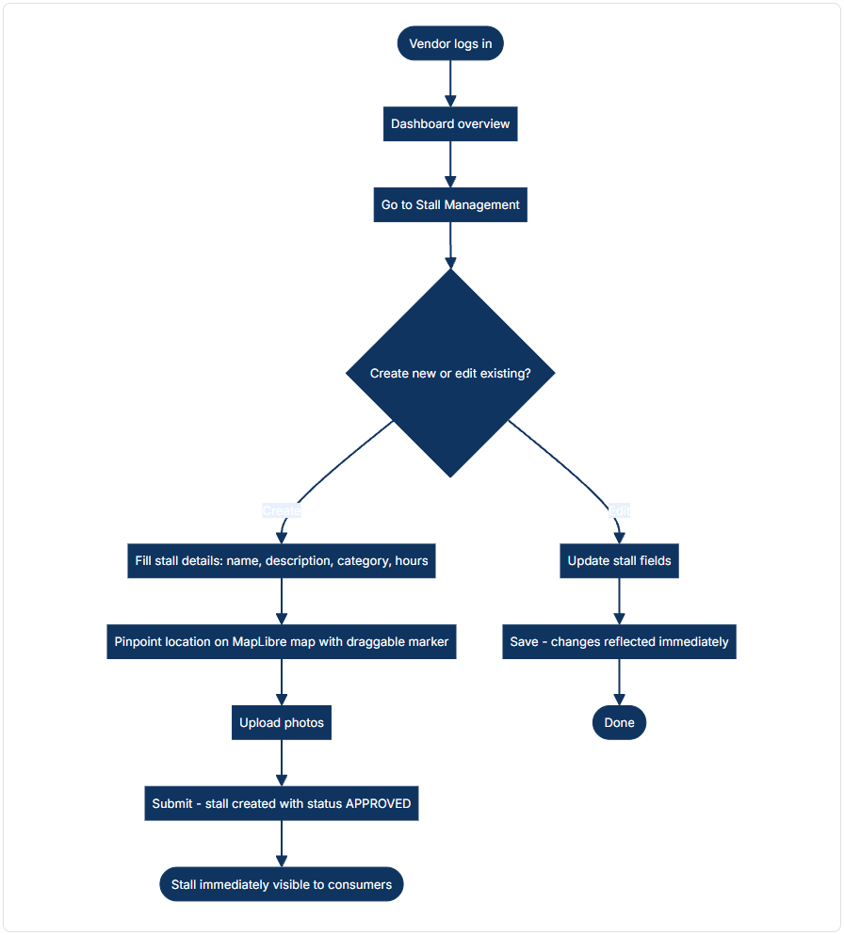

Workflow 3: Business Assistance Flags a Review
- Business Assistance logs in and navigates to Review Moderation
- All reviews are displayed with their flag status
- Agent can flag a review → marks it as flagged, hidden from public
- Agent can unflag a review → restores it to public view
- Agent can remove a review → soft-deletes it and recalculates vendor rating
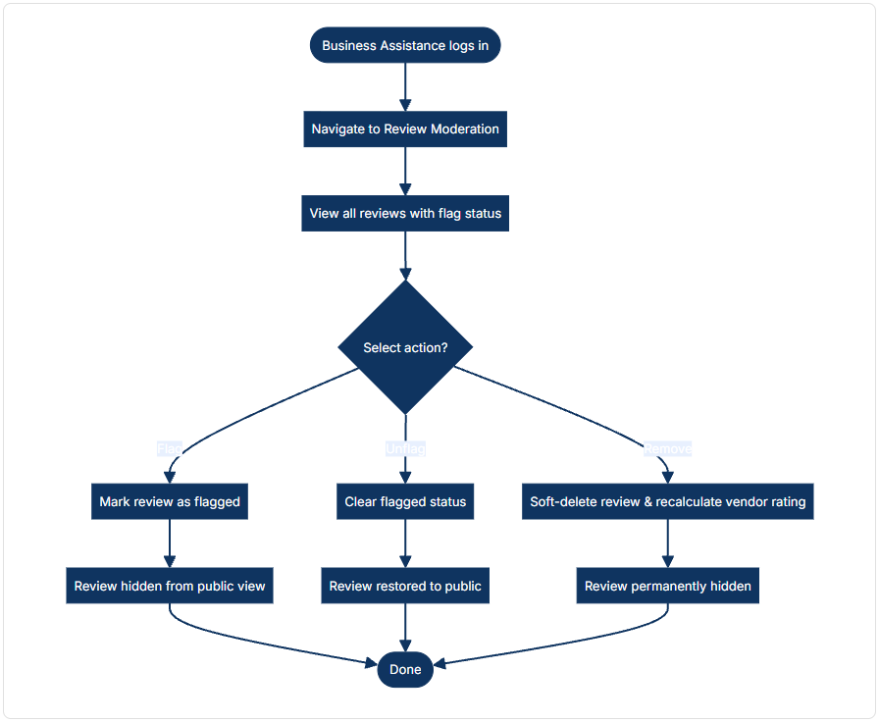

4. Team Responsibilities per User Stories
Kong LeakSmey — Consumer Domain, and also help in other admin roles.  - Route-based vendor search UI (origin/dest input, map, results strip)  - Vendor filtering by cuisine, price, open-now, search  - Vendor detail slide-in panel with menu, hours, reviews  - Review writing & display (consumer-facing)  - Favorites & search history UI  - User auth modal (login/signup)  - Map integration (MapLibre GL JS, markers, route polyline) | Leng Layhok — Vendor & Developer Admin  - Vendor stall CRUD pages & API (auto-approved on creation)  - Menu item management (frontend + backend)  - Vendor dashboard with metrics  - Location pinpoint with draggable map marker  - Vendor onboarding & settings pages  - Developer admin: SQL query editor, system health, DB maintenance  - Developer: backup/recovery management | Keo Seavpav — Global Admin & Business Assistance  - Admin user management (list, create, ban, role change)  - Role & permissions management  - Admin stall management (CRUD for any vendor's stalls)  - Review moderation: flag, unflag, soft-delete with rating recalculation  - Vendor onboarding configuration (Telegram link, message)  - Admin audit: live database activity monitor  - Auth system (JWT middleware, RBAC), database schema & PostGIS setup

5. Development Planning
Sprint 1 — Foundation Done
Week 1-2
- Project scaffolding: React + Vite + TypeScript frontend, Express + ESM backend
- Database schema: 11 tables (users, places, reviews, menu_items, etc.) with PostGIS GIST indexes
- Authentication system: register, login, JWT tokens, OTP password reset, RBAC middleware
- Core UI structure: routing, auth context, theme context, shared components
- Backend OOP architecture: repositories, services, controllers with DI
Sprint 2 — Core Features In Progress
Week 3-4
- Consumer route-based vendor search (OSRM routing + PostGIS proximity scoring)
- Interactive MapLibre map: vendor markers, route polyline, draggable marker
- Vendor stall CRUD — auto-approved on creation, no pending workflow
- Vendor dashboard with real metrics (total/open stalls, avg rating)
- Menu item CRUD (global + per-stall scoped)
- Vendor filtering: cuisine, price range, open-now, name/menu search
- Review system: consumer writes reviews, vendor views their reviews
Sprint 3 — Admin & Business Assistance Upcoming
Week 5-6
- Global admin: user management (CRUD, ban, role change)
- Business Assistance: stall CRUD for any vendor (admin-managed)
- Review moderation: flag, unflag, soft-delete with rating recalculation
- Vendor onboarding configuration (Telegram link, message via admin panel)
- Role & permissions management with JSONB privileges
- Admin audit: live pg_stat_activity + audit_log viewer
- Developer tools: SQL query editor with 11 presets, VACUUM/ANALYZE maintenance
- Developer admin: system health dashboard, backup/recovery tracking
Sprint 4 — Polish & Deployment Upcoming
Week 7
- Persist favorites & search history to backend (currently in-memory/localStorage)
- Performance optimization: map marker pooling, query caching, lazy loading
- Error boundary coverage & edge case handling
- Swagger API documentation completion
- Database indexing audit & query optimization
- Deployment to staging/production

