INSPECTION REPORT
Subject: Request for Installation of Perimeter Fence
Location: Rear of Barangay Hall, Brgy. Topland, City of Korondal
Observations:
- The only current barriers are dilapidated cyclone wire and temporary bamboo fencing.
- These existing materials are insufficient, deteriorating, and do not provide adequate security for the property.
- The back portion remains largely open and unprotected, marked mostly by overgrown grass and vegetation.
- The lack of a solid barrier allows easy unauthorized access to the Barangay Hall premises.

Findings:
- A permanent perimeter fence is needed to replace the temporary materials and secure government assets.
- A stable structure is necessary to ensure the safety of the facility and clearly define property limits.

Recommendation:
- Construction of a permanent Concrete Hollow Block (CHB) perimeter fence to replace the existing cyclone wire and bamboo.

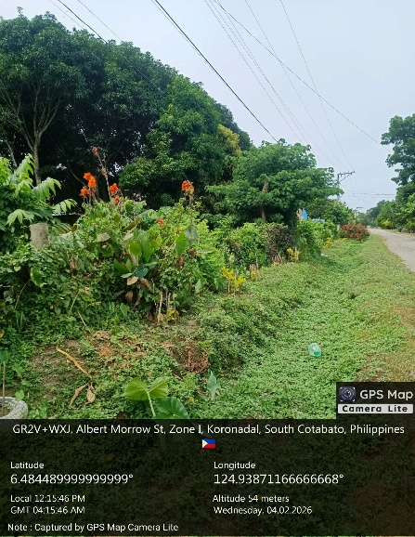
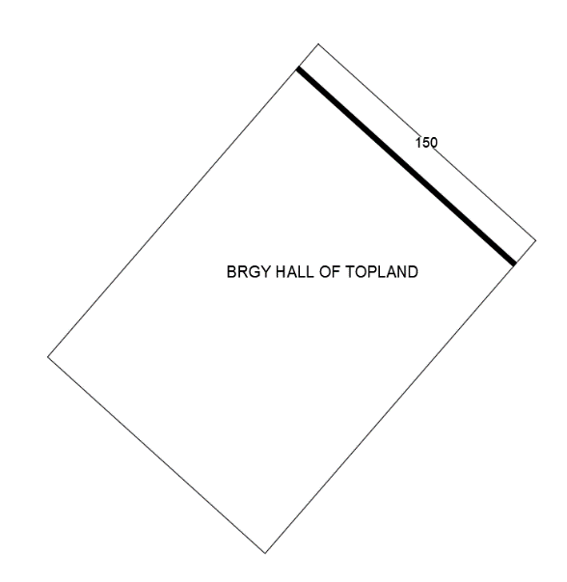
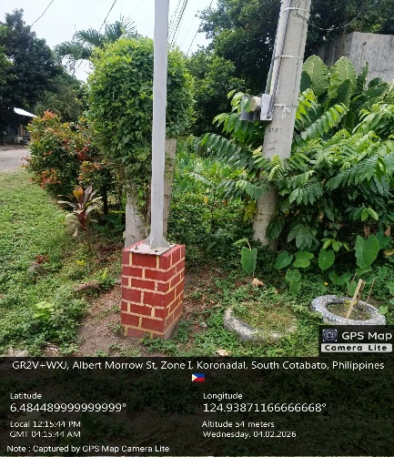
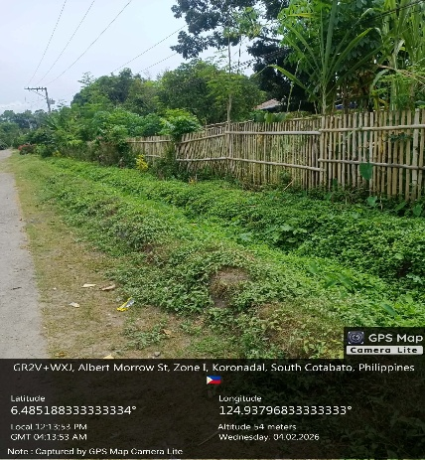
Documentation:

Inspected by: Engr. Severino Johnrome E. Usero
Date of Inspection: 30 January 2026

