NAME OF REQUESTER | LOCATION | DESCRIPTION OF REQUESTED MATERIAL | QUANTITY REQUESTED | CURRENT  STATUS
Johar Masandag | Sitio Angeles, Barangay Saravia | Concrete Pipe (No. 18) | 7 Pieces | INSPECTED
DOCUMENTATION
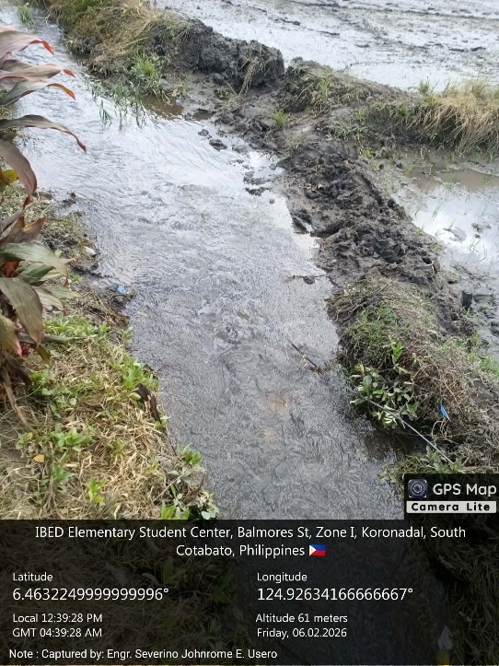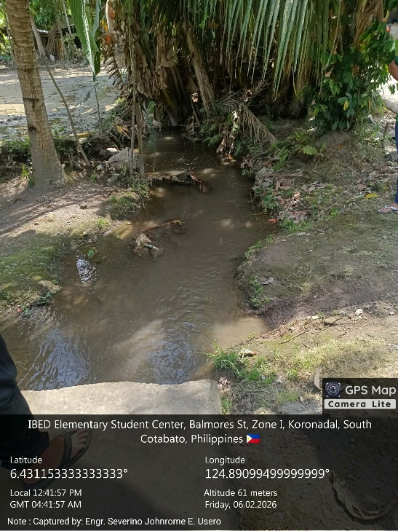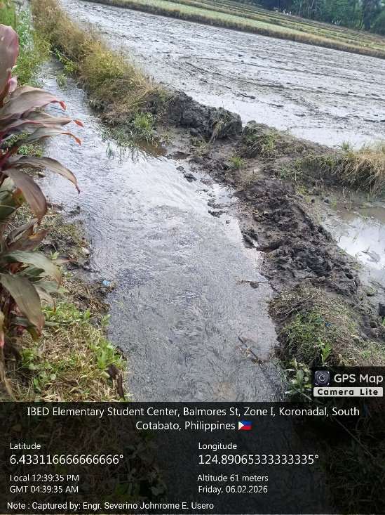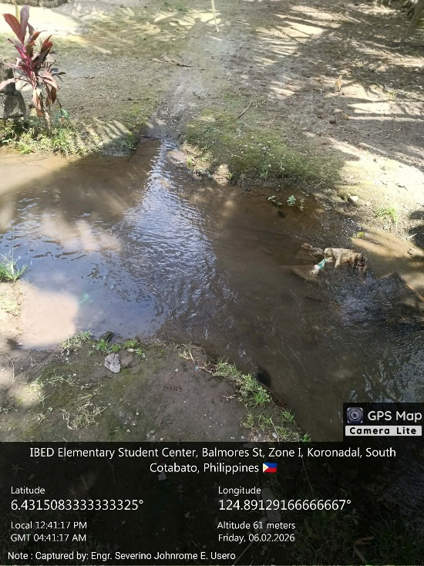

Inspected by: Engr. Severino Johnrome E. Usero
Date of Inspection: 2 February 2026

