INSPECTION OF RESIDENTIAL ASSISTANCE
NAME OF REQUESTER | LOCATION | DESCRIPTION OF REQUESTED MATERIAL | QUANTITY REQUESTED | CURRENT  STATUS
Maribelle Tumandan | Prk. Lower New Leyte Zulueta, Brgy. Topland | Corrugated GI Sheet | 10 pcs | INSPECTED
 |  | Cement | 6 bags
 |  | CWN # 3 | 3 kg
 |  | CWN # 4 | 2 kg
 |  | CWN # 5 | 3 kg
DOCUMENTATION
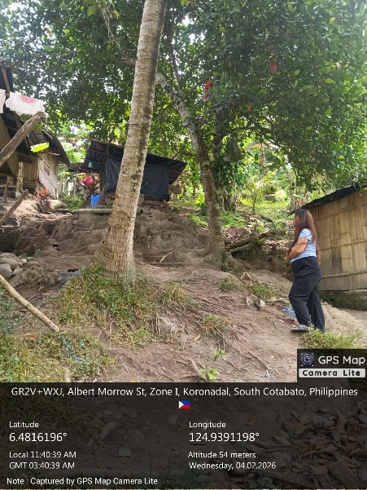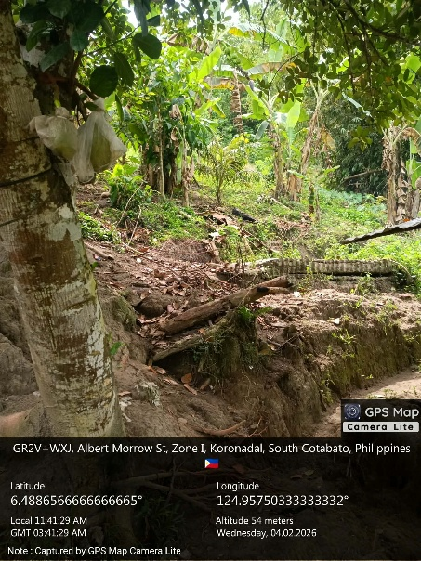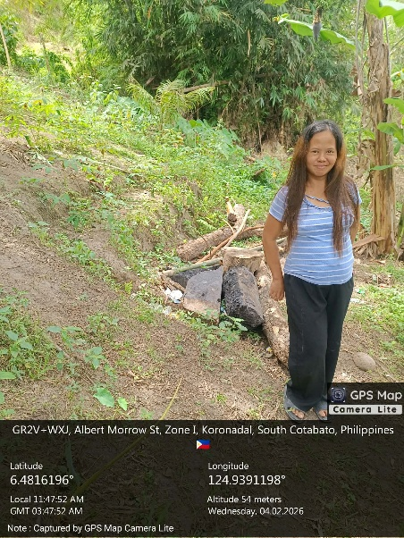
(Note: The person present in the attached picture is her sister)

Technical Findings
The request is for the construction of a private dwelling for the requester and one minor child.

Recommendation
Approval for the release of the listed construction materials to facilitate the establishment of a basic shelter.

