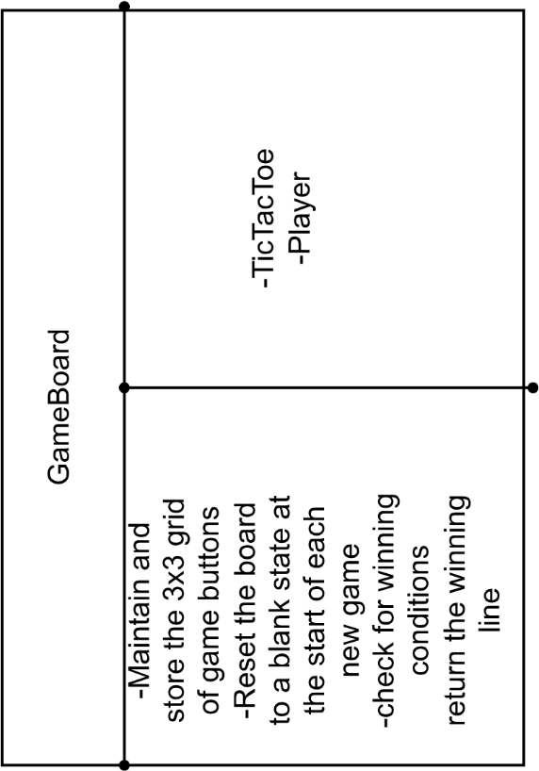
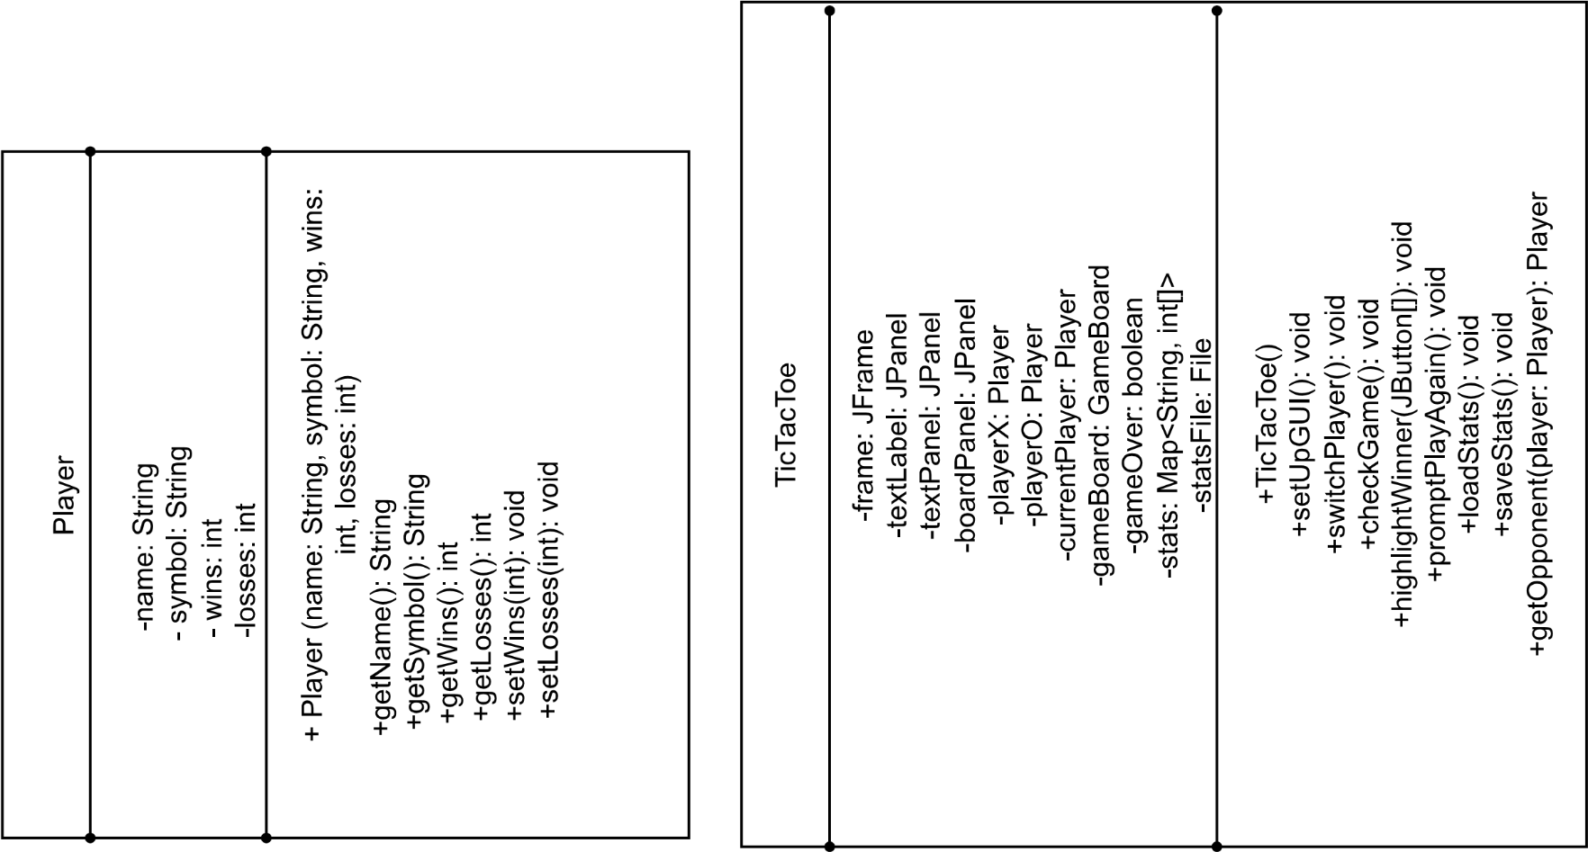
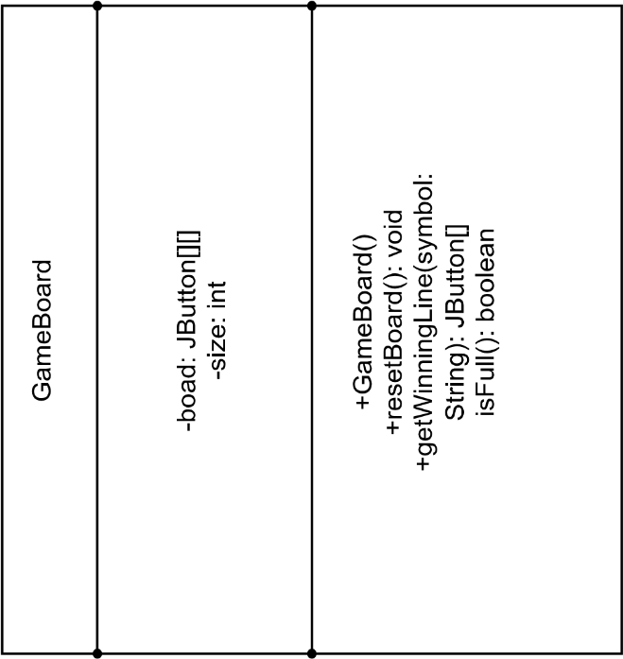

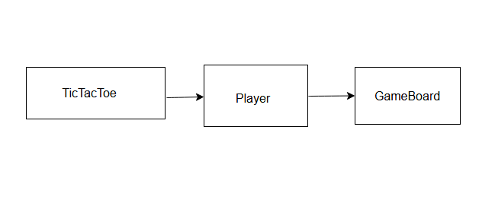
Description: Collaborators: none
I, Lauren Lay, worked on this project alone. The project is a GUI-based Tic-Tac-Toe game for two players. Players take turns placing their symbols (X or O) on a 3x3 grid. The game detects wins, ties, and keeps track of each player’s statistics across multiple rounds. Players can enter custom nicknames, and game history is saved in a text file. The program uses object-oriented design principles to separate concerns into different classes, including Player, GameBoard, and the main TicTacToe controller.

Repository: https://github.com/Laylauren/TicTacToe

