DL EXAM
Sentiment Analysis from text and Images

1st Step:
The First step is to load the data which is straightforward with the help of Kaggle API
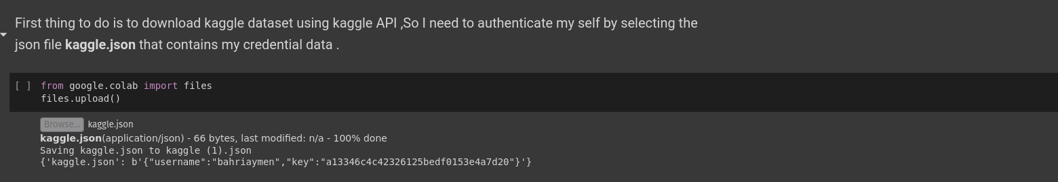
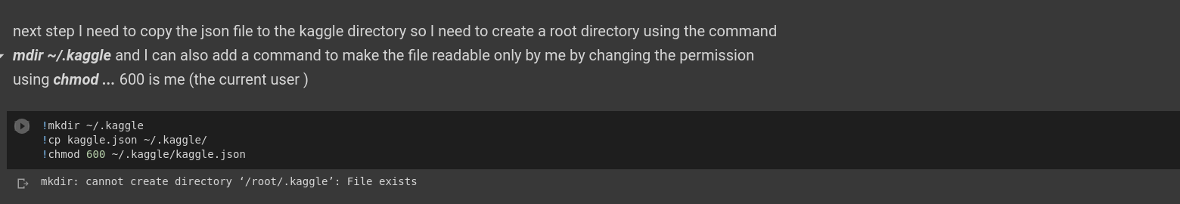

2nd Step :
After Unzipping the data an important step (that I see it important is to split the images of each class rename them according to their class and move them to subdirectories of train ,validation and test ,this step is the most important step because it helps us use the dataset object later by calling image_dataset_from_directory ,which in turns will generate batches of data from each class ,reshaped to our desired shape ,i.e (300,300) and their corresponding labels

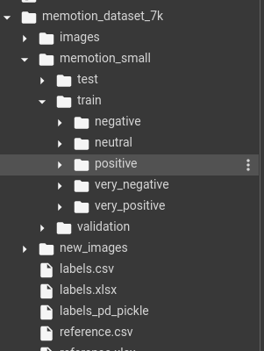

after runing the code cell we end up with those directories ,the dataset object used later will list all subdirectories lets say for training and returns an iterable object that I will feed it into the model

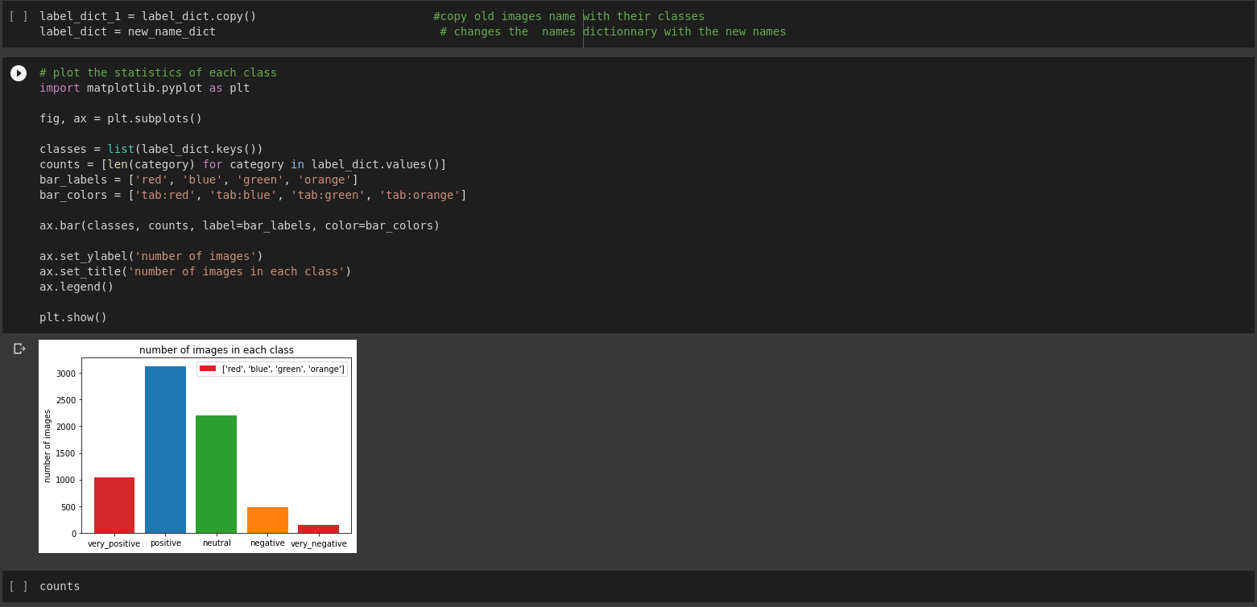
the data distribution is very unbalanced ,classes negative and very negative contains a small number of samples ,so the model will be not able to generalize on those tow classes and will certainly overfits on the others .I could use data augmentation to increase the number of samples of those tow classes but I won’t use it since visually speaking ,images of the same class doesn’t have sheared patterns between them so this step could be useless ,it could be useful but I won’t include it here

3rd Step :
I can now prepare a basic model architecture ,since I am dealing with images ,CNN models will be the best choice because as opposed to dense layers ,they learn features from their position in images and can recognize them anywhere later when testing the model
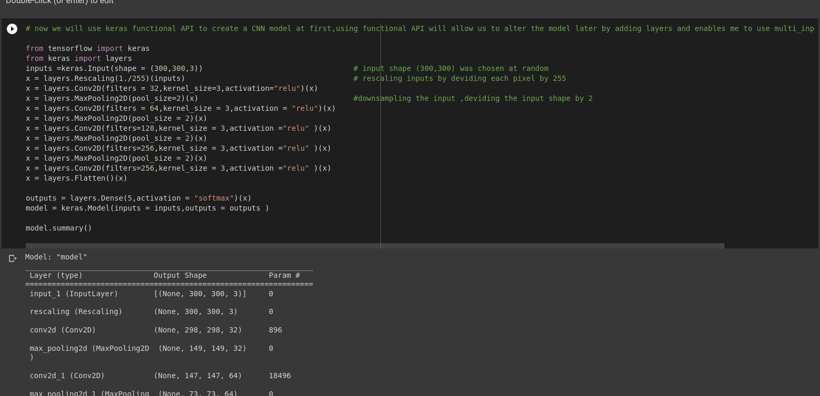

The MaxPooling layers used will downsample the feature maps by halving them(deviding by 2 the dimension of their outputs it consists of extracting windows from the input feature maps(output of convolution layers ) and outputting the max value of each channel.

4th Step :
I need to split the data between training ,test,and validation
the number of samples chosen for each call is much random because the negative and very negative classes contains very few examples ,we tried to split them by using most of them on training (200 negative ,100 very negative ) and the rest to test and validation
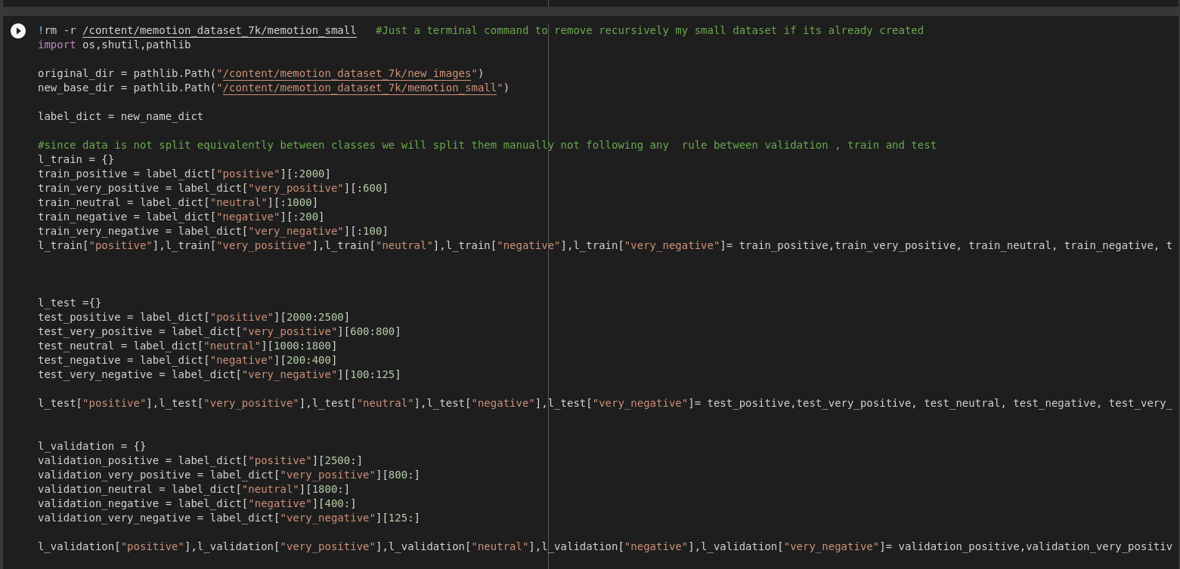
Now that train,validation and test contain the chosen number of images for each class we need to create subdirectories and save data for each set accordingly ,this what the function make_subset does :
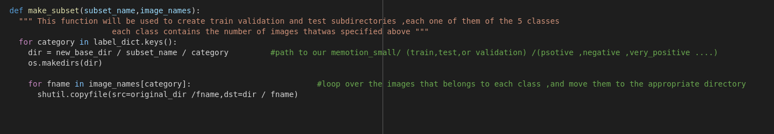

we call the function and give it as parameters the name of our 3 directories (train,validation,test) and the dictionary that contains the data for each set ,for the train set for example ,it will create a subdirectory inside memotion_small called train,and 5 sub_directories with the name of the five classes ,for each class it copies the images according to their names drawn from the dictionary to the specified directory holding that class name .
5th Step :
Since our directories are ready and each one contains the correct data ,we can now use the dataset object by using the image_dataset_from_directory class as discussed before it will list all the subdirectories assuming that each (train,validation,test) contains correct subdirectories with correct data ,it will then assign classes to those subdirectories ,ordered list of integers as the subdirectories order .

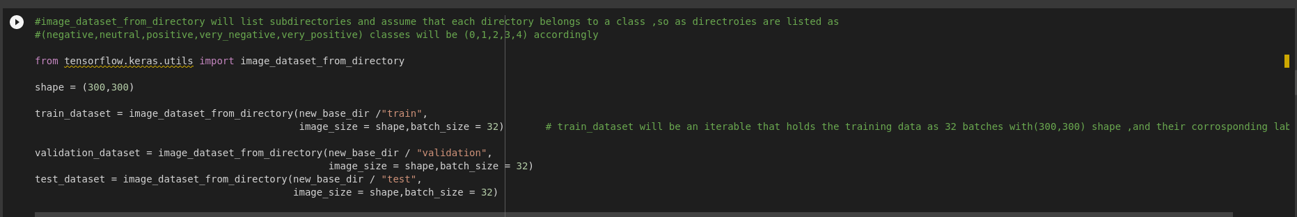

We can check for instance the shape of tensors that the image_dataset_from_directory returns ,it returns an iterable that we can loop on its elements .
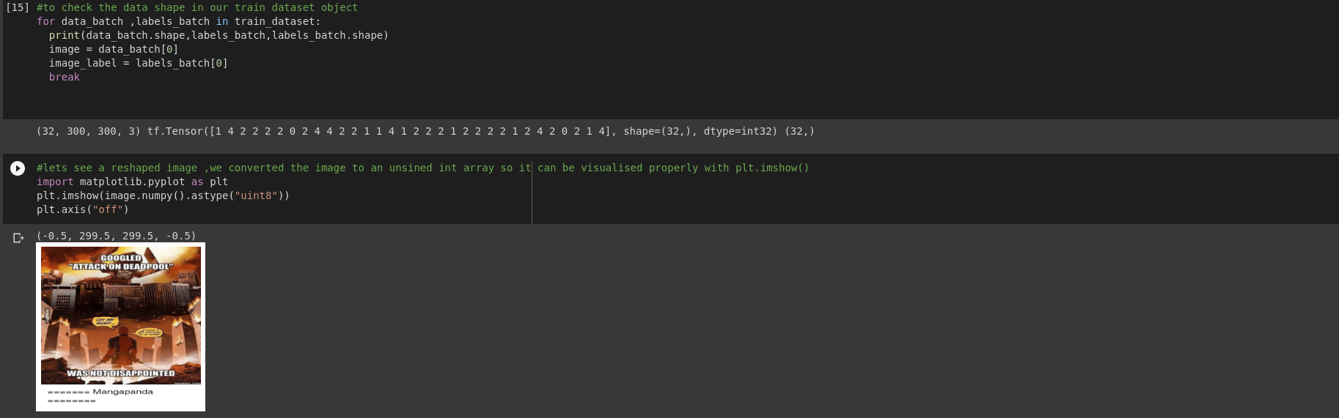
The shape of the data is (32,300,300,3) which is a batch of 32 samples of (300,300) 3 channel images

6th Step :
Now we are ready to fit our model ,at first sight we can only fit the data ,see if the model fit and try different number of epochs and batch sizes ,to remove the need of waiting till the end of fit each time to check the accuracy and loss on train and validation we can simply use keras callbacks ,EarlyStopping ,specify which metric to monitor and the number of epochs where to interrupt the fit if there are no change or improvements .
We can also use ModelCheckpoint callback to save the best version of the model obtained .
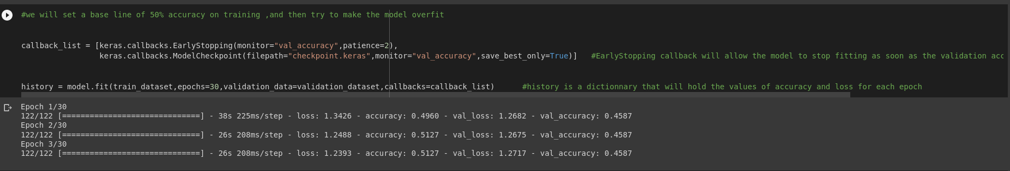
7th Step :

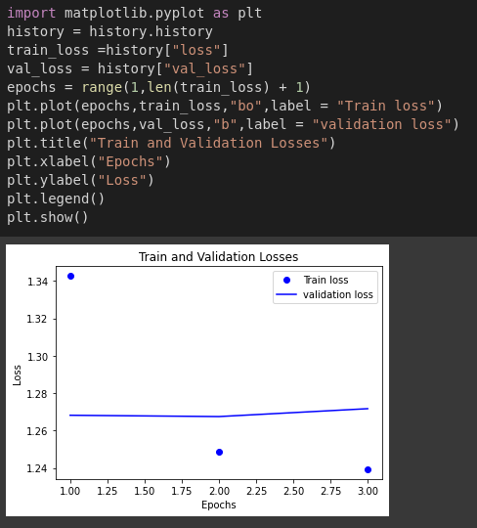
To be able to plot metrics versus epochs the fit method returns and object that has an attribute called history that records metrics during each epoch ,we can use it to plot the accuracy and loss for both train and validation .

Now that the accuracy of train is very low ,we can think of increasing the number of layers ,which means giving the model more degrees of freedom ,adding layers will allow the model to learn more complex representation on the way and can help it (a big theoretical maybe ) learn a better representation of the data ,this will never happen mainly because looking at the images can say that data is very noisy meaning that each class related to an image doesn’t really hold any clear visual representation with respect to other images ,so likely the model won’t be able to learn any good representations of those data ,and since images contains text ,where text is more related to the classes ,maybe we can use a multi input model and make it learn to link images to text ,this what we tried but didn’t work due to the labels of both classes ,I try to make it work nevertheless .

We can list the layers of our model
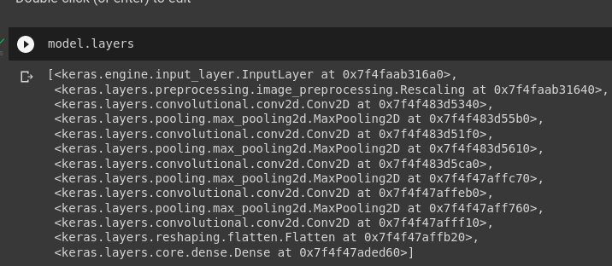

We can see that the index of the layer just before flatten ,is 10
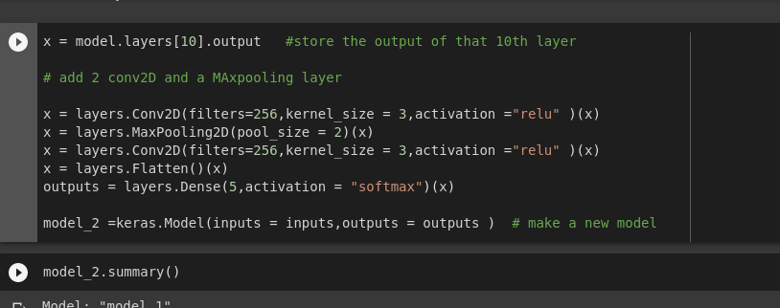
so we can use the output of this layer and use it as the input for the new layers that we will add to the model ,here 2 conv2D layers with a maxpooling in between ,since maxpooling halves the shape by 2 ,we just used one layer ,so we don’t need to change the input shape .

8th Step :

we compile and fit the model just as before
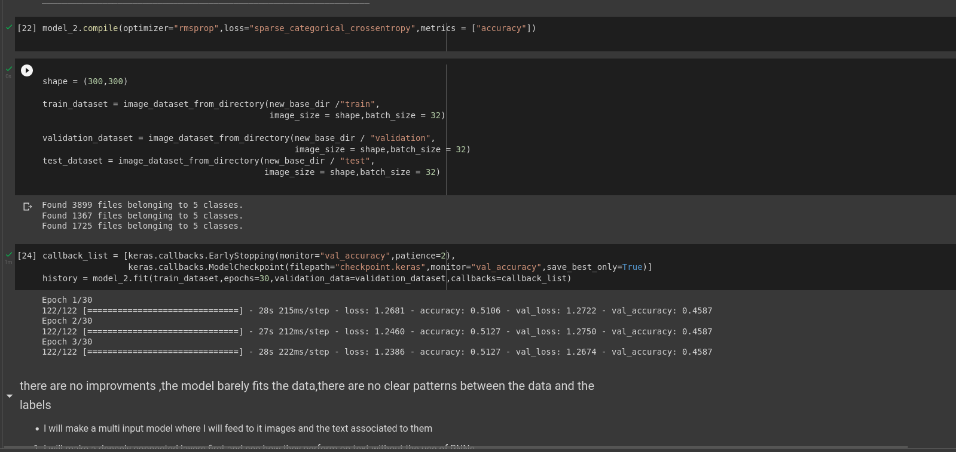

we can see that the accuracy of training was improved for the first epoch but the values are the same as the old model so there are no improvements
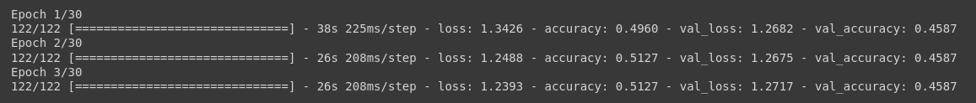Figure 1: old model
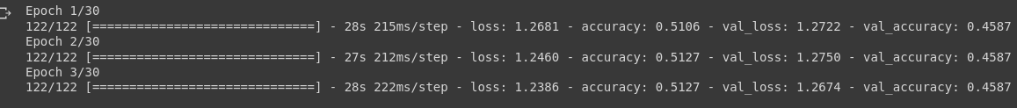Figure 2: model with added layers

9th Step :
Now we will make a new model to process text instead of a CNN model ,the model will be a simple sequential model ,

as what we did with images ,instead of recording the names of images belonging to each class ,I will record the text belonging to each class ,letting in mind that I need to maintain the same index for the text and images so I keep the same labels (having in mind that I will use the multi input model in future )

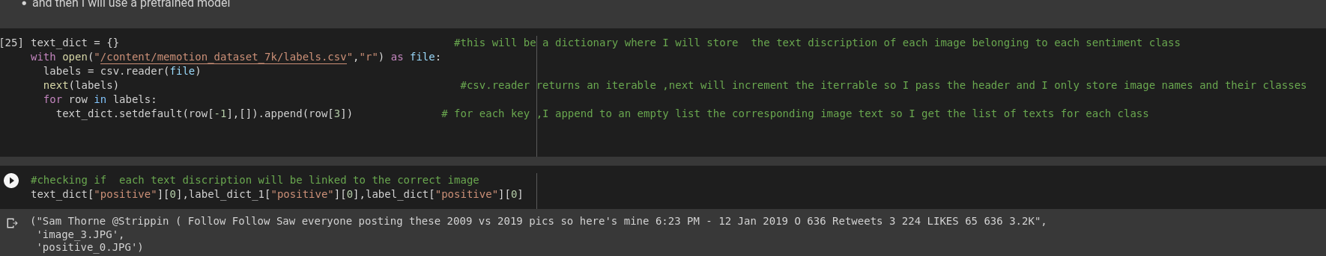

the text descriptions are in the 4th column of the csv file ,classes are in the final column (index -1, and 3) so for each class as a key I append to an empty list the corresponding class ,that empty list is the value of the text_dict dictionary .

now we need to decode the text into integers with the help of a dictionary ,We though that we could use a dictionary from the imdb example that is prebuilt in keras .
So for each word we store the index of the corresponding word if its exists if it doesn’t I replace it with 0 instead ,this could not be practical because 0 could alter the text meaning and bias the model,but it what I though about using .
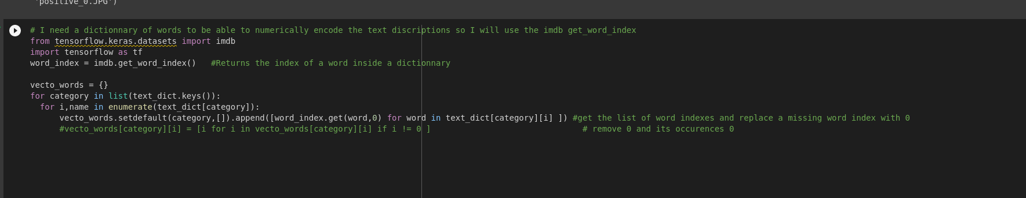
Just as before,for each class ,I add to an empty list a list that contains the integers for each text ,the role of get word method is will return the index of the word if it exist ,or it will return 0 if not

10th Step :
Now that we have numbers instead of words ,we prepare the train ,test and validation the same way we did with images

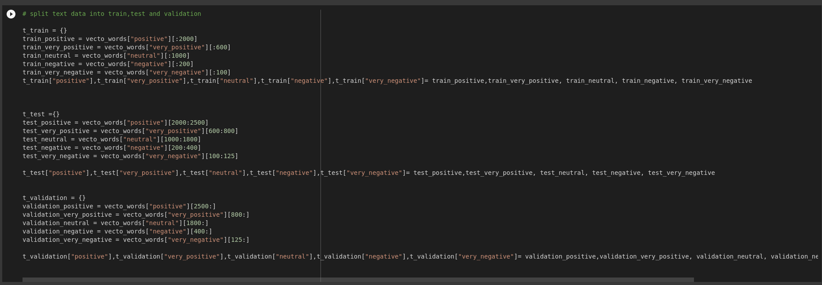

11th Step :

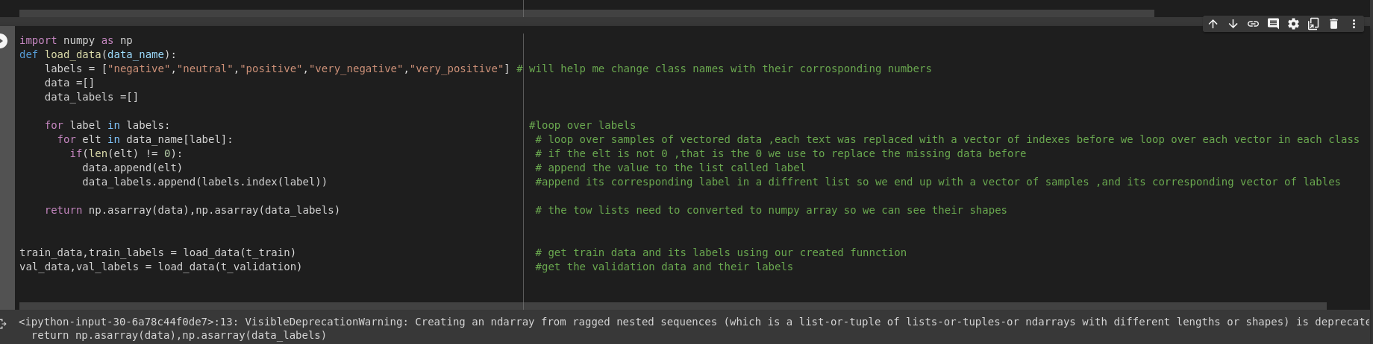
the data is stored in a dictionary and to be able to use it to train a model it should be in the form of tensors ,so we defined a function that transforms the data ,for each vector belonging to each class ,store the vector on a list and its corresponding class in separate list ,we used the same labels as in the CNN section ,hoping that later I can use them both to tra11th Step :in a multi input model

12th Step:
we can now define a sequential model ,before feeding the data to this model we should convert it to a tensor that contains only 0s and 1s ,so we used a function that takes each data vector and replace each index of that vector by 1 in that position index ,for making such a tensor we need to search for the max index available in the train an validation data because that will be used as the second axis dimension for our tensor ,we finally get a tensor with (number of samples ,dimension) shape ,for each sample we have a vector that contains 0 and 1s ,and its label ,we could also hot encode the labels ,for this we used to_categorical

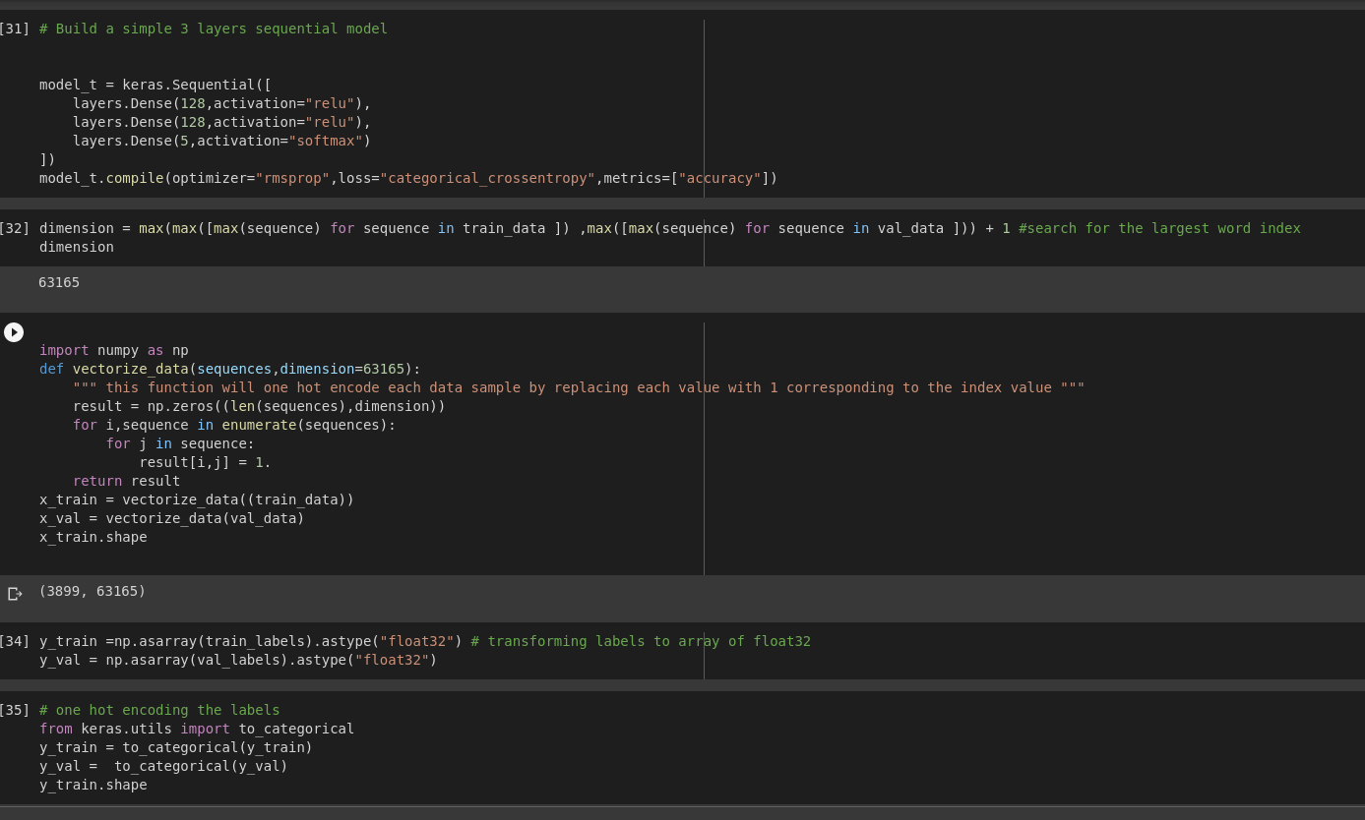

we fit then our model
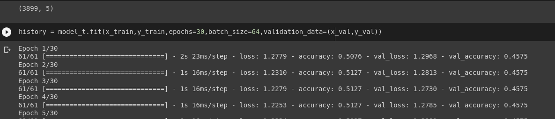

add more layers to see if we can make him over fits and use callbacks
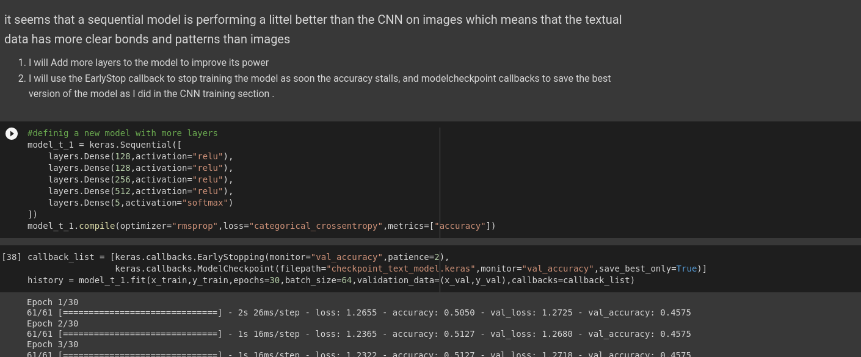
3th Step :

since the text and images seems to hold the same results I hough of using a multiinput model with the help of the functional api but it didn’t work due to an error because of data labeling ,one coming from dataset objects and the others from a tensor ,nonetheless Ill try to make it work and see what it gives
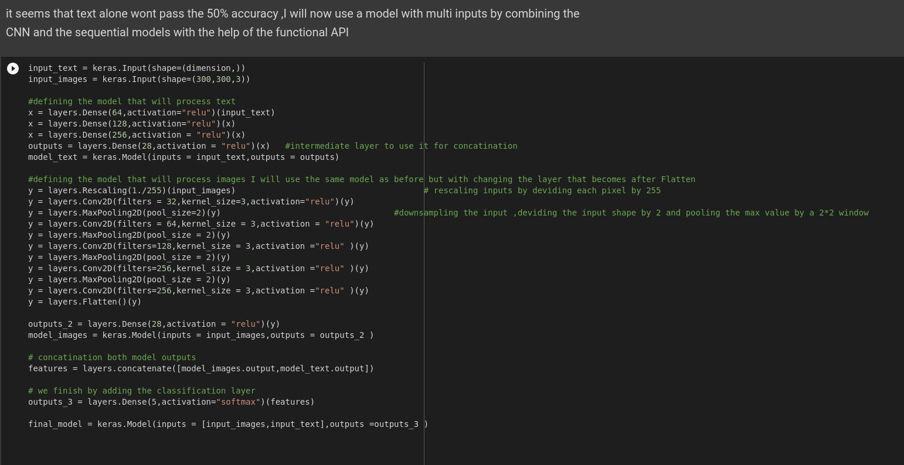
Final Step:
the final step was to use a pretrained model ,we could use Xception ,ResNet ,Densnet ,VGG19 or others ,we tried to use VGG16 a pretrained model on the ImageNet dataset with 1000 classes ,the first thing after importing the model base ,without the classification layer is to ,use its base to predict on the train and validation data,and record that output in list ,that will be used later as an input to a classifier that we create for our needs ,5 class classification ,,this is exactly as freezing the weights and training the classification layer

