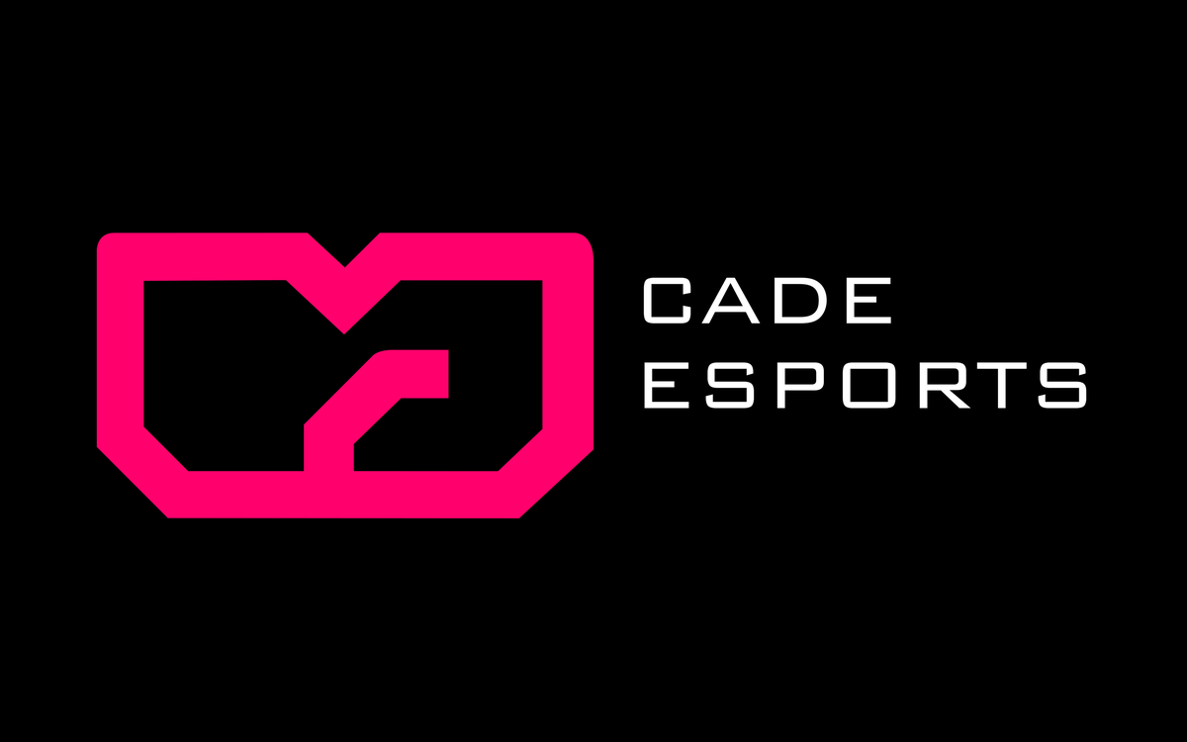

CADE ESPORTS ESOCCER LEAGUE
PLAYER REGISTRATION AGREEMENT
& CODE OF CONDUCT

Season 2025-2026 | Version 1.7 | Binding Contract

⚠ READ CAREFULLY BEFORE SIGNING
This Agreement is a legally binding contract between you and CADE Esports. By signing it, you agree to be bound by the Official Rulebook & Regulations, the Integrity & Anti-Match Fixing Policy, and all other official CADE Esports policies. Do not sign if you have not read and understood all three documents in full. Ignorance of any rule will not be accepted as a defence in any disciplinary proceeding.

SECTION A: PARTIES TO THIS AGREEMENT

This Agreement is entered into between:

PARTY 1: CADE ESPORTS ("the Organiser")
The organising body of the CADE Esports eSoccer League. By issuing this Agreement, CADE Esports agrees to administer the League in accordance with the published rules and to fulfil its obligations set out herein.

PARTY 2: THE PLAYER ("the Participant")
The individual signing this Agreement, whose details are set out in Section B below.

SECTION B: PLAYER REGISTRATION DETAILS
Complete ALL fields. Incomplete registrations will not be processed.

Full Legal Name

Date of Birth

Gender

Nationality

State of Origin

City / LGA of Residence

Phone Number (Primary)

Phone Number (Secondary)

Email Address

ID Type

ID Number

EA Account Username / GamerTag

PSN ID

Division Registering For | Division 1 / Division 2 / Division 3 / Onile (circle one)

BANK ACCOUNT FOR PRIZE DISBURSEMENT
(Required for Division 1 & Division 2. Prizes paid to registered account only.)

Bank Name

Account Name

Account Number

SECTION C: DIVISION 1 ADDITIONAL REGISTRATION DETAILS
Complete this section in full. All Division 1 players must be affiliated with a registered Esports Organisation. Solo registration is not permitted.

AFFILIATED ESPORTS ORGANISATION

Organisation Name

CAC Registration Number

Date of CAC Registration

Organisation HQ Address

Organisation Contact Person

Organisation Contact Phone

Organisation Contact Email

Documents Attached (tick all that apply):

☐ | CAC Certificate of Incorporation | ☐ | Organisation-Player Contract (signed)
☐ | Player’s Government-Issued ID | ☐ | Coach Registration Form
☐ | Passport Photograph | ☐ | Bank Account Details (for prize disbursement)

REGISTERED COACH DETAILS

Coach Full Name

Coach Phone Number

Coach Email Address

Coach ID Type & Number

SECTION D: TERMS & CONDITIONS OF PARTICIPATION

ARTICLE 1: ACKNOWLEDGEMENT OF RULES
1.1 The Participant acknowledges that they have received, read, and fully understood the following documents, each of which forms part of this Agreement:

  - CADE Esports eSoccer League: Official Rulebook & Regulations (Version 1.7, Season 2025-2026)
  - CADE Esports: Integrity, Anti-Match Fixing & Betting Policy (Version 1.4, Season 2025-2026)
  - This Player Registration Agreement & Code of Conduct

1.2 The Participant agrees to comply fully with all provisions of the above documents throughout the season and any subsequent disciplinary period.
1.3 The Participant acknowledges that ignorance of any rule shall not be accepted as a defence in any disciplinary proceeding.

ARTICLE 2: ELIGIBILITY DECLARATIONS
2.1 The Participant declares that all information provided in Sections B and C of this Agreement is true, accurate, and complete. They understand that providing false information is grounds for immediate disqualification and a potential ban.
2.2 The Participant declares that they meet all eligibility requirements for the division in which they are registering, as set out in Part Two of the Official Rulebook.
2.3 The Participant declares that they are not currently serving a ban or suspension imposed by CADE Esports or any other recognised esports governing body, except as previously disclosed in writing to CADE.
2.4 The Participant declares that their EA account is in good standing and that they are the sole authorised user of that account. Account sharing or use of another person’s account in CADE competition is prohibited.
2.5 Division 1 specific: The Participant declares that their affiliated organisation is a CAC-registered legal entity and that a valid Organisation-Player Contract is in place. They further declare that they have a registered coach as required by the Rulebook.

ARTICLE 3: MATCH PARTICIPATION OBLIGATIONS
3.1 The Participant agrees to be available for ALL scheduled match days throughout the entire season without exception. Failure to appear on any match day without an approved reason is a breach of this Agreement.
3.2 The Participant agrees to arrive at the official venue ON TIME as specified in the match day schedule, regardless of when their individual match is scheduled. Being present but not checked in with the LOC representative does not constitute punctual arrival.
3.3 The Participant acknowledges and accepts the progressive late arrival sanction system set out in Section 3.8 of the Official Rulebook, including point deductions and the possibility of a season ban for repeated lateness.
3.4 The Participant agrees to dress appropriately and presentably at all official CADE events, in accordance with the Dress Code requirements in Section 3.7 of the Official Rulebook.
3.5 The Participant agrees to notify the League Operations Committee at least 2 hours in advance of any genuine inability to attend a scheduled match, and to provide supporting documentation within 24 hours.
3.6 The Participant acknowledges that repeated unexcused absences, unexplained forfeits, or suspicious patterns of non-performance may be referred to the Integrity & Disciplinary Committee.
3.7 Division 1 specific: The Participant agrees to submit their FUT squad roster to the LOC by 10:00 AM every Thursday before a match weekend. The Participant acknowledges that failure to submit may result in a forfeit for that weekend’s matches.
3.8 Division 1 specific: The Participant agrees to post at least once per week on a minimum of two (2) of the following platforms: Twitter/X, Instagram, or TikTok, positively promoting the CADE Esports eSoccer League and encouraging viewership. The Participant acknowledges that failure to comply with this obligation may result in league point deductions.
3.9 Division 2 specific: The Participant confirms that they will bring their own console, controller, and peripherals to every in-person match event, and that their equipment will comply with the BYOD rules in the Rulebook.

ARTICLE 4: INTEGRITY & ANTI-CORRUPTION OBLIGATIONS
The obligations in this Article are among the most important in this Agreement. Breach of any clause in Article 4 may result in permanent disqualification from all CADE Esports competitions.

4.1 The Participant agrees NOT to engage in, attempt, or facilitate match fixing, spot fixing, result manipulation, deliberate underperformance for corrupt purposes, or any other form of conduct prohibited under the CADE Integrity Policy.
4.2 The Participant agrees NOT to place any bet on any match in which they are a direct participant.
4.3 The Participant agrees NOT to place any bet on any CADE League match using inside information obtained by virtue of their participation in the League.
4.4 The Participant agrees NOT to disclose inside information (squad selection, health/form, withdrawal intent, or other non-public information) to any person where there are reasonable grounds to believe that person could use it for betting advantage.
4.5 The Participant agrees that if they receive ANY approach from any person seeking to arrange corrupt conduct or obtain inside information for betting purposes, they WILL report that approach to the IDC within 24 hours via the Confidential Reporting Hotline, and will preserve all communications relating to the approach.
4.6 The Participant acknowledges that failure to report a corrupt approach within 24 hours is itself a disciplinary offence under the Integrity Policy.
4.7 The Participant consents to the monitoring of their in-game performance data and, where legally permissible and a warrant or appropriate legal process is obtained, their betting account activity, for the purposes of integrity monitoring.
4.8 The Participant agrees to cooperate fully and honestly with any IDC investigation, including attending hearings, providing documents, and giving truthful testimony. Obstruction or dishonesty in an investigation will be treated as a serious aggravating factor.

ARTICLE 5: CODE OF CONDUCT
5.1 The Participant agrees to treat all fellow players, coaches, officials, volunteers, spectators, and CADE staff with respect and dignity at all times.
5.2 The Participant agrees that any public statement (spoken, written, or social media post) that brings CADE Esports, its competitions, its sponsors, or its participants into disrepute may constitute a conduct violation subject to disciplinary action.
5.3 The Participant agrees not to use offensive, abusive, racist, sexist, homophobic, or otherwise discriminatory language in any official CADE communication or at any CADE event.
5.4 The Participant agrees not to consume alcohol or controlled substances during any official CADE match event. Arriving at an event visibly impaired is a conduct violation.
5.5 The Participant agrees not to engage in, encourage, or allow cheating behaviour, including use of exploits, glitches, unauthorised software, macros, or modified hardware, in any CADE match.

ARTICLE 6: PRIVACY & DATA CONSENT
6.1 The Participant consents to CADE Esports collecting and processing their personal data (name, contact details, ID, EA account data, in-game performance data, match recordings) for the purposes of: (a) competition administration; (b) prize disbursement; (c) integrity monitoring; (d) regulatory compliance; and (e) marketing communications (which may be opted out of separately).
6.2 CADE Esports will process personal data in accordance with the Nigerian Data Protection Act 2023 (NDPA). Data will not be sold to third parties, but may be shared with: (a) licensed betting operators for integrity purposes; (b) law enforcement bodies under legal compulsion; and (c) the EA platform as required for competition administration.

ARTICLE 7: PRIZE MONEY & FINANCIAL TERMS
7.1 Prizes will be disbursed to the bank account registered in Section B of this Agreement within SIXTY (60) working days of the season’s conclusion. The Division 1 prize pool for Season 2025/2026 is ₦3,000,000 total, distributed as shown in the table below.
DIVISION 1 PRIZE DISTRIBUTION (TOTAL POOL: ₦3,000,000)
Position | Prize
🥇 1st Place | ₦1,000,000
🥈 2nd Place | ₦600,000
🥉 3rd Place | ₦400,000
🏅 4th Place | ₦300,000
🎖 5th Place | ₦200,000
6th Place | ₦150,000
7th Place | ₦100,000
8th Place | ₦50,000
9th to 16th (Relegation) | ₦25,000 each

7.2 Prizes are subject to applicable Nigerian withholding tax. CADE Esports will deduct and remit withholding tax as required by Nigerian tax law and will provide documentation to the Participant.
7.3 A Participant under investigation for or convicted of an integrity violation at the time of prize disbursement will have their prize withheld pending resolution. If found guilty, prizes relating to the affected matches or season may be permanently forfeited.
7.4 The Participant acknowledges that CADE Esports has no obligation to compensate any player for costs of participation including equipment, travel, squad development (FUT coins/cards), or other personal expenditures, unless specifically agreed in a separate commercial arrangement.

ARTICLE 8: SANCTIONS & CONSEQUENCES
8.1 The Participant acknowledges that breach of any provision of this Agreement, the Official Rulebook, or the Integrity Policy may result in one or more of the following sanctions:

  - Formal written warning
  - Match forfeit and/or suspension
  - Relegation or disqualification from the current season
  - Forfeiture of prize money
  - Temporary or permanent ban from all CADE Esports competitions
  - Public announcement of disciplinary action
  - Referral to Nigerian law enforcement authorities (for criminal conduct)

8.2 The Participant acknowledges that the IDC has full authority to impose these sanctions, and that the IDC’s decision may only be challenged through the formal appeals process set out in the Integrity Policy.
8.3 The Participant agrees that CADE Esports’ financial liability for any act or omission under this Agreement is limited to the return of the registration fee paid, except in cases of CADE’s proven gross negligence.

ARTICLE 9: TERM & TERMINATION
9.1 This Agreement is effective from the date of signing and remains in force for the duration of the Season 2025-2026, including any applicable disciplinary periods extending beyond the season.
9.2 CADE Esports may terminate this Agreement and a Participant’s registration immediately upon a finding of an integrity violation or serious conduct breach.
9.3 A Participant who voluntarily withdraws from the League must notify the LOC in writing. Voluntary withdrawal does not refund registration fees and the Participant remains bound by confidentiality and integrity obligations for 1 year post-withdrawal.

ARTICLE 10: ORGANISATION LIABILITY
10.1 The registered Esports Organisation affiliated with the Participant (as named in Section C) acknowledges and accepts joint responsibility for ensuring that the Participant complies with all obligations under this Agreement, the Official Rulebook, and the Integrity Policy throughout the season.
10.2 Where a Participant is found guilty of a serious integrity violation, including but not limited to match fixing, spot fixing, corrupt betting, deliberate corrupt forfeiting, or any other form of fraud connected to CADE League competitions: the affiliated organisation may be held legally liable and subject to civil action by CADE Esports, affected third parties (including licensed betting operators and sponsors), and other aggrieved parties under applicable Nigerian law.
10.3 CADE Esports reserves the right to notify the Corporate Affairs Commission (CAC), the EFCC, the NFIU, and any other relevant regulatory authority of findings against an organisation arising from the conduct of its registered player.
10.4 An organisation that knowingly directed, encouraged, financially incentivised, or concealed a player’s integrity violation shall be treated as a co-respondent in any disciplinary or legal proceeding, and may be permanently banned from registering players in any CADE Esports competition.
10.5 The organisation representative signing Section E(c) of this Agreement warrants on behalf of the organisation that: (a) the Organisation-Player Contract submitted to CADE is genuine and current; (b) the organisation is not aware of any integrity violations by the Participant; and (c) the organisation will immediately notify CADE Esports if it becomes aware of any conduct by the Participant that may constitute a breach of this Agreement or the Integrity Policy.

ARTICLE 11: GOVERNING LAW & DISPUTE RESOLUTION
11.1 This Agreement is governed by the laws of the Federal Republic of Nigeria.
11.2 Any dispute arising from this Agreement that is not resolved through the internal IDC process or appeals process shall be referred to binding arbitration under the rules of the Lagos Court of Arbitration.
11.3 The parties waive any right to bring claims in public courts except where required by law.

SECTION E: DECLARATIONS & SIGNATURES

By signing below, I, the Participant named in Section B, confirm that:

- I have read and fully understood the CADE Esports Division 1 Elite League Official Rulebook & Regulations (Version 1.7).
- I have read and fully understood the CADE Esports Integrity, Anti-Match Fixing & Betting Policy (Version 1.4).
- I have read and fully understood this Player Registration Agreement & Code of Conduct.
- All information I have provided in this Agreement is true, accurate, and complete.
- I agree to be bound by all rules, policies, and terms set out in the above documents for the duration of Season 2025-2026 and any applicable disciplinary period thereafter.
- I commit to showing up to ALL scheduled match days for the full season.
- I commit to arriving on time and dressed appropriately at every official CADE Esports event.
- I understand that breach of any provision may result in sanctions up to and including permanent disqualification and referral to law enforcement.
- I consent to the collection and processing of my personal data as described in Article 6.
- I commit to wearing my official team/organisation jersey to every match throughout the season.
- I commit to attending the mandatory pre-season photo and video shoot on the 18th and 19th of April.
- I acknowledge that my organisation must pay the ₦50,000 caution fee to Zenith Bank, Account Number 1310080522, Account Name Cade Entertainment, by the 20th of the season start month. My participation depends on proof of this payment being received.

(a) PLAYER SIGNATURE

Player’s Signature: |  | Date:

Player’s Full Name (Print):

(b) COACH OR TEAM MANAGER SIGNATURE: Division 1
By signing below, the Registered Coach (or Team Manager acting as courtside stand-in) confirms they have read all referenced CADE documents and accept responsibility for ensuring the Player under their care complies with all League rules and obligations. A signature from either the Coach or the Team Manager is required before the player is cleared to compete.

Coach or Team Manager Signature: |  | Coach or Team Manager Full Name (Print):

(c) ORGANISATION SIGNATURE: Division 1 Mandatory
By signing below, the authorised representative of the Esports Organisation named in Section C confirms that: (i) the organisation has read and understood all referenced CADE documents; (ii) it accepts joint responsibility for the Player’s compliance with all League rules; (iii) all submitted documentation including the Organisation-Player Contract is genuine; and (iv) it acknowledges and accepts the organisation liability provisions set out in Article 10 of this Agreement, including the possibility of civil action and legal referral in cases of serious integrity violations by the Player.

Organisation Representative Signature: |  | Representative Name & Title (Print):

Organisation Name: |  | CAC Registration Number:

Organisation Official Stamp (if available): |  | Date:

(d) FOR OFFICIAL USE ONLY: CADE ESPORTS

Registration Approved By (CADE Official): |  | Date Approved:

Player ID / Registration Number | (CADE Use Only)

This document must be retained by CADE Esports for the duration of the season and for a minimum of 3 years thereafter.
One original to be filed by CADE Esports • One copy to be provided to the Player • One copy to the Player’s registered organisation (Division 1 only)

