Introduction to Madwifi
Mainly, it is a good start to learn 4 basic procedures:

- Transmission procedure
It starts by calling ath_hardstart. There are descriptions for this function and for any other difficult and main function, which is called by ath_hardstart (immediately or not).
- Reception Procedure
It starts by calling ath_rx_tasklet. There are descriptions for this function and for any other difficult and main function, which is called by ath_rx_tasklet immediately or not.
- The query of the packets
- Rate adaptation algorithms

The common structures which you should know, before start learning...

- Structure net_device （Netdevice.h (linux\include\linux)）
This structure describes the underlying device. In this case the device is the wireless card. (Whenever there is a pointer that is called dev, it should point to an instance of this structure...)

- Structure ath_softc （If_athvar.h (madwifi-trunk3314\src\ath) ）
This structure describes the software adjustments of the device. Every dev has its own instance of this structure. (Whenever there is a pointer that is called sc, it should point to an instance of this structure...)

- Structure ieee80211vap（Ieee80211_var.h(madwifi-trunk3314\src\net80211)）
Virtual AP (Access Point), a technique to allow one physical access point to behave like it is multiple access points. In some contexts, it also refers to having multiple modes of operation (e.g. station, monitor, wds) running at the same time. (Whenever there is a pointer that is called vap, it should point to an instance of this structure...)

- Structure ieee80211com（Ieee80211_var.h(madwifi-trunk3314\src\net80211)）
Data that is common to one or more virtual AP's. State shared by the underlying device and the net80211 layer is exposed here. Every vap points to the corresponding（相当的, 对应的） common data via the pointer vap->iv_ic. (Whenever there is a pointer that is called ic, it should point to an instance of this structure...)

- Structure ieee80211_node（Ieee80211_node.h (madwifi-trunk3314\src\net 80211)）
This structure keeps node specific information. Note that drivers are expected to derive from this structure to add device-specific per-node state. Each node represents another station in the network. (Whenever there is a pointer that is called ni, it should point to an instance of this structure...)

- Structure sk_buff（Skbuff.h (\linux\include\linux)）
This structure keeps all the necessary information about a package. It has a variety of information and a pointer data that keeps the whole packet (header, body, tail). (Whenever there is a pointer that is called skb, it should point to an instance of this structure...)

- Structure ath_buf （If_athvar.h (g:\madwifi-trunk3314\src\ath) ）
A structure similar to the previous one, but it is more specific. The previous structure keeps packets for every device. This structure keeps these packets that are related to the 80211 Atheros wireless device. Every instance of this structure is associated with an instance of the sk_buff structure, via the pointer bf_skb. (Whenever there is a pointer that is called bf, it should point to an instance of this structure...)

- Structure ieee80211_cb（Ieee80211_linux.h (g:\madwifi-trunk3314\src\net80211)）
This structure keeps a control buffer for every skb. Every skb points to its control buffer via the pointer skb->cb. (Whenever there is a pointer that is called cb, it should point to an instance of this structure...)

- Structure ether_header（If_ethersubr.h (g:\madwifi-trunk3314\src\net80211)）
A structure, that keeps information about the Ethernet header. (Whenever there is a pointer that is called eh, it should point to an instance of this structure...)

- Structure ieee80211_frame（Ieee80211.h (g:\madwifi-trunk3314\src\net80211)）
A structure, that keeps information about the 80211 frame header. (Whenever there is a pointer that is called wh, it should point to an instance of this structure...)

- Structure ath_desc（Ieee80211.h (g:\madwifi-trunk3314\src\net80211)）
This structure describes an instance of the structure ath_buf. So every bf is associated with an instance of this structure, which is its description, via the pointer bf->bf_desc. (Whenever there is a pointer that is called dc, it should point to an instance of this structure...)

Other useful information...

- The MAC frame format... (Table 1)
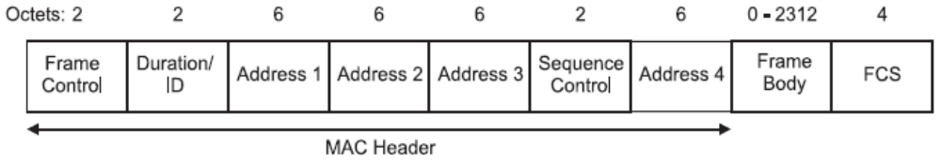

- Address field contents (for Data packets)... (Table 2)
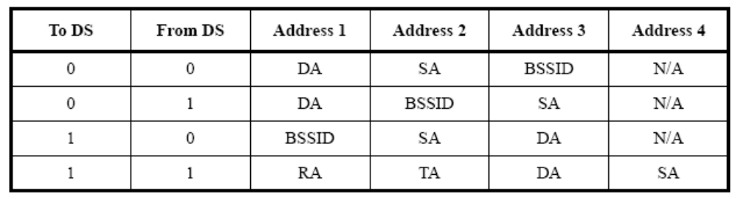
（802.11书81页，由上至下为IBSS， From AP（基础结构型），To AP（基础结构型），WDS（桥接器）。Address1为接受端Address2为发送端。DA为目的地址，SA为源地址，BSSID为AP无线接口的MAC。RA代表接收端地址，TA代表发送端地址）。
DS means Distribution System and actually is an AP (Access Point).

