VENDEING MACHINE DOCUMENTATION

group 12

ITRW 313

Contents

Problem Statement: 2

Input Example: 2

# Problem Statement:

*The user must choose from items which they would like to buy. They can buy cola, orange, sweets and chocolate. Where cola cost R8.50, orange R10.00, sweets R12.50 and chocolate R15.00. Only payments with R5, R2, R1, 50c, 20c and 10c are accepted. The program should total the payment units until the price of an item is paid and calculate the change.*

## Input Example:

* User choose cola which is 8.50
* User pays with a R5 coin.
* User pays with a R2 coin
* The user pays with another R2 coin
* R5 + R2 + R2 = R9
* R8.50 – R9.00 = 0.50c change

# End User Documentation

## Introduction

As stated before the program is a Vending Machine application.

When the program is ran on CLIPS the program will ask the user to enter a number based on the selection in case for example – CHOICE 2 –(ORANGE R10.00)

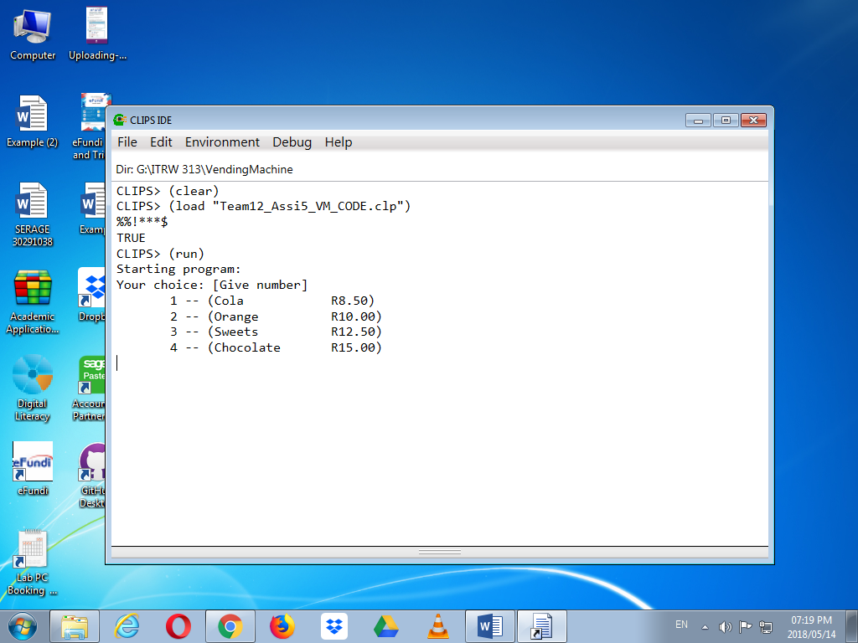

At selection the output will be the amount needed from the user and the different coins that the machine accepts.

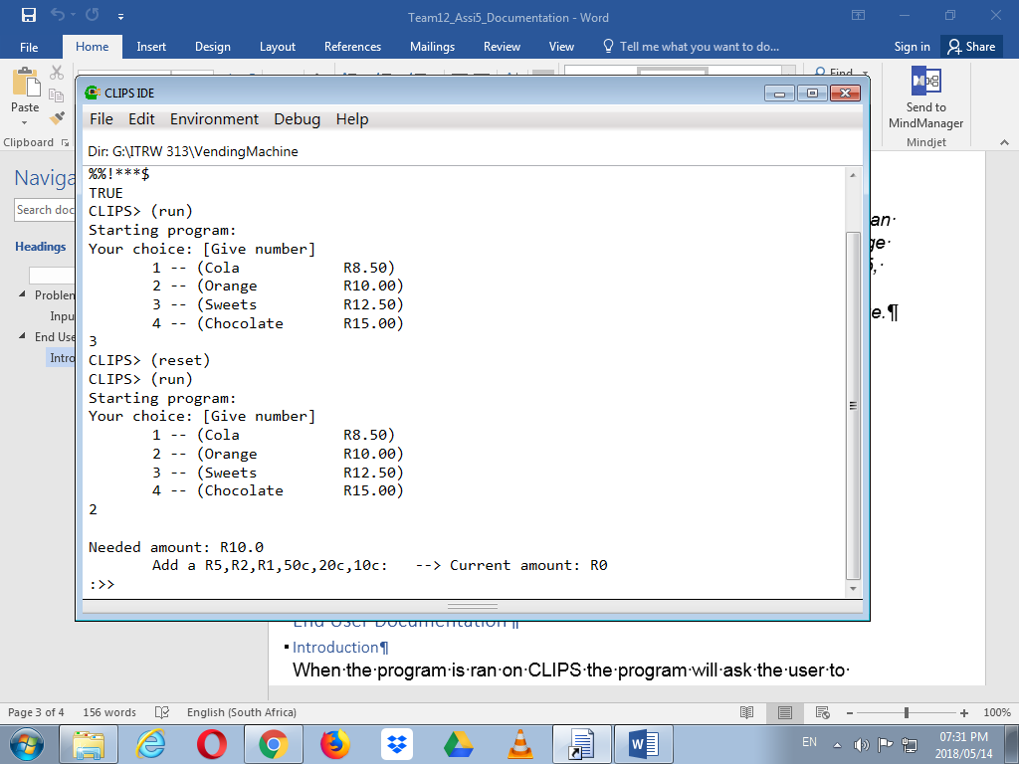

After the program states the amount needed, the user will enter the amount in terms of the coins that the machine accepts. In this case the total amount is R10.00 so the user will “put in” two R5 coins and after doing so the program will display a message : “DONE !!! 🡺” with the amount that was “put in’ the machine and exact change.

