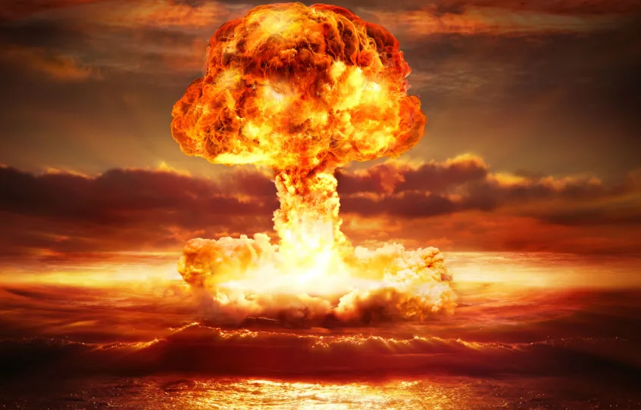Game Design Document

*TOY TANKS* 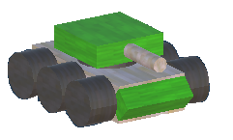

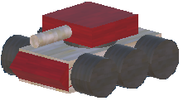

A 3D Action Game by Alt-F4

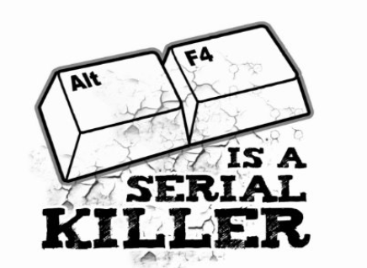

This page: Table of Contents and Team Member Listing

|  |  |  |
| --- | --- | --- |
| Table of Contents  [1 Game Overview](https://n-xovwktmtjsnaxyc2mwes2xu7pohqedmdm6zjw5q-2lu-script.googleusercontent.com/userCodeAppPanel)  [2 High Concept](https://n-xovwktmtjsnaxyc2mwes2xu7pohqedmdm6zjw5q-2lu-script.googleusercontent.com/userCodeAppPanel)  [3 Unique Selling Points](https://n-xovwktmtjsnaxyc2mwes2xu7pohqedmdm6zjw5q-2lu-script.googleusercontent.com/userCodeAppPanel)  [4 Platform Minimum Requirements](https://n-xovwktmtjsnaxyc2mwes2xu7pohqedmdm6zjw5q-2lu-script.googleusercontent.com/userCodeAppPanel)  [5 Competitors / Similar Titles](https://n-xovwktmtjsnaxyc2mwes2xu7pohqedmdm6zjw5q-2lu-script.googleusercontent.com/userCodeAppPanel)  [6 Synopsis](https://n-xovwktmtjsnaxyc2mwes2xu7pohqedmdm6zjw5q-2lu-script.googleusercontent.com/userCodeAppPanel)  [7 Game Objectives](https://n-xovwktmtjsnaxyc2mwes2xu7pohqedmdm6zjw5q-2lu-script.googleusercontent.com/userCodeAppPanel)  [8 Game Rules](https://n-xovwktmtjsnaxyc2mwes2xu7pohqedmdm6zjw5q-2lu-script.googleusercontent.com/userCodeAppPanel)  [9 Game Structure](https://n-xovwktmtjsnaxyc2mwes2xu7pohqedmdm6zjw5q-2lu-script.googleusercontent.com/userCodeAppPanel)  [10 Game Play](https://n-xovwktmtjsnaxyc2mwes2xu7pohqedmdm6zjw5q-2lu-script.googleusercontent.com/userCodeAppPanel)  [10.1 Game Controls](https://n-xovwktmtjsnaxyc2mwes2xu7pohqedmdm6zjw5q-2lu-script.googleusercontent.com/userCodeAppPanel)  [10.2 Game Camera](https://n-xovwktmtjsnaxyc2mwes2xu7pohqedmdm6zjw5q-2lu-script.googleusercontent.com/userCodeAppPanel)  [10.2.1 HUD](https://n-xovwktmtjsnaxyc2mwes2xu7pohqedmdm6zjw5q-2lu-script.googleusercontent.com/userCodeAppPanel)  [10.2.2 Maps](https://n-xovwktmtjsnaxyc2mwes2xu7pohqedmdm6zjw5q-2lu-script.googleusercontent.com/userCodeAppPanel)  [11 Players](https://n-xovwktmtjsnaxyc2mwes2xu7pohqedmdm6zjw5q-2lu-script.googleusercontent.com/userCodeAppPanel)  [11.1 Characters](https://n-xovwktmtjsnaxyc2mwes2xu7pohqedmdm6zjw5q-2lu-script.googleusercontent.com/userCodeAppPanel)  [11.2 Metrics](https://n-xovwktmtjsnaxyc2mwes2xu7pohqedmdm6zjw5q-2lu-script.googleusercontent.com/userCodeAppPanel)  [11.3 States](https://n-xovwktmtjsnaxyc2mwes2xu7pohqedmdm6zjw5q-2lu-script.googleusercontent.com/userCodeAppPanel)  [11.4 Weapons](https://n-xovwktmtjsnaxyc2mwes2xu7pohqedmdm6zjw5q-2lu-script.googleusercontent.com/userCodeAppPanel)  [12 Player Line-up](https://n-xovwktmtjsnaxyc2mwes2xu7pohqedmdm6zjw5q-2lu-script.googleusercontent.com/userCodeAppPanel)  [13 NPC](https://n-xovwktmtjsnaxyc2mwes2xu7pohqedmdm6zjw5q-2lu-script.googleusercontent.com/userCodeAppPanel)  [13.1 Enemies](https://n-xovwktmtjsnaxyc2mwes2xu7pohqedmdm6zjw5q-2lu-script.googleusercontent.com/userCodeAppPanel)  [13.1.1 Enemy States](https://n-xovwktmtjsnaxyc2mwes2xu7pohqedmdm6zjw5q-2lu-script.googleusercontent.com/userCodeAppPanel)  [13.1.2 Enemy Spawn Points](https://n-xovwktmtjsnaxyc2mwes2xu7pohqedmdm6zjw5q-2lu-script.googleusercontent.com/userCodeAppPanel)  [13.2 Allies / Companions](https://n-xovwktmtjsnaxyc2mwes2xu7pohqedmdm6zjw5q-2lu-script.googleusercontent.com/userCodeAppPanel)  [13.2.1 Ally States](https://n-xovwktmtjsnaxyc2mwes2xu7pohqedmdm6zjw5q-2lu-script.googleusercontent.com/userCodeAppPanel)  [13.2.2 Ally Spawn Points](https://n-xovwktmtjsnaxyc2mwes2xu7pohqedmdm6zjw5q-2lu-script.googleusercontent.com/userCodeAppPanel)  [14 Art](https://n-xovwktmtjsnaxyc2mwes2xu7pohqedmdm6zjw5q-2lu-script.googleusercontent.com/userCodeAppPanel)  [14.1 Setting](https://n-xovwktmtjsnaxyc2mwes2xu7pohqedmdm6zjw5q-2lu-script.googleusercontent.com/userCodeAppPanel)  [14.2 Level Design](https://n-xovwktmtjsnaxyc2mwes2xu7pohqedmdm6zjw5q-2lu-script.googleusercontent.com/userCodeAppPanel)  [14.3 Audio](https://n-xovwktmtjsnaxyc2mwes2xu7pohqedmdm6zjw5q-2lu-script.googleusercontent.com/userCodeAppPanel)  [15 Procedurally Generated Content](https://n-xovwktmtjsnaxyc2mwes2xu7pohqedmdm6zjw5q-2lu-script.googleusercontent.com/userCodeAppPanel)  [15.1 Environment](https://n-xovwktmtjsnaxyc2mwes2xu7pohqedmdm6zjw5q-2lu-script.googleusercontent.com/userCodeAppPanel)  [15.2 Levels](https://n-xovwktmtjsnaxyc2mwes2xu7pohqedmdm6zjw5q-2lu-script.googleusercontent.com/userCodeAppPanel)  [15.3 Artificial Intelligence NPC](https://n-xovwktmtjsnaxyc2mwes2xu7pohqedmdm6zjw5q-2lu-script.googleusercontent.com/userCodeAppPanel)  [15.4 Visual Arts](https://n-xovwktmtjsnaxyc2mwes2xu7pohqedmdm6zjw5q-2lu-script.googleusercontent.com/userCodeAppPanel)  [15.5 Audio](https://n-xovwktmtjsnaxyc2mwes2xu7pohqedmdm6zjw5q-2lu-script.googleusercontent.com/userCodeAppPanel)  [15.6 Minimum Viable Product (MPV)](https://n-xovwktmtjsnaxyc2mwes2xu7pohqedmdm6zjw5q-2lu-script.googleusercontent.com/userCodeAppPanel)  [16 Wish List](https://n-xovwktmtjsnaxyc2mwes2xu7pohqedmdm6zjw5q-2lu-script.googleusercontent.com/userCodeAppPanel)   |  | | --- | |  | | Game Development Team Members  LEAD GAME DESIGNER  Alex Miller  LEAD PROGRAMMER  Simon Kincaid  ADDL. PROGRAMMING  Alex Miller  Abdul Wardak  Lazar Kojic  LEAD ARTIST  Abdul Wardak  ADDL. ART  Alex Miller  LEAD LEVEL DESIGNER  Lazar Kojic |

|  |
| --- |
|  |

1 Game Overview

**Title**: Toy Tanks

**Platform**: PC Standalone

**Genre**: Action/Arcade Shooter

**Rating**: (10+) ESRB

**Target**: Casual gamer (aging from 10 - 70)

**Release date**: December, 2019

**Publisher**: ALT-F4

**Description**: Toy Tanks is an arcade shooter game that turns your living room floor into a battlefield. Load weapon on your tiny toy tank and attack enemies. To achieve victory, you must eliminate all enemy tanks and turrets which increase in number with each level.

**Game Genre:** Toy Tanks does not fit into any one genre perfectly, though can be considered a “arcade shooter” because of arcade-like level structure and powerups, or “action game” as a more broad definition.

# 2 High Concept

Toy Tanks takes the player through the three levels of a closed rectangular space where you are controlling a small green tank and must destroy all enemies in order to win. Enemies consist of red tanks which actively patrol and search for your tank, and stationary turrets that wait for your tank to enter their line of sight. Be wise, and don’t fight them on open space. Instead, hide behind cover and hunt the enemy tanks from behind and eliminate them one by one.

# 3 Unique Selling Points

• Stunning particle effects

• Challenging, yet addicting gameplay

# 4 Platform Minimum Requirements

PC STANDALONE

OS: Windows 10

Graphics card: DX9 (shader model 2.0) capabilities; generally

everything made since 2004 should work

# 5 Competitors / Similar Titles

- Wii Play Tanks! minigame

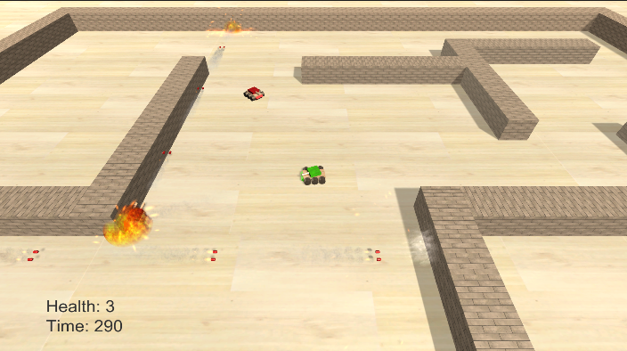

# 6 Synopsis

Your living room floor has spontaneously transformed into a battlefield, and your favorite toy tank (the green one) is under attack by countless red tanks. You must fend them off and defend your living room!

# 7 Game Objectives

Complete all 3 levels by eliminating all enemy tanks and turrets before your health or the time reaches 0.

# 8 Game Rules

The player controls the green tank and can move forward and backward, rotate the tank body left and right, and rotate the tank turret left and right. The tank body and turret rotate independently from one another. The player tank must shoot at other tanks and turrets 3 times to destroy them. The player tank begins with only 3 health, but this can increase by collecting health powerups. A speed powerup can be picked up to increase movement for a short time, and a lightning powerup can be picked up to increase rate of fire for a short time. If the player tank is hit by an enemy, they have a brief moment of invincibility to avoid a quick death from many bullets. Enemy tanks will have a set patrol route which they will follow until the player tank is spotted. They will shoot at the player tank until the player breaks line of sight. Then, the enemy tanks will drive towards the player’s last known position, and then drive back to their patrol route. Enemy turrets will stay in one place and wait for the player tank to enter their field of view, and then they will shoot at it. Enemies are unable to damage other enemies with their bullets. The player loses if they run out of time or they run out of health. The player wins if they destroy all of the enemy tanks and turrets. Upon loss, the player is given the option to restart the level. Upon victory, the player is given the option to go to the next level. Upon victory on the last level, they are prompted to go to the credits.

# 9 Game Structure

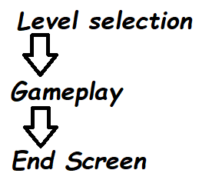

# 10 Game Play

## 10.1 Game Controls

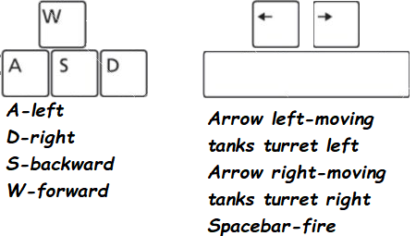

## 10.2 Game Camera

Camera stays in a fixed position above the player tank and will follow it as it moves. The camera will not change angle or rotate in any way.

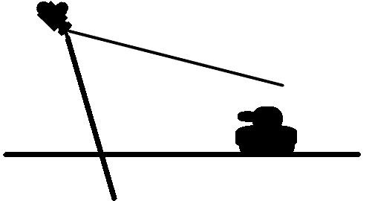

### 10.2.1 HUD

HEALTH

-Indicates the amount of life the player has

TIME

-Indicates the amount of time left to finish the game

# 11 Player

11.1 Characters

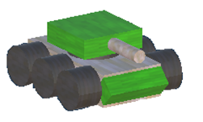Player tank that has distinguishing green front fender

And green turret

11.2 Metrics

Speed: 5

Starting Health: 3

Rate Of Fire: 0.5

Rotate Body Speed: 2

Rotate Turret Speed: 2

11.3 State

## Idle: Level Started or not in motion (simulation of engine working)

## Move: Any direction on the screen (forward, backwards, left, right)

## Death: The screen will switch to end scene

11.4 Weapons

Tank turret: Can shoot up to 2 rounds per second, takes 3 rounds to destroy an enemy.

12 Player Lineup



# 13 NPC

## 13.1 Enemies

Enemy tank is constantly searching for the Player, while turret has fixed position waiting the moment when the Player is on his site to fire.

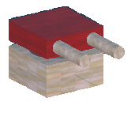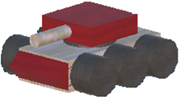

13.1.1 Enemy States

**Tank**

Idle: No Idle state.

Patrol: Constantly moving on patrol route.

Shooting: Shooting at player.

Searching: Moving towards player’s last known position.

Returning: Moving back to patrol route.

Death: Explodes.

**Turret**

Idle: Fixed position, not moving.

Shooting: Shooting at the player.

Death: Explodes.

## 13.2 Allies / Companions

N/A

# 14 Art

14.1 Setting

The game takes place on the living room hard wood floor, with some wooden barriers erected.

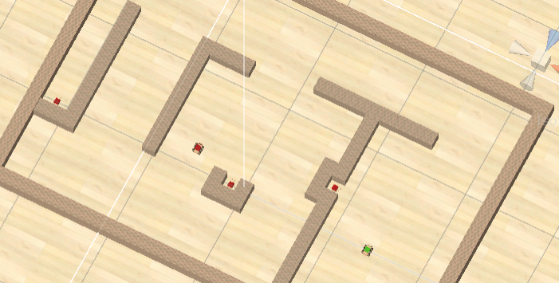

## 14.2 Level Design

## The level is closed space and it consists of the obstacles/walls that separates enemies and the player. Powerups are scattered around the stage, and enemy tanks patrol in a way that is possible for the player to avoid and exploit. However, these are covered by stationary turrets.

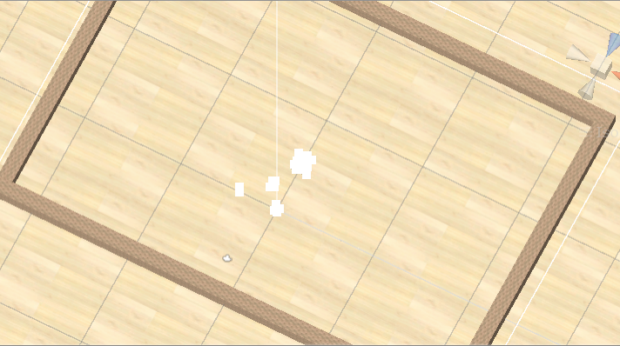

## 14.3 Audio

Cheesy and cartoony music and sound effects. Popping noises and generic explosions.

|  |  |  |
| --- | --- | --- |
| Name | Category | Description |
| CreditsBGM | Background Music | Plays in the credits |
| LevelBGM | Background Music | Plays in the levels |
| TitleBGM | Background Music | Main Menu music |
| Balloon Popping-SoundBible.com-1247261379 | FX | Bullet Hit Sound |
| Bomb Explosion 1-SoundBible.com-980698079 | FX | Plays when hit the target |
| Grenade Explosion-SoundBible.com-2100581469 | FX | Grenade Explosion |
| metalClick | FX | Tank in motion |
| Punch_HD-Mark_DiAngelo-1718986183 | FX | Bullet Sound |
| Drop | FX | Hammer Dropping |
| Flyby | FX | Speed powerup |
| Wrench | FX | Health powerup |
| Lightning | FX | Bullet powerup |

# 15 Procedurally Generated Content

## 15.1 Environment

Game contains no procedurally generated environments.

## 15.2 Levels

Levels are hand crafted and are not procedurally generated.

## 15.3 Artificial Intelligence NPC

Enemy tanks utilize a variant of the A* pathfinding algorithm in order to navigate the levels and move towards their patrol points and the player’s position.

## 15.4 Visual Arts

Game objects/environment meant to have a wooden toy / block type feel.

Incredible particle effects are a unique selling point of this game:

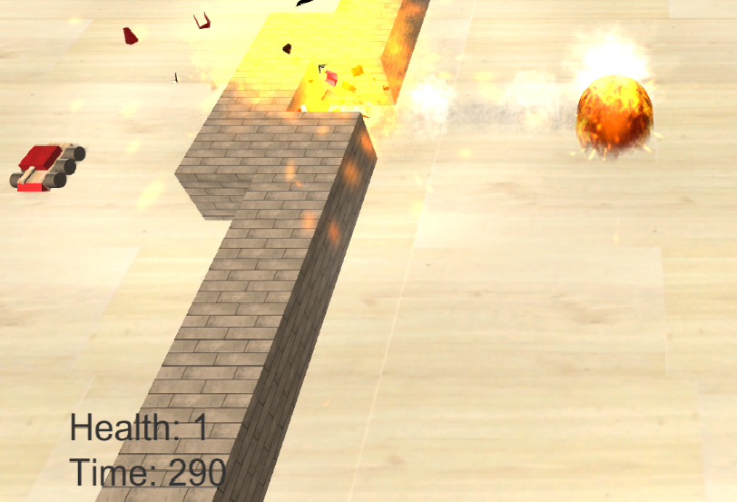

## 15.5 Audio

Refer to 14.3

## 15.6 Minimum Viable Product (MPV)

- Only one option given when choosing player character (tank).

- No enemy variety, only tanks and turrets.

- Plain looking environments.

- Only 3 levels.

- Only PC platform available.

# 16 Wish List

* Allied tanks.
* Different kinds of tanks.
* Different looking levels.
* More powerups.
* Scaling difficulty.
* Larger levels.
* New objectives

Bibliography

**Art:**

|  |  |
| --- | --- |
| BulletExplosion.png | [**https://www.vippng.com/preview/hhRmho_explosion-png-free-download-explosion-fire-png/**](https://www.vippng.com/preview/hhRmho_explosion-png-free-download-explosion-fire-png/) |
| Smoke.png | [**https://www.pinpng.com/picture/iiwRhRh_sparks-transparent-smoke-explosion-hd-png-download/**](https://www.pinpng.com/picture/iiwRhRh_sparks-transparent-smoke-explosion-hd-png-download/) |
| BulletSmoke.png | [**http://clipart-library.com/clipart/1206754.htm**](http://clipart-library.com/clipart/1206754.htm) |
| MuzzleSmoke.png | [**https://www.pngfind.com/mpng/owwim_free-png-download-large-smoke-png-images-background/**](https://www.pngfind.com/mpng/owwim_free-png-download-large-smoke-png-images-background/) |
| MuzzleFlash.png | [**https://www.hiclipart.com/free-transparent-background-png-clipart-tzmcp/download**](https://www.hiclipart.com/free-transparent-background-png-clipart-tzmcp/download) |
| Hammer.png | [**http://pngimg.com/download/1135**](http://pngimg.com/download/1135) |
| Nut.png | [**https://www.kissclipart.com/bolt-nut-png-clipart-nut-bolt-clip-art-jp2dh4/**](https://www.kissclipart.com/bolt-nut-png-clipart-nut-bolt-clip-art-jp2dh4/) |
| Wave.png | Created in Photoshop |
| Lightning.png | Created in Photoshop |
| Spin.png | Created in Photoshop |
| Wood Textures | [**https://assetstore.unity.com/packages/2d/textures-materials/wood/15-original-wood-texture-71286**](https://assetstore.unity.com/packages/2d/textures-materials/wood/15-original-wood-texture-71286) |

**Audio:**

|  |  |
| --- | --- |
| IntroBGM.mp3 | **https://www.fesliyanstudios.com/royalty-free-music/download/dreams-of-a-child/219** |
| LevelBGM.mp3 | [**https://www.fesliyanstudios.com/royalty-free-music/download/eye-laugh/293**](https://www.fesliyanstudios.com/royalty-free-music/download/eye-laugh/293) |
| CreditsBGM.mp3 | [**https://www.fesliyanstudios.com/royalty-free-music/download/happy-tree/276**](https://www.fesliyanstudios.com/royalty-free-music/download/happy-tree/276) |
| Punch_HD-Mark_DiAngelo-1718986183.mp3 | [**http://soundbible.com/1876-Punch-HD.html**](http://soundbible.com/1876-Punch-HD.html) |
| metalClick.mp3 | [**https://www.kenney.nl/assets/rpg-audio**](https://www.kenney.nl/assets/rpg-audio) |
| Balloon Popping-SoundBible.com-1247261379.mp3 | [**http://soundbible.com/1522-Balloon-Popping.html**](http://soundbible.com/1522-Balloon-Popping.html) |
| Bomb Explosion 1-SoundBible.com-980698079.mp3 | [**http://soundbible.com/107-Bomb-Explosion-1.html**](http://soundbible.com/107-Bomb-Explosion-1.html) |
| Grenade Explosion-SoundBible.com-2100581469.mp3 | [**http://soundbible.com/1467-Grenade-Explosion.html**](http://soundbible.com/1467-Grenade-Explosion.html) |
| Drop.mp3 | [**http://soundbible.com/1096-Dropping-A-Wrench.html**](http://soundbible.com/1096-Dropping-A-Wrench.html) |
| Wrench.mp3 | [**http://soundbible.com/1211-Air-Wrench.html**](http://soundbible.com/1211-Air-Wrench.html) |
| Lightning.mp3 | [**http://soundbible.com/538-Blast.html**](http://soundbible.com/538-Blast.html) |
| Flyby.mp3 | [**http://soundbible.com/1891-Flyby.html**](http://soundbible.com/1891-Flyby.html) |

**Powerup Prefabs:**

[**https://github.com/NickCuso/HardlyBot/tree/master/Unity/Assets/PowerUps%20Vol%201%20Free**](https://github.com/NickCuso/HardlyBot/tree/master/Unity/Assets/PowerUps%20Vol%201%20Free)

**Scripts:**

Pathfinding adapted from A* Pathfinding Tutorial by Sebastian Lague

<https://www.youtube.com/watch?v=-L-WgKMFuhE>

Save system adapted from save/load tutorial by Ray Wenderlich

<https://www.raywenderlich.com/418-how-to-save-and-load-a-game-in-unity>

Pictures used in GDD:

<https://www.zazzle.com/alt_f4_is_a_serial_killer_postcard-239034891382940436>

https://images2.minutemediacdn.com/image/upload/c_crop,h_1126,w_2000,x_0,y_83/f_auto,q_auto,w_1100/v1555949079/shape/mentalfloss/581049-mesut_zengin-istock-1138195821.jpg