LAN Assignment – Phase 1

# Overview

This document outlines the topology and configuration for the Head Office branch of our WAN. It defines the configuration for each gateway router, level 3 distribution switches, and an example configuration for an access switch.

# Topology Diagram

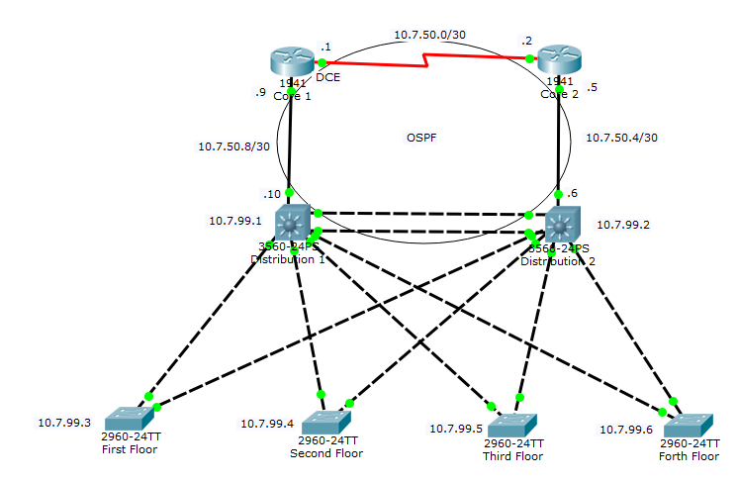

# Gateway Routers (Core)