LAN Assignment – Phase 1

# Overview

This document outlines the topology and configuration for the Head Office branch of our WAN. It defines the configuration for each gateway router, level 3 distribution switches, and an example configuration for an access switch.

# Physical Topology

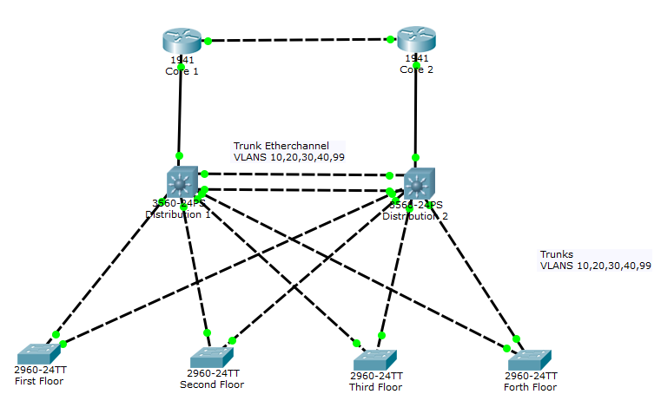

Our physical topology includes two cisco gateway routers, two layer 3 distribution switches, and four access switches (each access switch will need 42+ ports, or we will otherwise require two switches per floor). The routers are connected to each other with a Gigabit port via an Ethernet cross over cable. I would recommend Cat6 cables which are faster and tested to handle a bandwidth of up to 250 MHz (EBAY Buying Guide, 2017). However, these are more expensive, so if the budget does not allow it, Cat5e would be sufficient. The routers are also connected to the gigabit ports of the layer 3 switches via straight-through Cat6/5e cables.  
The distribution switches are connected via two Cat5e crossover cables in fast Ethernet ports. They are joined using an etherchannel port-channel.  
Each access switch has a single connection to each distribution switch using a Cat5e crossover cable in fast Ethernetports. Using etherchannel and two fast ethernet ports for connection to the distribution switches was considered. It was deemed unnecessary on the grounds that there is already a redundant path via the other distribution switch, and that it would eat into available ports. This is something that we could consider in the future if the head office ever grows to a point where we reach maximum bandwidth. Access switches will connected to the pre-cabled Cat5e on each floor.

# Logical Topology

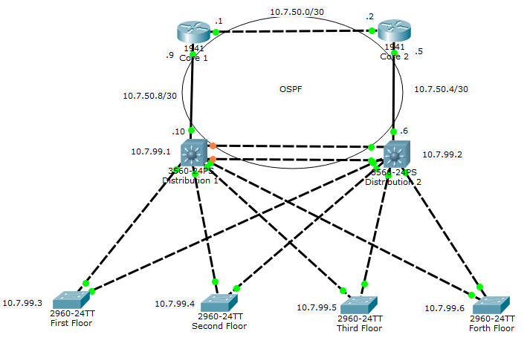

Router ID 3.3.3.3  
Backup DR

Router ID 4.4.4.4  
Dedicated Router



Router ID 2.2.2.2

Router ID 1.1.1.1

Distribution 2 SVI’s:  
10.7.10.2 (VLAN 10)  
10.7.20.2 (VLAN 20)  
10.7.30.2 (VLAN 30)  
10.7.40.2 (VLAN 40)  
10.7.99.2 (VLAN 99)

Distribution 1 SVI’s:  
10.7.10.1 (VLAN 10)  
10.7.20.1 (VLAN 20)  
10.7.30.1 (VLAN 30)  
10.7.40.1 (VLAN 40)  
10.7.99.1 (VLAN 99)

FHRP Standby IP:  
10.7.10.3 (VLAN 10)  
10.7.20.3 (VLAN 20)  
10.7.30.3 (VLAN 30)  
10.7.40.3 (VLAN 40)  
10.7.99.254 (VLAN 99)

# Addressing Table

|  |  |  |  |  |
| --- | --- | --- | --- | --- |
|  | VLAN | Network | Subnet | Usable Address Range |
| Sales & Marketing | 10 | 10.7.10.0 | 255.255.255.0 | .1 - .254 |
| Human Resources | 20 | 10.7.20.0 | 255.255.255.0 | .1 - .254 |
| Finance | 30 | 10.7.30.0 | 255.255.255.0 | .1 - .254 |
| Administration | 40 | 10.7.40.0 | 255.255.255.0 | .1 - .254 |
| Management | 99 | 10.7.99.0 | 255.255.255.0 | .1 - .254 |
| Point to Point 1 | - | 10.7.50.0 | 255.255.255.252 | .1 - .2 |
| Point to Point 2 | - | 10.7.50.4 | 255.255.255.252 | .5 - .6 |
| Point to Point 3 | - | 10.7.50.8 | 255.255.255.252 | .9 - .10 |

Variable Length subnetting was calculated and considered. However due to the large numbers of address spaces available to us, we decided that this network would be easier to manage and maintain using fixed length subnetting.

# OSPF

Open Shortest Path First (OSPF) will be configured between the gateway routers and distribution switches. OSPF offers faster convergence and scales to larger network implementations than the older protocol RIP. It is a link state routing protocol that was developed as a replacement for the distance vector routing protocol offered by RIP. RIP uses hop-count as the only metric, which can quickly become problematic, whereas OSPF looks at a number of factor when deciding the best route to take. These factors can be customised by the network administration for greater control over network paths.

As we have relatively small numbers of employees, a single area ospf was decided. However as head office grows we can change this so we have multiple areas to reduce processing and memory overhead.

OSPFv4 is being used in our network as we are using IPv4 as our IP protocol. A further advantage of OSPF is that MD5 can be implemented, to improve network security. This means that routers will only accept OSPF updates from peers with the same pre-shared password.

Hello Timers (10seconds) and Dead internals (4 x Hello) will be left at their default values.

All interfaces connecting to the access switches will be configured as passive interfaces, as OSPF does not need to be advertised through them.

As we are using Gigabit point to point links, the auto-cost reference-bandwidth will be set to 1000 on both routers and distribution switches.

Cost and/or bandwidth can be changed to help support the flow of traffic through our network.

A Dedicated router will be selected because we have a multi-access network. In this case distribution 2 is elected as the DR because it has the largest router ID. Distribution 1 is the Backup DR as it has the second highest router ID. The DR is responsible for the flooding of LSAs through the network. The BDR can perform the same job is the DR fails.

# VLANS and Spanning Tree



Priority for VLANs 30,40

Priority for VLANs 10,20,99

This network will be configured with rapid PVST. This will allow for spanning tree configuration on a per VLAN basis. This is important in our network with multiple VLANs. It means we can use every available link, when shared around each VLAN, and if a link happens to fail, the port in “discarding-state” can be flipped straight to the “forwarding-state” without significant down time.

Distribution 1 switch is configured as the priority switch (root bridge) for VLANS 10, 20, and 99, and secondary for VLANS 30 and 40. Distribution 2 is configured as the priority switch (root bridge) for VLANs 30, and 40 and secondary for 10, 20, and 99. This will ensure each VLAN has a loop-free path through the network (Software Configuration Guide, 2016).

There are 5 VLANS in this network. VLAN 10 is Sales&Marketing, VLAN 20 is HR, VLAN 30 is Finances, VLAN 40 is Administration, and VLAN 99 is the management VLAN for each switch. All connections between the distribution switches and access switches are configured as Trunks. They only allow the above mention VLANs on them. VLAN 99 has been configured as the Native VLAN on each device.

All Access Switch switchports that are not connecting to the distribution switches will be set to PortFast and BPDG Guard. PortFast means that those interfaces will always be blocking until a host device is attached. It is then set to forwarding immediately. A BPDU guard is a way to stop other switches being added to the network, and messing up the configured spanning tree protocol in place. If a device sending BPDU’s is attached to this port, it will be put into an error-disabled state.

# Etherchannel

An Etherchannel is a logical link made up of 2 or more physical links. This is also known as link aggregation. In our network topology, we have used an etherchannel between our two distribution switches. This allows for faster bandwidth between the two devices and redundancy in case one of the links happen to fail. It also allows us to configure FHRP (discussed later), so that all hosts can have a virtual default gateway. We decide upon using two cables to make the etherchannel, but as we experience growth we can add more. For now, two Cat5e provides more than enough bandwidth for all our data needs.

We also considered using etherchannel between the access and distribution switches. It was deemed an unnecessary addition to our topology, as we would need more cables, and it would remove a further 2 switchports from our access switches.

# First Hop Redundancy Protocol (FHRP)

FHRP removed the issue of giving a host a single default gateway. In this situation, if that gateway goes down, the host will no longer be able to access anything outside of its own network. FHRP creates a virtual IP address using multiple interfaces. This way the host machine can connect to the virtual default gateway. In this situation, if one of the physical gateways goes down, the other will begin accepting packets for the virtual address and connectivity is not lost.

# Gateway Routers (Core) - Config

We are implementing two cisco routers as a redundant gateway into our LAN. After doing some research we have selected two Cisco ASR 1001-X Routers to purchase as our gateway routers. These are 1 rack unit devices with upgradable throughput (2.5, 5, 10, 20Gbps) (Cisco ASR 1006-X Router, 2017). This will allow us to scale in the future as our head office grows.

The routers are joined via a gigabit ethernet link. Each router is connected to a layer 3 switch via a gigabit Ethernet link.

OSPF is used to advertise the network links between the routers and layer 3 switches.

The configuration is as follows:

**Core1:**

**Interface Config**

(config-if)# int g0/0

(config-if)# ip address 10.7.50.0 255.255.255.252

(config-if)# no shut

(config-if)# int g0/1

(config-if)# ip address 10.7.50.1 255.255.255.252

(config-if)# no shut

**OSPF Config:**

(config)# router ospf 1

(config-router)# router-id 1.1.1.1

(config-router)# log-adjacency-changes

(config-router)# network 10.7.50.9 0.0.0.0 area 0

(config-router)# network 10.7.50.1 0.0.0.0 area 0

(config-router)# area 0 authentication message-digest

(config-router)# exit

(config)# int g0/0

(config-if)# ip ospf message-digest-key 1 md5 P@ssw0rd

(config)# int g0/1

(config-if)# ip ospf message-digest-key 1 md5 P@ssw0rd

**Core2:**

**Interface Config**

(config-if)# int g0/0

(config-if)# ip address 10.7.50.5 255.255.255.252

(config-if)# no shut

(config-if)# int g0/1

(config-if)# ip address 10.7.50.2 255.255.255.252

(config-if)# no shut

**OSPF Config:**

(config)# router ospf 1

(config-router)# router-id 2.2.2.2

(config-router)# log-adjacency-changes

(config-router)# network 10.7.50.2 0.0.0.0 area 0

(config-router)# network 10.7.50.5 0.0.0.0 area 0

(config-router)# area 0 authentication message-digest

(config-router)# exit

(config)# int g0/0

(config-if)# ip ospf message-digest-key 1 md5 P@ssw0rd

(config)# int g0/1

(config-if)# ip ospf message-digest-key 1 md5 P@ssw0rd

# Distribution Routers – Config

Distribution Switch 1

**//Spanning-tree**spanning-tree mode rapid-pvst

spanning-tree VLAN 10,20,99 root primary  
spanning-tree VLAN 30,40 root secondary **//VLAN Config**  
vlan 10

name Sales&Marketing

vlan 20

name HR

vlan 30

name Finance

vlan 40

name Administration

vlan 99

name Managementint vlan 10

ip address 10.7.10.1

int vlan 20

ip address 10.7.20.1

int vlan 30

ip address 10.7.30.1

int vlan 40

ip address 10.7.40.1

**//Setting up Etherchannel**

int range f0/23-24

channel-group 1 mode active

int port-channel 1

switchport trunk encapsulation dot1q

switchport mode trunk

switchport trunk allowed vlan 10,20,30,40,99

**//Configuring Interfaces To Access Switches**

int f0/1

switchport trunk native vlan 99  
switchport trunk encapsulation dot1q

switchport mode trunk

switchport trunk allowed vlan 10,20,30,40,99

int f0/2

switchport trunk native vlan 99

switchport trunk encapsulation dot1q

switchport mode trunk

switchport trunk allowed vlan 10,20,30,40,99

int f0/3

switchport trunk native vlan 99

switchport trunk encapsulation dot1q

switchport mode trunk

switchport trunk allowed vlan 10,20,30,40,99

int f0/4

switchport trunk native vlan 99  
switchport trunk encapsulation dot1q

switchport mode trunk

switchport trunk allowed vlan 10,20,30,40,9

**//Configuring IP Address and FHRP For Each VLAN**

int vlan 10

ip address 10.7.10.1 255.255.255.0

standby version 2

standby 1 ip 10.7.10.3

standby 1 priority 150

standby 1 preempt

int vlan 20

ip address 10.7.20.1 255.255.255.0

standby version 2

standby 1 ip 10.7.20.3

standby 1 priority 150

standby 1 preempt

int vlan 30

ip address 10.7.30.1 255.255.255.0

standby version 2

standby 1 ip 10.7.30.3

int vlan 40

ip address 10.7.40.1 255.255.255.0

standby version 2

standby 1 ip 10.7.40.3

int vlan 99

ip address 10.7.99.1 255.255.255.0

standby version 2

standby 1 ip 10.7.99.254

standby 1 priority 150

standby 1 preempt

Distribution Switch 2 **//Spanning-tree**spanning-tree mode rapid-pvst  
spanning-tree VLAN 10,20,99 root secondary  
spanning-tree VLAN 30,40 root primary **//VLAN Config**  
vlan 10

name Sales&Marketing

vlan 20

name HR

vlan 30

name Finance

vlan 40

name Administration

vlan 99

name Managementint vlan 10

ip address 10.7.10.2

int vlan 20

ip address 10.7.20.2

int vlan 30

ip address 10.7.30.2

int vlan 40

ip address 10.7.40.2

**//Setting up Etherchannel**  
int range f0/23-24

channel-group 1 mode active

int port-channel 1

switchport trunk encapsulation dot1q

switchport mode trunk

switchport trunk allowed vlan 10,20,30,40,99

**//Configuring Interfaces To Access Switches**  
int f0/1

switchport trunk native vlan 99  
switchport trunk encapsulation dot1q

switchport mode trunk

switchport trunk allowed vlan 10,20,30,40,99

int f0/2

switchport trunk native vlan 99

switchport trunk encapsulation dot1q

switchport mode trunk

switchport trunk allowed vlan 10,20,30,40,99

int f0/3

switchport trunk native vlan 99

switchport trunk encapsulation dot1q

switchport mode trunk

switchport trunk allowed vlan 10,20,30,40,99

int f0/4

switchport trunk native vlan 99  
switchport trunk encapsulation dot1q

switchport mode trunk

switchport trunk allowed vlan 10,20,30,40,99

**//Configuring IP Address and FHRP For Each VLAN**

int vlan 10

ip address 10.7.10.2 255.255.255.0

standby version 2

standby 1 ip 10.7.10.3

int vlan 20

ip address 10.7.20.2 255.255.255.0

standby version 2

standby 1 ip 10.7.20.3

standby 1 priority 150

standby 1 preempt

int vlan 30

ip address 10.7.30.2 255.255.255.0

standby version 2

standby 1 ip 10.7.30.3

standby 1 priority 150

standby 1 preempt

int vlan 40

ip address 10.7.40.2 255.255.255.0

standby version 2

standby 1 ip 10.7.40.3

standby 1 priority 150

standby 1 preempt

int vlan 99

ip address 10.7.99.2 255.255.255.0

standby version 2

standby 1 ip 10.7.99.254

## Example Access Switch

int f0/1  
switchport mode trunk  
switchport allowed vlans 10,20,30,40,99  
switchport trunk native vlan 99  
int f0/2  
switchport mode trunk  
switchport allowed vlans 10,20,30,40,99  
switchport trunk native vlan 99  
  
int range f0/3-24  
switchport mode access  
spanning-tree portfast  
spanning-tree bpduguard enable

References

Cisco ASR 1006-X Router. (2017). Cisco. Retrieved from: https://www.cisco.com/c/en/us/products/routers/asr-1001-x-router/index.html

Catalyst 2960 and 2960-S Software Configuration Guide. (2016). Cisco. Retrieved from: http://www.cisco.com/c/en/us/td/docs/switches/lan/catalyst2960/software/release/12-2_55_se/configuration/guide/scg_2960.html

Chapter 8. Single-Area OSPF. (2017). Cisco NetAcad.

EBAY Buying Guide. (2017). *EBAY*. Retrieved from: http://www.ebay.com/gds/What-are-the-Different-Types-of-Ethernet-Cables-/10000000177629325/g.html