**FeedA 0.020; KillB 0.051; Perpendicular; Long Rainbow; 256x256; 5000 Iterations**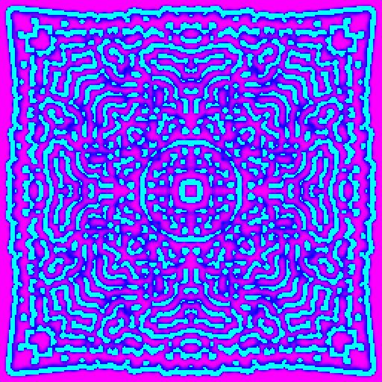

**FeedA 0.030; KillB 0.060; Convolution; Long Rainbow; 64x64; 5000 Iterations**

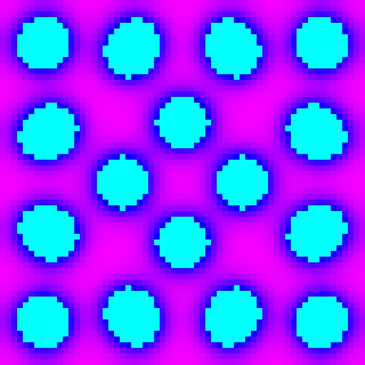

**FeedA 0.040; KillB 0.059; Convolution; Long Rainbow; 64x64; 5000 Iterations**

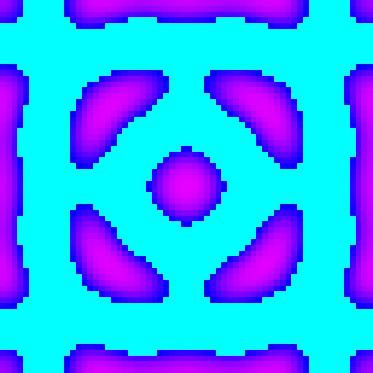

**FeedA 0.040; KillB 0.064; Convolution; Long Rainbow; 64x64; 5000 Iterations**

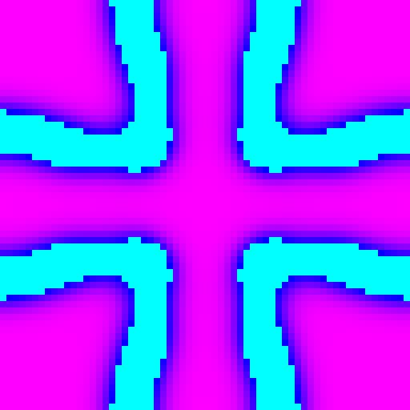

**FeedA 0.030; KillB 0.055; Convolution; Long Rainbow; 64x64; 5000 Iterations**

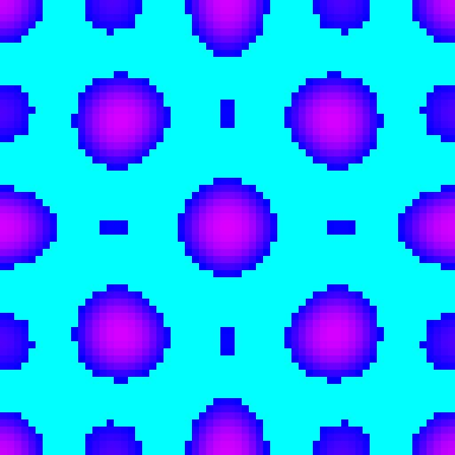

**FeedA 0.054; KillB 0.061; Delta; Long Rainbow; 64x64; 5000 Iterations**

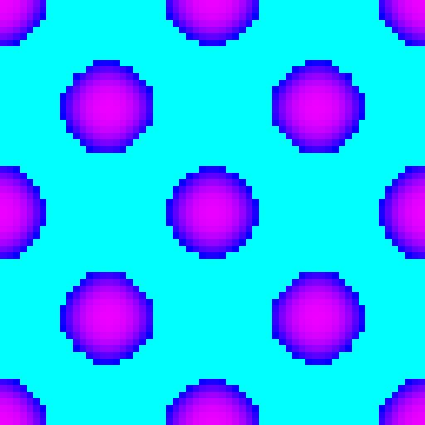

**FeedA 0.043; KillB 0.062; Delta; Long Rainbow; 64x64; 5000 Iterations**



**FeedA 0.030; KillB 0.060; Perpendicular; Long Rainbow; 64x64; 5000 Iterations**

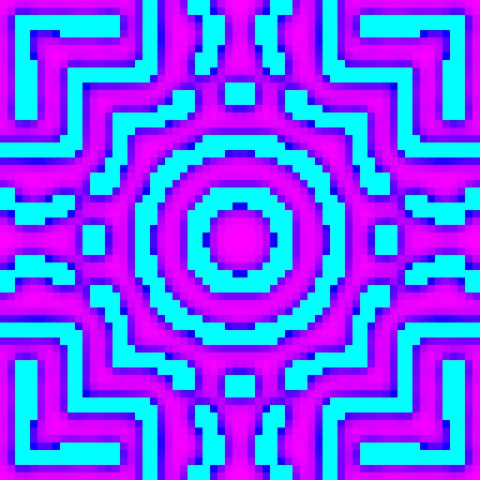

**FeedA 0.040; KillB 0.059; Perpendicular; Long Rainbow; 64x64; 5000 Iterations**

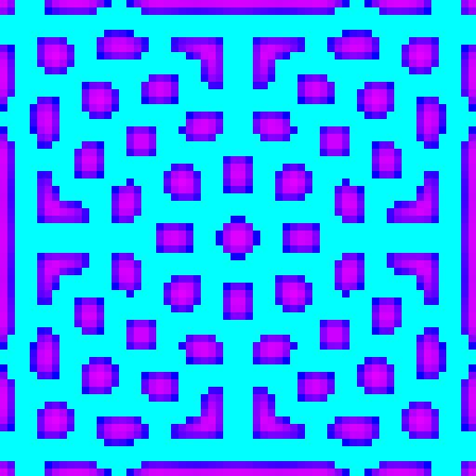

**FeedA 0.022; KillB 0.061; Perpendicular; Long Rainbow; 64x64; 5000 Iterations**

