

CSCC01 Final Project

**TODO: Team Name**

Ryan Blasetti

Lazar Glumac

King Lai

Yara Radwan

Jaedon Wong

Aum Patel

Parth Patel

October 23, 2020

Table of Contents

**Current CRC Cards**……………………………………………………….....……..**3**

Front-End CRC Cards…………………………………………………….…...…….3

Back-End CRC Cards.……………………………………………...…………….....5

**System Design**……………………………………………………………..………..**8**

Architecture Diagram of the System.………………………………………...….....8

Components of the Diagram.…………………………………………...………......8

**Current CRC Cards**

Front-End CRC Cards











Back-End CRC Cards





















**System Design**

Architecture Diagram of the System

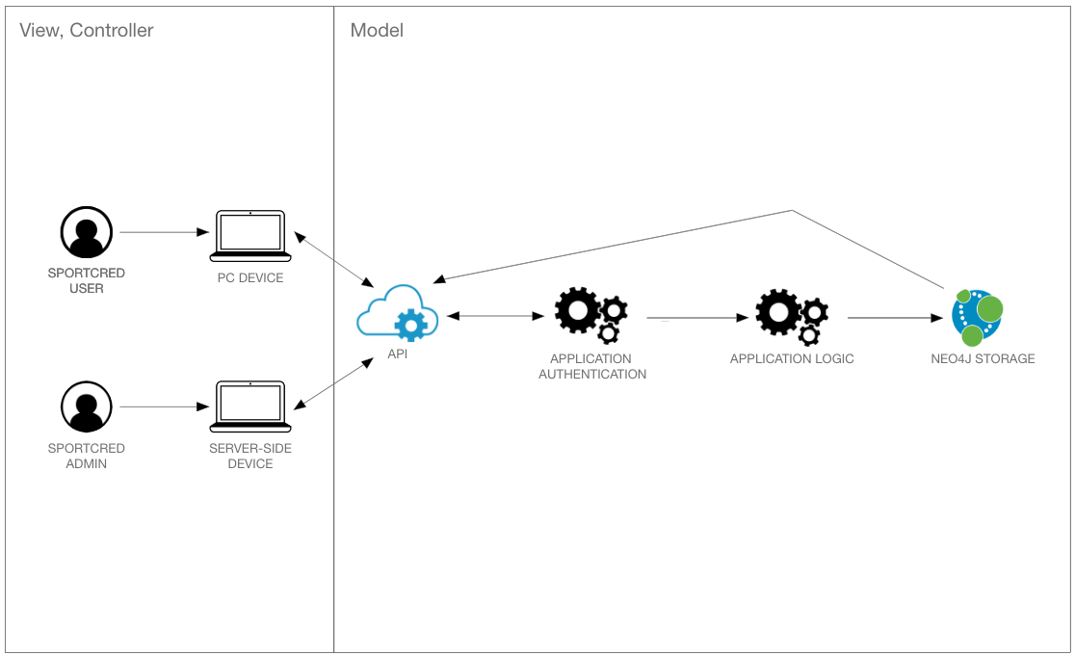

Components of the Diagram:

* **Sportcred User:** A user that will be engaging with the React web-app (represents the view and controller)
* **Sportcred Admin:** A user from Sportcred that is able to make additions to the site from the program by having special privileges (in terms of sending HTTP requests)
* **PC Device:** A compatible device that can host the React web-app (represents the view and controller)
* **Server-Side Device:** A device authorized by SPORTCRED to carry out HTTP requests to make additions to the overall React web-app (including adding trivia questions, etc.)
* **API:** The network endpoints that are accessed by various HTTP requests
* **Application Authentication:** The credentials of the user are base 64 encoded upon registration, and upon login decoded in order to validate the user’s login
* **Application Logic:** The code that facilitates the exchange and modification of data from the Neo4j database
* **Neo4j Storage:** The designated backend database to hold all user information