REPORT AND TUTORIEL ARDUINO CONNECT
Tangible interface using an Arduino board, an IMU 9 Degree of Freedom inertial unit and 3D Slicer
Internship CAMBA 2021

Tangible interface for interacting with Slicer’s 3D view, done in 2021 for ICM and ISIR Sorbonne by Marine CAMBA, thanks to the already existing Arduino plugin.

- What this plugin does:
Make the 3D view moves using a IMU 9DoF (accelerometer, magnetometer and gyroscope). It is connected to an Arduino UNO which return the angle made by the IMU and send it to Slicer to make the 3D view moves depending on the angle given.

- How the plugin works:
This programm creates a node to store the data coming from the Arduino device.

To get the data we need to:
- get the node : self.ArduinoNode = slicer.mrmlScene.GetFirstNodeByName("arduinoNode")
- add an observer :
sceneModifiedObserverTag=self.ArduinoNode.AddObserver(vtk.vtkCommand.ModifiedEvent, self.name_of_the_method)
- get the data : data= self.ArduinoNode.GetParameter("Data")

Knowing that the data that is read is only what is printed in the arduino code Serial.println(Data_to_be_seen), there can be as many prints as one wants, just remind that you'll get them one at a time using data= self.ArduinoNode.GetParameter("Data").
Indeed, if you want to print an array for example you'll print (array[0], array[1]) and only array[0] will be taken into account in the code. That is why we separated it in multiple lines (see below).

This code makes pair with arduino_accelerometer_slicer.ino, the arduino code part. It works with IMU 9DoF Groove from Seeed, and one needs to install its librairy, see here : https://github.com/Seeed-Studio/Seeed_ICM20600_AK09918.

The arduino part send (print) 6 datas :
- 3 ints : 0 1 and 2 to know what axis the data belongs to (0 for x, 1 for y and 2 for z),
- 3 floats : roll pitch and yaw which corresponds to the angle made by the IMU, theses are absolutes angles, they do not depends from the previous one.

The IMU works like a compass so we can get all 3 angles, and the calibration is mandatory.

- How to make it work:
(See also Tutoriel Arduino Slicer in French in the file Tutoriels)

Upload arduino_accelerometer_slicer.ino to the arduino
Add this plugin to Slicer
Go to modules>developper tools> Arduino Move It
Click on Detect device
CLick on Connect
Click on Move Three D View
Do a 8-shape movement for 10seconds to callibrate it
When the view starts to move, hold the IMU flat and go on the three d view, click on the pin and select the view A
You can now start to move the IMU to see the 3D move, be careful, the slower you move the better Slicer will display the model (around 3FPS instead of 6 when
using the mouse)

- Beware :
Due to the drift on the IMU, after quitte sometime, the view is not really align with the IMU, disconnect it using the button on slicer, and re do this tutoriel.
Also, decreasing the delay on arduino_accelerometer_slicer.ino won't give you more FPS but would make slicer bug (too many informations to be treated), just try to move slowly or put the IMU down on a table and make the moves on only one axis to get used to it (move only along z, than x…).

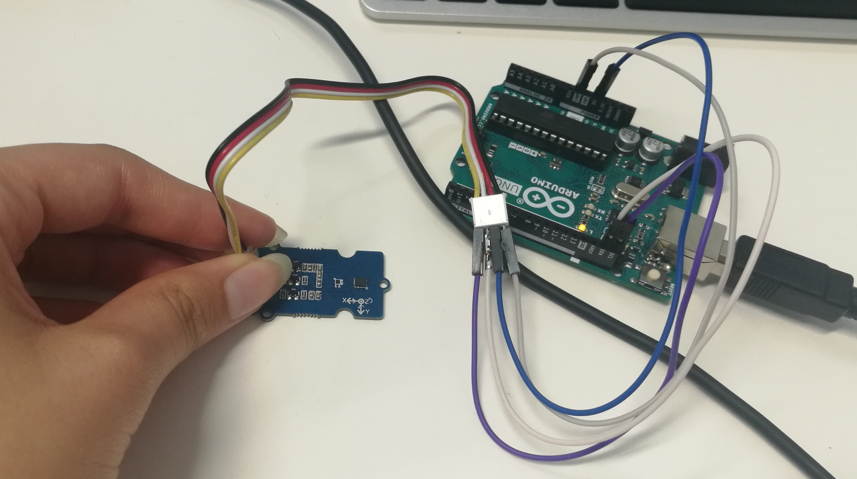
- Connecting the IMU to arduino
On the IMU it written which wire is what so :
Black = Ground
Red = CC = 5V
White = SDA
Yellow = SCL

- Examples
Go to ISIR’s or ICM cloud > stage Marine > Arduino Move It > Videos

