Initial capture are all UDP traffic

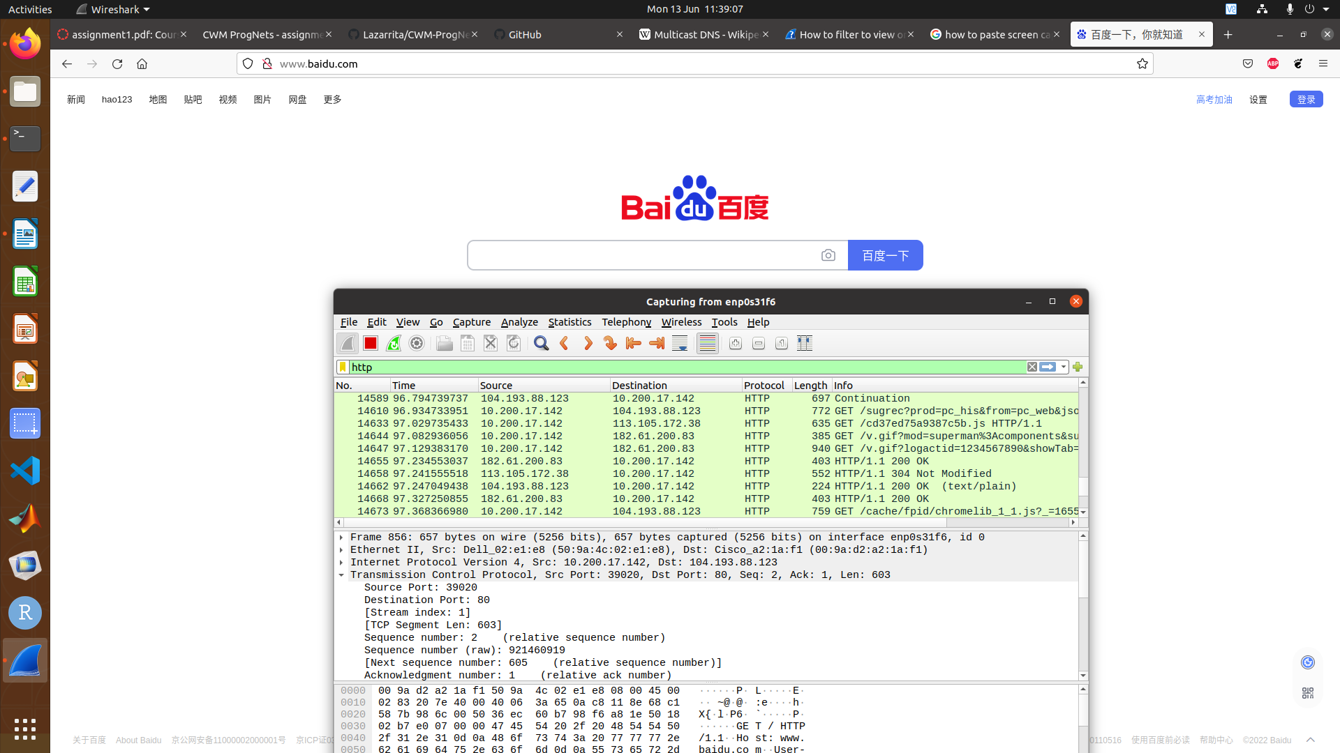
In order to capture http traffic, it was necessary to access a website that does not run on https. Baidu.com is an example that then allowed http traffic to be captured.

Capturing using tcpdump, and then reading from the file captured.pcap. 2nd photo below shows the captured packets in wireshark after using scp to transfer captured.pcap from raspberry pi to lab machine.
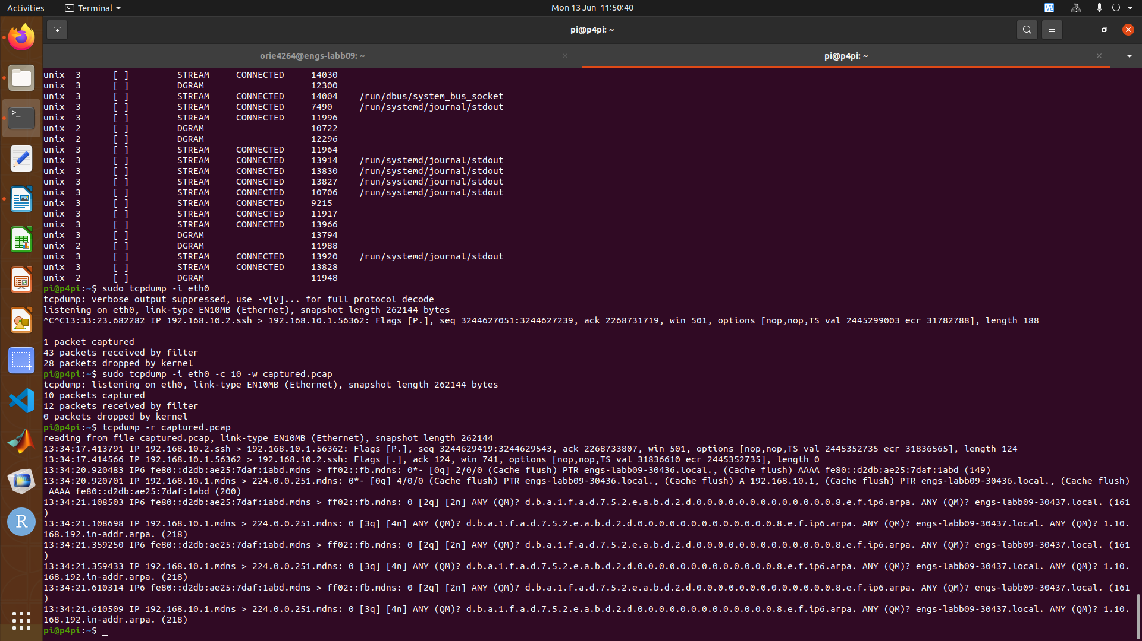
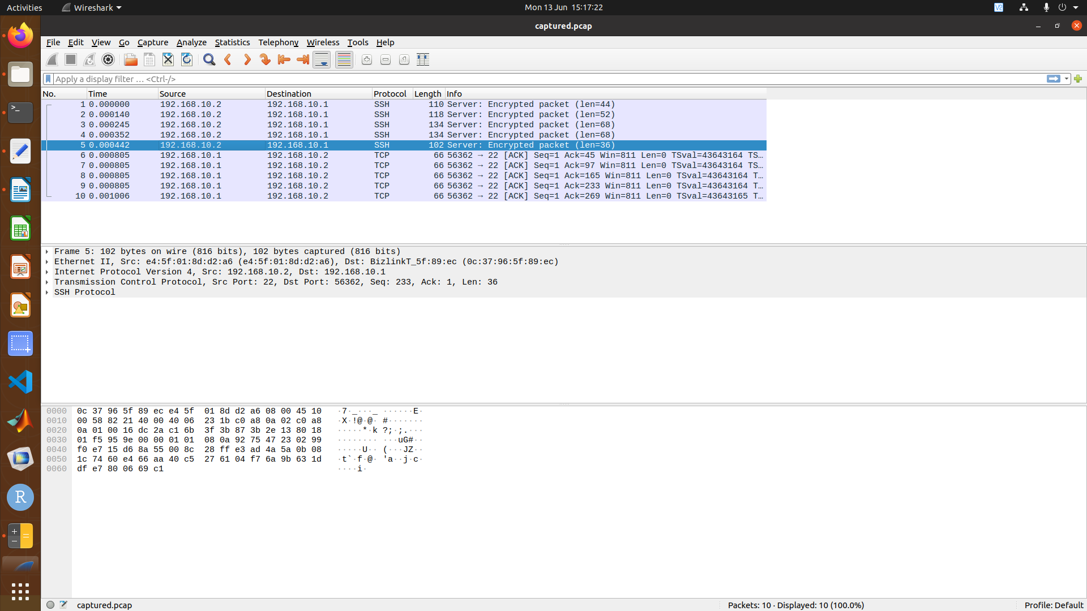

adwin_config is able to filter the incoming packets onto the lab machine to only capture the 100 packets sent from the raspberry pi to the lab machine. Using 192.168.20.1 allows easier checking of which files were sent without filtering. (Mainly for next part)

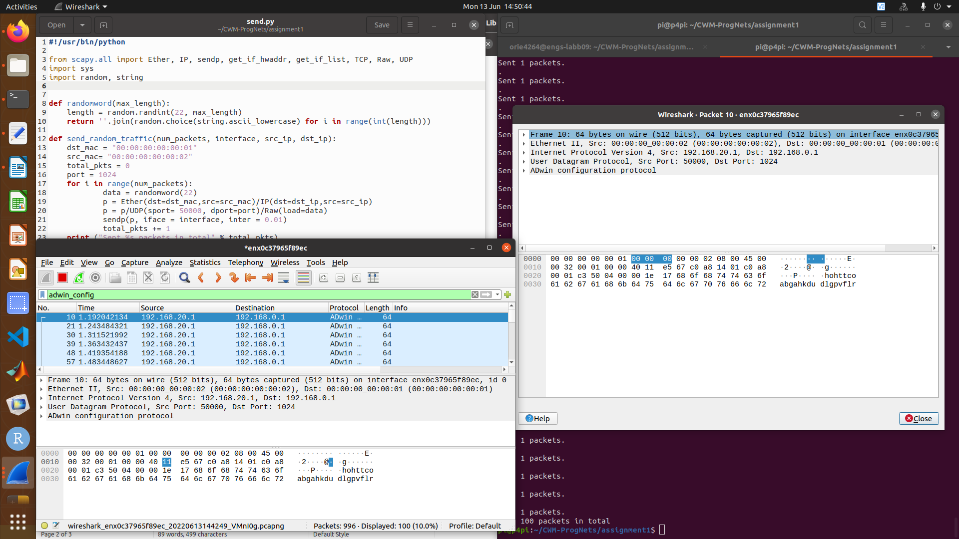
1 packet size = 64 bytes.
Colour is blue, meaning that it is UDP protocol.

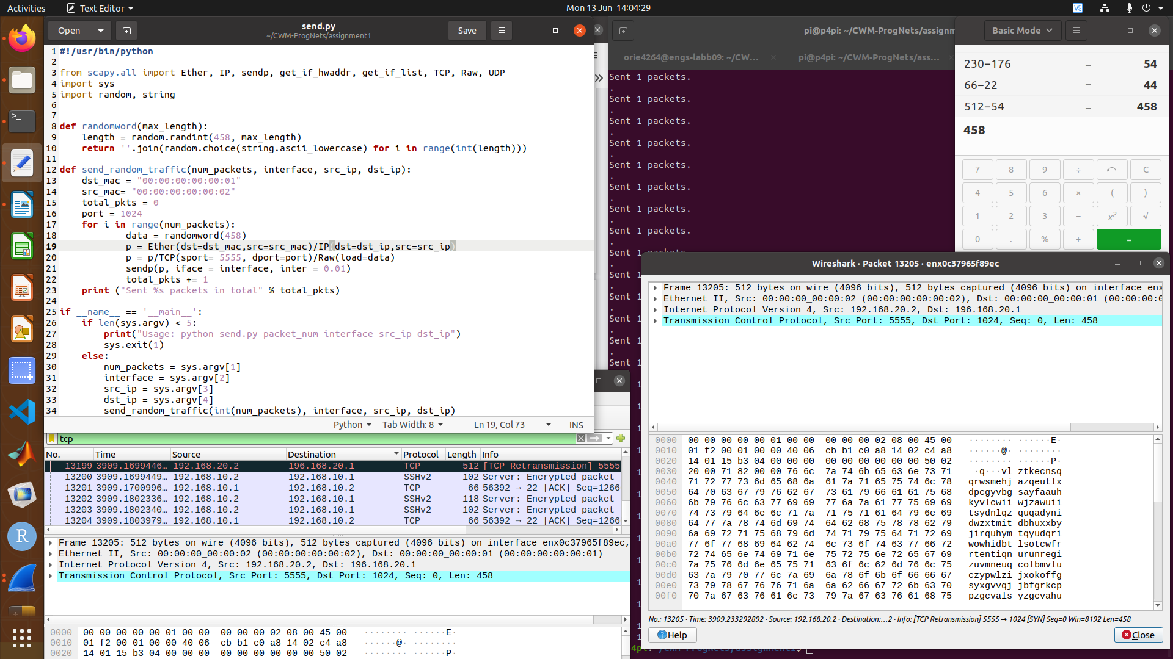
Following picture shows code used to achieve 512B in size. 458 is the length used, as I found out via experimenting with a few values that the difference between length and word size is a fixed 54 when changed to TCP. When in UDP the difference is only 42 (64-22), likely due to differences in overhead when implementing the different protocols.

Source port is changed to 5555. Source ip is set as 192.168.20.1 to be easier to see in wire-shark (turns up in black).

Code is copied below (via txt). Highlighted changes made

#!/usr/bin/python

from scapy.all import Ether, IP, sendp, get_if_hwaddr, get_if_list, TCP, Raw, UDP
import sys
import random, string

def randomword(max_length):
length = random.randint(458, max_length)
return ''.join(random.choice(string.ascii_lowercase) for i in range(int(length)))

def send_random_traffic(num_packets, interface, src_ip, dst_ip):
dst_mac = "00:00:00:00:00:01"
src_mac= "00:00:00:00:00:02"
total_pkts = 0
port = 1024
for i in range(num_packets):
data = randomword(458)
p = Ether(dst=dst_mac,src=src_mac)/IP(dst=dst_ip,src=src_ip)
p = p/TCP(sport= 5555, dport=port)/Raw(load=data)
sendp(p, iface = interface, inter = 0.01)
total_pkts += 1
print ("Sent %s packets in total" % total_pkts)

if __name__ == '__main__':
if len(sys.argv) < 5:
print("Usage: python send.py packet_num interface src_ip dst_ip")
sys.exit(1)
else:
num_packets = sys.argv[1]
interface = sys.argv[2]
src_ip = sys.argv[3]
dst_ip = sys.argv[4]
send_random_traffic(int(num_packets), interface, src_ip, dst_ip)

