Lab machine pinging raspberry pi
10 counts, 0.2s interval
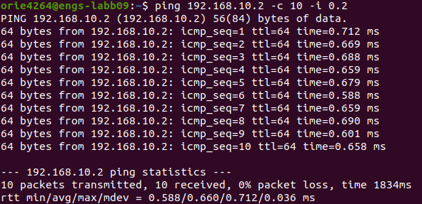
min/avg/max/mdev = 0.588/0.660/0.712/0.036ms

Raspberry pi pinging lab machine
10 counts, 0.2s interval
min/avg/max/mdev = 0.587/0.702/0.813/0.067ms
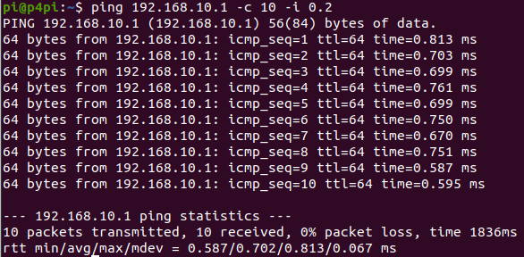

Raspberry pi pinging lab machine
100 counts, 0.001s interval (sudo)
min/avg/max/mdev = 0.143/0.458/0.674/0.140ms
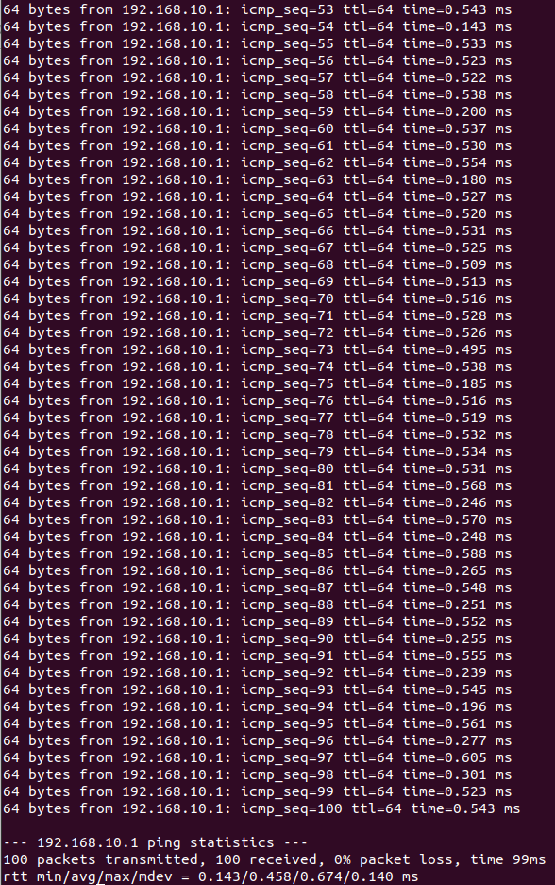

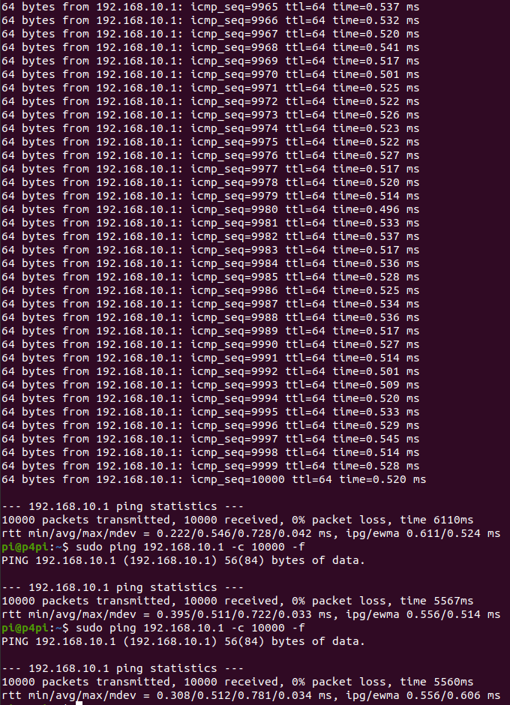
Raspberry pi pinging lab machine
10,000 counts, flooding (sudo)
Data below shows 3 different runs. Found out that not using -i will not display individual pings.
5. Raspberry Pi pinging lab machine

Initial 3 conditions
1000 measurements, intervals 0.01, 0.001 and 0.0001 respectively
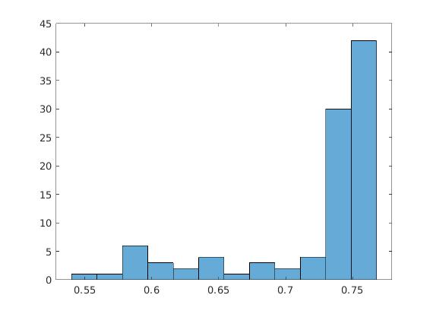
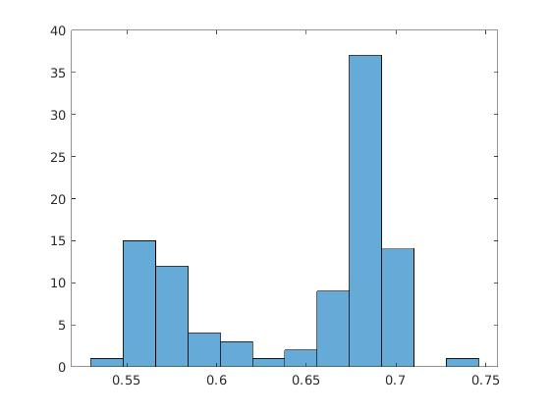
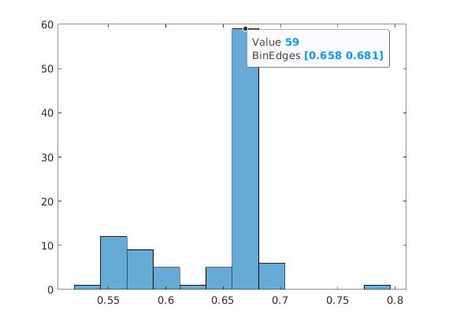

The trend shows that reducing intervals results in generally faster round trips
Rerunning the test with more runs as I reduce interval time (to match total run time, I.e 10,000 runs for 0.001s interval and 100,000 runs for 0.0001s interval respectively, left and right)
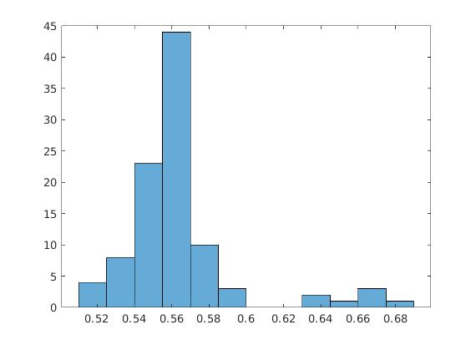
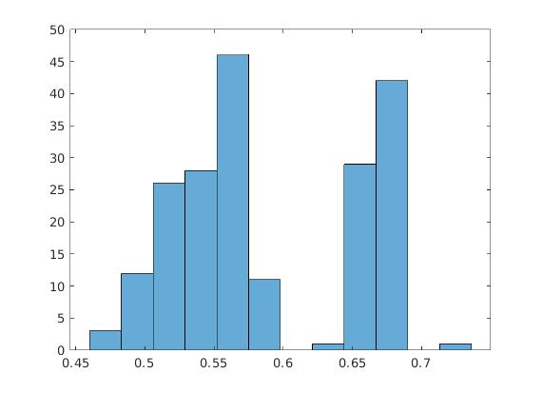
Increasing the total number of runs seemed to have shifted the graph towards the left compared to the original 1000 pings (reduced round trip time on average).

When running the same test three times (1000 round trips, 0.01s interval), there seems to be quite some variance in the tests itself, as seen in the picture below where 3 of the histograms are overlayed. Each histogram is run on the same conditions (1000 pings, 0.01s interval).
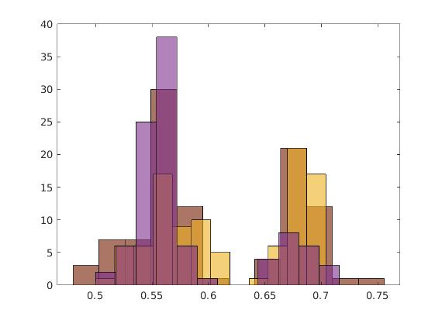
When put into CDF form, the graphs below are obtained. (Side by side with histogram)
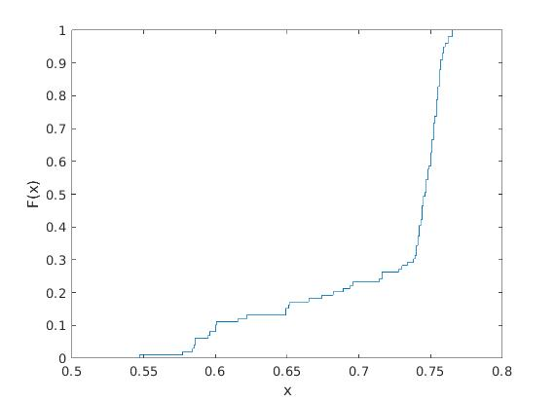
1000 pings, 0.01s interval. Large number of pings occur with round trip timings around 0.75ms
90% of round trip timings are below 0.76ms

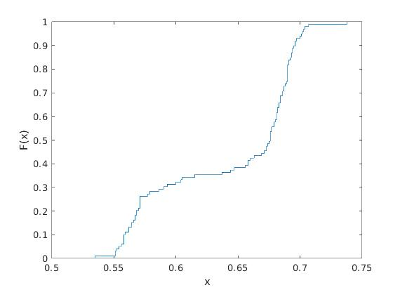

1000 pings, 0.001s interval. Round trip timings are mostly located around 0.675ms and 0.55ms. Overall on average it is faster than 0.01s intervals.
90% of round trip times are below 0.7ms
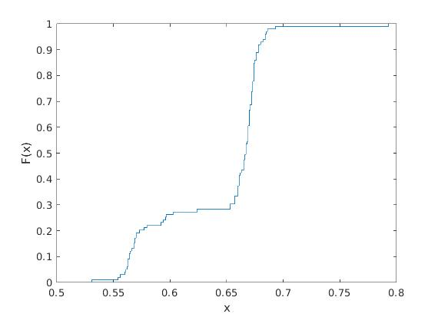
1000 pings, 0.0001s interval. Round trip timings is generally also skewed more towards the left than 0.001s interval.
90% of round trip times are below 0.67ms

Checking CDFs for greater ping numbers (10,000 pings 0.001s and 100,000 pings 0.0001s)
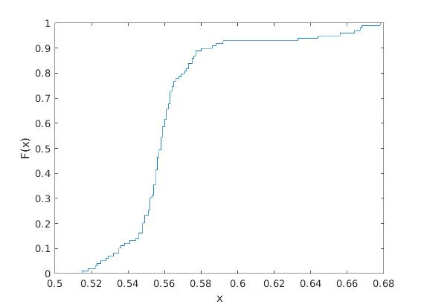

10,000 pings, 0.001s interval. 90% of round trip timings are below 0.59ms
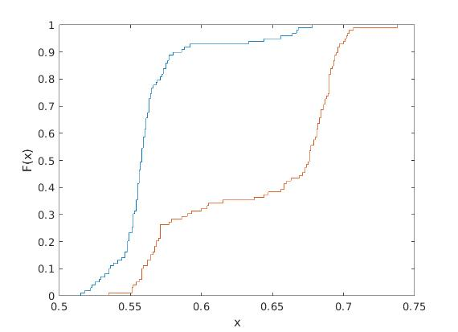
The comparison becomes obvious when plotted together. Blue lines = 10,000 pings, brown = 1000pings.
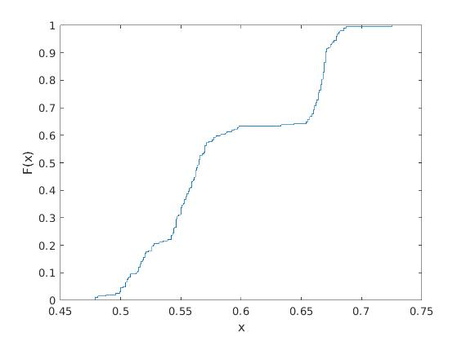

Same trends occurs for the 0.0001s interval, when raised to 100,000 pings (Graphs above)
Comparison to 1000pings graph below, brown line = 100,000 pings. Blue line = 1000 pings, red-brown line = 100,000 pings.

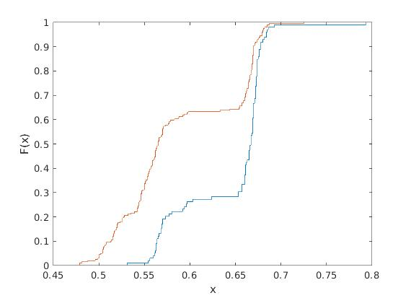
Question: Why does different intervals lead to different round trip results
From the data, small intervals generally have lower round trip times (faster). One possibility might be due to the caching between intervals, which is fully utilised when the intervals are small and less when intervals are big (other processes might have cut in), optimising the switch paths that it can take between the 2 systems internally, assuming there are switches that need to be passed to record the pings within each system.

Another possibility might be due to lower interval pings may be sent in batches, and are just spaced out with a frame delay between them rather than having the processor send the pings individually, keeping a path constantly open just for the pings and allowing it to return faster as well. It may also reduce system latency factor if pings are recorded in batches since it only starts once per batch rather than multiple times.

Out of the parameters (min, max, mean etc. ). I estimate that mode is the most accurate parameter to use to estimate system latency. This is due to some graphs having very skewed results which may not be reflective if we used mean. Min and Max also have too big of variances as delays can occur at the very start which will vary the numbers wildly across repeated experiments. Median shows where most of the round trip timings lie, which will more likely have shared characteristics which in this case would be the system latency at the lab machine before returning to the raspberry pi machine. As latency can vary somewhat, it would give a rough estimate of where the majority of the latency values were.

It will also give a slight overestimation since there are other overheads, giving us a slightly conservative estimate (larger latency).

Iperf section

Setting lab machine as server, Raspberry Pi as client.
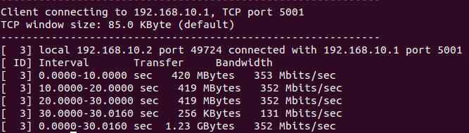
10 seconds for each experiment (30s to run 3 runs for reproducibility)
Effective bandwidth: Approximately 353 Mbits/sec.

Setting Raspberry Pi as server, lab machine as client
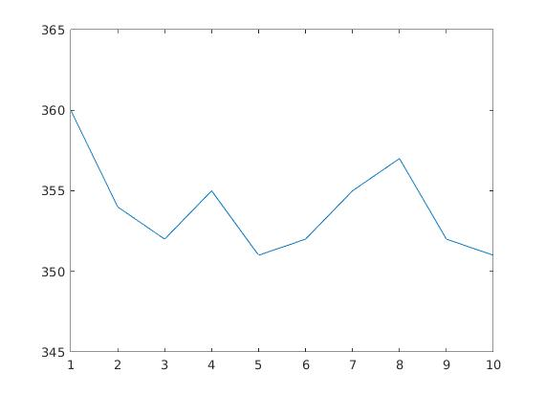

y-axis: Bandwidth in Mbits/s x-axis: time/s
Bandwidth generally hovered around 350-360Mbits/s for total bandwidth

Setting Raspberry pi as server, lab machine as client. Bi-directional iperf
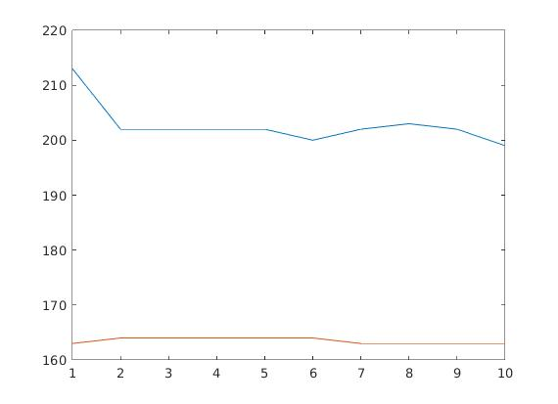

y-axis: Bandwidth in Mbits/s x-axis: time/s
The blue line is the bandwidth from machine to raspberry pi, and orange line is bandwidth from raspberry pi to machine.

One way iperf UDP, lab machine to raspberry pi. 5 seconds long with varying bandwidth.
There are no packet losses (0%) over the varying bandwidths. After repeating each bandwidth test multiple times, there is still no packet losses. Packet losses only occur when pushing bit rate to 1000mb/s, where it saturates the channel capacity of the 1Gb/s ethernet cable. Losses then occur due to imperfections within the pathway itself.

When changing time to a much longer duration (60seconds), there is still no packet losses. Perhaps the UDP protocol bandwidth is preventing any losses from occuring.
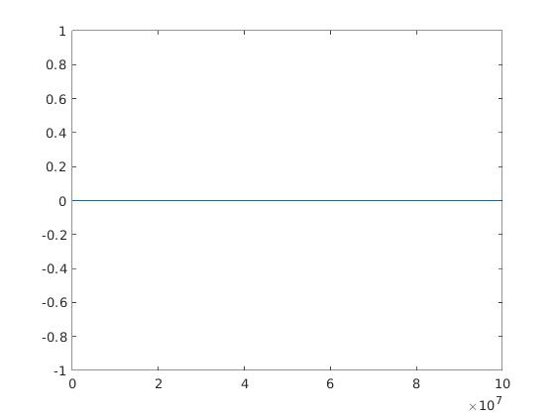
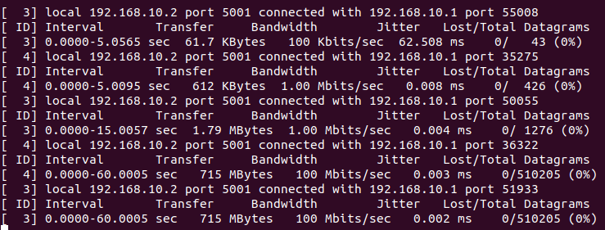
Y-axis = packet loss %
X-axis = Bandwidth limit in bits (log scale)

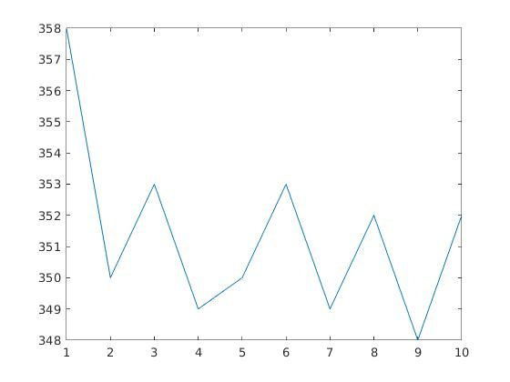

Y-axis = Bandwidth in Mbits/s X-axis = time/s

Set Raspberry Pi as iperf3 server, lab machine as client.
TCP,
10s long experiment, interval 1
Plot above shows bandwidth over each interval in Mbits/s

Running one way via UDP, with varying bandwidths. There is still no datagrams losses, unclear as to how is there any packet loss without exceeding cable bandwidth(bandwidth of machine to raspberry pi exceeds 100Mbits/sec.).

Graph will be the same as iperf packet losses. (0% throughout)

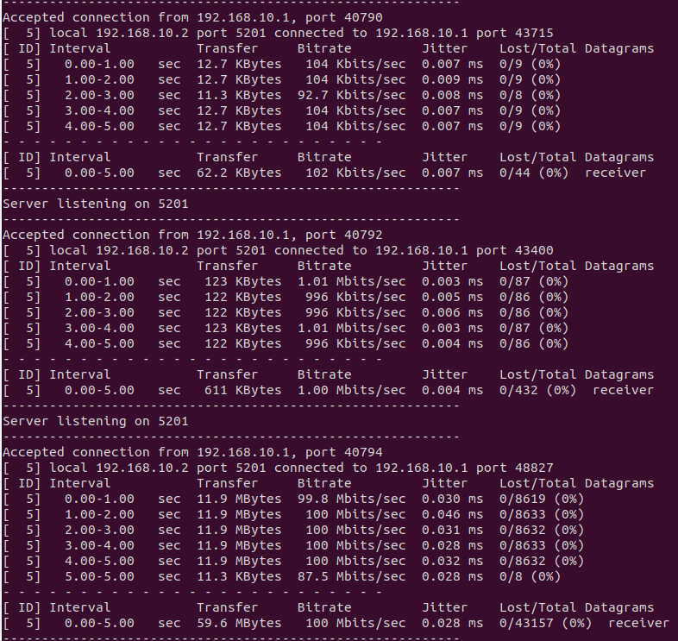
In terms of raw data, there isn’t really any observed differences between iperf and iperf3. The amount of data transferred in each test is the same, and no data loss occurred.

Simply put, 1Gb/s is 10 times greater than 100mb/s. There is far enough buffer that no packet loss should occur.

