Successfully set up CLI

Repeating iperf experiment from assignment 2

1. Set lab machine as iperf server, Raspberry Pi as client.
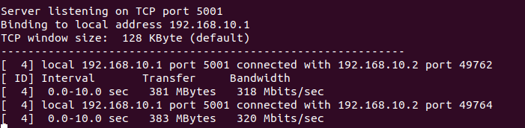
TCP, 10s long experiment.

The bandwidth has decreased from around 350 Mbits/sec to around 320 Mbits/sec compared to assignment 2.

2. Set raspberry Pi as iperf server, lab machine as client.
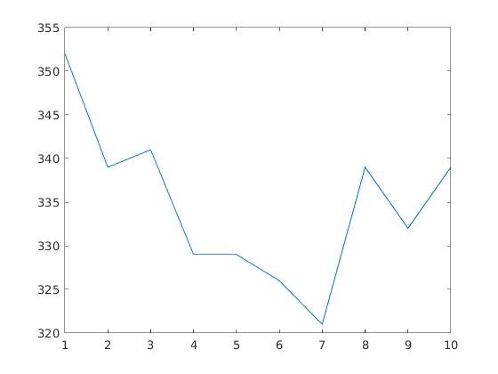
TCP, 10s long experiment, 1s interval

y-axis: Bandwidth in Mbits/s x-axis: time/s
Average around 335Mb/s (Same as in assignment 2).

3. Set Raspberry Pi as iperf server, lab machine as client.
Bi-directional iperf, TCP, 10s long experiment with 1s interval. The upper line is Raspberry Pi to Machine, and blue line is machine to raspberry pi, which is odd (should be other way round)
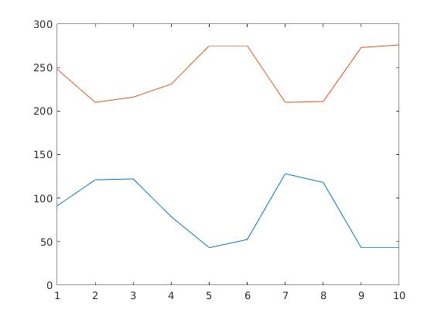

X-axis: time/s Y-axis: Bandwidth in Mbits/s
When I reran the test.
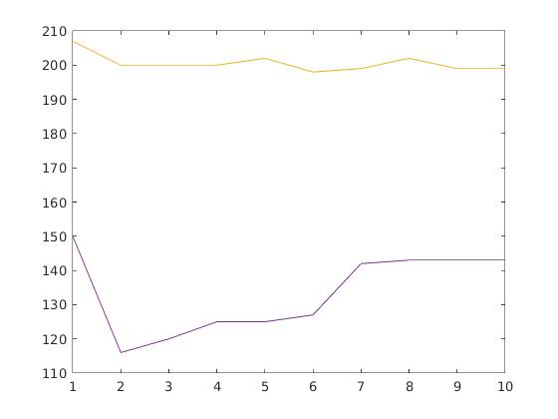

X-axis: time/s Y-axis: Bandwidth in Mbits/s
The values now align with what I saw in assignment 2, where machine to raspberry pi is faster than raspberry pi to machine. (Yellow line is Machine to Raspberry pi, purple line is Raspberry pi to machine).
4. One way iperf using UDP. Machine to Raspberry Pi server.
Tests: 5s, Bandwidths: 100kb/s, 1mb/s, 100mb/s.
No packet losses registered until bandwidth limit is at 1000mb/s
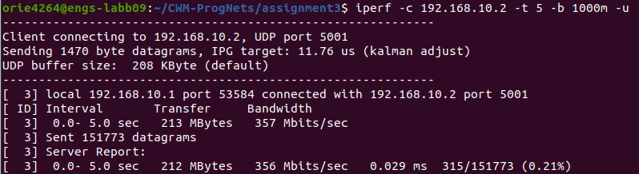

No difference from assignment 2, except for small drops in bandwidth

When running on ip address 192.168.10.250, bandwidth = 316Mbits/sec when Pi machine = client, Lab machine = server

When Pi machine = server, Lab machine = client. Bandwidth = 338 Mbits/s

When changing egress port to 3.
When Pi machine = client, lab machine = server. Bandwidth = 350Mbits/s
When Pi machine = server, lab machine = client. Bandwidth = 355Mbits/s
No duplicate pings.

When changing mac address.
Still getting proper bandwidth, but no duplicate pings.

