DeFIGuard - 25k Dataset & Model Evaluation Report

1. The 25k Dataset: Composition
In this phase of the project, we scaled our dataset to approximately 25,000 transactions. Our goal is to build an Anti-Money Laundering (AML) detection pipeline that can accurately find suspicious transactions hiding among legitimate ones.
To train and test the model, we injected two complex, real-world money laundering patterns into the data:
- Peel Chains: A long sequence of transactions where a small amount is 'peeled' off at each step, acting like a chain of drops to slowly cash out funds.
- Smurfing: A fan-out and fan-in pattern where a single source wallet distributes funds to multiple 'mule' wallets, which then forward the money to a central collector wallet. This hides the large transfer.
Dataset Breakdown:
- Total Transactions: 26,854
- Normal (Legitimate): 25,000 (93.1%)
- Peel Chains: 1,050 (3.9%)
- Smurfing: 804 (3.0%)
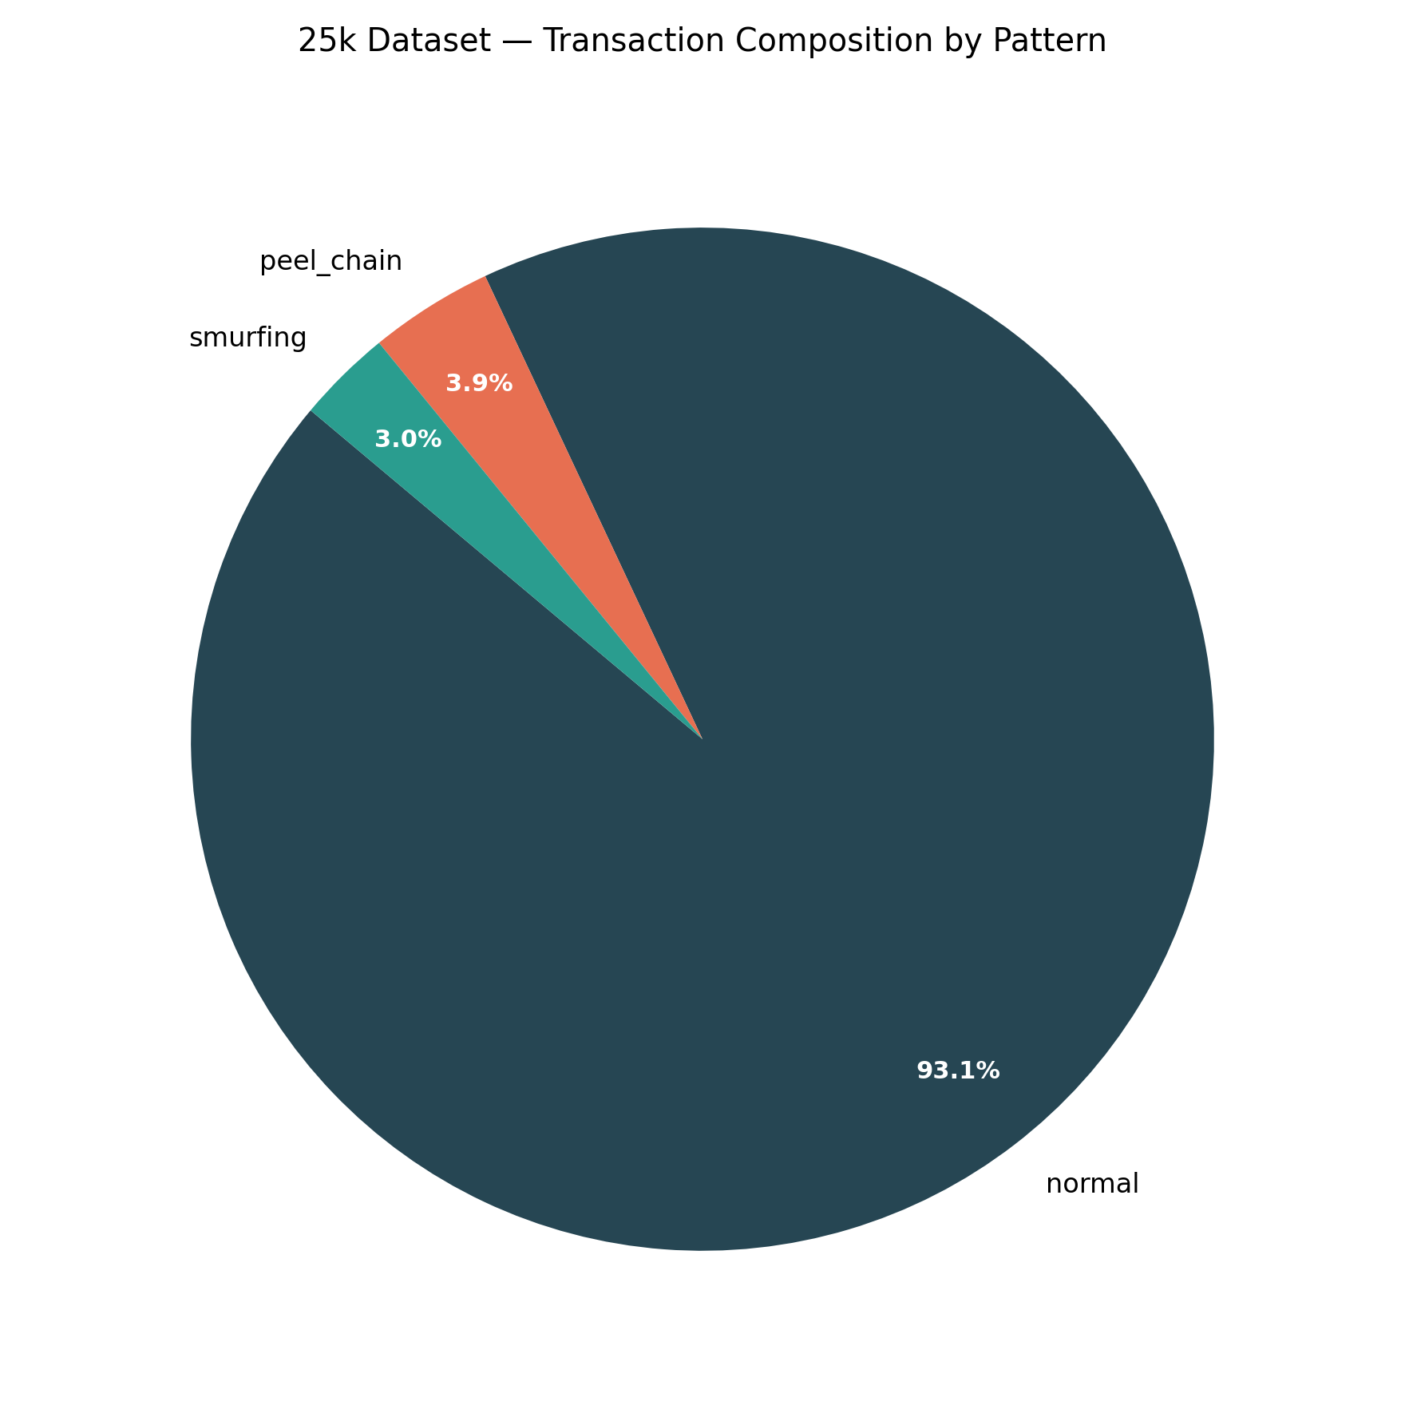

2. Model Evaluation and Layers
How do we know if our model is doing a good job? Since suspicious transactions only make up about 7% of the data, traditional 'Accuracy' can be misleading (a model that guesses 'Normal' every time would still be 93% accurate!). Instead, we use PR-AUC (Precision-Recall Area Under Curve), which heavily penalizes false alarms and rewards correctly catching the rare suspicious events.
We tested our models in three layers of increasing complexity:

Layer 1: Traditional Baselines
We started with standard machine learning models using basic transaction features (like amounts and simple network degrees).
- Random Forest: 0.8603 PR-AUC
- Logistic Regression: 0.9015 PR-AUC
- XGBoost: 0.9311 PR-AUC
XGBoost was the clear winner here, setting a strong baseline.
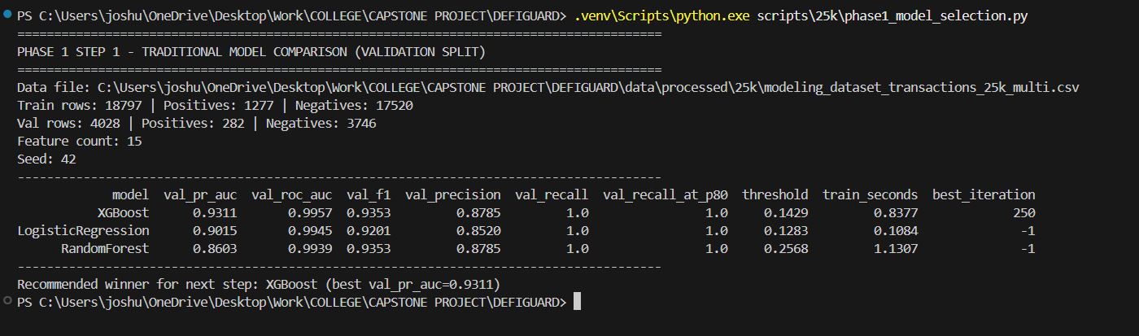

Layer 2: Adding Graph Context (GraphSAGE)
Next, we gave the model 'Graph Context'. We used an advanced Graph Neural Network (GraphSAGE) to map the shape and structure of the wallets' transaction history. Did giving XGBoost this structural awareness help?
- XGBoost Baseline: 0.9250 PR-AUC
- XGBoost + GraphSAGE: 0.9351 PR-AUC (+0.0101)
Yes! The graph features helped the model better recognize the structural signatures of smurfing and peel chains.
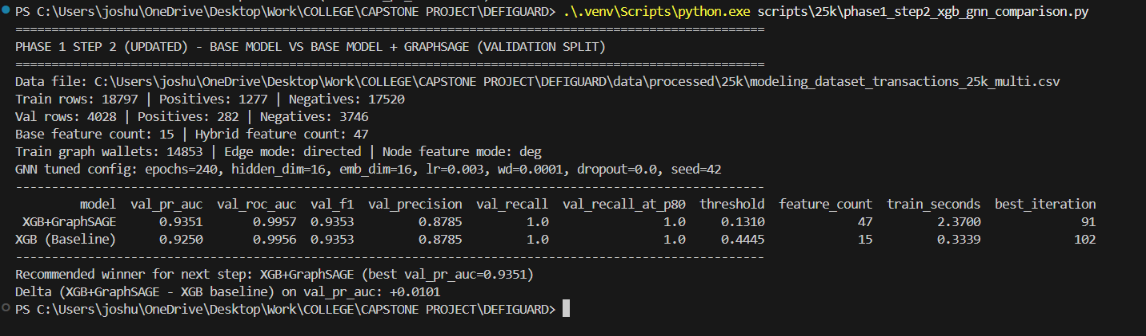

Layer 3: Adding Temporal Intelligence (NTS)
Finally, we tested 'Temporal Intelligence'. Money laundering is rarely instantaneous; it involves deliberate delays and time-spreads. We engineered Network Time Spread (NTS) features to capture the rhythm and timing of transactions.
- XGBoost Baseline: 0.9250 PR-AUC
- XGBoost + NTS: 0.9365 PR-AUC (+0.0114)
This yielded the biggest jump. The model learned that the timing of transactions is just as suspicious as the structure.
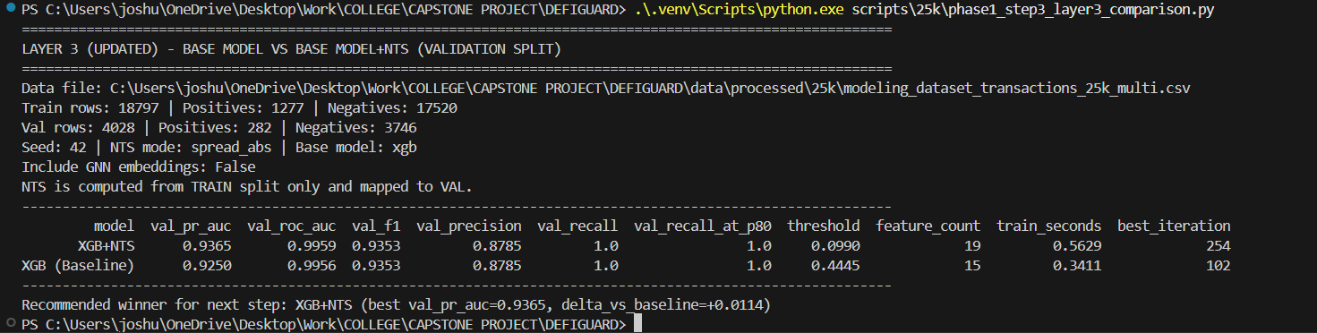

3. The Final Winner
The final winner is XGBoost augmented with Temporal Intelligence (NTS), achieving the highest PR-AUC score of 0.9365.
Why did this win?
While Graph Neural Networks (GraphSAGE) successfully captured the spatial layout of laundering operations, the time-based features proved to be an even stronger signal. Both peel chains and smurfing rely on specific sequence timings to move funds securely. By giving XGBoost awareness of these temporal rhythms, the model became highly effective at distinguishing complex money laundering from normal DeFi activity.

