User Manual

**Simple chess ver1.0**

Authors: Cody Ding, UCI 3rd year CE major student

Jiawei Li, UCI 4th year CE major student

Yiming He, UCI 3rd year CE major student

Table of contents

* Computer chess
* Installation
* Chess program functions and features
* Back matter

Glossary

The pieces and how they move

**Rook** - the chess piece can move horizontally and vertically across the board.

**Bishop** - the chess piece can move diagonally across the board.

**Queen** - the chess piece can move horizontally, diagonally, and vertically across the board.

**Pawn** - the chess piece can only move forward across the board. For its initial move, the pawn can only move forward two positions or one position. When the pawn reaches the end of the board, it can automatically be promoted to another piece.

**King** - the chess piece can move in all directions, but only one step for each time. King cannot move to check. The special movement rule for the King is called “castling”.

**Knight**- the chess piece can move two steps forward plus one step sideways.

Special moves

**Castling** - each player can only castle once per game when the condition is met. In castling, the player moves King two positions to its left or right towards its Rook. Player can choose which side he/she wants to move. The Rook then moves to the squares besides the King and towards the center of the board.

The requirements for castling are that neither King nor Rook involved have moved before, King cannot move out of check, through check, or into check, and there should not be any pieces of either color between the King and Rook involved in the castling.

**En passant** - French words mean “in passing”. Either player's pawns can capture a horizontally adjacent enemy pawn when it has just moved two squares forward. The capturing pawn moves to the square that the enemy’s pawn just passed. The capture is only made when the enemy pawn only moves one square forward and it is only permitted immediately after the enemy pawn moves two squares forward.

1. **Computer chess**

1.1Usage scenario

The object programme file needs to be in a runnable state at all times. It will run on the user's computer and have the following interface.

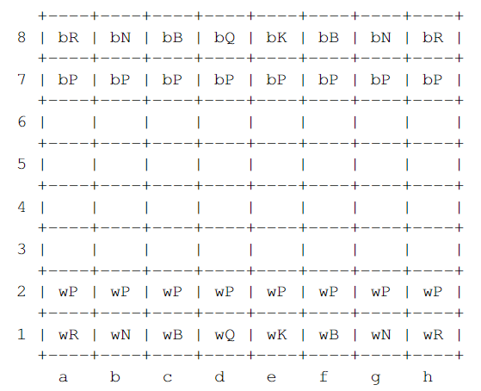

The user interface consists of ascii characters, where we use Arabic numerals to represent the vertical axis of the chessboard and alphabetical order to represent the horizontal axis. Within each space, we use two characters to represent specific pieces. For example, the w at the beginning represents the white player, and the b represents the black player. The second letter indicates the role of the piece. For example, K means king and Q means queen.

1.2 Goals

The goal of this project is to allow players to play chess against AI. We will allow the player to freely choose black or white, will determine the piece type, and make sure they play the game in the correct way, meaning that the player's behavior complies with the official rules. We will allow the player to move the piece by entering a string, such as E2 E4 (meaning move the piece at E2 to E4), and produce a log that is easy to read. After the player has made an action, the board and pieces will be displayed in a correct, readable way. Meanwhile, AI players will respond in less than a minute.

1.3 Features

This program allows players to compete with AI, and has a complete chess function, which will restrict players to make inputs that conform to the rules of the game, and output AI steps to display the chessboard. There will be complete rules, such as Judgment Castling and "En passant".

1. **Installations**

2.1 System requirements

Linux-based OS

Undetermined

2.2 Setup and Configuration

Using command “gtar xvzf Chess_V1.0.tar.gz '' to unzip the package.

Typing “evince chess/doc/chess.pdf” to open the user manual.

To set up the program, use the command “cd chess” to navigate into the chess folder. Then, use the “make” command to build all required files. After finishing building, use the “chess” command to run the program.

2.3 Uninstalling

Using the command “rm -r chess” to remove all files.

1. **Chess Program Functions and Features**

3.1 Print Manual:

Print a menu that provides selection for the player to play with another player or machine and choose black or white.

Input: user selection.

Output: next menu page or begin the chess.

3.2 Initialize Board:

Reset all pieces to initial positions and clean the log.

No user input.

3.2 Update Board:

Redraw the board when players make moves.

No user input.

3.3 Players move - user input for which piece and where the piece moves to.

Output error if the move is against the rule. If not, update the board based on the player's selection, then changing turns to the other player.

If a player entered xx, abort the game and return to manual.

3.4 Check Valid Move

Check all valid moves for one specific piece.

When a invalid input or invalid move appears, ask the player to input a valid move.

Linked to following functions:

Avoid Check, Castling, En passant (Promotion)

3.5 Avoid Check

When one side has been checked, try to find a valid move to avoid being in check. All other steps in this situation will be considered invalid, and when no valid step can be found, one side loses the game automatically.

3.6 Castling

Requirement: King & rook never moved, king not be in check, king cannot pass

through check, no pieces between king and rook.

When all requirements are satisfied and the player chooses to castle, move both

pieces to their locations.

3.7 En passant:

Check if one pawn has never moved or not,then determine its next move can be either 1 square forward or 2 squares forward.

3.8 Record:

Record all steps into a log file.

**Back Matter**

Copyright © 2022 BigBang. All rights reserved.

Error Message

Invalid input: When user input is invalid, print errorMessage1, ask user to input a valid value.

Invalid move: When user’s move against official rules, print errorMessage2, ask the user to make a valid move.

Index