Documentation
This doc is a documentation of solving the GCP-BigQuery-Projec1 tasks.

Create a git repo
On my computer:
cp -r gcp-bigquery-3 gcp-bigquery-project1
rm -r .git
git init

on github GUI:
create a project

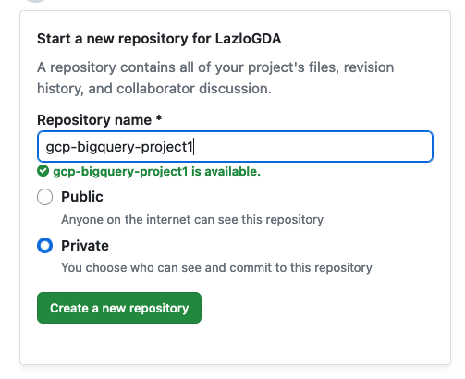

Add team members:
Settings - Access - Collaborators - Manage Access

On my computer:

git remote add origin https://github.com/LazloGDA/gcp-bigquery-project1.git

git add .

git commit -m “first commit”

git push -u origin main

Create the Infra in GCP by terraform

In this quest I used the following git repository:
https://github.com/LazloGDA/gcp-bigquery-project1.git

Part 1: Project Setup
On GCP Console:
Create a new project:
IAM & Admin - Create a project: Project name: gcp-bigquery-project1

Add team members to the project:
IAM & Admin - IAM - Grant Access

Enable compute Engine API:
Google Cloud - Compute Engine - Compute Engine API - Enable

On my computer:

Open a terminal

Create a new gcloud configuration:
gcloud init

project: gcp-bigquery-project1
Region: europe-west3-a (22)

(Or use an existing one:
gcloud projects list
gcloud config set project $MY_PROJECT_ID)

Get credentials:
gcloud auth application-default login

Part 2: Setting up Cloud SQL:

cd terraform-sql
terraform init
terraform apply -var-file sql.tfvar

google_sql_database_instance.postgres: Creation complete after 10m15s [id=project1-db]
google_sql_database.newdatabase: Creating...
google_sql_user.users: Creating...
google_sql_database.newdatabase: Creation complete after 8s [id=projects/gcp-bigquery-project1/instances/project1-db/databases/project1]
google_sql_user.users: Still creating... [10s elapsed]
google_sql_user.users: Creation complete after 11s [id=project1//project1-db]

Apply complete! Resources: 3 added, 0 changed, 0 destroyed.

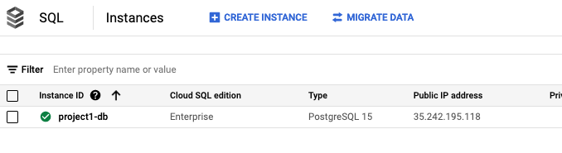

gcloud sql connect project1-db --database=project1 --user=project1
postgres=>\i INIT_SCRIPT_NAME_IF_WE_HAVE.sql
postgres=>\d # list tables
PICTURE

postgres=>\l # list all databases
postgres=>SELECT current_database(); # check the current database

A really good article about Cloud SQL instances with only Private IP:
https://medium.com/google-cloud/cloud-sql-with-private-ip-only-the-good-the-bad-and-the-ugly-de4ac23ce98a

Part 3: Creating a Cloud Storage Bucket
cd terraform-bucket
rm -r .terraform .terraform.lock.hcl terraform.tfstate terraform.tfstate.backup
terraform init
terraform apply -var-file bucket.tfvar

google_storage_bucket.bigquery_bucket: Creating...
google_storage_bucket.bigquery_bucket: Creation complete after 2s [id=gcp-bigquery-project1-bucket]

Apply complete! Resources: 1 added, 0 changed, 0 destroyed.

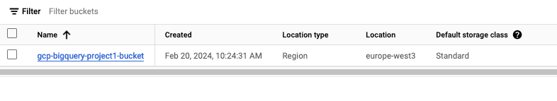

Part 4: Setting up Dataproc Cluster:

For enabling web-interfaces (Component gateways) I added to main.tf below lines,
And I had to change the provider to "google-beta"

cluster_config {
endpoint_config {
enable_http_port_access = "true"
}
}

https://stackoverflow.com/questions/73104501/terraform-gcp-data-proc-component-gateway-enable-issue

cd terraform-dataproc
terraform init
terraform apply -var-file dataproc.tfvar

google_dataproc_cluster.small_cluster: Creation complete after 2m13s [id=projects/gcp-bigquery-project1/regions/europe-west3/clusters/project1-cluster]

Apply complete! Resources: 1 added, 0 changed, 0 destroyed.

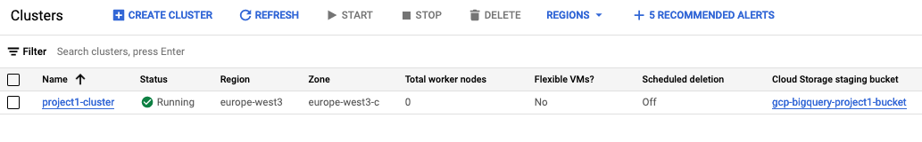
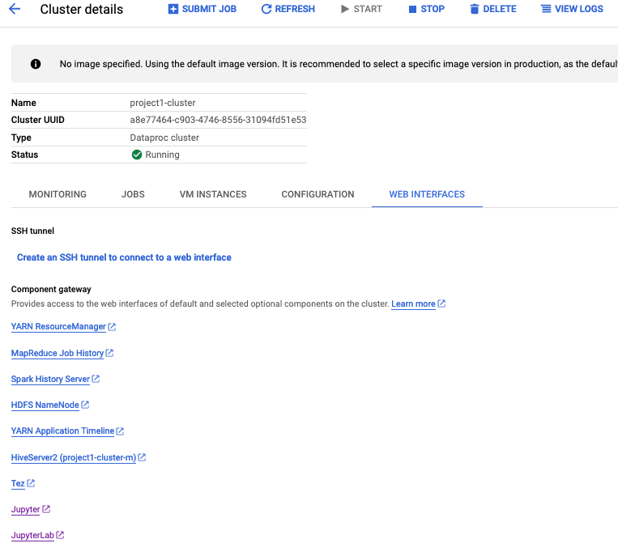

Setting up spark - BigQuery connector
Other Problems, error:

At first the connection from the Spark cluster to the BigQuery did not work.
The solution are these parameters:
gcloud dataproc clusters create ${CLUSTER_NAME} \
--region ${REGION} \
--initialization-actions gs://goog-dataproc-initialization-actions-${REGION}/connectors/connectors.sh \
--metadata bigquery-connector-version=1.2.0 \
--metadata spark-bigquery-connector-version=0.21.0 \
--metadata hive-bigquery-connector-version=2.0.3

But I had to find how to implement it in terraform. Here is the solution:
cluster_config {
… # other parameters
initialization_action {
script = "gs://goog-dataproc-initialization-actions-europe-west3/connectors/connectors.sh"
timeout_sec = 500
}
gce_cluster_config {
metadata = {
bigquery-connector-version="1.2.0"
spark-bigquery-connector-version="0.21.0"
hive-bigquery-connector-version="2.0.3"
}
}

}

Next error after that:
pyspark.sql.utils.IllegalArgumentException: requirement failed: Temporary GCS path has not been set
The solution is a spark .option in the pyspark code:
.option("temporaryGcsBucket","gcp-bigquery-project1-bucket") \

We needed the bucket name that we used in the project..

Setting up BigQuery to connect to CloudSQL with Private IP

Connecting BigQuery to CloudSQL with private IP, It's a little bit tricky.
These are the steps:
- First of all I used this article to create a necessary terraform files for the Cloud SQL with Private IP and the necessary network services:
https://cloud.google.com/sql/docs/postgres/configure-private-ip#terraform

- But the “Enable Private Path” setting is missing from this code.
I added to it later:
ip_configuration {
enable_private_path_for_google_cloud_services = true <-- flag set to true
}
This article was really helpful:
- https://stackoverflow.com/questions/67223682/connecting-bigquery-to-cloudsql-with-private-ip
- The next step to configure BigQuery to Connect to Cloud SQL according this guide:
https://cloud.google.com/bigquery/docs/connect-to-sql#create-sql-connection

Create BigQuery and Machine Learning model

Part 1: BigQuery environment
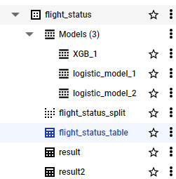

Part 3: Machine Learning model

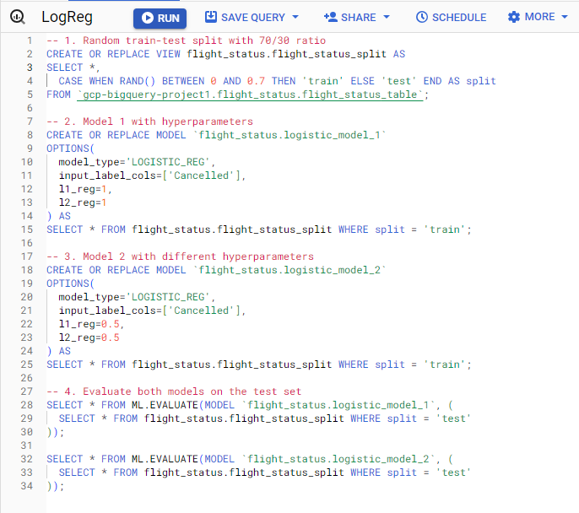

Visualization

Part 1: Looker connection
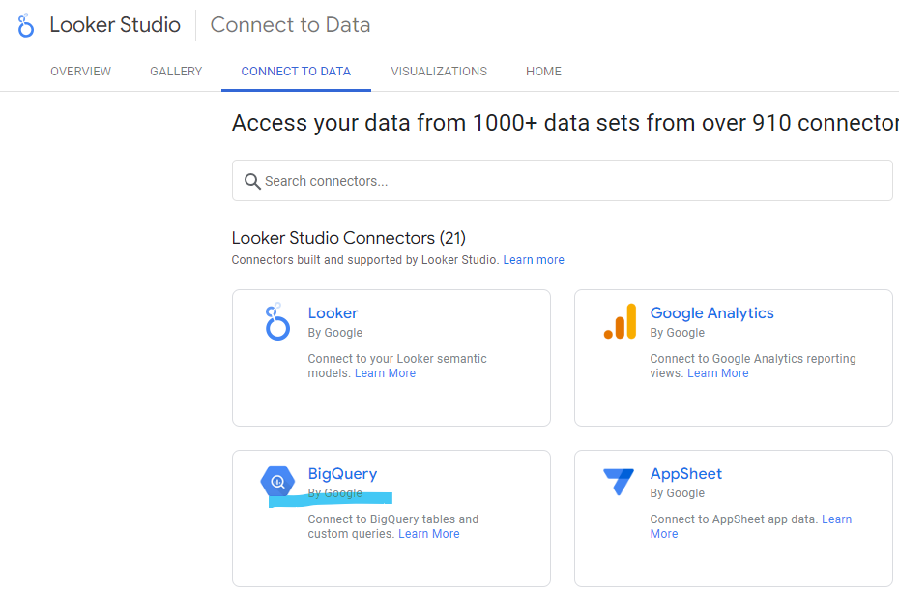

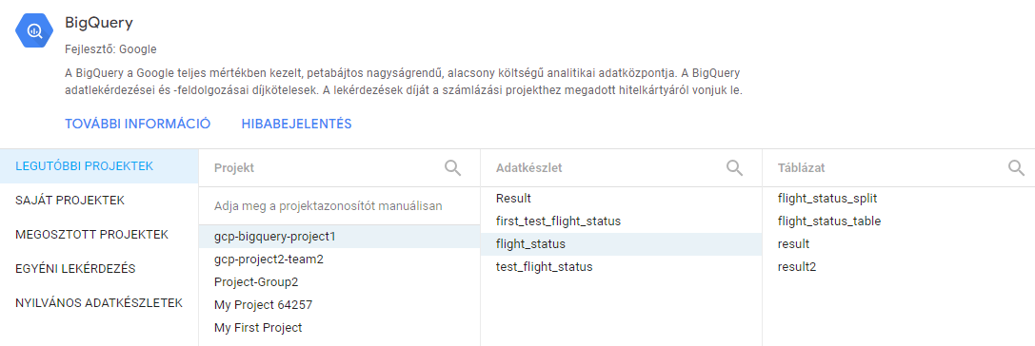

Part 2: Build visualizations and keep them uptodate

