Vertex AI: Use custom prediction routines with Sklearn to preprocess and postprocess data for predictions

I used this codelab link:
https://codelabs.developers.google.com/codelabs/vertex-cpr-sklearn#1

The detailed description of these steps are written in the codelab.
In this document, I just wrote some notes.

My final version of the codes with this document is available in this Github repository:
https://github.com/LazloGDA/vertexai-custom-model

Enable APIs:
Compute Engine
Artifact Registry
Vertex AI API
Notebooks API

Set the Cloud Shell environment
gcloud config set project project-4-vertexai
projectid=project-4-vertexai
region=europe-west1
echo $projectid

project-4-vertexai

echo $region

europe-west1

Create a new aiml-vpc
gcloud compute networks create aiml-vpc --project=$projectid --subnet-mode=custom

Created [https://www.googleapis.com/compute/v1/projects/project-4-vertexai/global/networks/aiml-vpc].
NAME: aiml-vpc
SUBNET_MODE: CUSTOM
BGP_ROUTING_MODE: REGIONAL
IPV4_RANGE:
GATEWAY_IPV4:

Instances on this network will not be reachable until firewall rules
are created. As an example, you can allow all internal traffic between
instances as well as SSH, RDP, and ICMP by running:

$ gcloud compute firewall-rules create <FIREWALL_NAME> --network aiml-vpc --allow tcp,udp,icmp --source-ranges <IP_RANGE>
$ gcloud compute firewall-rules create <FIREWALL_NAME> --network aiml-vpc --allow tcp:22,tcp:3389,icmp

Create the user-managed notebook subnet
gcloud compute networks subnets create workbench-subnet --project=$projectid --range=172.16.10.0/28 --network=aiml-vpc --region=$region
--enable-private-ip-google-access

Created [https://www.googleapis.com/compute/v1/projects/project-4-vertexai/regions/europe-west1/subnetworks/workbench-subnet].
NAME: workbench-subnet
REGION: europe-west1
NETWORK: aiml-vpc
RANGE: 172.16.10.0/28
STACK_TYPE: IPV4_ONLY
IPV6_ACCESS_TYPE:
INTERNAL_IPV6_PREFIX:
EXTERNAL_IPV6_PREFIX:

Cloud Router and NAT configuration
Router:
gcloud compute routers create cloud-router-europe-west1-aiml-nat --network aiml-vpc --region=$region

Creating router [cloud-router-europe-west1-aiml-nat]...done.
NAME: cloud-router-europe-west1-aiml-nat
REGION: europe-west1
NETWORK: aiml-vpc

NAT:
gcloud compute routers nats create cloud-nat-europe-west1 --router=cloud-router-europe-west1-aiml-nat --auto-allocate-nat-external-ips --nat-all-subnet-ip-ranges --region=$region

Creating NAT [cloud-nat-europe-west1] in router [cloud-router-europe-west1-aiml-nat]...done.

Create a user managed service account for User managed Notebook
gcloud iam service-accounts create user-managed-notebook-sa \
--display-name="user-managed-notebook-sa"

Created service account [user-managed-notebook-sa].

Add roles:

Storage Admin
Vertex AI User
Artifact Registry Administrator

gcloud projects add-iam-policy-binding $projectid --member="serviceAccount:user-managed-notebook-sa@$projectid.iam.gserviceaccount.com" --role="roles/storage.admin"

gcloud projects add-iam-policy-binding $projectid --member="serviceAccount:user-managed-notebook-sa@$projectid.iam.gserviceaccount.com" --role="roles/aiplatform.user"

gcloud projects add-iam-policy-binding $projectid --member="serviceAccount:user-managed-notebook-sa@$projectid.iam.gserviceaccount.com" --role="roles/artifactregistry.admin"

gcloud iam service-accounts list

DISPLAY NAME: user-managed-notebook-sa
EMAIL: user-managed-notebook-sa@project-4-vertexai.iam.gserviceaccount.com
DISABLED: False

Create the user managed Notebook

gcloud notebooks instances create workbench-tutorial \
--vm-image-project=deeplearning-platform-release \
--vm-image-family=common-cpu-notebooks \
--machine-type=n1-standard-4 \
--location=europe-west1-d \
--shielded-secure-boot \
--subnet-region=europe-west1 \
--subnet=workbench-subnet \
--no-public-ip --service-account=user-managed-notebook-sa@$projectid.iam.gserviceaccount.com

Waiting for operation on Instance [workbench-tutorial] to be created with [projects/project-4-vertexai/locations/europe-west1-d/operations/operation-170913
7143477-61273804f3513-a0087364-42286349]...done.
Created notebooks instance workbench-tutorial [https://notebooks.googleapis.com/v1/projects/project-4-vertexai/locations/europe-west1-d/operations/operation-1709137143477-61273804f3513-a0087364-42286349].

Open the Jupyterlab on the user-managed notebook instance

On the console: Wertex AI - Workbench - User-Managed Notebooks
In the list of instances - Open JupiterLab

Create a bucket

Open a Terminal on JupiterLab Launcher

gsutil mb -l europe-west1 gs://project-4-vertexai-cpr-bucket

Train model
In Terminal:
mkdir cpr-codelab
cd cpr-codelab

In JupyterLab
Go into the cpr-codelab directory
And here create a new python3 notebook with this name: task.ipynb

The necessary codes in the “Train model” section in the task.ipynb

PERSONAL CHANGES:
- For this lab I used the REGION = "europe-west1" settings. So I had to change the code in the task.ipynb in several places. You can see my version in the git repo.

- I had to modify one line in the requirements.txt file, because the orig code did not worked for me:
Orig code line was:
scikit-learn~=1.0.0
My code line:
Scikit-learn
You can see my version in the git repo.

Save a preprocessing artifact

The necessary codes in the “Save a preprocessing artifact” section in the task.ipynb

Build a custom serving container using the CPR model server

The necessary codes in the “Build a custom serving container using the CPR model server” section in the task.ipynb

Deploy model to Vertex AI
The necessary codes in the “Deploy model to Vertex AI” section in the task.ipynb

Result:
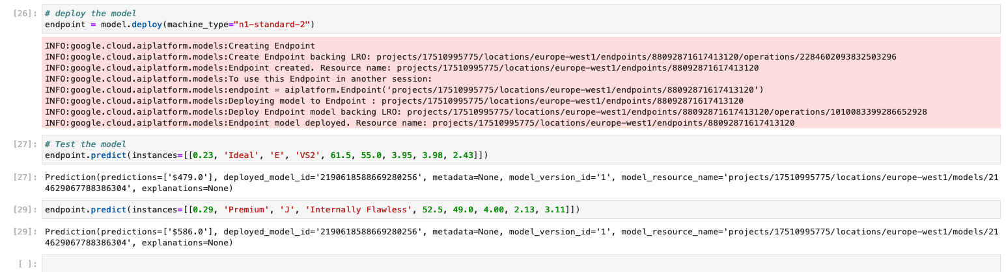
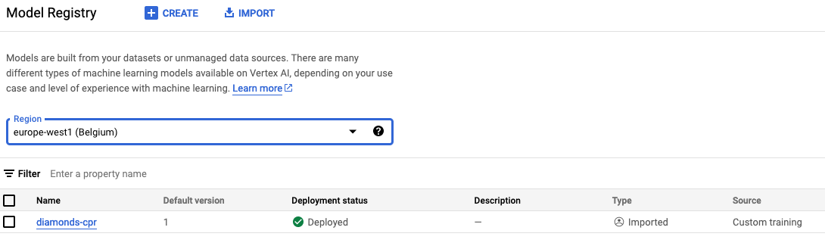

Appendix

Git Repo
My final version of the codes with this document is available in this Github repository:
https://github.com/LazloGDA/vertexai-custom-model

