|  |  |
| --- | --- |
| **Project Case** |  |
| COMP7116 | T0283  Computer Vision |
| **Computer Science** | **E182-COMP7116-LO02-00** |
| ***Valid on*** *Even Semester Year 2017/2018* | **Revision 00** |

1. Seluruh kelompok tidak diperkenankan untuk:

*The whole group is not allowed to:*

* + - Melihat sebagian atau seluruh proyek kelompok lain,

*Seeing a part or the whole project from other groups*

* + - Menyadur sebagian maupun seluruh proyek dari buku,

*Adapted a part or the whole project from the book*

* + - Mendownload sebagian maupun seluruh proyek dari internet,

*Downloading a part or the whole project from the internet,*

* + - Mengerjakan soal yang tidak sesuai dengan tema yang ada di soal proyek,

*Working with another theme which is not in accordance with the existing theme in the matter of the project,*

* + - Melakukan tindakan kecurangan lainnya,

*Committing other dishonest actions,*

* + - Secara sengaja maupun tidak sengaja melakukan segala tindakan kelalaian yang menyebabkan hasil karyanya berhasil dicontek oleh orang lain / kelompok lain.

*Accidentally or intentionally conduct any failure action that cause the results of the project was copied by someone else / other groups.*

1. Jika kelompok terbukti melakukan tindakan seperti yang dijelaskan butir 1 di atas, maka **nilai kelompok** yang melakukan kecurangan (menyontek maupun dicontek) akan di – **NOL** – kan.

*If the group is proved to the actions described in point 1 above, the score of the group which committed dishonest acts (cheating or being cheated) will be “Zero”*

1. Perhatikan jadwal pengumpulan proyek, segala jenis pengumpulan proyek di luar jadwal tidak dilayani.

*Pay attention to the submission schedule for the project, all kinds of submission outside the project schedule will not be accepted*

1. Jangan lupa untuk melihat kriteria penilaian proyek yang ditempel di papan pengumuman, atau tanya asisten anda.

*Don’t forget to look at the project assessment criteria that posted on the announcement board, or ask your teaching assistant.*

1. Persentase penilaiaan untuk matakuliah ini adalah sebagai berikut:

*Marking percentage for this subject is described as follows:*

|  |  |  |
| --- | --- | --- |
| **Tugas Mandiri**  *Assignment* | **Proyek**  *Project* | **UAP**  *Final Exam* |
| 40% | 60% | - |

1. Software yang digunakan pada matakuliah ini adalah sebagai berikut:

*Software will be used in this subject are described as follows:*

|  |
| --- |
| **Software**  *Software* |
| Microsoft Visual C# 2010 Express  Emgu CV 2.3.0 |

## Ekstensi file yang harus disertakan dalam pengumpulan tugas mandiri dan proyek untuk matakuliah ini adalah sebagai berikut:

*File extensions should be included in assignment and project collection for this subject are described as follows:*

|  |  |
| --- | --- |
| **Tugas Mandiri**  *Assignment* | **Proyek**  *Project* |
| Folder Project (SLN, CS, RESX, EDMX, CSPROJ, USER, EXE, PDB, CACHE, TXT, RESOURCES, DLL, SETTINGS, image files(JPG/PNG/GIF)), Video Files (Avi, Mp3, Mp4) | Folder Project (SLN, CS, RESX, EDMX, CSPROJ, USER, EXE, PDB, CACHE, TXT, RESOURCES, DLL, SETTINGS, image files(JPG/PNG/GIF)), Video Files (Avi, Mp3, Mp4) |

**Soal**

*Case*

**LOmoCamera**

**LOmoCamera** is a simple application to edit your picture or video. As s programmer, you are asked to create the application with the following requirements:

1. **Login Form**

* Components:
* Label : Title, Email, Password, Error
* Text Box : Email, Password
* Button : Login
* Link Label : Register
* Descriptions:
* If the user **clicks** **Register** **Link Label**, then the application will **go** to **Register Form**
* If the user **clicks Login Button**, then the application will:
* Validate **email** and **password** must be **same** with the **registered email** and **password (case sensitive)**.
* If the user **inputs incorrect data**, **show error message**.
* If the user **inputs correct data**, **go** to **Menu Form**.

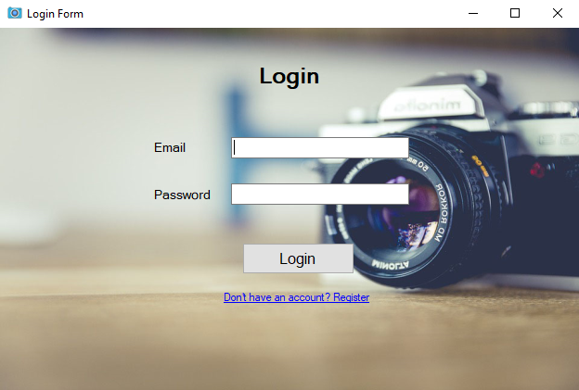

Figure 1. Login Form

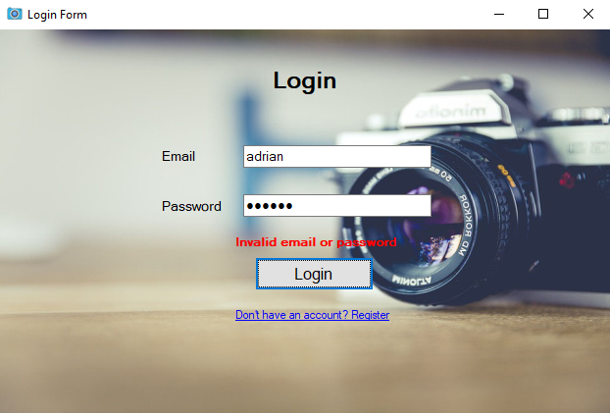

Figure 2. Login Form with error

1. **Register Form**

* Components:
* Label : Title, Email, Password, Confirm Password, Full Name, Gender, Error
* Text Box : Email, Password, Confirm Password, Full Name
* Radio Button : Male, Female
* Check Box : Agreement
* Button : Register
* Link Label : Login
* Descriptions:
* If the user **clicks Login Link Label**, then the application will **go** to **Login Form**
* If the user **clicks Register Button**, then the application will:
* Validate **email**, **password**, **confirm password**, **full name** must be **filled**.
* Validate **gender** must be **chosen**.
* Validate **agreement** must be **checked**.
* Validate **email** must be following conditions:
* Email length must be **more than 10**
* Email must **contain** ‘**@**’character
* Email must **not start** with ‘**@**’ or ‘**.**’ Character
* Email must **end** with “**yahoo.com**” or “**gmail.com**”
* Example:
* Correct : **lukito@yahoo.com**
* Incorrect : **@yahoo.com**

: **lukito@a.com**

: **lukitoyahoo.com**

* Validate **confirm password** must **same** with **password**
* If the user **inputs incorrect data, show error message**.
* If the user **inputs correct data, show success message** and **go** to **Login Form**

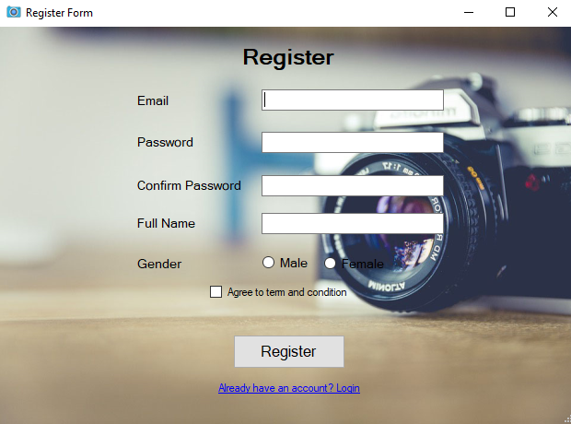

Figure 3. Register Form

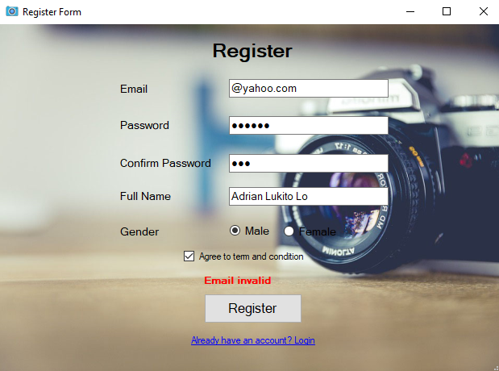

Figure 4. Register Form with error

1. **Menu Form**

* Components:
* Label : Title, Choose Menu
* Button : Edge Detection, Shape Detection, Image Processing, Pattern

Recognition and Classification, Logout

* Descriptions:
* Title **display** user’s **name** with following condition:
* If the user’s gender is **Male,** then the **user’s** name **will be started with** ‘**Mr.’**
* If the user’s gender is **Female**, then the **user’s** name **will be** **started with** ‘**Mrs.**’
* If the user **clicks Edge Detection**, then the application will **go** to **Edge Detection Form**
* If the user **clicks Shape Detection**, then the application will **go** to **Shape Detection Form**
* If the user **clicks Image Processing**, then the application will **go** to **Image Processing Form**
* If the user **clicks Pattern Recognition and Classification**, then the application will **go** to **Pattern Recognition and Classification** **Form**
* If the user **clicks Logout**, then the application will **go** to **Login Form**

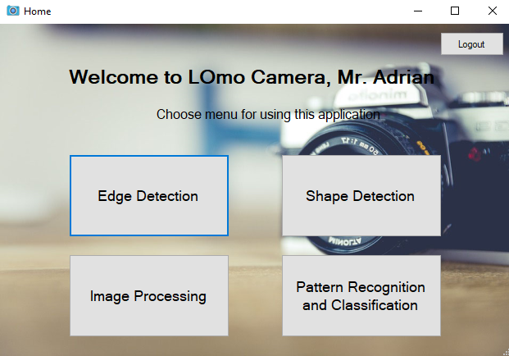

Figure 5. Menu Form

1. **Edge Detection Form**

* Components:
* Picture Box : Uploaded Image, Canny Image, Laplace Image, Sobel Image
* Label : Canny, Laplace, Sobel, Aperture Size, High, Low
* Button : Back, Upload
* Combo Box : Aperture Size
* Track Bar : High, Low
* Group Box : Mode, Editor
* Descriptions:
* **Set Aperture Size** value to **3**, **5**, and **7**
* **Set Maximum** value of **High Track Bar** to **200** and **Minimum** value of **High Track Bar** to **0**
* **Set Maximum** value of **Low Track Bar** to **100** and **Minimum** value of **Low Track Bar** to **0**
* If the user **clicks Back Button**, then the application will **go** to **Menu Form**
* If the user **clicks Upload Button**, then the application will:
* **Show Open File Dialog** to **choose image** with **image file extension filter** (**.jpg**, **.jpeg**, **.png**, **.bmp**)
* If the user **confirms** choosing image:
* **Show** the **chosen image** in the **Uploaded Image Picture Box**
* **Show** the **chosen image** in the **Canny Image Picture Box** with **Canny Edge Detector Mode** which **aperture size** set to **3**, **high** set to **150**, and **low** set to **60.**
* **Show** the **chosen image** in the **Laplace Image Picture Box** with **Laplace Edge Detector Mode** which **aperture size** set to **7**
* **Show** the **chosen image** in the **Sobel Image Picture Box** with **Sobel Edge Detector Mode** which **aperture size** set to **3**, **x order** set to **1**, **y order** set to **0**
* If the user **clicks Canny Picture Box**, then the application will:
* If the user **hasn’t chosen image yet**, **show error message** “**Please upload image first**”
* Otherwise, then:
* **Show High Label** and **Low Label**
* **Show High Track Bar** and **Low Track Bar**
* **Change Canny Label** to **aqua color** and **bold**
* **Show** the **chosen image mode** in the **Uploaded Image Picture Box**
* If the user **clicks Laplace Picture Box**, then the application will:
* If the user **hasn’t chosen image yet**, **show error message** “**Please upload image first**”
* Otherwise, then:
* **Hide High Label** and **Low Label**
* **Hide High Track Bar** and **Low Track Bar**
* **Change Laplace Label** to **aqua color** and **bold**
* **Show** the **chosen image mode** in the **Uploaded Image Picture Box**
* If the user **clicks Sobel Picture Box**, then the application will:
* If the user **hasn’t chosen image yet**, **show error message** “**Please upload image first**”
* Otherwise, then:
* **Hide High Label** and **Low Label**
* **Hide High Track Bar** and **Low Track Bar**
* **Change Sobel Label** to **aqua color** and **bold**
* **Show** the **chosen image mode** in the **Uploaded Image Picture Box**
* If the user **changes high** or **low track bar value**, the change will affect **Canny** **Edge Detection in real time**
* If the user **change aperture size value**, the change will affect **all mode aperture size in real time**

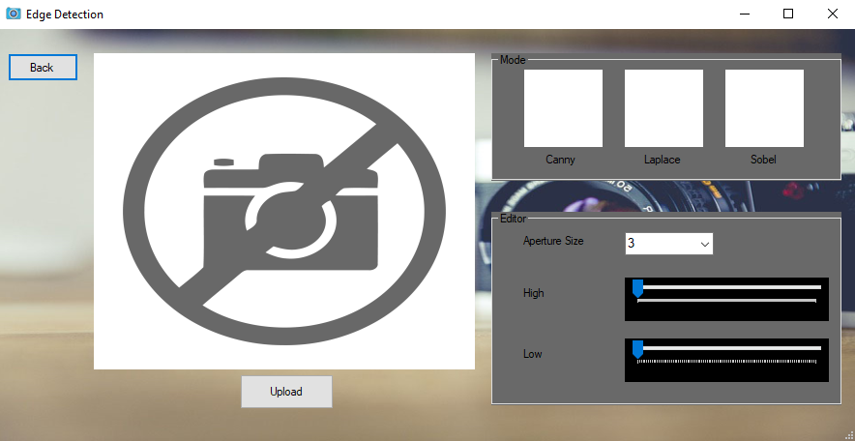

Figure 6. Edge Detection Form

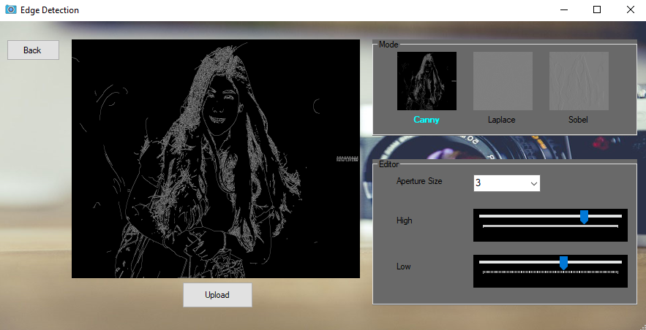

Figure 7. Edge Detection Form (Canny Edge Detection)

1. **Shape Detection Form**

* Components:
* Picture Box : Uploaded Image
* Button : Back, Upload, Process
* Check Box : Line, Rectangle, Circle
* Group Box : Shape Mode
* Descriptions:
* When **Shape Detection Form starts**, the application will **disable** **Process Button**
* If the user **clicks Back Button**, then the application will **go** to **Menu Form**
* If the user **clicks Upload Button**, then the application will:
* **Show Open File Dialog** to **choose image** with **image file extension filter** (**.jpg**, **.jpeg**, **.png**, **.bmp**)
* If the user **confirms** choosing image, then the application will:
* **Show** the **chosen image** in the **Uploaded Image Picture Box**
* **Enable Process Button**
* If the user **clicks Process Button**, then the application will:
* If the user **hasn’t chosen image yet**, **show error message** “**Please upload image first**”
* If the user **hasn’t check shape check box**, **show error message** “**Choose Shape Detection Mode**”
* Otherwise, then:
* **Detect image** according to the **checked Shape Detection Check Box** with **different color** for each **detection type**
* **Show detected image** in the **Uploaded Image** **Picture Box**

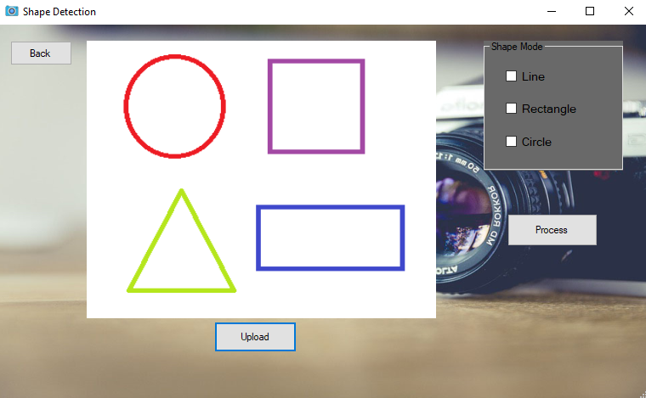

Figure 8. Shape Detection Form

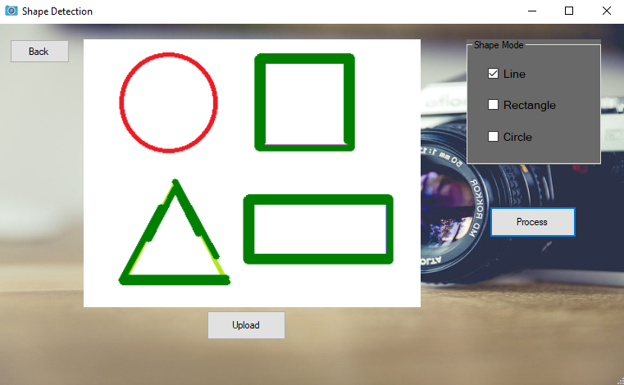

Figure 9. Shape Detection Form (Line Shape)

1. **Image Processing Form**

* Components:
* Picture Box : Uploaded Image, Smooth, Grayscale, Threshold
* Label : Smooth, Grayscale, Threshold, Smooth (Track Bar), Threshold (Track

Bar), Brightness

* Button : Back, Upload
* Track Bar : Smooth, Threshold, Brightness
* Group Box : Mode, Editor
* Descriptions:
* When **Image Processing Form starts**, the application will:
* **Hide Editor Group Box**
* **Set Maximum** value of **Threshold Track Bar** to **255** and **Minimum** value of **Threshold Track Bar** to **0**
* **Set Maximum** value of **Brightness Track Bar** to **255** and **Minimum** value of **Brightness Track Bar** to **0**
* **Set Maximum** value of **Smooth Track Bar** to **201** and **Minimum** value of **Smooth Track Bar** to **1**
* If the user **clicks Back Button**, then the application will **go** to **Menu Form**
* If the user **clicks Upload Button**, then the application will:
* **Show Open File Dialog** to **choose image** with **image file extension filter** (**.jpg**, **.jpeg**, **.png**, **.bmp**)
* If the user **confirms** choosing image, then the application will:
* **Show** the **chosen image** in the **Uploaded Image Picture Box**
* **Change all picture box** in **Mode Group Box** based on the **image mode label name**
* If the user **clicks Smooth Picture Box**, then the application will:
* If the user **hasn’t chosen image yet**, **show error message** “**Please upload image first**”
* Otherwise, then:
* **Show Smooth** (Track Bar) **Label**
* **Show Smooth Track Bar**
* **Show Editor Group Box**
* **Show** the **chosen image mode** in the **Uploaded Image Picture Box**
* If the user **clicks Grayscale Picture Box**, then the application will:
* If the user **hasn’t chosen image yet**, **show error message** “**Please upload image first**”
* Otherwise, then:
* **Hide Editor Group Box**
* **Show** the **chosen image mode** in the **Uploaded Image Picture Box**
* If the user **clicks Threshold Picture Box**, then the application will:
* If the user **hasn’t chosen image yet**, **show error message** “**Please upload image first**”
* Otherwise, then:
* **Show Threshold Label** (**inside Editor Group Box**) and **Brightness Label**
* **Show Threshold Track Bar** and **Brightness Track Bar**
* **Show Editor Group**
* **Show** the **chosen image mode** in the **Uploaded Image Picture Box**
* If the user **change threshold** or **brightness track bar value**, then will affect **Threshold Detection real time**
* If the user **change smooth track bar value**, then will affect **Smooth Detection real time**

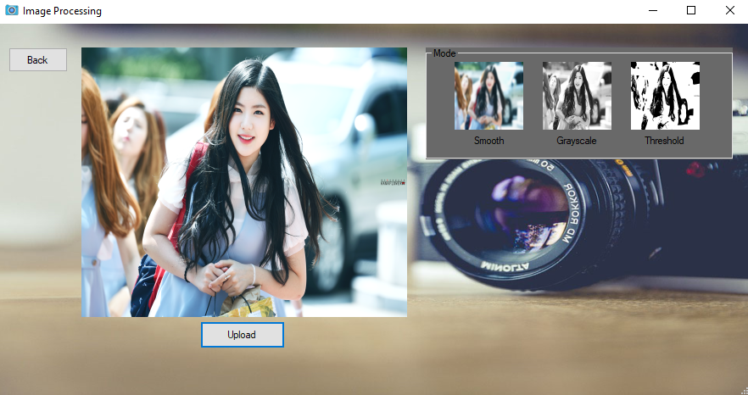

Figure 10. Image Processing Form

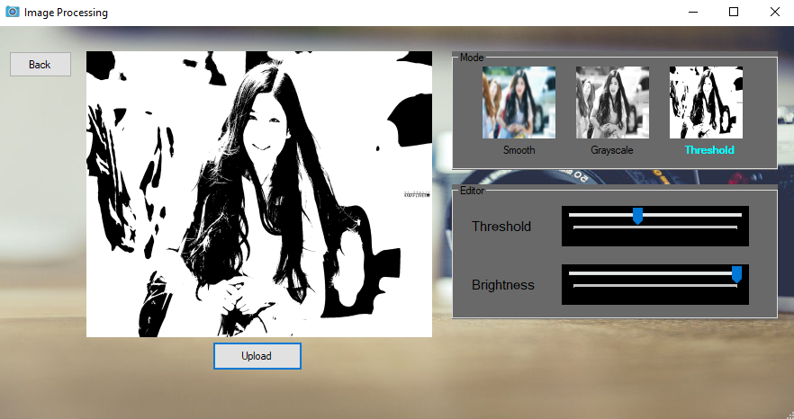

Figure 11. Image Processing Form (Threshold Detection)

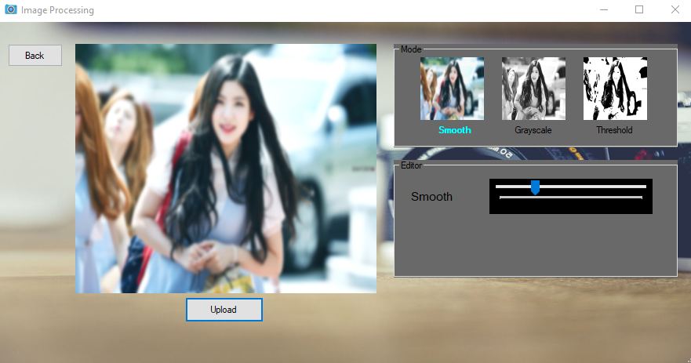

Figure 12. Image Processing Form (Smooth Detection)

1. **Pattern Recognition and Classification Form**

* Components:
* Picture Box : Uploaded Image
* Button : Back, Upload Image, Upload Video, Stop Video, Play Video
* Check Box : Face, Eye, Canny Edge Detector
* Group Box : Object to Detect
* Descriptions:
* When **Pattern Recognition and Classification Form starts**, the application will **disable Stop Video Button** and **Play Video Button**
* If the user **clicks Back Button**, then the application will **go** to **Menu Form**
* If the user **clicks Upload Image Button**, then the application will:
* **Show Open File Dialog** to **choose image** with **image file extension filter** (**.jpg**, **.jpeg**, **.png**, **.bmp**)
* If the user **confirms** choosing image, then the application will:
* **Show** the **chosen image** in the **Uploaded Image Picture Box**
* **Disable Stop Video Button** and **Play Video Button**
* If the user **clicks Upload Video Button**, then the application will:
* **Show Open File Dialog** to **choose video** with **video file extension filter** (**.mp4**, **.gif**, **.avi**, **.mkv**)
* If the user **confirms** choosing video, then the application will:
* **Show** the **chosen video** in the **Uploaded Image Picture Box**
* **Enable Stop Video Button** and **Play Video Button**
* If the user **clicks Stop Button Video**, then the application will **stop** the **played video**
* If the user **clicks Play Button Video**, then the application will **play** the **stopped video**
* If the user **check Eye Check Box** or **Face Check Box** or **Canny Edge Detector Check Box**, then the application will:
* **Detect image** or **video** according to the **checked Object Detection Check Box** with **different color** for each **detection type**
* **Show detected image** in the **Uploaded Image** **Picture Box**

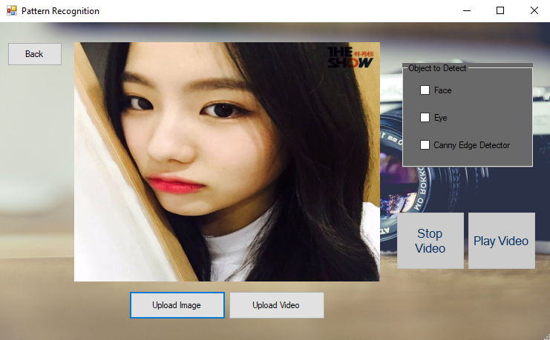

Figure 13. Pattern Recognition and Classification Form

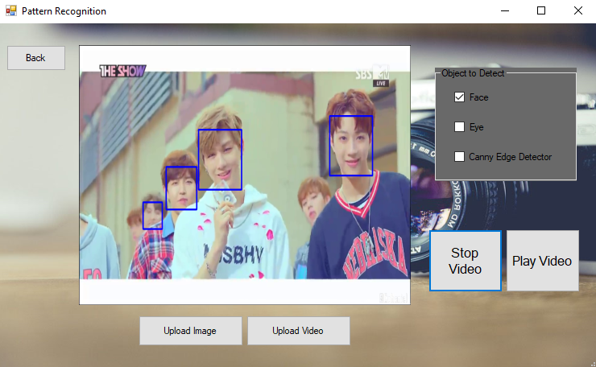

Figure 14. Pattern Recognition and Classification Form (Face Detection)

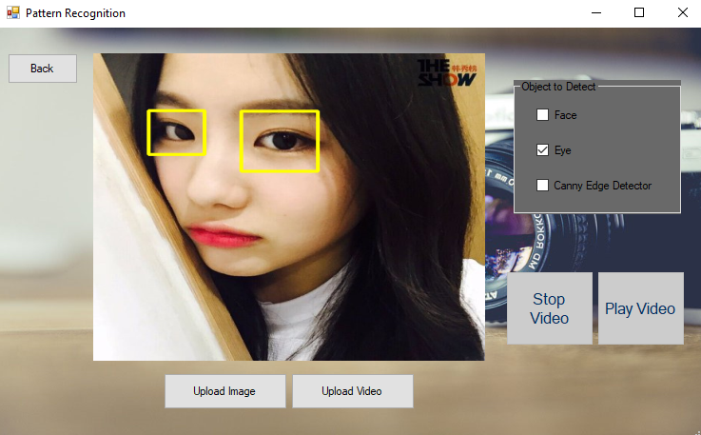

Figure 15. Pattern Recognition and Classification Form (Eye Detection)

Here are the rules that you must follow to create your project:

1. Use appropriate software for this subject based on **Sistem Praktikum** that can be downloaded from Binusmaya.
2. Use the techniques taught during practicum.
3. Collect appropriate files for this subject based on **Sistem Praktikum** that can be downloaded from Binusmaya.
4. Include the other files that can support your project, such as:
   * All files in your project
   * Other files (image, audio, video, etc.) used in your project
   * *.DOC file (documentation of your project) that contains the reference links of additional files (image, audio, video, etc.) used in your project

**References:**

**https://www.youtube.com/watch?v=tjHv4xq9zHg**

**https://pbs.twimg.com/profile_images/819802778138619905/CQalrY9U.jpg**

**http://i.imgur.com/0FF6KKH.png**

**http://www.guruparents.com/image-files/shapes.png**

**https://www.amfmph.com/wp-content/plugins/social-media-builder//img/no-image.png**

**https://pixabay.com/get/e830b0092ff6093ed1534705fb0938c9bd22ffd41cb017409cf2c17ca1/analog-1516728_1920.jpg**

**https://www.google.co.id/url?sa=i&rct=j&q=&esrc=s&source=images&cd=&ved=0ahUKEwiHn_OhgN_YAhWDH5QKHamtAFkQjBwIBA&url=http%3A%2F%2Fwww.iconarchive.com%2Fdownload%2Fi99343%2Fdtafalonso%2Fandroid-lollipop%2FCamera-Next.ico&psig=AOvVaw0zDmBvjpRWbXqhNKH6A85k&ust=1516278576840982**