**Introduction:**

HTML (Hypertext Markup Language) and CSS (Cascading Style Sheets) are two fundamental technologies used for creating and designing websites.

HTML is the standard markup language used to structure the content of a web page. It consists of a series of tags that define the elements and layout of the page. HTML tags provide semantic meaning to different parts of the content, such as headings, paragraphs, lists, images, and links. With HTML, you can organize and present information on a web page in a structured and accessible manner.

CSS, on the other hand, is a style sheet language used for describing the presentation and visual appearance of a web page written in HTML. It enables you to control the layout, colors, fonts, and other visual aspects of your web pages. CSS works by associating style rules with HTML elements or applying them globally to the entire document. It allows you to create visually appealing and consistent designs across multiple web pages.

Both HTML and CSS are essential skills for web developers and designers. They form the foundation of web development and are often used alongside other technologies such as JavaScript to create interactive and dynamic web experiences.

**Page 1:**

*The html tags used in this page are :*

• **<!DOCTYPE html>**: Specifies the document type as HTML5.

• **<html>** : The root element of an HTML document.

• **<head>** : Contains meta information about the document, such as title and linked resources.

• **<meta>** : Provides metadata about the HTML document, such as character encoding and viewport settings.

• **<link>** : Specifies external resources to be linked, such as stylesheets.

• **<style>** : Defines inline CSS styles for the document.

• **<title>** : Sets the title of the document displayed in the browser's title bar or tab.

• **<body>** : Represents the content of the HTML document.

• **<header>** : Defines a container for introductory content, typically containing headings or logos.

• **<h1>** : Represents a top-level heading.

• **<span>** : Used for styling or grouping inline elements.

• **<div>** : Defines a container or a division of the document.

• **<a>** : Creates a hyperlink to another web page or resource.

• **<img>** : Inserts an image into the document.

• **<h2>** : Represents a second-level heading.

• **<p>**: Defines a paragraph of text

*The css properties used in this page are :*

**box-sizing**: Specifies the sizing behavior of an element's box.

**font-family**: Sets the font family for text content.

**background**: Sets the background properties, including color and gradient.

**background-image**: Sets the background image for an element.

**background-size**: Sets the size of the background image.

**background-attachment**: Sets whether the background image scrolls with the content or **remains fixed.**

**text-align:** Aligns the text content horizontally.

**color:**  Sets the color of the text.

**padding**: Sets the padding space around the content.

**letter-spacing**: Adjusts the spacing between characters.

**text-shadow**: Adds shadow effects to the text.

**margin:** Sets the margin space around an element.

**grid-gap**: Sets the gap size between grid items.

**grid-template-coloumns**: Defines the number and size of columns in a grid layout.

**place-conten**t: Aligns grid items along the grid's row and column axes.

**background-color**: Sets the background color of an element.

**border-radius**: Rounds the corners of an element.

**box-shadow**: Adds a shadow effect to an element.

**height:**  Sets the height of an element.

**object-fit:**  Specifies how an image or video should fit within its container.

**transform**: Applies a 2D or 3D transformation to an element.

**transition:** Specifies the transition effects for an element.

**opacity:** Sets the opacity level of an element.

**position:** Sets the positioning method of an element.

**width:** Sets the width of an element.

**cursor:** Sets the type of cursor to be displayed when hovering over an element.

**Code :**

<!DOCTYPE html>

<html lang="en">

<head>

    <meta charset="UTF-8">

    <meta http-equiv="X-UA-Compatible" content="IE=edge">

    <meta name="viewport" content="width=device-width, initial-scale=1.0">

    <link rel="stylesheet" href="styleHistorical.css">

    <link rel="stylesheet" href="styles.css">

    <!-- <title>Historical Places Of India</title> -->

    <style>

        * {

    box-sizing: border-box;

}

body {

    font-family: fantasy;

    background: linear-gradient(135deg, #D2B48C, #8B4513);

    background-size: 500;

    background-attachment: fixed;

}

header {

    text-align: center;

    color:  #333333;

    padding: 10px 1px 10px 1px;

    letter-spacing: 5px;

    text-shadow: 2px 1px 5px grey;

}

.head {

    color: #b7043d;

}

.container {

    display: grid;

    margin: 20px;

    grid-gap: 50px;

    grid-template-columns: 400px 400px 400px;

    place-content: center;

}

.items {

    background-color: rgba(128, 234, 178, 0.365);

    margin: 10px;

    /* border: 1px solid black; */

    border-radius: 10px;

    box-shadow: 10px 10px 5px rgba(0, 0, 0, 0.39);

    /* backdrop-filter: blur(4px); */

    height: 470px;

}

.items h2 {

    color: black;

    text-align: center;

    font-weight: lighter;

}

.items p {

    color: #525151;;

    padding: 2px 12px 2px 12px;

    /* justify-content: center;

    text-align: center; */

    letter-spacing: 1.2px;

    font-weight: lighter;

    font-size: 14px;

    text-align: justify;

}

.image {

    width: 380px;

    border-radius: 4px;

    height: 228px;

    object-fit: cover;

    border-top-left-radius: 10px;

    border-top-right-radius: 10px;

}

.imgContainer {

    position: relative;

    width: 380px;

    height: 228px;

    cursor: pointer;

}

.imgContainer:before {

    content: "";

    position: absolute;

    top: 0;

    left: 0;

    width: 100%;

    height: 100%;

    background-color: hsl(271, 76%, 53%);

    transform: scale(0);

    transition: all 800ms linear;

    transform-origin: 0 50%;

    z-index: 2;

    opacity: 0.3;

}

.imgContainer:hover:before {

    transform: scale(1);

}

.imgTitle {

    font-size: 2rem;

    left: 25%;

    top: 50%;

}

.descrip {

    font-size: 1rem;

    left: 25%;

    top: 65%;

    width: 50%;

}

.imgContainer:hover span {

    opacity: 1;

}

 .imgTitle, .descrip{

    position: absolute;

    color: #fff;

    opacity: 0;

    transition: all 800ms linear;

    z-index: 3;

}

.line {

    left: 0;

    top: 0;

    position: absolute;

    background: #fff;

    transition: all 800ms linear;

}

.top {

    width: 3px;

    height: 0;

    left: 20%;

}

.imgContainer:hover .top {

    height: 100%;

}

.left {

    width: 0;

    height: 3px;

    top: 95%;

}

.imgContainer:hover .left {

    width: 100%;

}

    </style>

</head>

<body>

    <header >

        <h1>Historical <span class="head">Places Of West Bengal</span></h1>

    </header>

    <div class="container">

        <div class="items">

            <div class="imgContainer">

                <a href="indian_library.html">

                    <img class="image"

                        src="indian_library.jpg">

                <span class="imgTitle">Indian Library</span>

                <span class="descrip">Click Here to Know More</span>

                <span class="line top"></span>

                <span class="line left"></span>

            </a>

            </div>

            <h2>Indian Library</h2>

            <p>The Indian Library, located in Kolkata, is a treasure trove of knowledge. It is one of the oldest and largest libraries in India, housing a vast collection of books, manuscripts, and rare documents. The magnificent architecture and serene ambiance make it a must-visit for book lovers and history enthusiasts.</p>

        </div>

        <div class="items">

            <div class="imgContainer">

                <a href="howrah_bridge.html"

                        alt="" class="image">

                        <img class="image"

                        src="howrah_bridge.jpg">

                <span class="imgTitle">Howrah Bridge</span>

                <span class="descrip">Click Here to Know More</span>

                <span class="line top"></span>

                <span class="line left"></span>

            </a>

            </div>

            <h2>Howrah Bridge</h2>

            <p>The iconic Howrah Bridge, spanning the Hooghly River in Kolkata, is a symbol of engineering marvel and an integral part of the city's identity. Built in the early 20th century, it is one of the busiest cantilever bridges in the world. Walking across the bridge while admiring the panoramic views is an unforgettable experience.</p>

        </div>

        <div class="items">

            <div class="imgContainer">

                <a href="st_paul_cathedral.html"><img class="image"

                        src="st_paul_cathedral.jpg">

                <span class="imgTitle">St. Paul Cathedral</span>

                <span class="descrip">Click Here to Know More</span>

                <span class="line top"></span>

                <span class="line left"></span>

            </a>

            </div>

            <h2>St. Paul Cathedral</h2>

            <p>The Qutub Minar in Delhi also known as the Victory Tower, is the tallest brick minaret in the whole

                world, standing tall at a height of 72.5 metres. Built of marble and red sandstone.

            </p>

        </div>

        <div class="items">

            <div class="imgContainer">

                <a href="https://en.wikipedia.org/wiki/Victoria_Memorial,_Kolkata">

                    <img class="image"

                        src="https://images.thrillophilia.com/image/upload/s--DB8LV1Y9--/c_fill,g_center,h_450,q_auto,w_753/dpr_1.0,f_auto,fl_strip_profile/v1/images/photos/000/383/705/original/1651647391_shutterstock_1100136929.jpg.jpg">

                </a>

                <span class="imgTitle">Victoria Memorial</span>

                <span class="descrip">Click Here to Know More</span>

                <span class="line top"></span>

                <span class="line left"></span>

            </div>

            <h2>Victoria Memorial</h2>

            <p>Kolkata’s Victoria Memorial was constructed in

                honour of Queen Victoria, making it one of the relics of the British Raj. Built entirely out of white

                marble, the Victoria Memorial is almost a replica of its namesake in London.</p>

        </div>

        <div class="items">

            <div class="imgContainer">

                <a href="jorasanko_thakur_bari.html"> <img class="image"

                        src="jorasanko_thakur_bari.jpg">

                <span class="imgTitle">Jorasanko Thakurbari</span>

                <span class="descrip">Click Here to Know More</span>

                <span class="line top"></span>

                <span class="line left"></span>

            </a>

            </div>

            <h2>Jorasanko Thakurbari</h2>

            <p>Jorasanko Thakur Bari, the ancestral home of Nobel laureate Rabindranath Tagore, is a prominent cultural landmark in Kolkata. It showcases the life and works of the legendary poet and provides insights into Bengali art and culture. The museum inside the mansion exhibits Tagore's personal belongings, manuscripts, and artworks.</p>

        </div>

        <div class="items">

            <div class="imgContainer">

                <a href="hazar_duari.html">

                    <img src="hazar_duari.jpg"

                        alt="" class="image">

                <span class="imgTitle">Hazar Duari</span>

                <span class="descrip">Click Here to Know More</span>

                <span class="line top"></span>

                <span class="line left"></span>

            </a>

            </div>

            <h2>Hazar Duari</h2>

            <p>Hazar Duari, located in Murshidabad, is a historical palace known as the "Palace of a Thousand Doors." It was built during the 19th century by Nawab Nazim Humayun Jah, the ruler of Bengal, Bihar, and Odisha. The palace is a magnificent example of Indo-Islamic architecture and serves as a museum, showcasing artifacts and relics from the era of the Nawabs.</p>

        </div>

    </div>

</body>

</html>

**Output:**

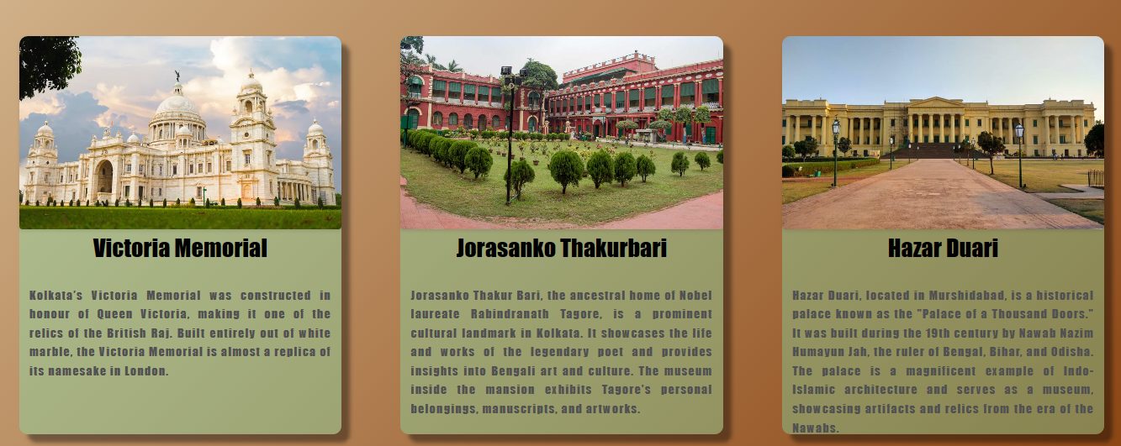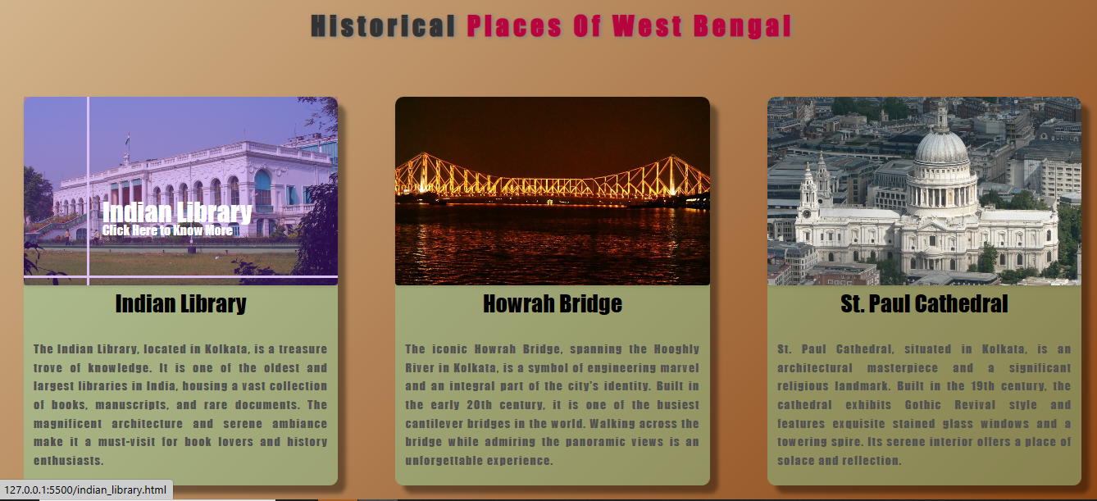

**Page 2:**

*The html tags used in this page are :*

* <!DOCTYPE html>: Specifies the document type as HTML.
* <html>: Represents the root element of an HTML page.
* <head>: Contains metadata and title for the HTML document.
* <meta>: Specifies metadata about the HTML document.
* <title>: Defines the title of the HTML document.
* <link>: Links an external CSS stylesheet to the HTML document.
* <style>: Contains inline CSS styles for the HTML document.
* <body>: Represents the content of the HTML document.
* <main>: Represents the main content of the HTML document.
* <section>: Defines a section of the HTML document.
* <img>: Displays an image in the HTML document.
* <h1>, <h2>: Defines headings in the HTML document.
* <p>: Represents a paragraph of text in the HTML document.
* <a>: Defines a hyperlink in the HTML document.
* <button>: Represents a button in the HTML document.
* <footer>: Represents the footer section of the HTML document.

*The css properties used in this page are :*

* **width**: Specifies the width of an element**.**
* **height:** Specifies the height of an element.
* **max-width:** Sets the maximum width that an element can have.
* **max-height:** Sets the maximum height that an element can have.

**Code:**

<!DOCTYPE html>

<html lang="en">

<head>

  <meta charset="UTF-8">

  <meta name="viewport" content="width=device-width, initial-scale=1.0">

  <title>National Library of India</title>

  <link rel="stylesheet" href="styles.css">

  <style>

    img {

      width: 100%;

      height: auto;

      max-width: 1080px;

      max-height: 720px;

    }

  </style>

</head>

<body>

  <main>

    <section>

      <img src="indian_library.jpg" alt="National Library of India">

      <h1>National Library of India</h1>

      <p>The National Library of India is a library located in Belvedere Estate, Alipore, Kolkata, India. It is India's largest library by volume and public record. The National Library is under the Ministry of Culture, Government of India.</p>

      <p>The library is designated to collect, disseminate, and preserve printed material produced within India. With a collection in excess of 2.5 million books and records, it is the largest in the country.</p>

      <p>In the early days of British rule, it was the residence of the Governor General of Bengal and India. Later on, it became the residence of the Lt. Governor of Bengal when the Governor General's and later the Viceroy's residence moved to today's Governor House.</p>

      <h2>History of the National Library</h2>

      <p>The National Library is a result of the merging of the public library with the Imperial Library—several government libraries. The National Library (1953), then the Imperial Library, housed several foreign (British) and Indian titles and was open to the public. It collects books, periodicals, and titles in virtually all the Indian languages while the special collections in the National Library of India house at least fifteen languages. The collections include 86,000 maps and 3,200 manuscripts.</p>

      <h2>The Imperial Library</h2>

      <p>The Imperial Library was formed in 1891 by combining a number of Secretariat libraries in Calcutta. Of those, the most important and interesting was the library of the Home Department, which contained many books formerly belonging to the library of East India College, Fort William, and the library of the East India Board in London. But the use of the library was restricted to the superior officers of the Government. Sir Ashutosh Mukherjee was appointed as the president of the Imperial Library Council (1910), to which he donated his personal collection of 80,000 books arranged in a separate section.</p>

      <h2>Declaring the Imperial Library as the National Library</h2>

      <p>After independence, the Government of India changed the name of the Imperial Library to the National Library by the Imperial Library (Change of Name) Act, 1948, and the collection was transferred from The Esplanade to the present Belvedere Estate. On 1 February 1953, the National Library was opened to the public by Maulana Abul Kalam Azad. The name of the National Library was changed to the National Library of India by section 18 of the National Library of India Act, 1976.</p>

      <h2>Discovery of Hidden Chamber</h2>

      <p>In 2010, the Ministry of Culture, the owner of the library, decided to get the library building restored by the Archaeological Survey of India (ASI). While taking stock of the library building, the conservation engineers discovered a previously unknown room. The secret ground-floor room, about 1000 sq. ft. in size, seems to have no opening of any kind.</p>

      <p>The ASI archaeologists tried to search the first-floor area (that forms the ceiling of the room) for a trap door but found nothing. Since the building is of historical and cultural importance, ASI has decided to bore a hole through the wall instead of breaking it. There are speculations about the room being a punishment room used by Warren Hastings and other British officials or a place to store treasure.</p>

      <p>In 2011, the researchers announced that the room was filled entirely with mud, probably in an effort to stabilize the building.</p>

      <h2>Visiting the National Library</h2>

      <p>The National Library is located on Belvedere Road in Alipore. It is open between 9 am and 8 pm on all working days and between 9.30 am and 6.00 pm on Saturdays, Sundays, and Government of India holidays. It remains closed on three national holidays: 26 January (Republic Day), 15 August (Independence Day), and 2 October (Birthday of Mahatma Gandhi).</p>

    </section>

    <a href="page2_new.html"><button class="back">Back</button></a>

    <a href="landing.html"><button class="home">Home</button></a>

  </main>

  <footer>

    <p>&copy; 2023 Historical Places. All rights reserved. | Website For Assignment 10</p>

  </footer>

</body>

</html>

**Output:**

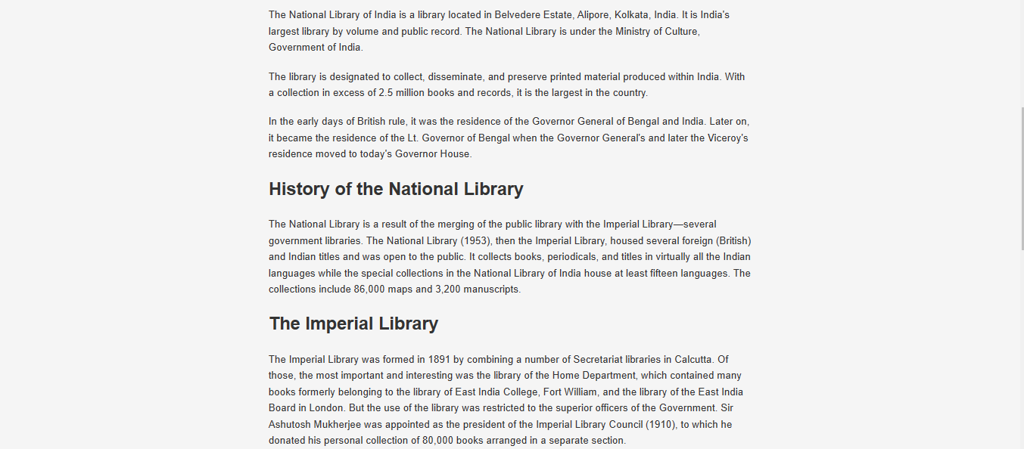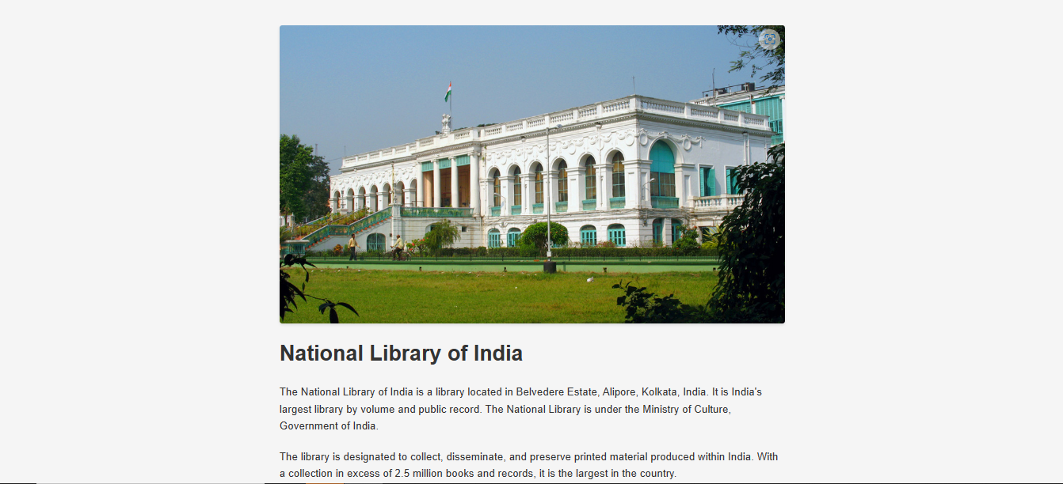

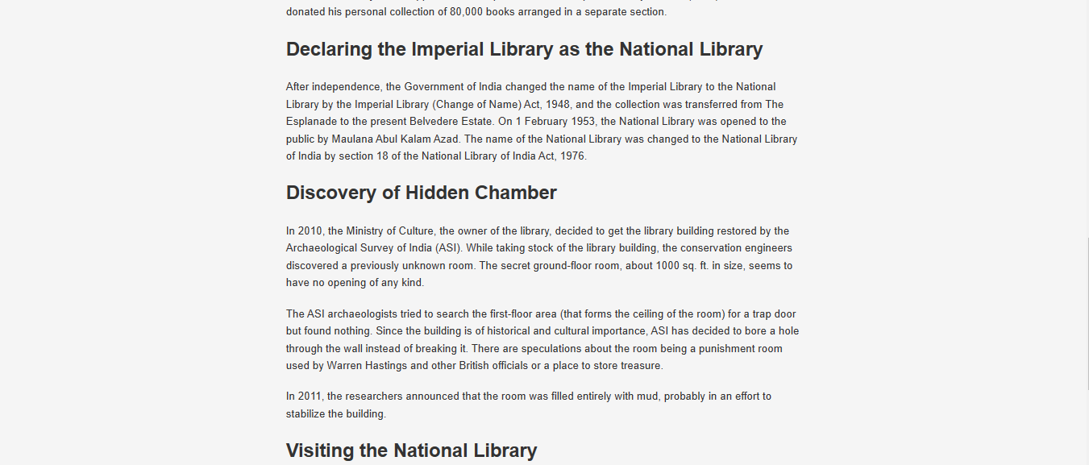**6**

